**ESP Session V Evaluation**

**Task 1 What and why is evaluated in ESP? What are the means used in this evaluation?**

**Task 2 What features does this test have that make it a suitable means of evaluating the learners´ understanding of the material they have studied?**

TEST

The diagram below shows the flow of coolant through a refrigeration system. Study the diagram and then write a description of how the coolant circulates through the system.

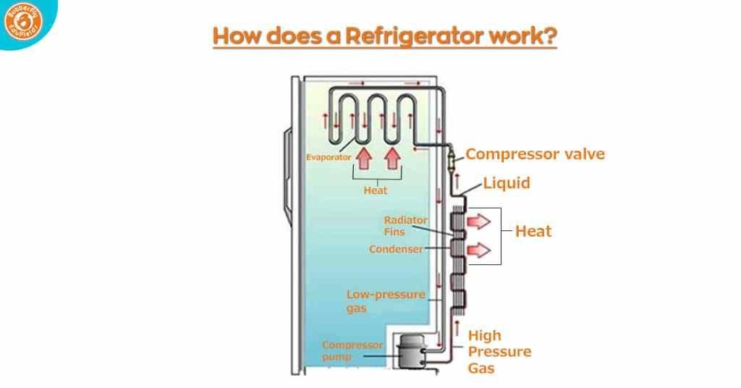

(https://www.butterflyfields.com/how-does-a-refrigerator-work/)

**Task 3 Consider the role of the following phenomena in ESP evaluation:**

***feedback continuous assessment proficiency reliability***