Animals in Antiquity work sheet

**Week 10: Animals in Mythology: Fill in this worksheet during the class and finish the necessary parts at home. You can use additional sheets of paper or create a posters to some tasks. Then submit the completed work no later than during the following class (5.12.).**

Task 1: Identify the following mythological creatures, which animal parts they consist of and to which myths they are connected to (shortly describe). If possible, find any modern (or historic) references to this creature in literature/movies etc. and state your opinion on why it was used there:

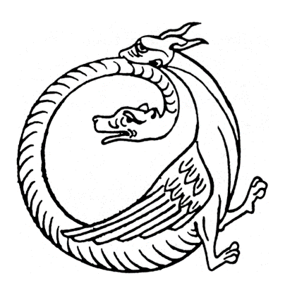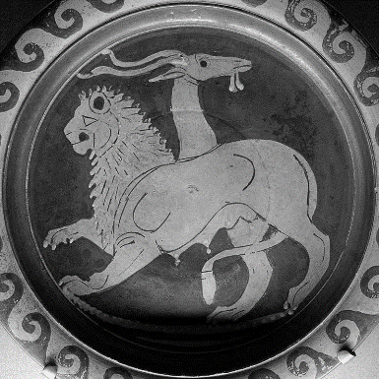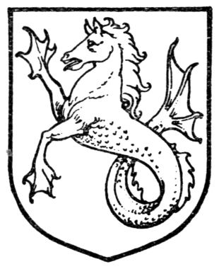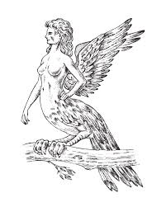

Task 2: Explain what the *centaurs* are, how they came to be and list the names of at least 5 of them. Explain the term *centauromachy*.

Task 3: In medieval times (and even today), it was very common to use mythological creatures in the coat of arms. Imagine you are creating your own coat of arms. Which mythological creature would you pick based on its attributes? Which attributes those are? Answer the questions and then use any tools you want to create your coat of arms, including a motto (painting/drawing/sketch/graphic/OR print and glue the picture of animal). Be as creative as you can!

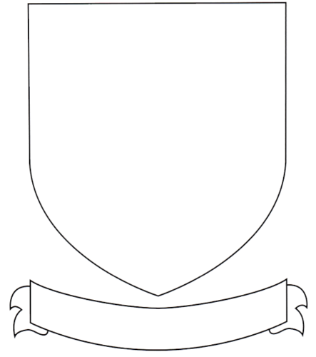

Task 4: Watch one of the following movies and then list mythical animals included in them:

Hercules (Disney, 1997), Clash of the titans (1981 or 2012), Percy Jackson (2010 or 2013).

Explain how the use of mythical animals in the movie differs from original myths and write the short review.

Task 5: Explain who *Minotaur* is where would you find him. Find out from which work of which famous author this description of him comes:

*„My sage cried out to him: "You think,*

*perhaps, this is the Duke of Athens,*

*who in the world put you to death.*

*Get away, you beast, for this man*

*does not come tutored by your sister;*

*he comes to view your punishments."*

Task 6: God Zeus was famous for his affairs. However, in order to get the girl, he often used deceit and took on himself a form of an animal. Which girls were victims of his transformations and which animals did Zeus transformed into? Explain in short the myths.

Task 7: A sphinx is a mythical creature with the head of a human and the body of a lion. Those who cannot answer her riddle suffer a fate typical in such mythological stories, as they are killed and eaten by this ravenous monster. What was the riddle the sphinx gave to Oedipus and on which occasion?