**1 The Celts and their languages**

**The Celts:** an overall name for a large group of Indo-European tribes that populated western, central and eastern Europe throughout the Iron and Medieval ages and spoke Celtic languages.

They can be identified with a particular archeological **Hallstatt culture** (8. – 5. cent. B. C) (The area between Danube, Rhine and Rhône).

During the **La Tène culture** era, 5.-1. cent. BC, the Celtic tribes spread into the eastern Europe as well as into the Balkans and Asia Minor.

In the 1. cent. BC, the areas inhabited by the Celtic tribes were considerably diminished due to the Roman colonization and the raids of Germanic tribes.

At the end of the “great European migration period” (6. cent. AD), the Celts were pushed all the way to the British Isles, where the Celtic languages survived until the present day.

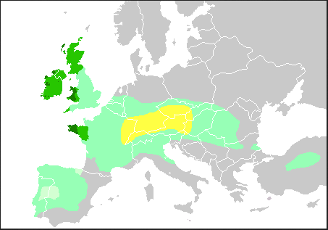

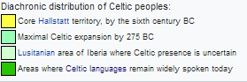

The oldest roots of the Celtic languages can be traced back into the first half of the 2. millennium BC. This rich ethnic group was probably created by a few pre-existing cultures merging together. The Celts shared a common language, culture and beliefs, but they never created a unified state.

The first time the Celts were mentioned in the classical Greek text was in the 6th cent. BC, in the text called *Ora maritima* written by**Hecateo of Mileto** (c. 550 BC – c. 476 BC). He placed the main Celtic settlements into the area of the spring of the river Danube and further west.

The ethnic name **Kelto**… (Herodotus), Kšltai (Strabo), *Celtae (Caesar),* KeltŇj (Callimachus), is usually etymologically explainedwith the ie. root *\*kelH- “to stick out" (Pokorny 1959, 544),* com*. lat. celsus “raised, erected, high, noble",* so it might have meant *“noble"* or *“people from highlands" (sr. Erhart, Slavia 67,*1998, 289-94, who derives the name *Čech* from the same root*).* Other possibility is *ie. root *kel-* “to beat" (Pokorny 1959, 545-47), *so the Celts* = “warriors".

In the first century B.C., J. Caesar noticed that the peoples known to the Romans as the Gauls called themselves Celts. This means that the name *Celts* was received by all the Celtic tribes of the Roman Gallia.

The lat. *Gallus* is most probably derived from an ethnic or tribal name and was later accepted by Latin during the period of the Celtic expansion into the Roman empire in the 5th cent. B.C.

The root probably comes from the proto-celtic *\*galno*, and means “*power, strength*”, ad old Irish *gal* “courage” and Welsh *gallu* “*to be able to*”.

Translated from KELTSKÉ JAZYKY, Václav Blažek

**The Celtic seasonal festivities**

Many customs and beliefs have survived until the modern days.

The Celts observed both solstices and equinoxes.

The day started traditionally with dusk on the “previous” day.

The year most probably started with **Samhain** (the Winter Calends, w. *Calan gaeaf*) **1st of November** (on the night before the Holy Day), even though some theories support the possibility that the Celtic calendar year started on Beltine.

This time was the time of the year, when people were most likely to encounter supernatural powers and beings. The Welsh saying ***pwca ar bob camfa*** *„a hobgoblin on every stile“* is connected to the time of samhain . In Scotland, people used to carve pumpkins, wear masks and begged for treats. Today, the festival has merged with the All Saints` Day and All Hallow`s Eve. Samhain plays a very important role in the classical Celtic literature (ex. The intoxication of Ulstermen, The dream of Oengus).

**Imbolc:** 1st of February, the beginning of spring, the cleansing after winter and the celebration of fertility. It has become the (Saint Brigid's Day). In Welsh it is known as **Gŵyl Fair y Canhwyllau** "Mary's Festival of the Candles", the Welsh name for Candlemas  (in Cristianity this corresponds with the **Presentation of Jesus at the Temple**).

**Beltine:**  the festival started on the night of the 31st April and continued throughout the first day of May. It is also known as the **Calends of May**, w. Calan Mai. In the Czech Republic this festival is called “the witches”.

During this festival, the Celts used to make two big fires and led their cattle in between them, in this way the animals should have been cleansed after the winter. On the Island of Man, people used to make big fires on the hilltops. People also used to visit sacred wells and springs. Dew collected at the Beltine night or in the morning was believed to have magical properties (it got ladies rid of freckles and wrinkles). The dairy products were the most prone to being cursed on Beltine. The name of the festival comes from the proto-celtic ***\*belo-te(p)niâ*** and means “*bright fire”.* In Edinburgh, Scotland, people traditionally welcome the first sunrays of the Beltine sunrise on the Arthur`s Seat. The Beltine festival was mentioned many times in the medieval masterpieces of Celtic literature (the colt of Teyrnon Twrf Liant- ad. Reading sample n.1 ). Household and farm workers were usually hired for a period from beltine to beltine (medieval law significance).

**Reading sample: Mabinogi, The First Branch of Mabinogi, Pwyll Pendeuic Dyuet „Pwyll, the lord of Dyfed“.**

**Lughnasad:** 1st of August, **the celebration of harvest**, this season was popular for marriages. Lughnasad has been observed especially in Britain until these days. It`s known as the 'Garland Sunday‘, 'Bilberry Sunday‘ or 'Mountain Sunday' (people welcome the Sun, waiting for the sunrise on mountains, there used to be a goat and cattle market in villages). In old Irish language, *Lugnasad* was a word combined fom the name of the god *Lug* and *násad* (gahtering), w. *ymsang*.

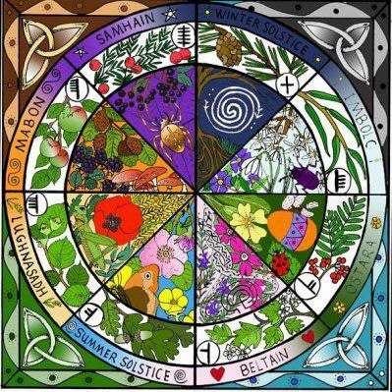

**2 Classification of Celtic languages**

History of the Classification of the Celtic Languages

The Celtic languages hold a special place in the early history of Indo-European linguistics, because they presented the first real challenge to the nascent science.

The demonstration that Irish and its relatives are related to Greek, Latin and Sanskrit was a genuine triumph, for these languages at the first sight seem to be very different.

(Fortson, Indo-European Linguistics, 2010, p. 309)

The relationship between Welsh and Latin and Greek was recognized earlier than the relationship within the family of the Celtic languages (ex. the relationaship between Welsh and Irish).

This first comparison was suggested by a Welsh historian **Gerald of Wales** (lat. Giraldus Cambrensis). In his “Description of Wales” (*Descriptio Cambriae)* , he managed to compare a few Welsh words with their Latin and Greek equivalents. In a few cases, the words he listed were indeed the words derived from the common Proto-Indo-European language (ex. *W.* ***haul*** *"sun": Lat. sōl, Gr. hélios,* ***halein*** *"salt": Lat. sal, Gr. hals*, ***enou*** *“name": Lat. nómen, Gr. ónoma [Ônoma].*

During the 16. and 17. centuries, more similarities were recognized between the insular Celtic languages and the continental languages of ancient, medieval and modern Europe (Irish with Greek, Welsh with the classical European languages, Irish with the Germanic languages).

Translated from *Keltské jazyky,* Václav Blažek.

The fact that the **Brythonic** and the **Goidelic** languages represented two main branches of the same language family (the Celtic languages), was first recognized in 1632 by a linguist **J. Davis.**

In 1707, **E. Lhuyd**, welsh naturalist, botanist, linguist and antiquary, presented in his masterpiece “*Archaeologia Britannica:*

*an Account of the Languages, Histories and Customs of Great Britain, from Travels through Wales, Cornwall, Bas-Bretagne, Ireland and Scotland”* the first attempt of a comparative grammar of the Celtic languages.

The Celtic languages belong amongst so called **Centum languages** (ad principle division of the Indo-European languages).

In the Avestan language “hundred” was pronounced as [satəm], (therefore Satem languages), ex. OSl. sъto, Lith. šimtas, Latv. simts. **The Satem languages** include **Indian, Baltic, Indo-Iranian, Slavic** and other languages.

On the other hand, in old Latin, c was pronounced as [k] . The number “hundred” was then pronounced as [kentum] and for this reason we call these languages **Centum languages** (ex. Gr. ha katon [heketon], Goth. hund [hund], G. hundert, E. hundred [handrid]. **The Centum languages include Germanic, Celtic, Italic and other languages.**

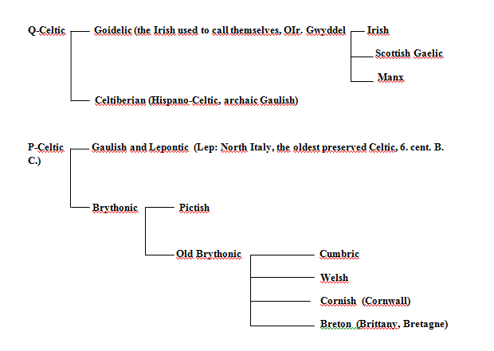

This classification is based on the different development of IE. ***\*kʷ****,* which was kept amongst the **Q-Celtic** languages and changed to p amongst the **P-Celtic** languages. This traditional model of Celtic languages classification is supported by H. Pedersen and K.H. Schmidt.

*IE.* ***\*kʷ*** appears in the Celtiberian (Hispano-Celtic) language, as well as in some early dialects of the Gaulish language (where it is taken for an archaic variation) and in the Ogham script (where it is traditionally transcribed as Lat. Q) as **/kṷ/**, which later develops into **/k/** in the Goidelic languages (Irish, Scottish Gaelic, Manx).

On the other hand, in the Gaulish, Lepontic and Brythonic languages, it changes into **/p/**.

Ex. OGaul. *cenn, W. pen(n), "head";* OGaul*.. mac(c), W. map, "son".*

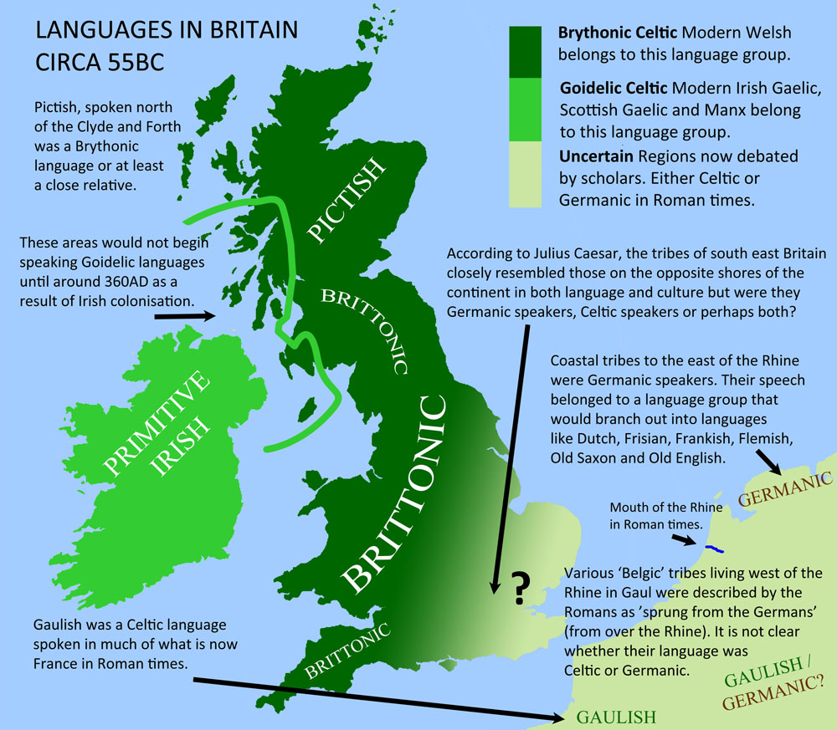

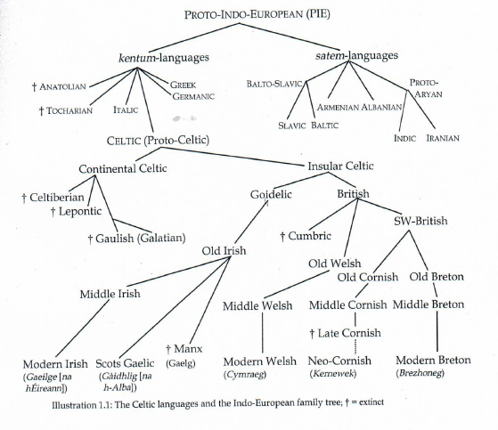

**Communities using the Celtic languages today include:**

**Wales:** cca 500 000 speakers (about 20% of population, esp. in North Wales)

**Bretagne**: about 210 000 speakers

**Scotland**: about 58 000 speakers

**Ireland**: only 75 000 speakers, but about one million speaks Irish as L2 in the Republic of Ireland.

**Cornwall**: only a few hundreds of speakers, new attempts of revival of the language presently continue .

**Manx**: the last native died in 1974, attempts of a revival, today about 2000 speakers, but only about 100 report that they would use Cornish in everyday conversation.

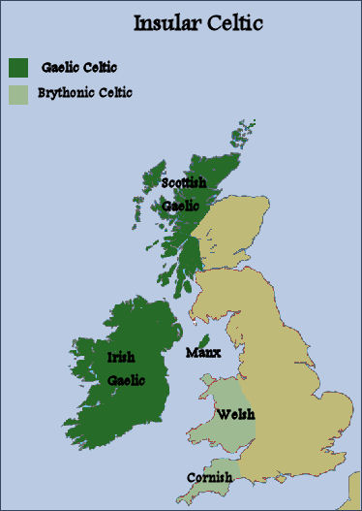

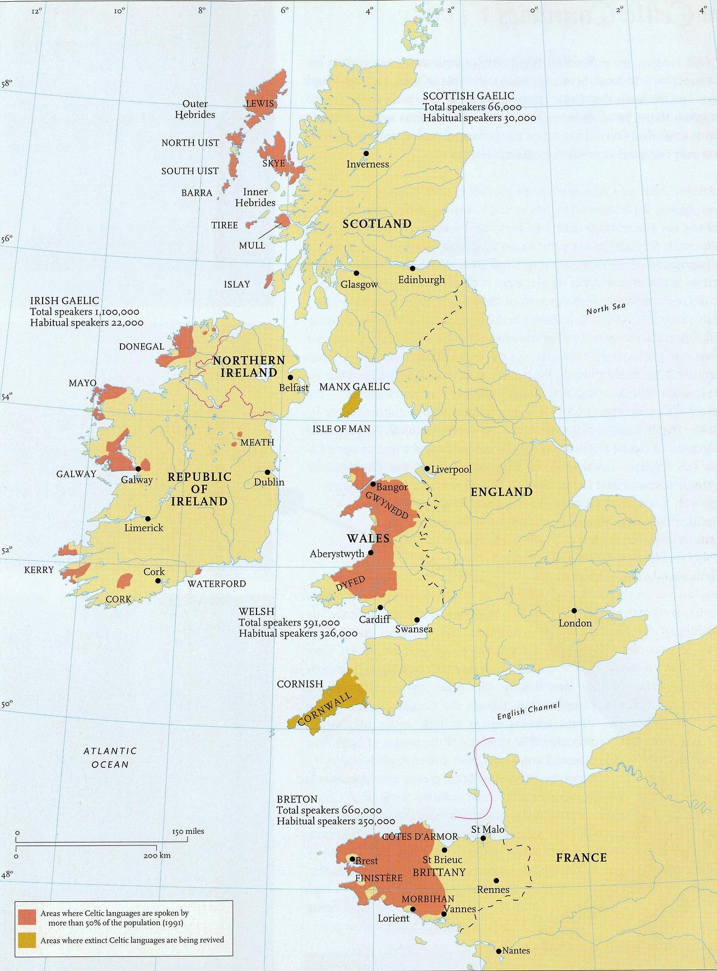

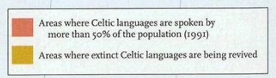

About 1500 descendants of the Welsh colony from the end of the 19th century and the beginning of the 20th century have kept their original Welsh language until the present day. Y Wladfa, W. “ *colony”* lies in province Chubut in Argentina and includes a few Welsh speaking settlements.

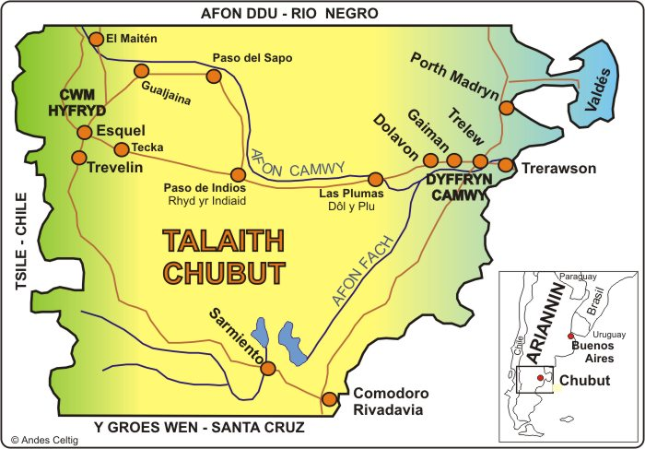

**Some typological features of modern Celtic languages**

The most distinctive phonological innovation is the loss of **Indo-European *p**, which occurred initially and medially.

Eg: Gl. *éan*, W. *edn, ader*, compare with L. *penna*, Gr. *pterón*, *E. feather*

Celtic languages are regarded as having a few archaic features: the lack of a verb “*have*” and the differentiation of gender in the numbers 3 and 4 (still surviving in Welsh).

**VSO** sentence structure in most modern Celtic languages

Scot. Gael: I am at the door. Tha mi aig an dorus.

(Is I at the door.)

**Consonant mutations**: The Celtic languages mutate some of the initial consonants of some nouns. The number of mutations depends on the language. The Welsh and Breton have three different mutations. The mutations are preserved vestiges of final syllables in prehistoric Celtic.

From Fortson, Indo-European Linguistics, 2010, p. 317 and Donald MacAulay, The Celtic Languages, 2008, p. 6-7.

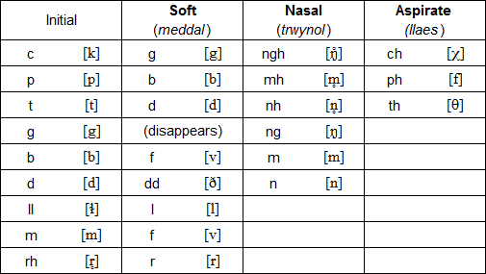

Modern Welsh mutations

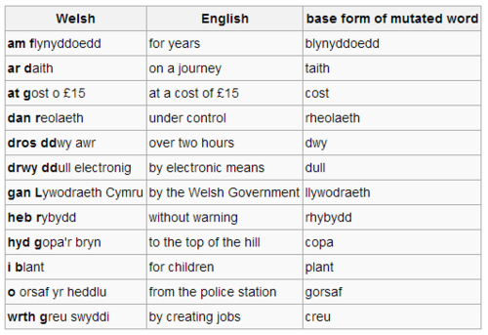

**Continental Celtic Languages**

Celtic languages were spoken on the European continent until the first half of the first millennium A. D.

**Gaulish:** the biggest of the Continental European languages was spoken in most of ancient **Gaul** and also in **Northern Italy**. Gauls were a huge ethnic group which consisted of a few hundred tribes living in the Western and Central Europe. One of the main tribes even settled (**3rd century B. C) in Asia Minor (Galatians)**. The Gauls are known in the classical history for their raids on Rome in the 4th cent. B. C. They were, however, later assimilated into Roman culture. Most discovered samples of the Gaulish language are written in the Roman and Greek alphabet.

**Lepontic language:** a language used by the Celtic tribes in the northern part of Italy. It`s not certain whether this language was not merely one of Gaulish dialects. Most of the found inscriptions are grave stones. The texts are written in the North Italian, so-called Lugano alphabet (taken over from the Etruscans). **The oldest examples of the Lepontic language are the oldest examples of Celtic languages ever found (6th cent. B. C).**

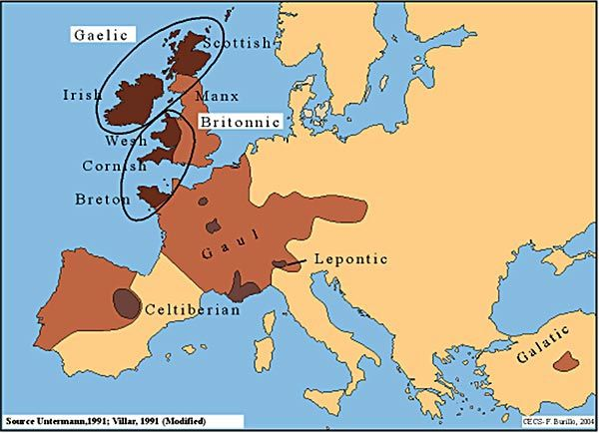

**Celtiberian (Hispano-Celtic)** language was spoken by the Celtic tribes which migrated in the 1st mil. B. C into the areas of the North-East of Spain. Celtiberian seems to be a very different to Gaulish and Lepontic, phonetically and morphologically. From this we can say that it separated from other Celtic languages at an early stage. Most of the inscriptions are dated into the 2nd and 1st cent. B. C, and are written in the Iberian script.

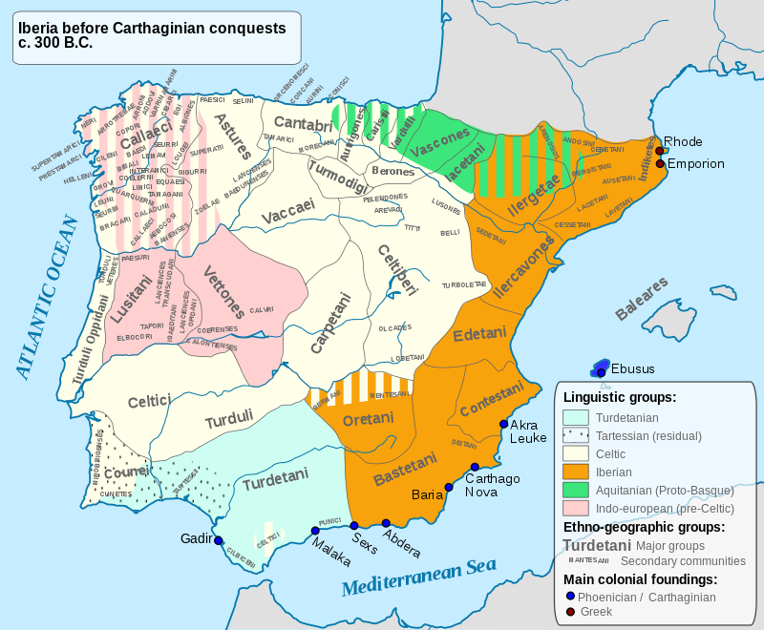

**3 Brittonic languages: Welsh, Cornish and Breton**

**Brittonic (also Brythonic or British Celtic)**

Brittonic was the Celtic language of the Celtic inhabitants of Britain before the Roman conquest (AD 43). At its greatest extent, to judge by the geographical distribution of place-names and river names, **British Celtic was spoken throughout Europe except in that part of Scotland** north of the Firth of Clyde and the Firth of Forth.

(Fortson, Indo-European Linguistics, 2010, p. 328)

The first evidence about the existence of Britain was given by a Greek geographer and explorer **Pytheas of Massalia**, who around 325 BC managed to organize a successful voyage to north Europe. Back then the name of the island was ***Prettan****…a (*later with  *b-*), which we find in W. *Prydein "Britain" (*kʷritanī, Prydyn “the Picts (*kʷritenī),* all from the IE. root *\*kʷer- “to do", comp. OIr. cruth, W. pryd “appearance"* (Schmidt 1993, 68).

The home name for Britain was ***Albion:*** *Albion ipsi [Britanniae insulae] nomen fuit; OIr. Albu, possible to connect to* W *elfydd “world”,* which reflects Celtic *\*albiĎdn-.* Etymological connection to L. *albus “white, light”,* analogical to SL*"světlý; svět" – “bright, world”(Hamp, ZCP 45, 1992, 87-88).* Ad. Václav Blažek, Keltské Jazyky

**The Picts and their language**

The north-east part of today`s Scotland was inhabited by the Picts. Their language might belong, according to the newest research, into the group of the Brittonic languages. However, not enough texts have been found to definitely support this theory.

The name ***Picti***  was first mentioned in the year **AD 297 by Eumenius**, an ancient Roman speaker and writer, in his ode to emperor Constantius. By the name **Picti** he calls the tribes which are the enemies of the British (next to the Irish). From yet another ode to the same emperor, written in the first decade of the 4th century by an unknown writer, the Picts are identified with **Caledonians**: “*the forests and marshes of the Caledonians and other Picts…*” Lat. word *pictus, pl. pictí* means *“painted”.* And indicates the habit of the Picts to paint or tattoo their skin. (Ceasar aleady described them in this way)

However, other etymological explanation looks at the parallels between the MIr. *cicht “wood-carver",* W*. pith,* Bret*. piz “attentive, watchful, careful*"< *\*k~iktu- (Stokes, Holder, aj.).*

Transl. Václav Blažek, Keltské Jazyky

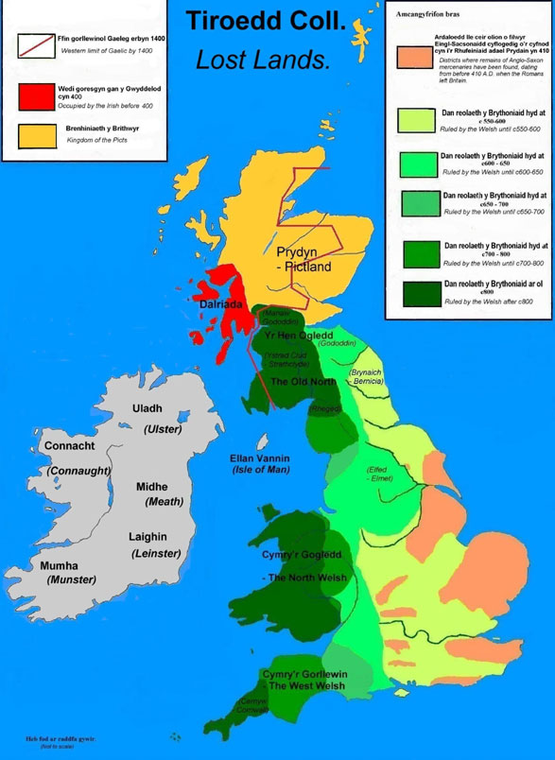

The defining phonological characteristic of Brittonic compared with Goidelic is the change of the common Celtic labiovelar ***\*kʷ*** to***p****.*

Ex: W. *pump* „five“ ˂ proto- celt. *kʷenkʷe, OIr. *cóic*. It is for this reason that Brittonic is often called **P-Celtic**.

Also characteristic of Brittonic is the change of initial **\*ṷ** to ***gw***, as in W. *gwr* (OW. *guir*) „ man“ and *gwyn* „white“ ˂ṷindos.

(Ad. Fortson, Indo-European Linguistics, 2010, p. 328)

**Cornish (Cornwall)**

Cornish is most closely related to Breton. It was spoken by the Celtic inhabitants of southwest England who remained after their neighbours migrated to Brittany in the sixth and seventh centuries, when the Anglo-Saxons spread over south England and cut the Cornish people from their Welsh neighbours. The Anglo-Saxon migration also caused some of the Cornish communities to move to **Armorica**, which was then by the Celtic new inhabitants named as Bretagne)

(Transl ad. Václav Blažek, Keltské Jazyky and taken from Fortson, Indo-European Linguistics, 2010, p. 334 )

**Old Cornish**: first texts- **religious glosses** (anotations) from the 9th cent. and in the year 1100 the longest Cornish text of this period- Vocabularium Cornicum „ Cornish Vocabulary“.

**Middle Cornish**: 14. and 15. cent. – around 10 000 preserved lines, mostly translated from English, fro, so called miracle plays- religious theatre pieces.

**Late Cornish**: dated until the death of the last native speaker (**1777**), Dolly Pentraeth. Today, revival of the Cornish languages is supported- **Neo-Cornish (Kernewek).** Thanks to this, Cornish is again actively used by a few people in the region.

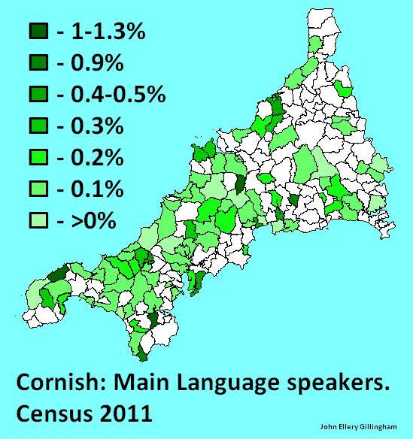

**Breton language**

The peninsula **Armorica** (Gaulish for “*place by the sea*” , started to be called Bretagne after the colonization of the British Celts coming from southeast England in between the **5th and 7th centuries** (thanks to the immigration of Anglo-Saxon tribes to Britain). The name ***Brez(h)oneg****.* Today E*. Brittany,* F*. Bretagne* clearly signifies the Celtic origin of the name.

Ad. Václav Blažek, Keltské Jazyk

**Old Breton**: the language flourished the most in the **9th century**. Most of the texts are religious in nature.

**Middle Breton**: (**12-17 cent**.) The area in which Breton was spoken shrank by almost one half. Most of the preserved texts are translations of religious texts from Latin and French. In the 12. cent., Breton was ceased to be used by the gentry which caused its continuous decline.

**Modern Breton**: **1659** – **the first book of Breton grammar and dictionary was published**. Modern Breton is composed of the most diverse dialects of any modern Celtic language. Nowadays, only the western part of the area is Breton-speaking (**Basse Bretagne**) and even here it is restricted to the countryside. Two-fifths of the ordinary vocabulary is of French origin. Today, it is estimated that 200 000 people use Breton on daily basis. (taken from Fortson, Indo-European Linguistics, 2010, p. 332)

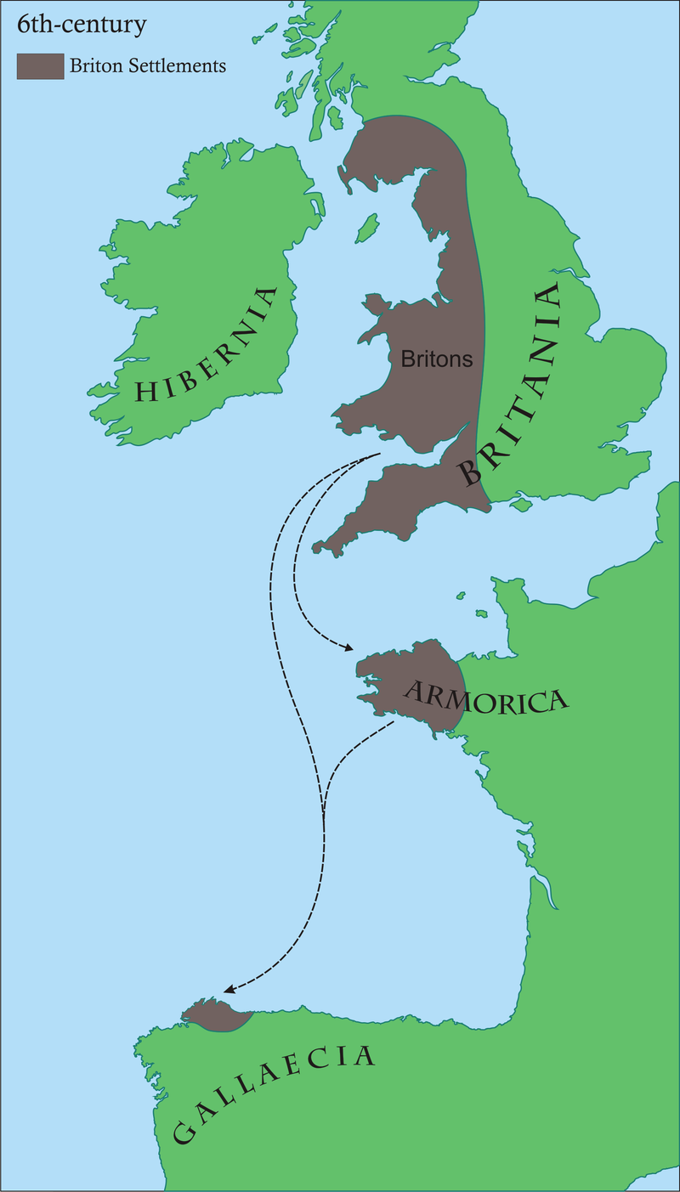

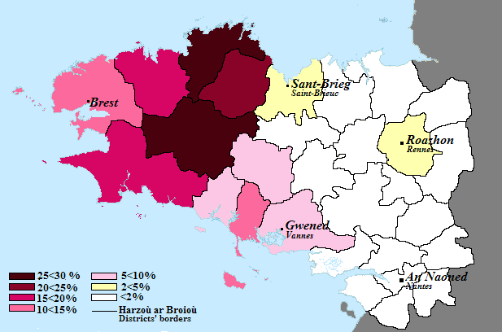

**Welsh**

The Welsh call themselves as ***Cymro****,* this name reflects Bret. *\*kom-brogos,-is “from the same land", comp. W. bro, OIr. mruig “land" .*

Ad. Václav Blažek, Keltské Jazyk

The English term *Welsh* comes from the Anglo-Saxon name for the Celtic tribes- „***weala*s**“ which means „foreigners“ (4. – 5. cent.). In that time, the British Celtic population was hardly linguistically differentiated. In the 6. and 7. cent., the areas inhabited by the Celts significantly shrank thanks to the Anglo-Saxon colonization.

**Old Welsh**: (8-12. cent.) followed the period of so called „primitive Welsh”. No literature from this period is preserved (the pieces of two important poets- **Taliesin and Aneirin** from the 6. cent. survived in later 12. – 13. cent. versions, of course modernized). From this period we only have short Welsh and Latin texts concerning a lawsuit.

**Middle Welsh**: (12-14. cent.) – the Welsh language flourished. This period offers copious literature of medieval romances and legends. The most famous masterpiece is **Mabinogi** – a collection of romances.

**Modern Welsh**: the beginning of this era is marked by the translation of the **Bible** in the year **1588** (by the bishop of Llandaff, **William Morgan**). This translation became the literary standard of the Welsh language for many next generations and it is very likely that without it, the Welsh language would have been long extinct. Since the beginning of the 15. cent., the higher strata of society were becoming Anglicized, and Welsh was completely banned from the use as an official administrative language in the mid. 15. cent. This didn`t change until the year 1967).

In the year **1993** by so called. **Welsh Language Act,** the Welsh language was made equal with English in all spheres of public life (law, education, administration, health care).

The Welsh is spoken mostly in counties **Gwynedd** and **Ynys Môn**. It is estimated that about 500 000 people use the Welsh language on daily basis.

Partly taken from Fortson, Indo-European linguistics, 2010, p. 329-331

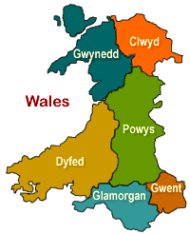

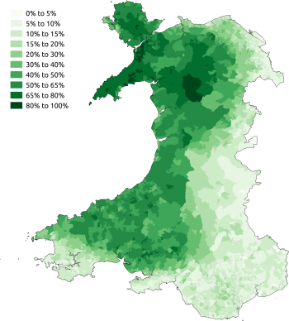

**Mabinogi**

From **1833 to 1849, Lady Charlotte Guest** (1812-1895)- the only daughter of the 9th Earl of Lindsey and wife of the Welsh industrialist Sir Josian John Guest, published her translation of the medieval Welsh prose tales she called ***The Mabinogion***. There are two collections of these tales, one in the **White Book of Rhydderch**, and the other in the **Red Book of Hergest**. The White Book is the older manuscript, dating from around 1325, but the only complete text is found in the Red Book, of around 1400. The Red Book is a massive compilation of poetry and prose which includes the text more properly referred to as **“The Mabinogi”** ; that is, the **Four Branches**. The error in the name came about as a result of the misunderstanding of the formulae which open and close the tales of *Pwyll, Branwen, Math,* and *Manawydan*.

**Four Branches of the Mabinogi**

The Four Branches of the Mabinogi (Pedair Cainc y Mabinogi) are the most clearly mythological stories contained in the Mabinogion collection.

**Pwyll Pendefig Dyfed**(Pwyll, Prince of Dyfed) tells of Pryderi's parents and his birth, loss and recovery.

**Branwen ferch Llŷr** (Branwen, daughter of Llŷr) is mostly about Branwen's marriage to the King of Ireland. Pryderi appears but does not play a major part.

**Manawydan fab Llŷr** (Manawydan, son of Llŷr) has Pryderi return home with Manawydan, brother of Branwen, and describes the misfortunes that follow them there.

**Math fab Mathonwy** (Math, son of Mathonwy) is mostly about the eponymous Math and Gwydion who come into conflict with Pryderi.

**Native tales**

 Beginning of "The Dream of Macsen Wledig"

Also included in Lady Guest's compilation are five stories from Welsh tradition and legend:

Breuddwyd Macsen Wledig(The Dream of Macsen Wledig)

Lludd a Llefelys (Lludd and Llefelys)

Culhwch ac Olwen(Culhwch and Olwen)

Breuddwyd Rhonabwy (The Dream of Rhonabwy)

Hanes Taliesin (The Tale of Taliesin)

**4 Modern Welsh**

Welsh is the most **widely spoken Celtic language**. It belongs into the group of **Brittonic languages** together with Breton and Cornish.

Welsh is currently spoken by about half a million people, especially in north Wales. There is also a small community of people speaking Welsh in Chubut Province in Argentina.

Despite the continuous efforts to spread the knowledge and usage of the language, the number of Welsh speakers continue to decrease (according to the **UK Census 2011**, the percentage of Welsh speakers decreased from 20.8% (in 2001) to 19% (in 2011). However, the number of today`s speakers (about 582 000 people) is greater than in 1991 (about 508 000 people).

The Bible translation made by the **Bishop of Llandaff, William Morgan** in the **second half of the 16th century** became the standard model of the modern Welsh grammar and lexis for many years to follow.

Welsh was spoken mostly amongst the rural population and was completely banned from the use as an official administrative language from the mid. 15. cent. until 1967.

In the **19th century**, virtually all teaching in the schools throughout Wales was in English, even in the areas where the pupils barely understood English. At the beginning of the 20th century, the policy slowly began to change (the hub of the Welsh education was Aberystwyth).

During the second half of the **20th century**, along with the **rise of nationalist organizations** (Welsh language society), the support for Welsh language grew.

**Meibion Glyndŵr** (sons of Glyndŵr) - terrorist organization responsible for burning summer houses of rich English. Their organization was called after **Owain Glyndŵr (1359-1415),** the last native Welshman to hold the title Prince of Wales.

**The Welsh Language Act in 1993** and the **Government of Wales act in 1998** state that the Welsh and English languages are to be treated equally in the public sector.

**In 2010 the Welsh Assembly** approved a set of rules to develop the use of Welsh within Wales and pressed on businesses and government offices and bodies to provide and support services through the medium of Welsh.

Today, education is provided in Welsh language on all levels. The students who live in Wales and study in English need to take up Welsh as a second language. The ability to speak Welsh is **desirable** for certain career choices in Wales, especially teaching, customer service and health care.

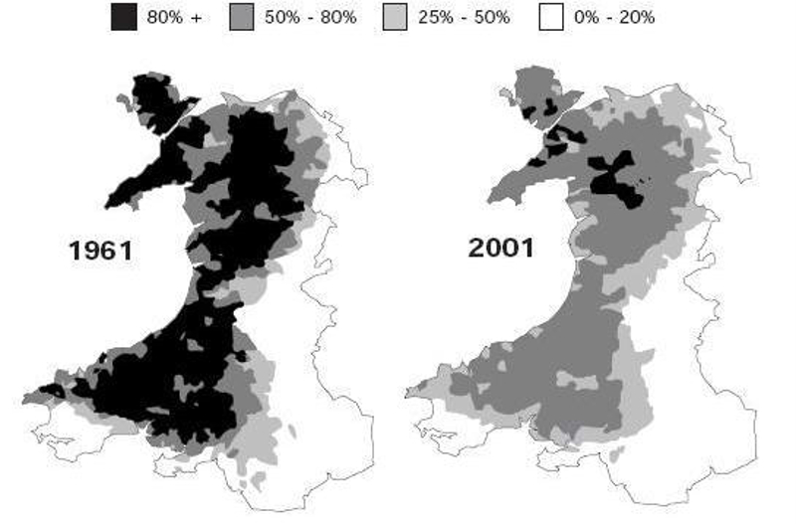

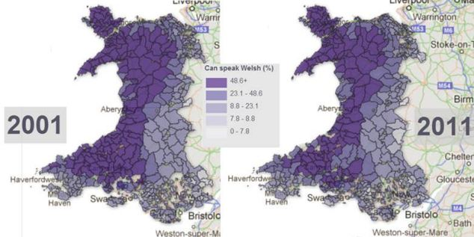

The quarrymen in **slate quarries** also contributed to the survival of the Welsh language by using it not only during the work, but also in their **workers` unions**, for religious purposes and during their leisure activities (where poetry and amateur theatre played a very important role). The owners and top managers of the quarries were however English speaking and interpreters were needed at the site. This led to many disputes and strikes.

The slate industry grew slowly until the early 18th century and then expanded rapidly until the late **19th century**. The most important slate producing areas were in northwest Wales (**Penrhyn Quarry, Bethesda, Blaenau Ffestiniog** and others)

**Hedd Wyn** (name means “blessed peace”)

(1887-1917)

Civil name **Ellis Humphrey Evans**, born in the village of **Trawsfynydd.**

Hedd Wyn was a Welsh language poet who was killed on the first day of the Battle of Passchendaele (west Flanders in Belgium) during the World War I.

He used to write romantic and anti-war poetry, he composed most of his poetry while working as a shepherd.

He won his first chair (the poetry prize, **Cadair y Bardd**) at the local eisteddfod in Bala. Afterwards, he won several more in local eisteddfodau all over Wales.

After his death, he was awarded the bard`s chair at the National Eisteddfod in 1917.

**Eisteddfod** is a Welsh festival of literature, music and performance and its tradition dates back to the 12th century.

**Modern Welsh dialects**

The Welsh dialects are most profoundly shown at the lexical level, even though there are some phonological and small grammatical variants. The most obvious division of the Welsh language is into the north and south dialect, however, there are also differences between eastern and western sub-areas.

The five generally recognised dialects are:

***Gwendodeg*** - north-west Wales

***Powyseg*** - north-east and northern mid-Wales

***Iaith Sir Benfro*** - north Pembrokeshire Welsh

***Dyfedeg*** - southern mid-Wales (Dyfed)

***Gwenhwyseg*** - south and south-east Wales

There are also some words specific to the north-west in Anglesey.

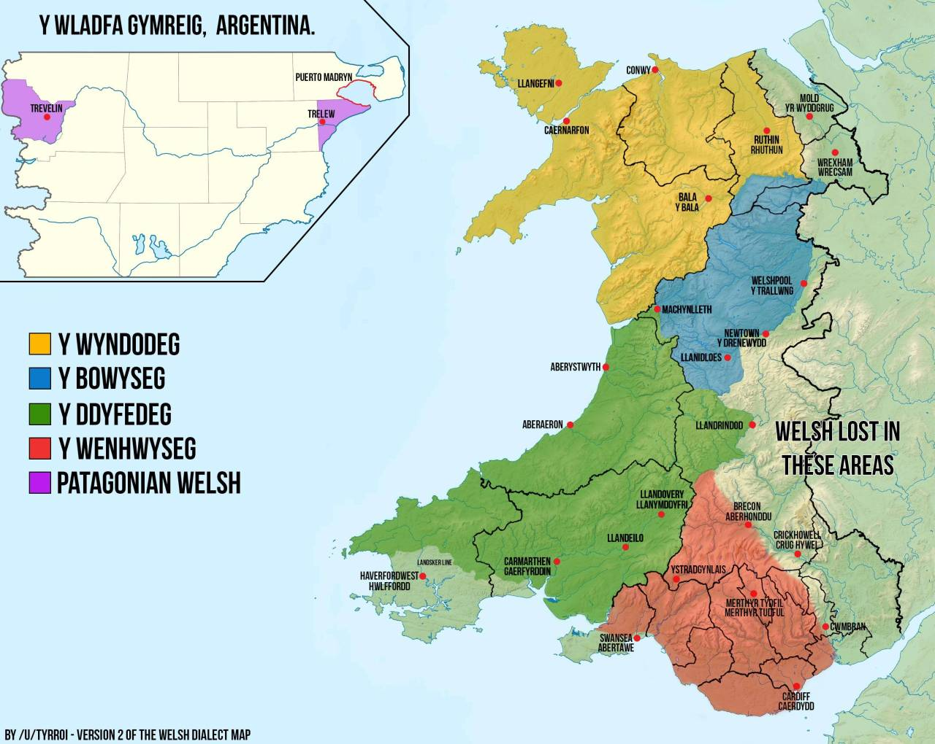

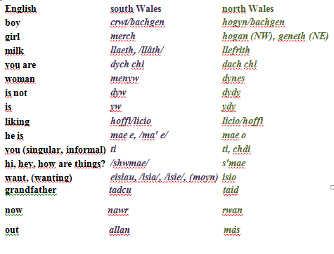

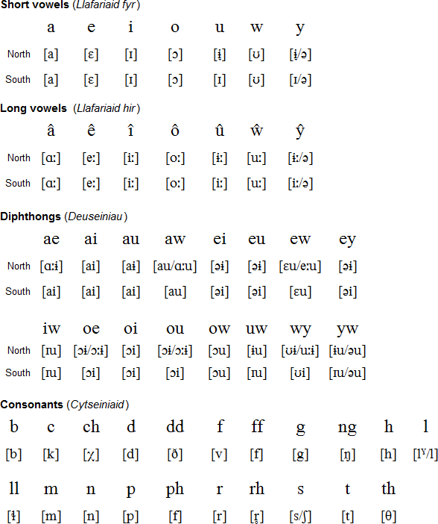

**Wild Wales: Its People, Language and Scenery**

A travel book written by the English Victorian writer **George Borrow** (1803-1881)

The describes Borrow`s personal experiences and insights during his journey across Wales, alone and on foot in 1854.

5. **Goidelic languages and History of Irish**

**Goidelic languages**

The Irish called themselves in the old Irish language as ***Goídel*,** hence the name. The most common etymological explanation says that this name was originally a brythonic borrowing and came from OW *Gwyddel “*Irish” (related to MW *gwyd* “wild”).

OIr word *goídelc* referred to the “Irish language”. In the classical modern Irish had this name developed into *Gaoidhealg,* which has been simplified into *Gaeilge.* (and this is by the way where the Eng. ***Gaelic*** originated from.

Transl. Václav Blažek, Keltské Jazyky

The Goidelic languages include:

**Irish**

**Scottish Gaelic**

**Manx**

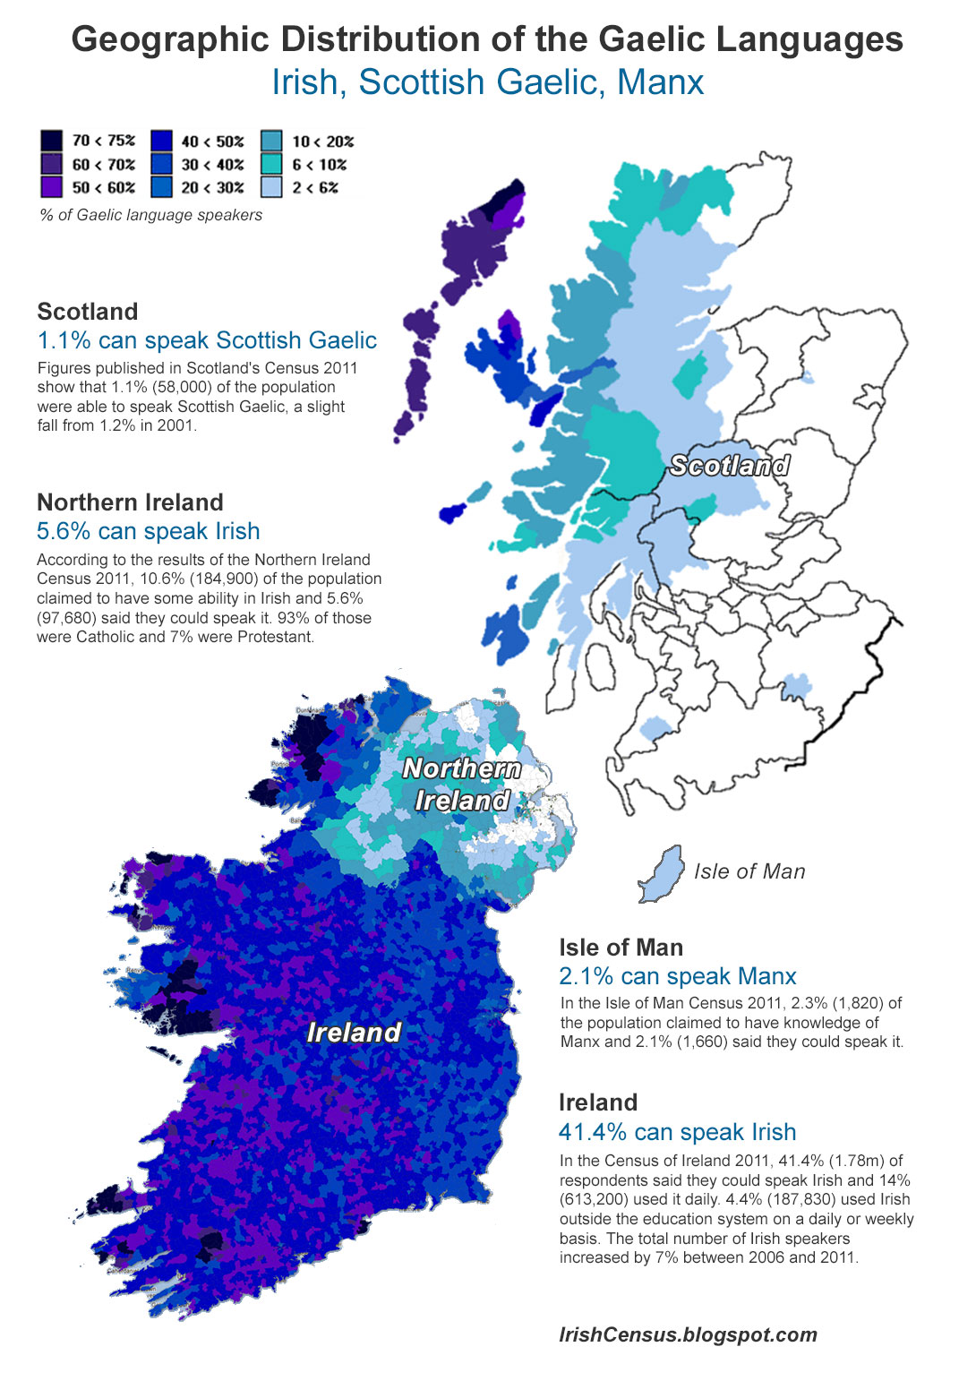

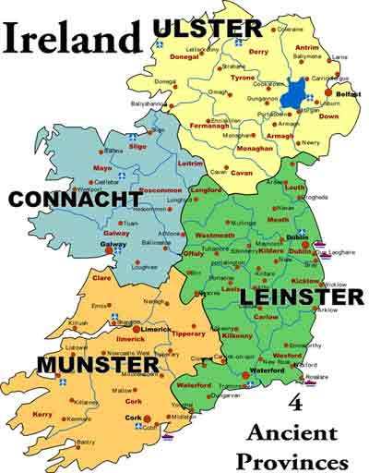

**History of Irish**

The proper name of Ireland is ***Ériu***(W Iwerydd).

The oldest documented words of goidelic origin are found in **Ptolemy`s  *Geography*** (around 150 AD)*,* where in the description of Ireland, he mentioned more than 30 place and tribal names.

**Proto-Goidelic**

Prehistoric ancestor of Irish, spoken in Ireland at least at the beginning of the Christian era, if not earlier.

**Primitive Irish (Ogam Irish)**

The earliest preserved Irish is found in about 300 stone inscriptions written in **Ogam (Ogham)** script. The origin of the Ogam script is unknown and most of the inscriptions come from southern Ireland and date back between the fourth and seventh centuries AD. They are usually short burial inscriptions.

In medieval manuscript tradition names for Ogam letters have come down to us. Often tree names are used for the names, but many of the identifications are dubious. Also not all original phonological values of the Ogam letters are absolutely clear.

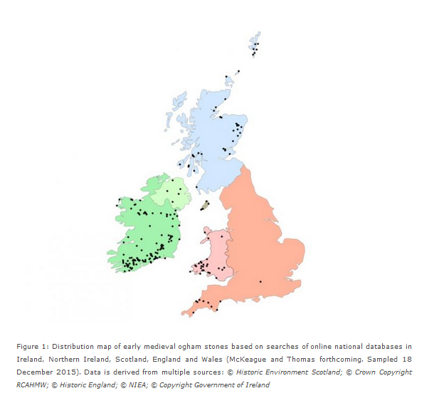

In the **fifth century**, Ireland converted to Christianity and this resulted in the introduction of the Roman alphabet. In the following two centuries, the Irish language changed radically and started resembling the Irish we know from the most popular medieval Irish literature.

**Old Irish**

Approximately from the seventh to the mid-900s.

Religious manuscripts brought to the Continent (Milan, Turin, Wűrzburg) by Irish missionaries in the eighth and ninth centuries represent our only contemporary documentation of the Old Irish classical period (commentaries on the psalms). They survived on the Continent for nobody understood them and they were not worn out from continuous use and recopied with modernized spellings.

Many texts that have survived have been copied into much later manuscripts.

Old Irish possesses an extremely high number of phonemes in comparison to other European languages (esp. consonants). 18 letters are thus used to express 66 sounds, which means that on average every letter has more than 3 sound meanings.

In modern Irish, the number of phonemes reduced to 52. This is dealt with by introducing **broad** and **slender** consonants (**palatalization**).

Example: **Old Irish poem *The Scolar and his Cat***

A poem about a monk and his cat (Pangur Bán) found in a manuscript in the monastery of St. Paul in Lavanttal in Austria (written around the 9th century).

**Middle Irish**

10-13th century

There were a lot of far-reaching changes the morphological system of the language - simplification of verb conjugations.

Reduction of phonemes.

By the end of the 13th century, the language was effectively as it is today.

**Modern Irish**

The modern Irish period begins with the codification of a normative form of the language by bards and other literary elite in the **13th century.** In the early 1600s, however, different regional varieties appeared (Munster, Connacht and Ulster) - they exist until these days.

During the **17th century**, Ireland received an English speaking ruling class and it´s status quickly deteriorated and became a language of the rural poor. During the **potato famine** (1845-1849) much of this population died and about a million and a half migrated into America.

Today, more people learn Irish as L2, but the future of the Irish speaking community, *Gaeltacht,* remains uncertain.

From Fortson, Indo-European Linguistics, 2010, and David Stifter, Old Irish for beginners, 2006.

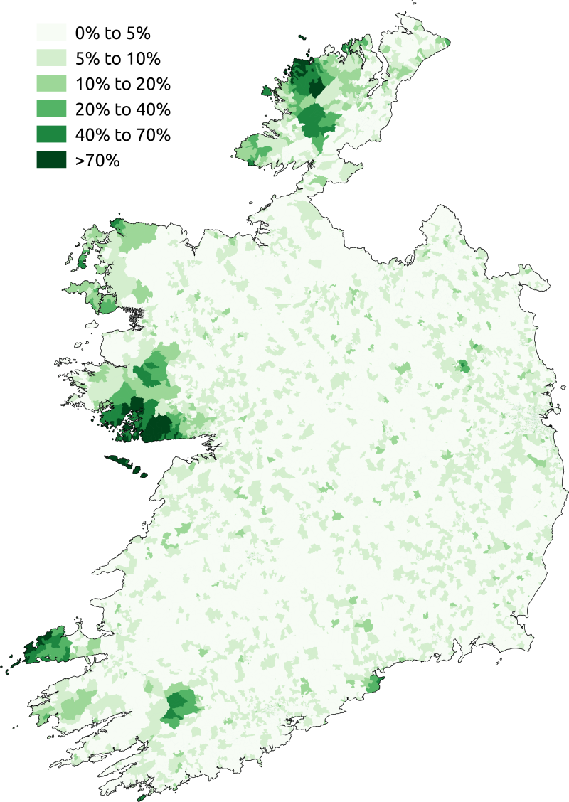

The percentage of respondents who said they spoke Irish daily outside the education system in the 2011 census in the State.

**Medieval Irish literature**

This literature represents the most extensive and best preserved texts of all the branches of Celtic mythology.

There are four main cycles:

**Mythological Cycle** (the mythological beginning of Ireland, Metrical Dindshenchas, The Dream of Aengus and others).

**Ulster Cycle** (set in the 1st century and takes place in Ulster and Connacht- group of heroic tales of warriors, the central piece is Táin Bó Cúailnge „*The Cattle Raid of Cooley*“ .

**Fenian Cycle** (deeds of Irish heroes, set probably in the 3rd century).

**Historical Cycle** (bards used to record the history and the genealogy of the kings they served- the resulting stories became the Historical Cycle).

**Scottish Gaelic and Manx**

**Scottish Gaelic**

Beginning around the **late fourth century**, immigrants from Ireland colonized what is now Scotland, establishing a colony called **Dál Ríata**, named after a town in northeast Ireland. The Scottish Dál Ríata became the centre of a kingdom and in the 7th century, the connection was severed.

The Gaelic inhabitants expanded inland and the Scottish territory grew. However, English language gradually began to replace Scottish Gaelic, which is today confined to the Outer Hebrides, the Island of Skye, Tiree and Islay.

In the 2011 census, 57 000 people, about 1.1% of Scottish population reported as able to speak Gaelic. Scottish Gaelic is not an official language of the UK. Apart from Scotland, Scottish Gaelic is spoken by about 7000 people in Canada (especially in Nova Scotia and Prince Edward Island).

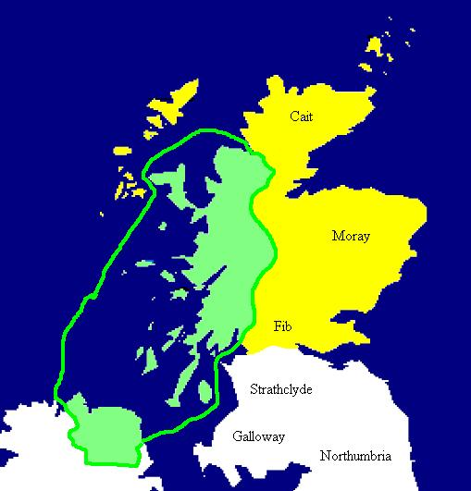

Map of Dál Riata at its height, c. 580–600. Pictish regions are marked in yellow.

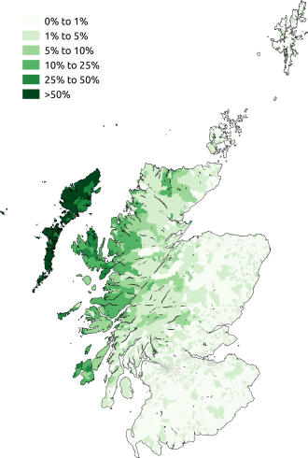

Geographic distribution of Gaelic speakers in Scotland in 2011.

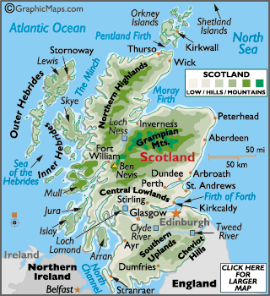

The same group of Irish colonists also settled on the **Isle of Man** (4-5th centuries). The Manx language is called *Gaelg* or *Gailck.* The name of the Island of Man is originally Old Norse *Manninsk* (pronounced Man-en) and is named after the Irish god of the sea **Manannán mac Lir** (Mac Lir means “son of the sea”)

Manx is the name given to the form of Goidelic language that developed on the island following the Irish colonization. Written Manx begins with a 17th century translation of a prayer. Most of the published literature is of religious nature.

The Manx orthography is unlike the Irish or Scottish Gaelic one (both related to the orthography of Early Modern Irish).

Manx uses the English alphabet, except for x and z, and uses digraphs and trigraphs are used. The orthography was developed by people who were unaware of traditional Gaelic orthography, as they had learned literacy in Welsh and English. Last native speaker of Manx died at the age of ninety-seven: Ned Maddrell in 1974.

From Fortson, Indo-European Linguistics, 2010.

