**ESP Session V Evaluation**

**Task 1 How does ESP testing differ from General English testing? What particular problems does the ESP tester face?**

**Task 2 Discuss the differences between the three basic types of assessment in ESP:**

* Placement tests
* Achievement tests
* Proficiency tests

**Task 3 What features do these tests have that make them (un)suitable means of evaluating the learners´ understanding of the material they have studied?**

**TEST A**

The diagram below shows the flow of coolant through a refrigeration system. Study the diagram and then write a description of how the coolant circulates through the system.

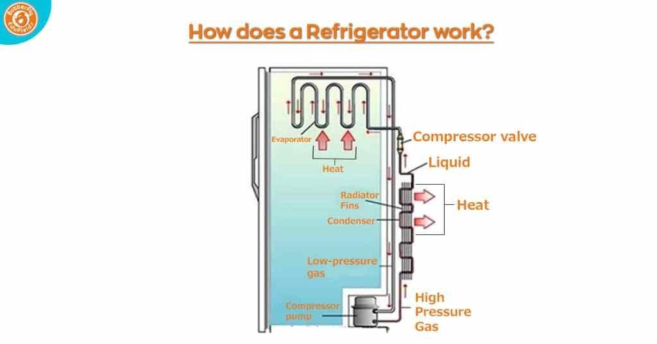

(https://www.butterflyfields.com/how-does-a-refrigerator-work/)

**TEST B**

Write a summary of approx. 200 words of the text below.

**Legal Custody**

Having legal custody of your children means that you are responsible for making decisions about the important things in their lives, like where they go to school, what religious instruction they receive, whether they need academic tutoring or psychological counselling, and when they go to the doctor.

During your marriage, you and your spouse probably made these decisions together, and when you divorce, judges want to keep it that way if at all possible. The default preference in the majority of states is for parents to share legal custody and continue to make decisions together for their children.

This is called joint legal custody. It can take many forms. Just as in an intact marriage, it’s not uncommon for one parent to be the primary caregiver, the same can be true after divorce even if the parents have joint legal custody. For example, a parent who is the primary caregiver might make many decisions that are part of legal custody, like authorizing routine or emergency medical treatment, or choosing a tutor for a child who needs academic help. While the other parent has the legal right to participate in those decisions, it’s up to the parents to decide how to make this work as a practical matter. They may agree that it’s easier and more efficient for one parent to have greater day-to-day responsibility.

Joint legal custody can become a battleground for parents who aren’t able to agree on things that might seem simple, like where the children should get medical care or whether they should take piano lessons. It only takes one parent to create ongoing conflict over this type of question, and it can make life miserable for everyone if every decision becomes a fight.

Judges find that type of decision making miserable, too. If parents fight over every question related to their kids, the most common solution is for the judge to give one parent sole legal custody. That parent then has the sole right to make decisions about the children’s health, education, and welfare.

**Task 4**

**Suggest a portfolio-based assessment for a chosen ESP course to replace a traditional achievement test.**