# Cinemagoers should ‘…learn from progressive movies, again and again.’ Cinemagoing in Czechoslovakia, 1949-52

Once it had come to power in Czechoslovakia in 1948, the ruling Communist Party (KSČ) sought to transform cinema’s primary function from entertainment to education. Pursuing a policy termed ‘cinefication,’[1] filmgoing was encouraged as ‘…a political act of self-education’, while watching Soviet films was considered a manifestation of ‘the inseparable friendship’ with the Soviet Union.[2] Various administrative and institutional mechanisms were put in place to secure attendances at the screenings of ideologically appropriate movies. Thus, the position of district promotional officer was established, charged with educating cinemagoers and increasing attendances, while 82 per cent of promotional expenses were dedicated to supporting ‘progressive films.’[3] In addition, work enterprises and educational and social organisations patronised screenings. An example is the Union of Czechoslovak-Soviet friendship sponsoring a ‘week of revolutionary cinema’ in Brno, promising full houses but screening to largely empty auditoria.[4]

Yet, as Pavel Skopal has argued, the ideological imperative had to be balanced against the financial requirement of working within State budgets.[5] Showing films that nobody wished to see, or giving away tickets to encourage admissions, generated very little in the way of revenue. Indeed, the central contradiction governing the operation of the film industry was that it was required to cover its costs while promoting inherently unpopular films.

In the years leading to Stalin’s death in 1953, Eastern Bloc countries were expected to replicate Soviet social, economic, and ideological practices.[6] The consequence of this policy, according to Roman Krakovský, was that social space at all levels was state-dominated and that the collective, as defined by the state and its representatives, overrode private interest. In effect, ordinary people did not participate as individuals in the process by which the ‘common good’ was established.[7]

János Kornai depicts the classical one-party socialist system as ‘the economy of shortage’– a market in which the demand for goods and services systematically exceeded the quantity supplied at a price determined centrally by the bureaucratic authorities.[8] In this respect, the film industry was no exception. It was plagued by shortages, made worse by the ideological baggage of its mass-cultural status.

In this fraught environment, the idea of film popularity - filmgoers making choices leading to some films proving more popular than others – is far from straightforward. Nevertheless, this possibility is investigated in this chapter through the published statistics of film screenings, attendances and box-office drawn principally from the Yearbooks compiled and published by the film historian and journalist Jiří Havelka, in which data were collected for both the Slovakian and Czech parts of the country.[9] In addition, a second investigation is undertaken into filmgoing in the city of Brno through the programming records of local cinemas. From this type of evidence, it is possible to identify not only what films filmgoers were attracted to but how the state distributor circulated them to cinemas in an orderly fashion.

9.1 General Context

Through the years of German occupation, Czechoslovakia did not experience the same collateral damage metered out to other Eastern European countries and the Soviet Union. Not subjected to major bombing, its cities remained, with some exceptions, intact, and consequently so did its cinemas. One of the exceptions was Brno, with an arms factory, bombed twice by American aircraft (in August and November 1944) and by the Red Army (in April 1945) with the consequence that one-fifth of the city’s buildings were damaged.[10] Although nine of Brno’s cinemas were affected, six re-opened almost immediately after hostilities ended. Only one was destroyed and never re-opened.[11]

A central hub of filmmaking during the interwar period, film production in Czechoslovakia, based on three studios located in and around Prague and one in Zlín, continued to produce films under the German Protectorate. Nationalised in June 1945, six of the projects started during the Protectorate were completed, while new projects were launched and services provided for the Soviet film industry.[12] Thus, Czechoslovakia not only maintained its production capacity but had a dense network of cinemas in operation, albeit unevenly distributed in the two parts of the country. In 1946, 1,942 cinemas were operating in the Czech part of the country (hereafter referred to as the Czech lands) but only 263 in Slovakia. Most cinemas were small, with fewer than 300 seats and only one-sixth of them had daily screenings.[13] By 1950, through reconstruction, the number of permanent Czech cinemas had risen to 2,545.[14]

Intensive ‘cinefication’ was an integral part of the official ‘Democratization of Culture’ programme promoted by the immediate post-war regime. Following the KSČ engineered coup of February 1948, cinema became an element in the state planning process. Distribution and exhibition were classified as ‘Informational and Enlightenment Services’.[15] At the same time, production was the subject of a heated debate between MIO (Ministry of Information and Enlightenment (Ministerstvo informací a osvěty) and the Ministry of Finance concerning its status as a cultural/industrial product.[16] A flavour of the disagreement can be found in the archives, with the MIO declaring that cinema was more than a business and that cinema production should be thought of in terms of the ‘creation of cultural entities’ and distribution, ‘the spreading of enlightenment through films’.[17]

To realise the first Five-year Plan (1948-53), the system of the socialist enterprise economy (socialistické podnikové hospodářství) - in which businesses were treated as independent enterprise workplaces - was replaced by complete centralisation.[18] Accordingly, Czechoslovak State Film (CSF) became an institution of state administration under the jurisdiction of the MIO in January 1951.[19] At a local level, district offices of the CSF were responsible for the fulfilment of an attendance plan for Soviet movies. For instance, in the city of Brno, the most attractive films were screened in bigger cinemas in the city centre, while less popular ‘progressive’ (Soviet) films dominated smaller cinemas. Thus, in January-September 1953, the two largest premiere cinemas – the Moskva and Družba - exceeded overall attendance targets (125.7 per cent and 103.5 per cent respectively), but not those set for Soviet movies (96.2 per cent and 79.8 per cent). It was the smaller cinemas that allowed the Authorities to meet this target.[20]

In the immediate Post-War period, coinciding with the displacement of the bulk of the German-speaking minority in the country, the most immediate industry issue was how to replace German and German subtitled films.[21] Participating in the American MPEA scheme, potential shortages were overcome by importing films from Hollywood, Western Europe and the Soviet Union.[22] During these years, the movies of Western Europe took a leading market share, both in terms of the number of screenings and attendances.[23]

However, these arrangements ended once the KSČ took control of the state. While MIO, in conjunction with the Culture and Publicity Department of the Central Committee of the Communist Party, continued to run the film industry through the now named Czechoslovak State Film, film policy took a new turn. A directive of the KSČ Central Committee issued in early 1948 set down a list of rules to govern film distribution during the early years of the communist regime, in which ideological and economic interests were made specific. These were:

* Distribution must privilege Czechoslovak film production. Of the foreign movies allowed to circulate, distribution needs to accent friendship with USSR and support Soviet, Polish, Bulgarian, and Yugoslav films.
* Film imports should support progressive tendencies and artistic values,
* Support should be given to small and independent West European and American production against MPEA producers.
* Imports should be rationed to preserve foreign currency reserves.
* For those MPEA films already contracted for, extend their circulation for as long as possible and have them distributed during ‘dead season’ – the period from mid-July to mid-September.[24]

Accordingly, following the Communist takeover of power in 1948, films that were ideologically unacceptable to the new regime – mainly from the capitalist West - were forbidden. (This did not preclude films from the West that were perceived as having a universal art value, such as the British film *Hamlet* (1948).[25] In conjunction with the Soviet film famine that was the consequence of the masterpiece policy emanating from Joseph Stalin, the outcome of this domestic policy was a chronic shortage in supply.[26] Only 76 films from Eastern Bloc countries were premiered in 1949, leading Jiří Málek (head of Czechoslovak Film distribution) to announce a shift from extensive to intensive distribution – meaning that cinemagoers should ‘…learn from progressive movies, again and again.’ Consumers were being asked to repeat-consume films.[27] These policies were subsequently reinforced in April 1950 when the praesidium of the Central Committee of the KSČ passed a resolution ‘On behalf of high ideological and artistic standards for Czechoslovak film’ that scoped the primary cultural-political directive for cinema. It demanded a distribution policy that ‘… can recruit and raise viewers to our new films, as well as those of the Soviet Union and the People Democracies. It is a serious task for the party and mass organisations, state enlightenment care bodies, and school administrations to ensure mass attendance at Czechoslovak, Soviet, and other progressive films.’[28]

In a short-lived experiment, discriminatory price practices were followed between 1951-54. A few films, perceived as having low ‘educational’ but high ‘entertainment’ value, carried higher admission prices. The likely explanation of this was the need to raise revenue.[29] In 1951, the strategy was applied to two films, the Austrian ice revue *Frühling auf dem Eis* and the two-part Czech historical comedy *Císařův pekař – Pekařův císař* (*The Emperor´s Baker* and *The Baker´s Emperor*). Two other films were distributed similarly a year later - the Austrian musical *Das Kind der Donau* and the West German film *Der Tiger Akbar*. Finally, in 1953 and 1954, the Swedish film *One Summer of Happiness* and the French *Aux Yeux du Souvenir* were added. After this, the practice was stopped, replaced by a strategy of extended programmes launched in 1953 that saw attractive movies screened in conjunction with a short film - commonly a documentary from the Soviet Union – thereby balancing the entertainment value of the feature film with the ideological significance of the documentary. Instead of all tickets being sold at the same high price (with the effect that only customers of the cheaper seats paid more), prices were raised by one crown above the standard price for all seats.[30] This practice also had the ‘virtue’ of increasing attendance figures for Soviet production, where the bulk of these documentaries were made.

9.2 Film Statistics

In 1950, Czechoslovaks went to the cinema as often as the French, East Germans, and West Germans, with just under ten visits per head.[31] Dividing the country into two parts, the Czech lands and Slovakia, the Havelka Yearbooks indicates a split in attendances of 83/17 (per cent). From this point onwards, attention will be focused on the former.

Table 9.1 shows that in 1947 over 50 per cent of Czech audiences attended films from the West. By 1952 this figure had fallen to just 6 per cent, with new releases tumbling from 199 in 1947 to 67 in 1951.[32] Not surprisingly, audiences readjusted to the new situation and restricted choice set of films by staying away, with audience numbers falling from 129.7 to 98.8 million between 1948 and 1950. From this low point, recovery took place, eventually peaking in 1957.[33]

Table 9.1 also shows that attendances per screening after 1947 consistently favoured domestic production and films from the West. Even with the support that came with ‘favoured status’, the average number of viewers per screening for Soviet cinema in 1950 was 148, compared to 228 for films from non-socialist countries, declining further by 1952 to 127, despite attendances growing by 7.4 per cent and receipts by 15.8 per cent.[34]

Table 9.1. Annual Cinema Attendances in the Czech lands, 1945-55

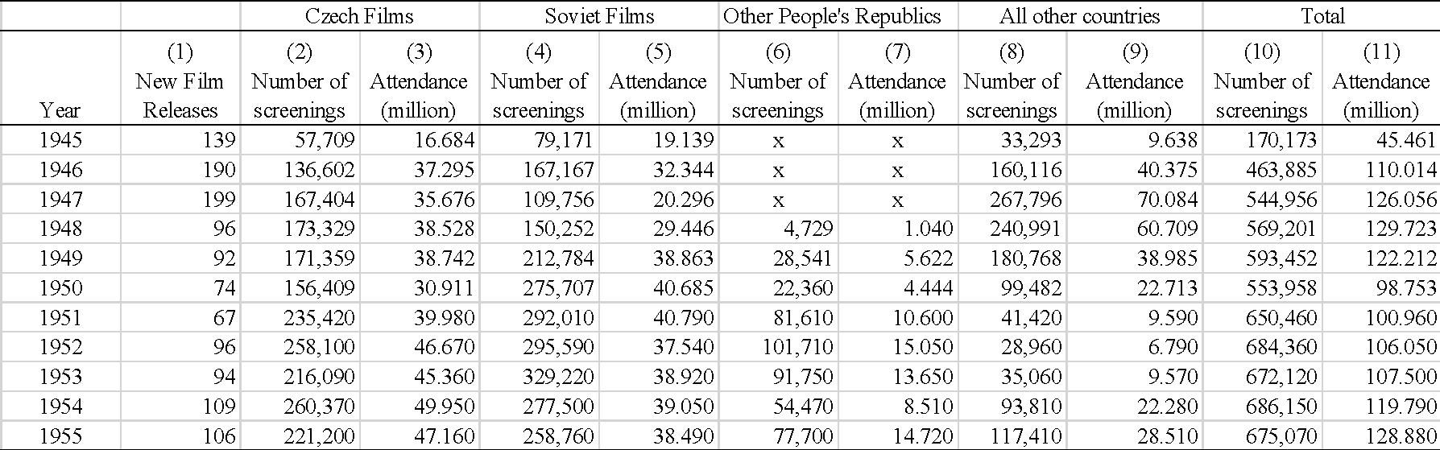

*Source*: Havelka, Jiří (1970) Čs. filmové hospodářství (1945-1950: 228). Praha: Československý filmový ústav; Havelka, Jiří (1972) Čs. filmové hospodářství (1951-1955: 342), I. díl. Praha: Československý filmový ústav.

*Note*: Here released refers to first screened in the Czech lands and not produced. Often a sizeable lag occurred between production and release.

Havelka’s Yearbooks also collected data on individual films, from which we learn that films remained in circulation for lengthy periods from their first release accumulating revenues. Accordingly, the attendances attributed to the 778 films in circulation between 1949 and 1952 are aggregates of the years they were on release, with endpoints of 1945 and 1955. Thus, the attendance figure of a film released in 1947 and withdrawn in 1953 will be the sum of attendances for those years. Where films are not removed, attendances are aggregated until 1955.

From Table 9.2, an idea of supply difficulties is apparent in the vintage of feature films in circulation. Between 1949 and 1952, only 40 per cent of the films in circulation were new releases, defined as films released between those years, excluding films first released earlier than 1949. Shortages of new films meant that movies stayed in circulation for longer, the diet of films consumers consumed was older, and repeat viewing was probably more common. The home country and the Soviet Union were the dominant suppliers, producing between them over 50 per cent of the films in circulation and almost 60 per cent of new movies. Czech films were popular with domestic audiences, taking a 43 per cent share of the market for new films, compared to the 29 per cent for the films of the Soviet Union.

Although 302 movies from the West are recorded in circulation, most were rented before the Communists took power and in the final stages of their licenced term. Between 1949-52 only 60 were cleared for distribution, with France supplying just over a third.

Joseph Garncarz has developed an index to measure the performance of film clusters - in this case, national origins. Measured by the market share (demand) to supply ratio, values rising above 1.0 indicate an increasingly strong reception and below 1.0 the opposite. Featured in column 7 of Table 9.2, the difference between the popularity of domestic productions and those of other nationalities is notable.

Table 9.2. Films in Circulation in the Czech lands, 1949-52

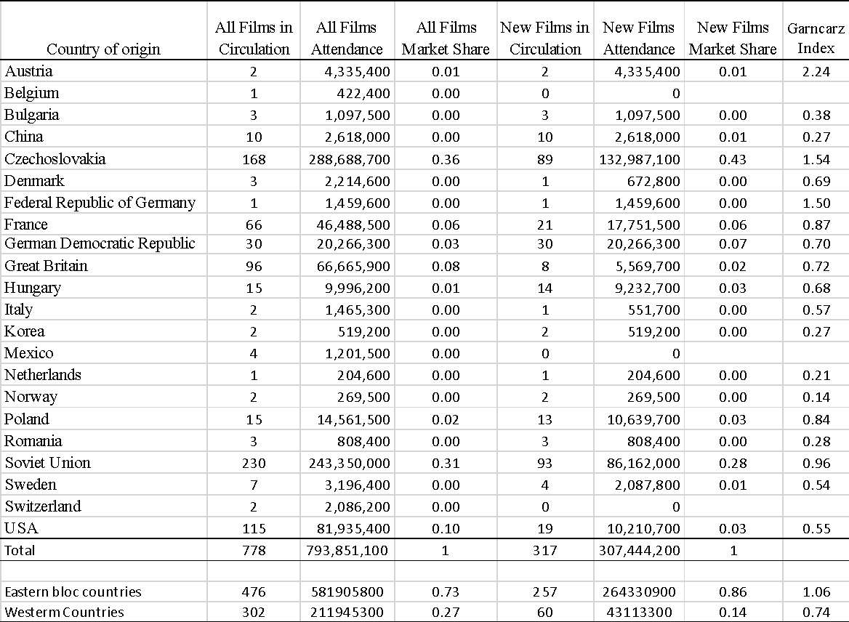

*Source*: source: Havelka, J., (1972) *Čs. filmové hospodářství. 1951–1955*, Praha 1972.

*Note*: All films in circulation during1949-52 are films that premiered between 1945 and 1952. New films in circulation during 1949-1952 are films that premiered during these years.

The descriptive statistics of attendance in the Czech lands for all and new films are presented in Table 9.3 and are remarkably similar. It might have been anticipated that attendances for new movies would exceed those of older films. However, the cumulative nature of attendances should be borne in mind when interpreting the figures. They display the familiar characteristics of a long-right-tail distribution, with the mean well above the median, the skewness coefficient positive and greater than 1, with the most popular film generating attendances many times that of the median film. However, the statistics depict a distribution less extreme than reported in other case studies found in the book, with the median film falling well into the second decile of the range. This result is likely to be the consequence of the relative shortage of new films entering the market, causing audiences to watch movies they like more often and others they might never have watched. The result is to bulk up the central parts of the distribution at the expense of the extremes.

Table 9.3. Descriptive Statistics of the Box-Office generated in the Czech lands, 1949-52.

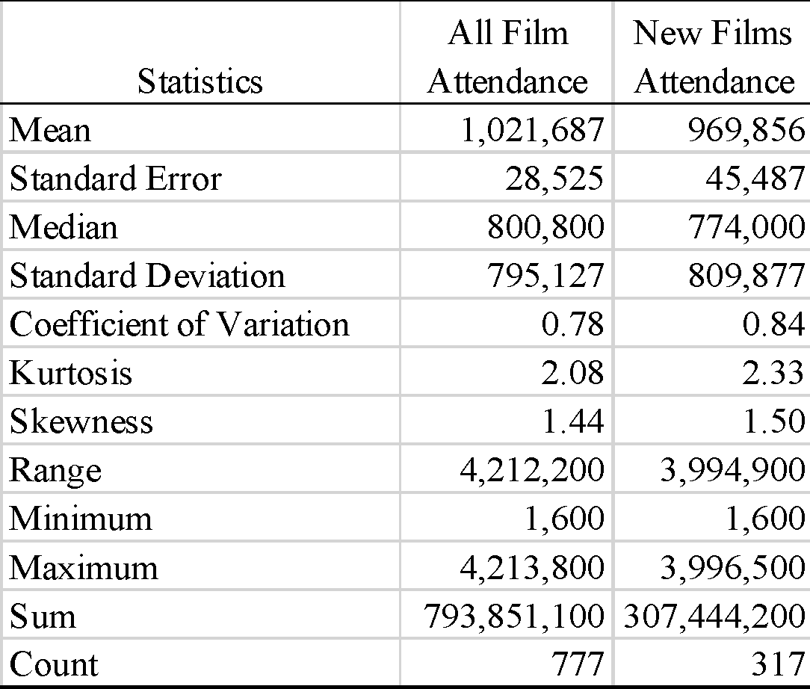

*Source*, Havelka (1972)

*Note*: Havelka does not provide attendance data for the Hollywood film *Action in the North Atlantic* (1943), distributed as *Konvoj do Murmaňska.*

The most popular new films released during 1949-52 are listed in Table 9.4. The decision taken here is to treat movies broken up into two parts (I and II) as a single entity, cumulating attendances from both parts. Not surprisingly, given their Garncarz Index value, Czech films dominate the Top 20, taking 11 berths. They also took 34 of the Top 50 berths and 55 of the Top 100. The films from the Soviet Union fared less well, taking seven, nine and 26 of the respective categories.

Table 9.4 Top 20 films released in the Czech lands, 1949-52

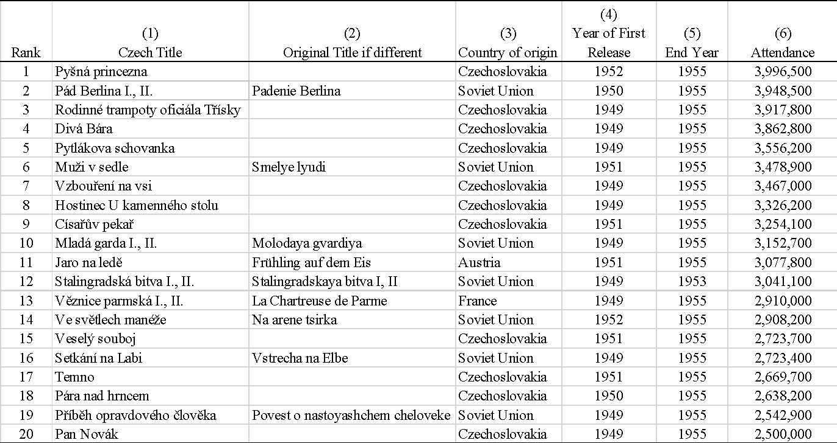

*Source*: Havelka (1972)

*Note*: The years refer to when films were first released in Czechoslovakia.

III POPSTAT

The POPSTAT method details how films circulate within a locality/territory - what films were screened at what cinemas and for how long. These operational details capture the dynamics of how films were distributed and where they were screened. Applying this method to the industrial city of Brno, with a population of 273,000 in 1952, provides new evidence about film popularity to supplement that derived from the Havelka Yearbooks for the Czech lands.[35]

Of the 36 functioning cinemas, film programmes have been collected for 24 from the daily listings in the city’s *Svobodné slovo* newspaper. Cinema weights derived from the sample cinemas’ admission prices and seating capacity have been calculated and are presented in Table 9.5. We believe these correspond to the classification system used by the film authorities, based upon locality and seating capacity. First-class grouped all the big and modern cinemas in the regional capital cities where the films were premiered, while second-class comprised cinemas with good technical standards, mainly in the bigger cities. The final category consisted of third-class cinemas situated in smaller towns and the suburbs and districts of the cities. In each case, the ticket prices were determined by the Authorities. Typically, the cinema auditorium was divided into three areas: front and back stalls and balconies. Before 1953, first-class tickets were priced at 10, 15 and 20 Kčs (crowns) respectively; in the second-class 5, 10 and 15 Kčs; and in the third-class, two prices of 5 and 10 Kčs were charged. A further category of cinema called Čas or Čásek were being established in the cities, screening a continuous programme of newsreels, short documentaries, and slapstick. In these cinemas, a single admission price of 5 Kčs was charged.

In the face of a national economic and financial crisis, the nominal value of the currency was reset overnight on 31 May 1953. Savings were devalued by 50:1, while prices (including cinema admission prices) and salaries were devalued by 5:1.[36] Although outside of our period, these dramatic changes affect the analysis in that the monetary values in the Havelka Yearbooks are expressed in new currency values.[37]

Table 9.5. Sample of Brno Cinemas operating in 1952

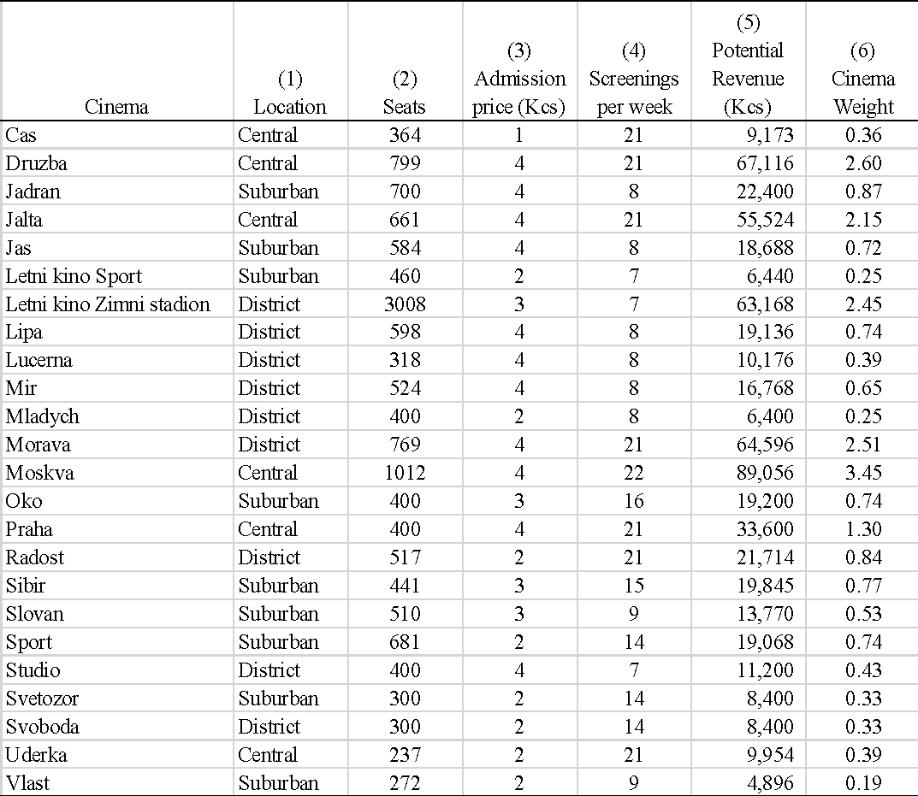

Source: *Svobodné slovo*

Note: Post-devaluation 1953 Czechoslovak Crowns (Kčs) are used.

The cinema weights in Table 9.5 reflect the new set of admission prices attributed to each of the cinemas in the Brno sample for routine screenings. In each, the top of the range price has been selected. Thus, eleven first-class cinemas charge an admission price of 4 Kčs; four cinemas belong to the second class, 3 Kčs; and eight third-class cinemas, 2 Kčs. The cinema Čas has a single admission price of 1.2 Kčs.[38]

The range of cinema weights varies from 3.45 for the 1,012-seater Moskva to 0.19 for the 272-seater Vlast, a difference of 17 times. Two of the cinemas – the Mladých and Studio - shared the same address but showed different programmes. The Letní Kino Sport and Letní Kino Zimní Stadion were open-air cinemas, only opening for the three summer months - from 6/7 June to 12 September. Another two cinemas, the Čas and Úderka, were dedicated to screening newsreels and information-type films. They have been included in the weighting process because occasionally they screened feature films: in 1952, the Čas cinema screened six films over 39 days, while the Úderka cinema screened more than 30 films over 119 days.

A POPSTAT Index series is created for each *ith* film screened in Brno during 1952 by multiplying the weight of the cinema at which it was screened by the days it was screened. Films were tracked forward until the end of January 1953. All programmes feature a single film attraction

Table 9.6. Descriptive Statistics of POPSTAT Index Values, Brno, 1952.

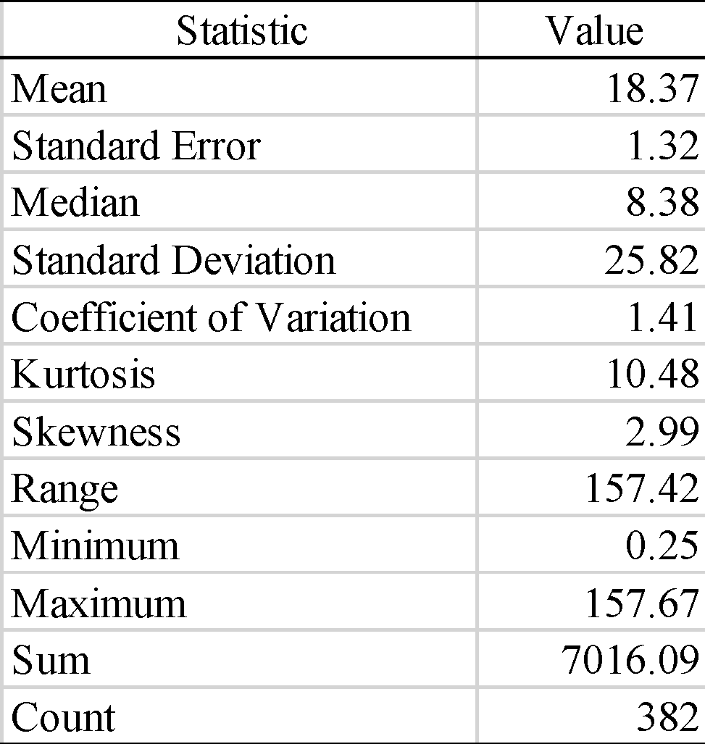

*Source*: *Svobodné slovo*

The descriptive statistics of the POPSTAT values are found in Table 9.6. It is instructive to compare the more extreme Brno statistical distribution with that generated by the official statistics found in Table 9.3. The Havelka derived statistics represent the Czech part of the country, including rural populations for which film choice was restricted because of limited access to cinemas. Furthermore, as explained, they cover multiple years, giving films more opportunities to increase their audience. The Brno statistics, in comparison, provide an annual cross-section of filmgoing practice in a large urban environment, in which film consumers had a plentiful choice, exaggerating the effect of some films being selected more often than others.

Table 9.7 shows that in Brno in 1952, a little over 20 per cent of the movies screened were released in 1951-52.[39] These films garnered 40 per cent of screenings in Brno. They took close to a 50 per cent market share (measured by the POPSTAT Index), providing evidence of a preference for new films – something not possible to establish from the accumulated national attendance statistics found in the Havelka Yearbooks. Accordingly, 80 per cent of film supply, 60 per cent of screenings and 50 per cent of market demand was generated by films first released before 1951. Films of earlier vintages kept urban cinemas supplied with films but had quick turnovers, explaining the extreme statistics associated with the distribution of POPSTAT Index values. Many films had few screenings; a few had many.

Table 9.7. Vintage of Films in Circulation in Brno in 1952

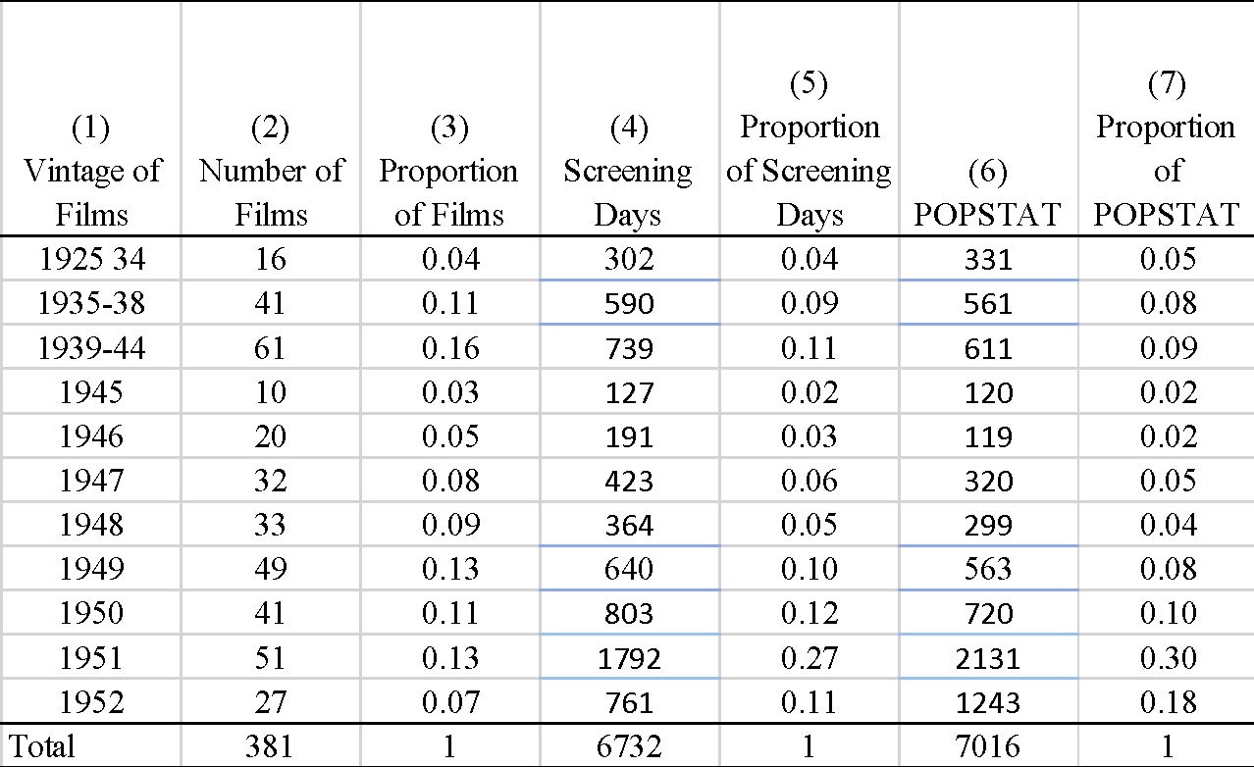

*Source:* Dataset

*Note*: The original release date of one film could not be traced.

Also of interest is the contribution made by (primarily Czech) films first released during the 1935-38 and Protectorate period of 1939-45. These vintage movies were often screened with a textual prelude that explained why they were once again in circulation. In this restricted market, audiences were attracted by newness and, in the case of re-run Czech movies, the opposite – familiarity and predictability.

The Top 20 films screened in Brno are reported in Table 9.8. Czech movies are well represented, taking eight of the berths, including the 1937 film *Tři vejce do skla* with Vlasta Burian, the biggest comedy star of the 1930s. However, most films popular with Brno audiences are from much more recent vintages and get an extensive screening in the city. Four films from the Soviet Union, two from East Germany and two from Hungary indicate a market dominated by films from the Eastern Bloc, with four films from the West ranked 12, 15, 17 and 18th; a pattern like the Top 20 listing derived from the Havelka Yearbooks for the Czech lands, featured in Table 9.4.[40]

Table 9.8. Top 20 Films in Brno, 1952

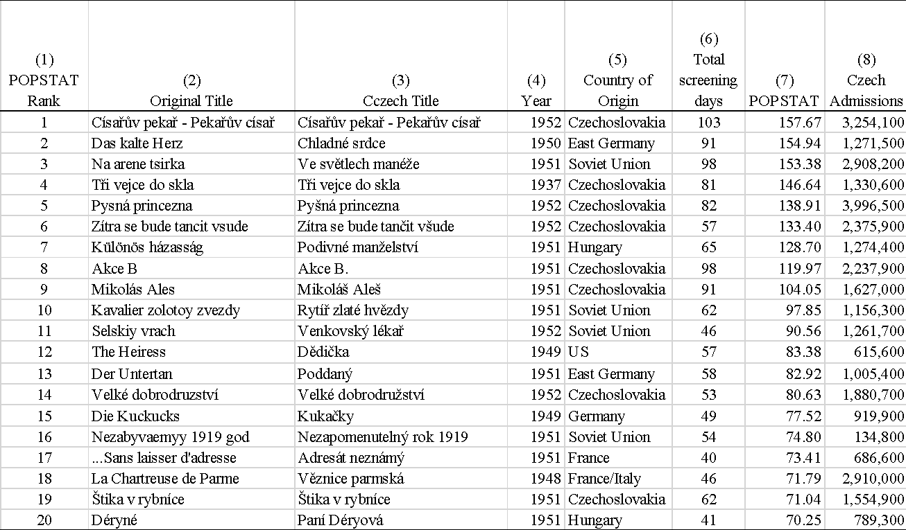

*Source*: Dataset, Havelka (1972)

*Note*: Two films - *Císařův pekař -Pekařův císař*; and *La Chartreuse de Parme* were issued in two parts

Comparing the popularity of films in Brno with the movies listed in the Havelka Yearbooks is problematic for several reasons. First, the collection periods are different. Second, movies released before 1952 had already been circulated in Brno, implying that their respective POPSTAT Index value does not capture their true popularity. The same is true for those films released in 1952 and still circulating in 1953 and later. The third problem is that the number of available prints will have restricted the availability of recently released movies in smaller towns and rural areas. Finally, some films were the subject of privileged distribution by the Authorities.

An example of the latter is the account of the director of distribution for the Bruno district Bohuslav Hammer who received an order to screen the 10th ranked Soviet film *Kavalier zolotoy zvezdy* at the same time of the keenly anticipated Czech historical comedy *Císařův pekař* – ranked first in Table 9.8. In the minutes of a meeting, Hammer is concerned that the Soviet film, following immediately after the screening of another Soviet film - *Donetskie shakhtyory* – would perform very poorly.[41] The implication is that Soviet ideologically loaded movies were perceived as a generic product, with only a brief capacity to attract audiences. Further, Hammer maintained that he required a long distribution window between the screening of such films for them to be effectively exploited.

Thus, while the collection of programming data for Brno is not sufficiently extensive to make a confident assessment of film popularity, it nevertheless provides insight into the manner of film distribution. It also draws attention to those films that received many bookings in Brno but fared less well in the rest of the Czech lands.

Table 9.9. Premiere Statistics of Top 20 Films

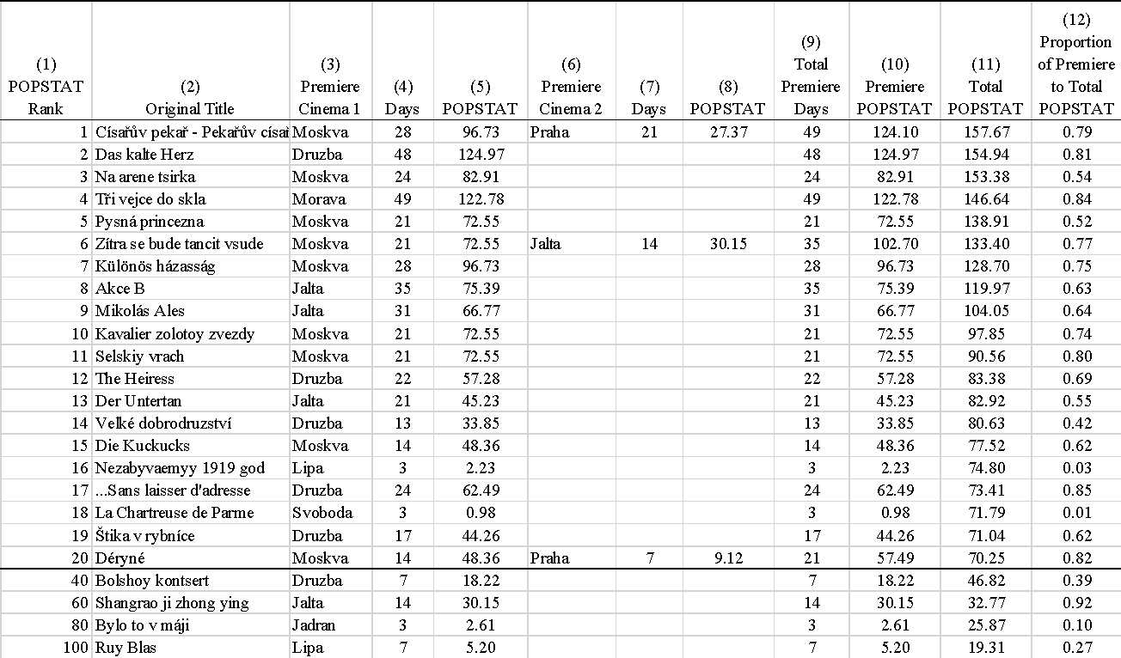

The top-ranking film was the Czech feature *Císařův pekař*. Between 29 February 1952 and 6 October, the movie passed through 12 cinemas and appeared on 103 daily programmes. As shown in Table 9.9, it opened the Moskva and Praha simultaneously for 28 and 21 days, generating almost 80 per cent of its POPSTAT Index value from these bookings. During the final week of its exhibition at the Moskva, it was screened simultaneously at the Sport. With a short two-week break, *Císařův pekař* then appeared in April 1952 at the Jadran, Mí r, Lí pa and Jas cinemas, each for a week booking. A two-month hiatus followed before the film was screened for a series of less than one-week bookings at the Vlast, Slovan, Letní Kino Sport and Studio cinemas.

Essentially *Císařův pekař* moved in an orderly fashion from box-office rich (cinemas with high weights) to box-office poor cinemas in a manner that was entirely in keeping with revenue maximising strategies found in the West.

1. ‘ Cinefication’ refers to screenings throughout the state. The term originates in the USSR in the 1920s when, along with ‘ electrification’ or ‘ radiofication’ , it established a vocabulary intended to indicate the promises of revolutionary change through modern technologies.
2. Brož and Hammer (xxxx:.86)
3. Černík, Artuš: *Výroční zpráva o čs. filmovnictví*. *Rok 1949*. Praha: Československý filmový ústav 1952, s. 160.
4. Krajská pracovní konference kraje Brno, 28. listopadu 1950. Moravský zemský archiv, G 604, inv. č. 15, Zápis ze schůzí a konferencí vedoucích kin – 1949-50.
5. Skopal, 2012: 81
6. Applebaum (2015: ch.13) ‘Homo sovieticus‘
7. Krakovský, R.(2015), ‘Building the Idea of The Common Good in People's Democracies: A Case Study of Communist Czechoslovakia in the 1950s’ Cahiers du Monde russe, Vol. 56, No. 2/3: 345-370
8. Kornai János (2008): From Socialism to Capitalism, Eight Essays pp.3
9. Bringing together Czech film industry-based statistics and business records in the form of a trade journal, Jiří Havelka published his first book in 1935 covering the period 1929-1934. With the intention of providing a service to Czechoslovak film industry both for the domestic and international business, he produced Yearbooks from that time onward until the early 1970s. The data used in this Chapter are drawn from the Czech part of the country. Statistics for the Slovak part are published in separate tables.
10. Kuča, Karel: *Brno. Vývoj města, předměstí a připojených vesnic*. Praha – Brno: Baset, 2000, p. 177.
11. See Václav Novák, xxx unpublished manuscript.
12. See Szczepanik, Barrandov, pp. 64-65.
13. Skopal (2014; 104).
14. Havelka 1945-50, p. 220;
15. Československý státní film. 4.
16. Bohumil Šmída, Organisace a výroba uměleckého filmu. Praha: Československý státní film 1954, s. 9.
17. See letter from MIO to Ministry of Finance – reaction to a letter from 9 July 1952, and minutes from a meeting organized by MI, 18 July 1952. NA, MIO, dodatky, k. 127.
18. Kaplan, Proměny české společnosti 1948-1960. Část první. Ústav pro soudobé dějiny AV ČR 2007, p. 92-95.
19. Bohumil Šmída, Organizace československého filmového podnikání: Praha: Státní pedgogické nakladatelství 1985, s. 154; National Archive, f. ÚV KSČ, 07/2, KSČ – Ústřední výbor 1945-1989, Praha – Gustav Bareš, sv. 2, arch. j. 11, 8.11.1949.
20. Krajská správa ČSF: Plnění plánu návštěvnost od 1.1.1953 do 30.9.1953. AMB, B 1/30. Since the late 1950s, quotas for share of screened films, share of screenings, and share of attendance were launched, in the ratio 35/65 – i.e., the share of the „other“ movies was kept under 35% (the rules changed in the following decades – since mid 1960s, it hold true for share of exhibited movies, but not share of screenings and viewers. Since early 1970s was the ratio changed again and the barrier for percentage of non-socialist countries production increased to 40%).
21. Skopal (2014: 104). For an account of post-war Czechoslovakia society, see Krakovský (2015). For an account of the imbalances of the Czech economy, see Chalupecký (20XX)
22. Hollywood and Western productions constituted more than 50% share of the screenings and 55,6% of the total attendance Bláhová (2009); Skopal (2014); Skopal (xxxx). For attendance figures in general see Havelka (1947, 1972).
23. Mareš, Petr (xxxx)
24. NA, úv ksč, kult. a pol. prop. odd., 660 – Státní ústřední půjčovna filmů – zápis y z jendání, porady – 1946-48
25. Hamlet. Filmová kartotéka, 11.11.1949, 42, p. 3-4.
26. On The Soviet film famine see Knight (2018). On the shortage in Czechoslovakia see Srov. Petr Mareš, Politika a „Pohyblivé obrázky“. Spor o dovoz amerických filmů do Československa po druhé světové válce. *Iluminace* 6, 1 (1994), s. 77–96; Petr Mareš, Všemi prostředky hájená kinematografie. Úvodem k edici dokumentu „Záznam na paměť“. *Iluminace* 3, 2 (1991), s. 75–105.
27. NA, f. 19/7 KSČ – Ústřední výbor 1945–1989, oddělení kulturně-propagační a ideologické, arch. j. 666. Jiří Málek´s report on film distribution in 1949 and its results, addressed to meeting of Board for culture, 28 January 1949.
28. Za vysokou ideovou a uměleckou úroveň československého filmu. Usnesení předsednictva Ústředního výboru KSČ o tvůrčích úkolech československého filmu. *Rudé právo* 30, 19. 4. 1950, č. 92, p. 1 and 3.
29. Rather than discriminating on the ‘quality’ of the seats, the highest price was applied to all the seats.
30. Skopal (2014); NESVEDA, Albert (1958): *Organisace a ekonomika distribuce filmů*. Praha: Československý film. (p.80)
31. Havelka (1970, 1972); Prommer (1999); Vincendeau (1995)
32. Havelka 1951-55, I. part, p. 342.
33. Ladislav Pištora, Filmoví návštěvníci a kina na území České republiky. Od roku 1945 do současnosti. Iluminace 9, 1997, č. 2, pp. 64, 68.
34. See Havelka, 1945-50, p. 228.
35. Kuča, Karel: *Brno. Vývoj města, předměstí a připojených vesnic*. Praha – Brno: Baset, 2000, p. 184.
36. Accordingly, the devaluation lowered cinema admission prices from 20 Kčs to 4 Kčs, 15 to 3 Kčs, 10 to 2 Kčs and 5 to 1 Kčs (Havelka, 1972).
37. See Chalupecký, P. for a detailed account of the economics and finance behind the 1953 crises.
38. The cinema classification implicit in Table 9.5 differs from the years of 1945-48, when only five cinemas were regarded as first-class. While these continued to premiere new films, they were obliged to charge the same price as the six newly created first-class cinemas. The much flatter pricing structure was designed to encourage cinemagoing among the population.
39. Here the distinction between released – first screened – and produced is significant, in that all films were subject to ideological scrutiny which took time, and film imports also required import licences to be granted, another time costing procedure. Source from Havelka, the years refer to the first screenings in Czechoslovakia - from the point when films started generating income.
40. These results differ markedly from the top-ranking results established for Cracow in the next chapter, which was dominated by international films, particularly those from France.
41. Inv.č. 77, všeob. Kor. 1952.