How to play the video without clicking the icon every time:

1. Open the PPT presentation

2. Click on “File”

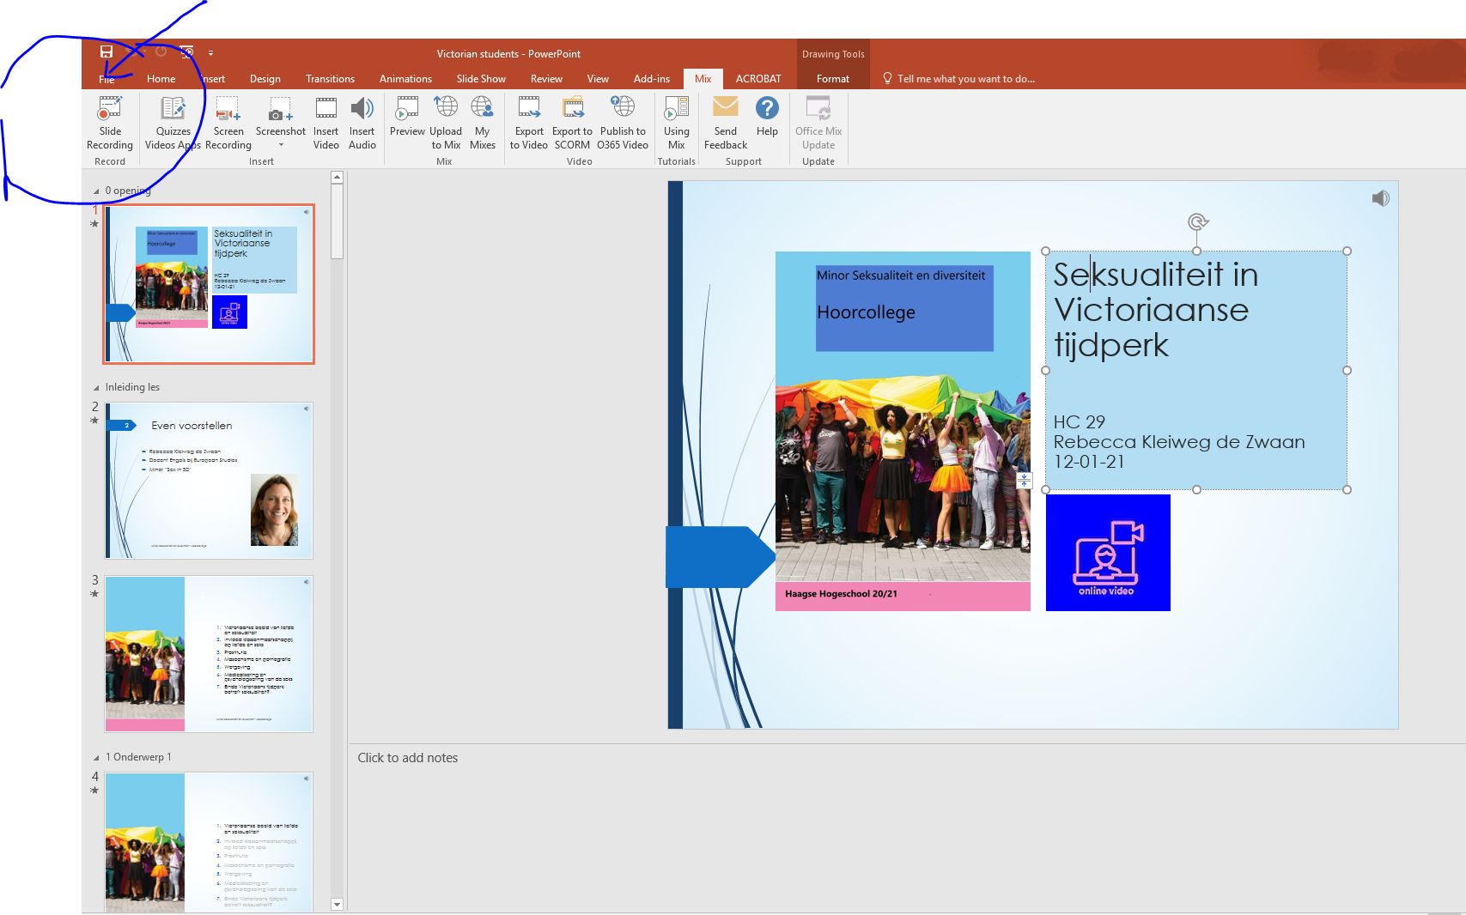

3. Click on “Export” en then on “Create a video”

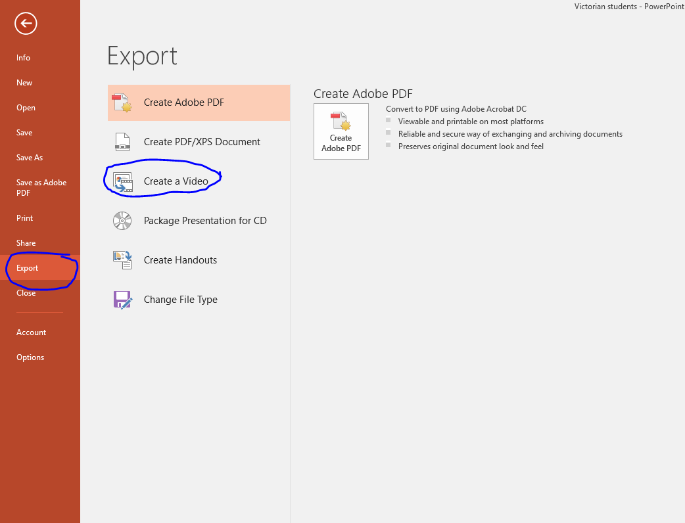

4. Click on “Don’t use Recorded Timings and Narrations” and then scroll to “Preview Timings and Narrations”. The video will then play

