MUNI 20221024 – Berlin Irving

C D 1

1. Duben, první duben (Josef Kainar) 2:28
Gustav Brom-voc, se svým orchestrem. December 19, 1956

2. Alexander’s Ragtime Band 2:12
Gery Scott-voc, Gustav Brom se svým orchestrem. September 10, 1958

3. Alexander’s Ragtime Band 2:43
Ella Fitzgerald-voc, Paul Weston and his Orchestra. March 19, 1958

4. Alexander’s Ragtime Band 3:00
Collins and Harlan. 1911

5. Follow the Crowd 2:01
Irving Berlin-voc & p. January 12, 1914

6. Dixieland Jass Band One Step (Dominick LaRocca) 2:41
Original Dixieland Jass Band. February 26, 1917

7. St. Louis Blues (William Christopher Handy) 4:01
Ciro’s Coon Club Orchestra. September 1917

8. Fuzzy Wuzzy Rag (Jelly Roll Morton) 3:13
Handy’s Orchestra of Memphis. September 21, 1917

9. Ory’s Creole Trombone (Kid Ory) 3:23
Ory’s Sunshine Orchestra. June 1922

10. How Deep Is the Ocean (How High Is the Sky) 3:11
Ella Fitzgerald-voc, Paul Weston and his Orchestra. March 17, 1958

11. How Deep Is the Ocean (How High Is the Sky) 3:29
Swingle Singers. February – March, 1988

12. Blue Skies 3:46
Ella Fitzgerald-voc, Paul Weston and his Orchestra. March 17, 1958

13. Blue Skies 3:16
Frank Sinatra-voc, Tommy Dorsey and his Orchestra. July 15, 1941

14. Blue Skies 3:19
Swingle Singers. February – March, 1988

15. Cheek to Cheek 5:41
Fred Astaire-voc, Oscar Peterson group. December 1952

16. Cheek to Cheek 3:01
Mel Tormé-voc, Marty Paich Dek-Tette. November 10 – 11, 1956

17. Cheek to Cheek 5:57
Ella Fitzgerald & Louis Armstrong-voc, Oscar Peterson group. August 16, 1956

18. Cheek to Cheek 3:52
Swingle Singers. February – March, 1988

19. Always 3:09
Ella Fitzgerald-voc, Paul Weston and his Orchestra. March 13, 1958

20. Always 2:18
Swingle Singers. February – March, 1988

21. They Say It’s Wonderful 3:01
Swingle Singers. February – March, 1988

22. They Say It’s Wonderful 3:01
Swingle Singers. February – March, 1988 O M Y L E M 2x

23. White Christmas 3:01
Bing Crosby-voc, John Scott Trotter and his Orchestra. May 29, 1942

24. White Christmas 3:04
Frank Sinatra-voc, Nelson Riddle and his Orchestra. August 23, 1954 N E N Í !!!

24. White Christmas 3:01
Swingle Singers. February – March, 1988

C D 2

1. Always 2:59
Tony Bennett-voc, Ray Conniff and his Orchestra. September 13, 1956

2. Always 1:42
Tony Bennett-voc, Ralph Sharon and his Orchestra. Carnegie Hall, June 9, 1962

3. Top Hat, White Tie & Tails 3:51
Fred Astaire-voc, Oscar Peterson group. December 1952

4. Top Hat, White Tie & Tails 2:36
Ella Fitzgerald-voc, Paul Weston and his Orchestra. March 19, 1958

5. Top Hat, White Tie & Tails 3:13
Mel Tormé-voc, Marty Paich Dek-Tette. November 10 – 11, 1956

6. Top Hat, White Tie & Tails 2:17
Swingle Singers. February – March, 1988

7. Let’s Face the Music and Dance 2:58
Ella Fitzgerald-voc, Paul Weston and his Orchestra. March 19, 1958

8. Let’s Face the Music and Dance 2:22
Mel Tormé-voc, Marty Paich Dek-Tette. November 10 – 11, 1956

9. I’m Puttin’ All My Eggs in One Basket 2:59
Louis Armstrong-voc, and his Orchestra. February 4, 1936

10. I’m Puttin’ All My Eggs in One Basket 3:01
Ella Fitzgerald-voc, Paul Weston and his Orchestra. March 19, 1958

11. I’m Puttin’ All My Eggs in One Basket 2:55
Fred Astaire-voc, Oscar Peterson group. December 1952

12. I’ve Got My Love to Keep Me Warm 3:00
Ella Fitzgerald-voc, Paul Weston and his Orchestra. March 18, 1958

13. I’ve Got My Love to Keep Me Warm 2:48
Swingle Singers. February – March, 1988

14. Heat Wave 3:03
Ethel Waters-voc, Bunny Berigan and others. October 10, 1933

15. Heat Wave 2:25
Ella Fitzgerald-voc, Paul Weston and his Orchestra. March 18, 1958

16. Heat Wave 2:55
Swingle Singers. February – March, 1988

17. Alexander’s Ragtime Band 2:35
Louis Armstrong-voc, and his Orchestra. July 2, 1937

18. Puttin’ on the Ritz 2:12
Fred Astaire-voc, small orchestra. London, March 26, 1930

19. Puttin’ on the Ritz 2:53
Fred Astaire-voc, Oscar Peterson group. December 1952

20. Puttin’ on the Ritz 2:18
Ella Fitzgerald-voc, Paul Weston and his Orchestra. March 18, 1958

21. Isn’t This a Lovely Day 4:29
22. I Used to Be Color Blind 4:17
23. Change Partners 3:16
24. Steppin’ Out with My Baby 2:24
25. No Strings 2:57
26. You’re Easy to Dance With 3:24
Fred Astaire-voc, Oscar Peterson group. December 1952

27. Song Is Ended 2:30
Ella Fitzgerald-voc, Paul Weston and his Orchestra. March 18, 1958

MUNI 20221024 – Berlin Irving

C D 1

1. Duben, první duben (Josef Kainar) 2:28
Gustav Brom-voc, se svým orchestrem. December 19, 1956

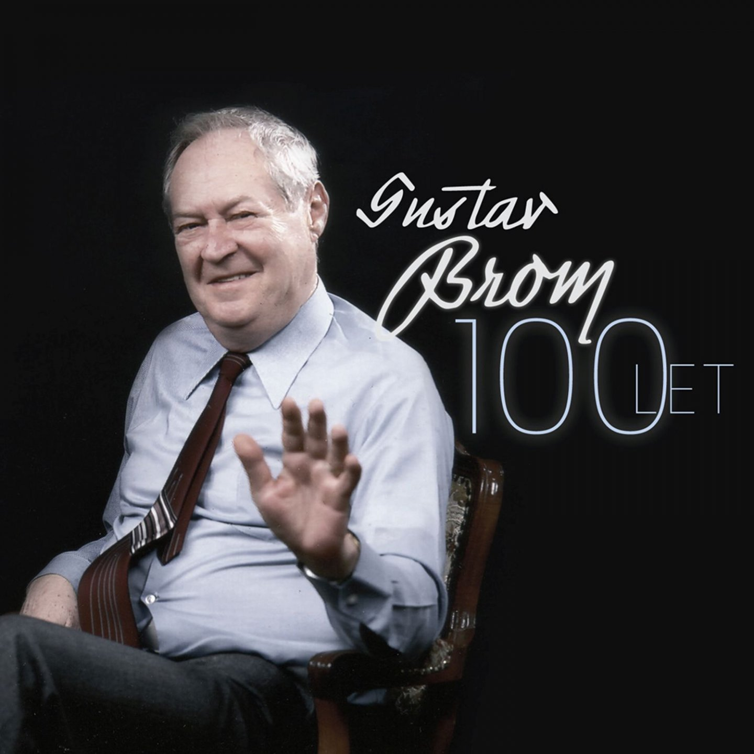

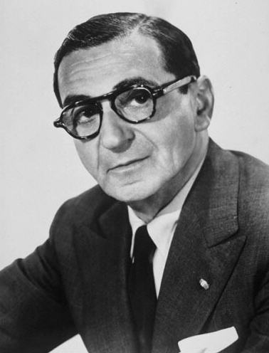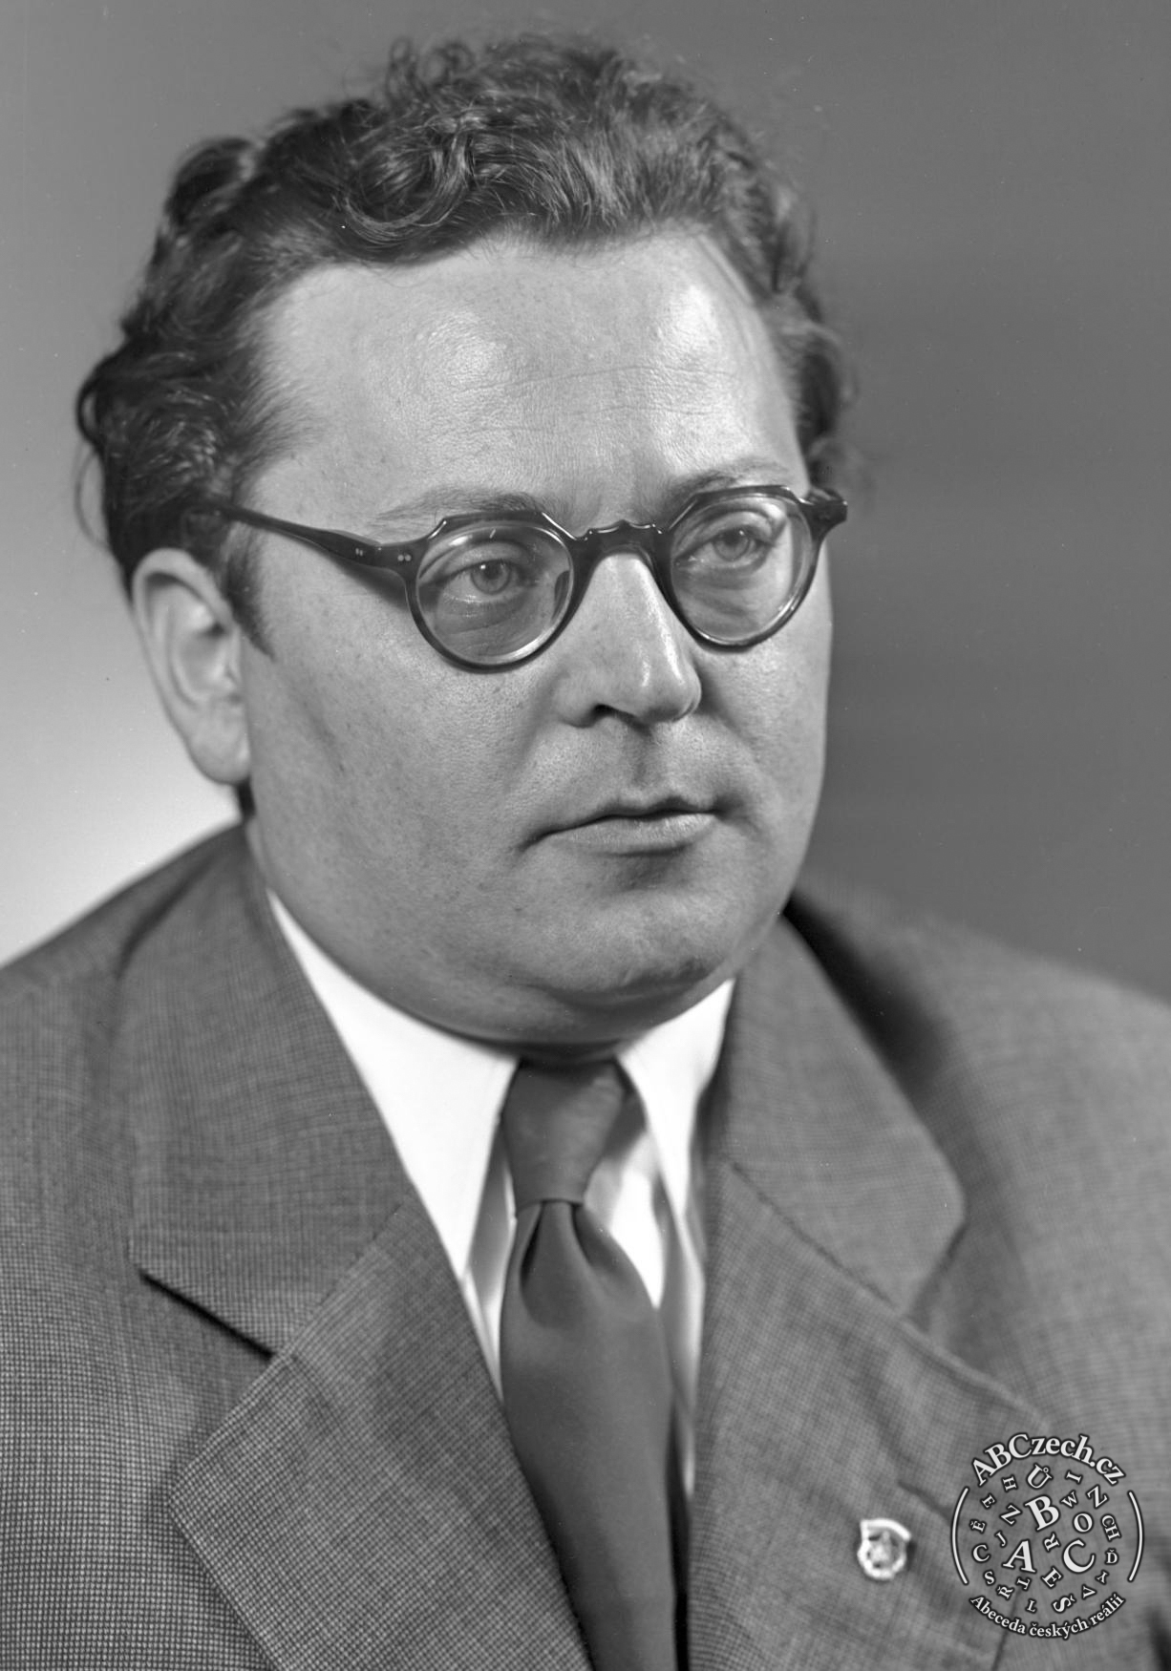
Irving Berlin (1888 – 1989) Josef Kainar (1917 – 1971)

2. Alexander’s Ragtime Band 2:12
Gery Scott-voc, Gustav Brom se svým orchestrem. September 10, 1958

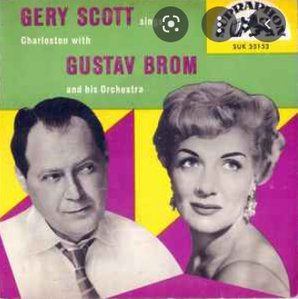

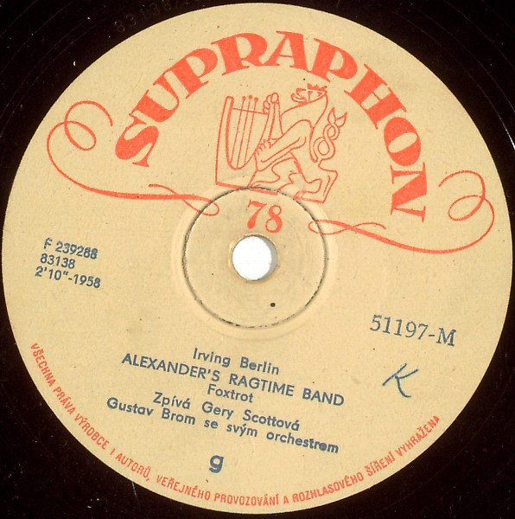

3. Alexander’s Ragtime Band 2:43
Ella Fitzgerald-voc, Paul Weston and his Orchestra. March 19, 1958

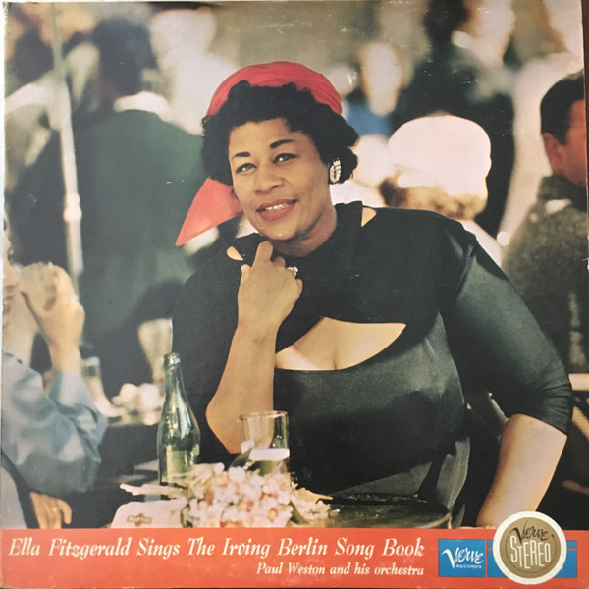

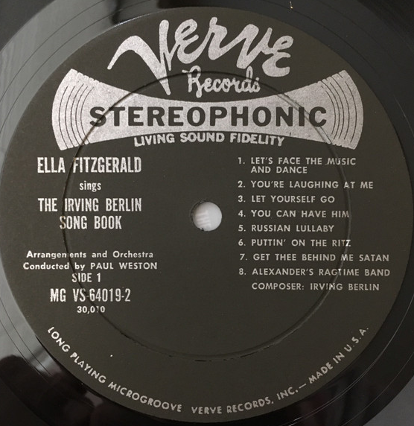

4. Alexander’s Ragtime Band 3:00
Collins and Harlan. 1911

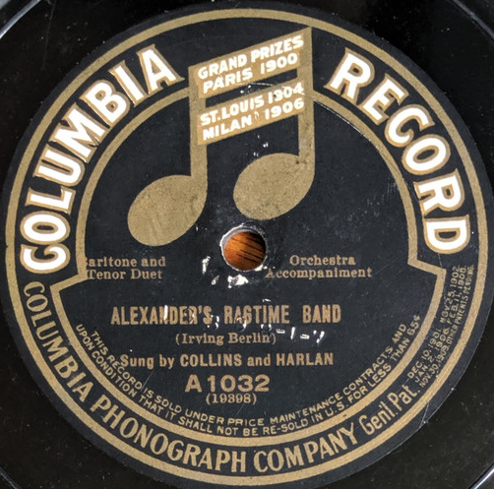

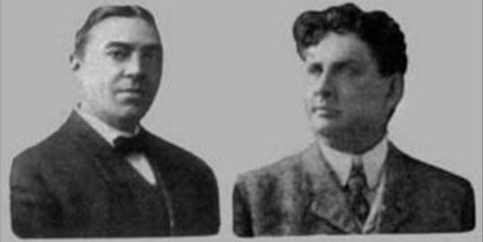
Arthur Collins (1864 – 1933) Byron G. Harlan (1861 – 1936)

5. Follow the Crowd 2:01
Irving Berlin-voc & p. January 12, 1914

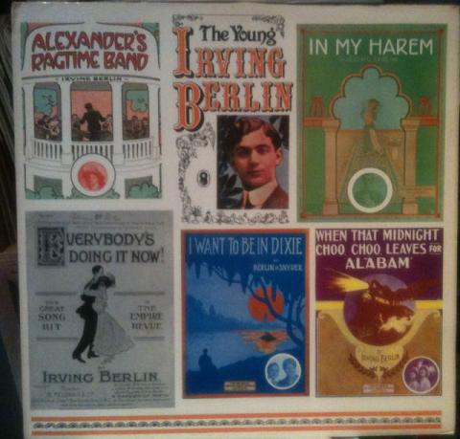

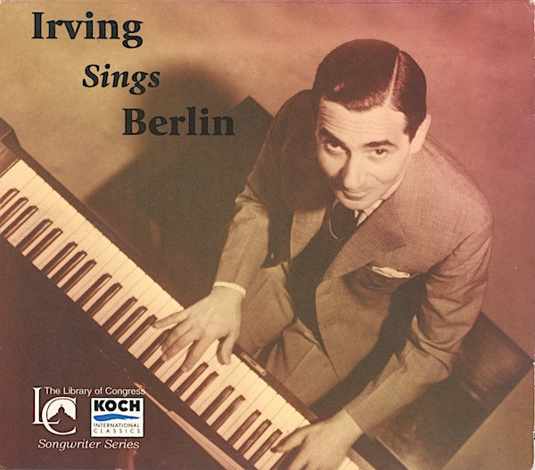

6. Dixieland Jass Band One Step (Dominick LaRocca) 2:41
Original Dixieland Jass Band. February 26, 1917

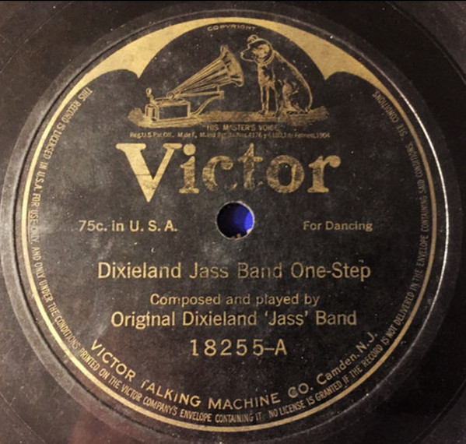

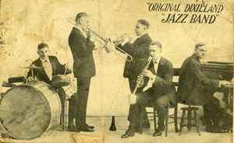

7. St. Louis Blues (William Christopher Handy) 4:01
Ciro’s Coon Club Orchestra. September 1917
Early black rag-jazz group which recorded in London during 1916-1917.

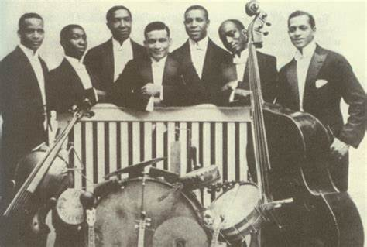

Banjo – Vance Lowry; Banjo – Ferdinand Allen; Bass – Sumner Edwards;
Cello – Walter Kildare; Drums, Vocals – Louis Mitchell; Piano – Dan Kildare

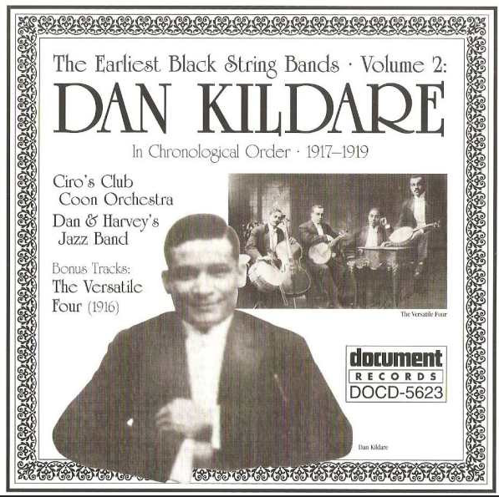

8. Fuzzy Wuzzy Rag (Jelly Roll Morton) 3:13
Handy’s Orchestra of Memphis. September 21, 1917

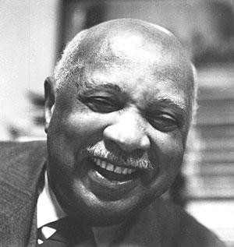

William Christopher Handy (1873 – 1958)

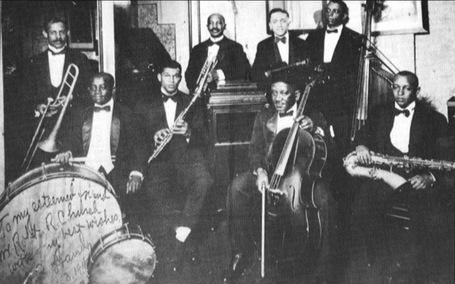

W.C. Handy (tp) Sylvester Bevard (tb) Wilson Townes (cl,as) Alex Poole (as,cl) Charles Harris, Nelson Kincaid (cl,ts) Edward Alexander, William A. Tyler, Darnell Howard (vln) Henry Graves (cello) Charles Hillman (p) Archie Walls (tu,b) Jasper Taylor (d,xyl)

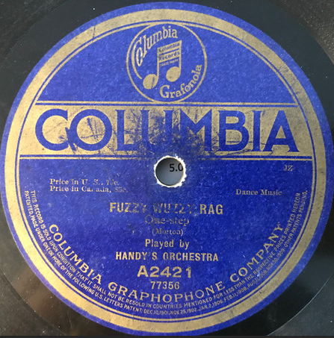

9. Ory’s Creole Trombone (Kid Ory) 3:23
Ory’s Sunshine Orchestra. June 1922

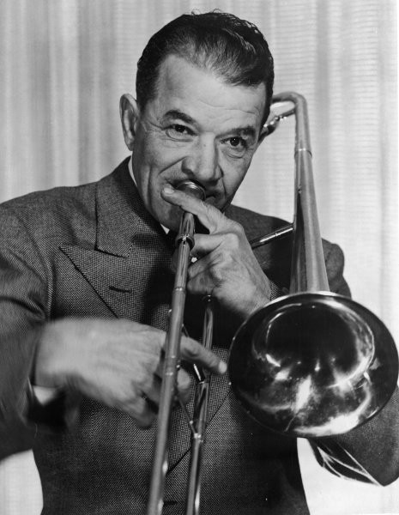

Kid Ory (1886 – 1973)

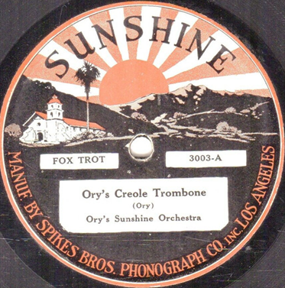

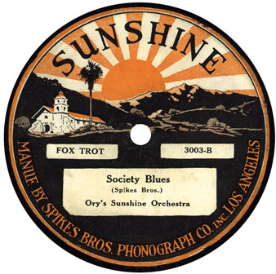

10. How Deep Is the Ocean (How High Is the Sky) 3:11
Ella Fitzgerald-voc, Paul Weston and his Orchestra. March 17, 1958

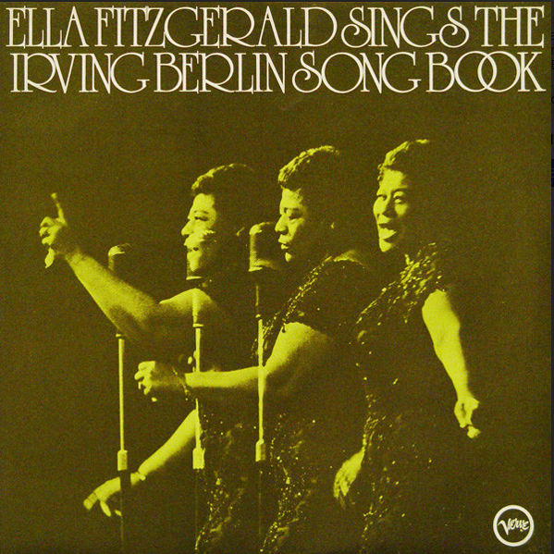

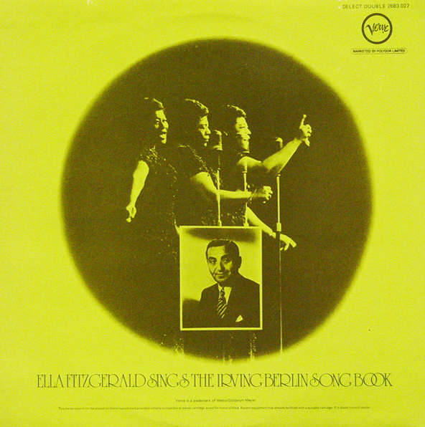

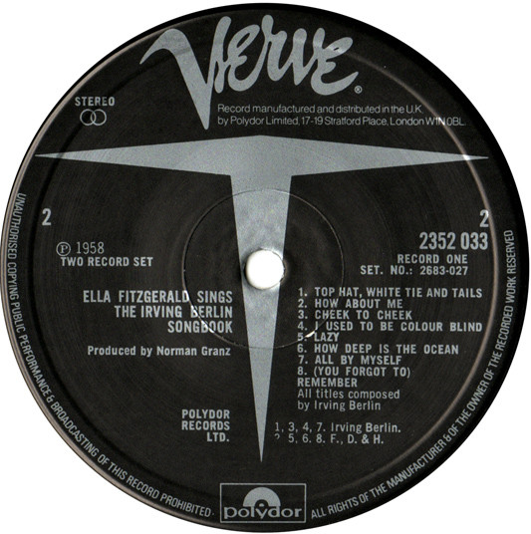

11. How Deep Is the Ocean (How High Is the Sky) 3:29
Swingle Singers. February – March, 1988

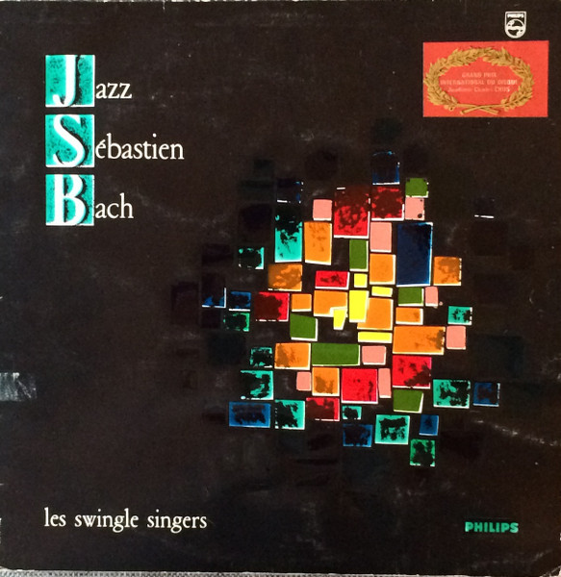

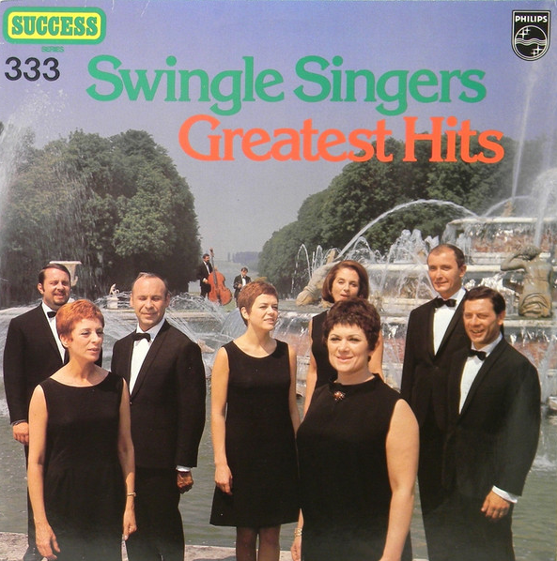

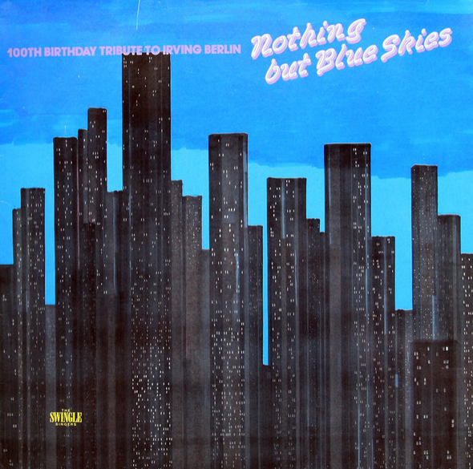

12. Blue Skies 3:46
Ella Fitzgerald-voc, Paul Weston and his Orchestra. March 17, 1958

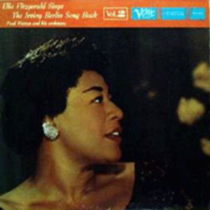

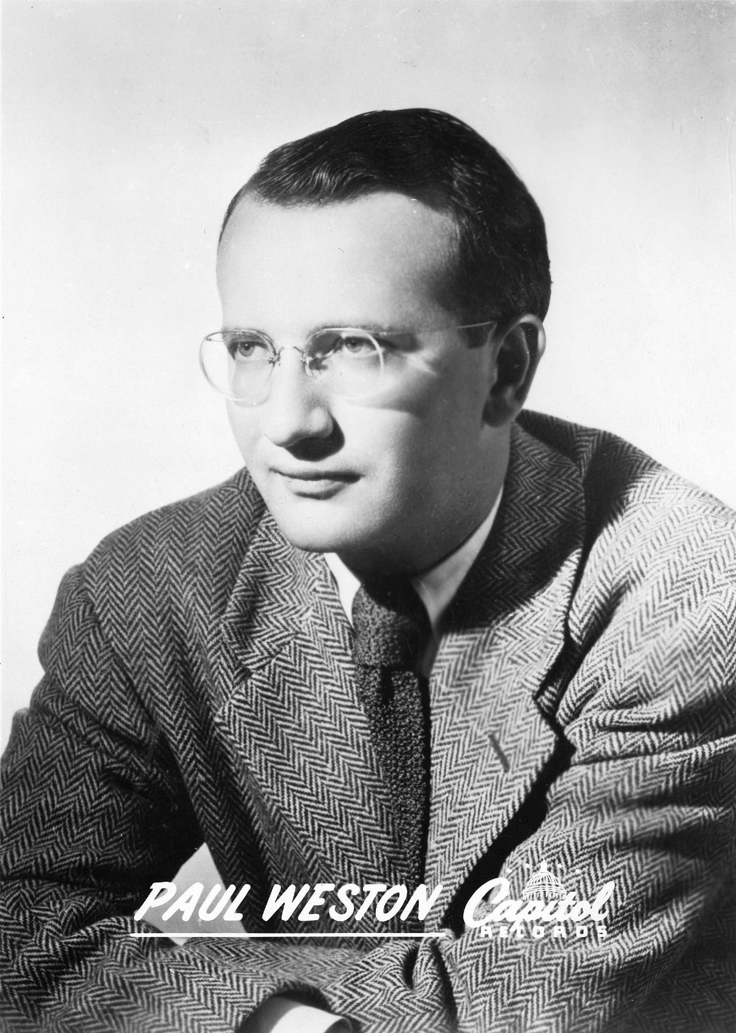

13. Blue Skies 3:16
Frank Sinatra-voc, Tommy Dorsey and his Orchestra. July 15, 1941

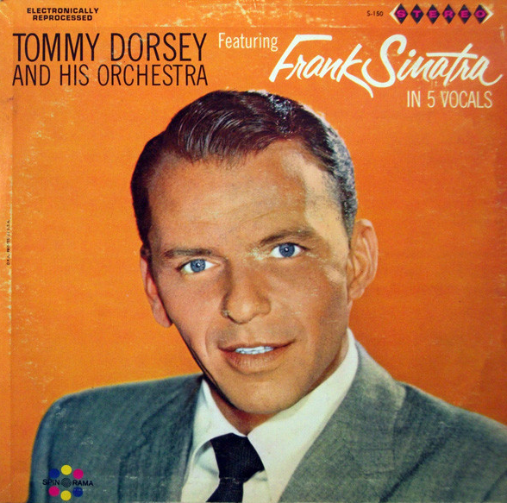

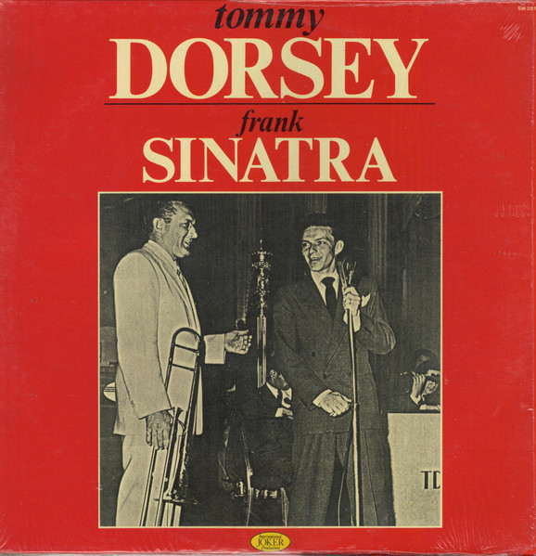

14. Blue Skies 3:19
Swingle Singers. February – March, 1988

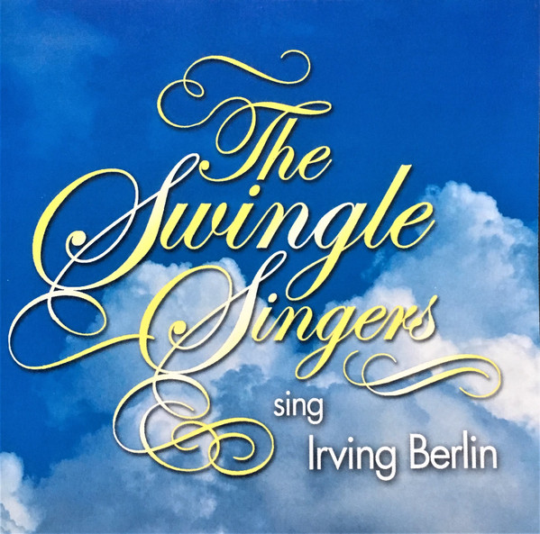

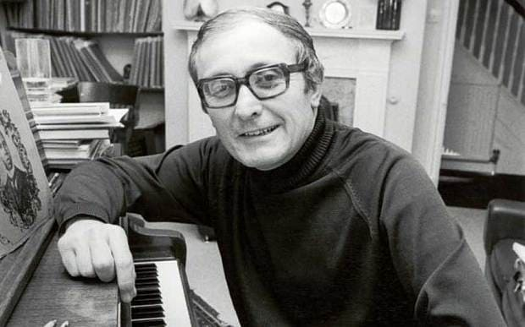

Ward Swingle (1927 – 2015)

15. Cheek to Cheek 5:41
Fred Astaire-voc, Oscar Peterson group. December 1952

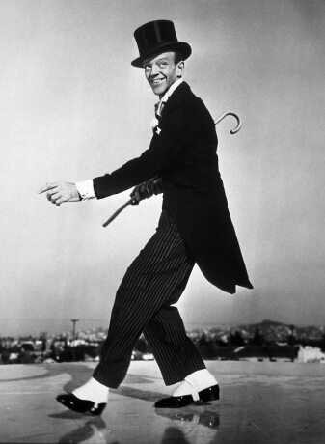

16. Cheek to Cheek 3:01
Mel Tormé-voc, Marty Paich Dek-Tette. November 10 – 11, 1956

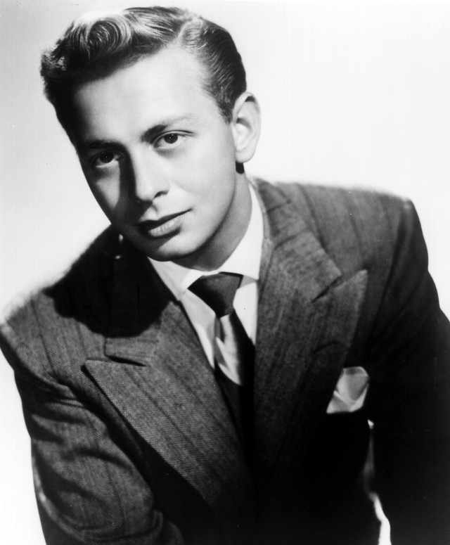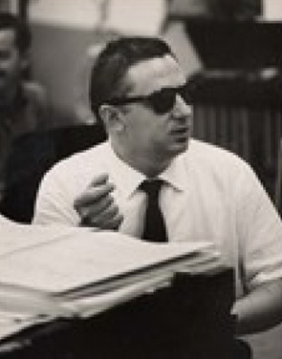
Mel Tormé (1925 – 1999) Marty Paich (1925 – 1995)

17. Cheek to Cheek 5:57
Ella Fitzgerald & Louis Armstrong-voc, Oscar Peterson group. August 16, 1956

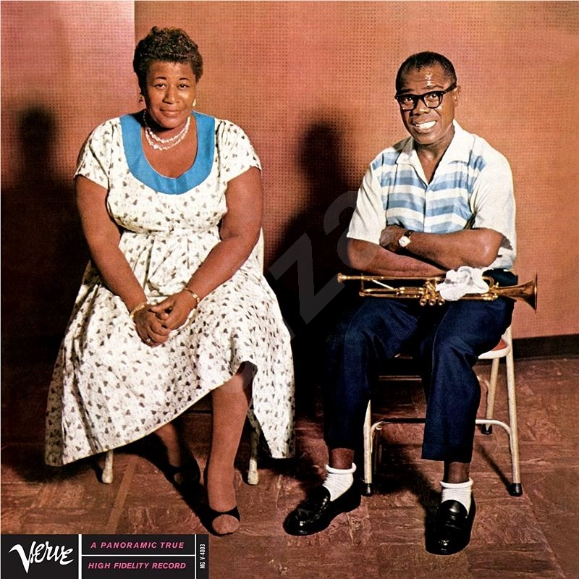

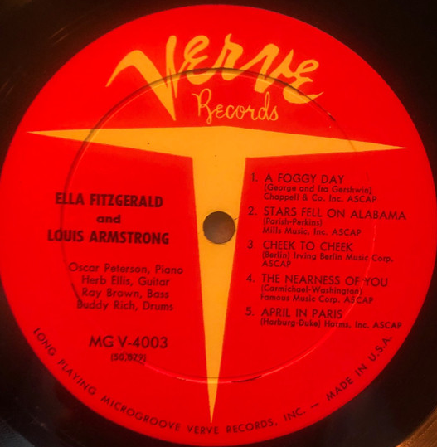

18. Cheek to Cheek 3:52
Swingle Singers. February – March, 1988

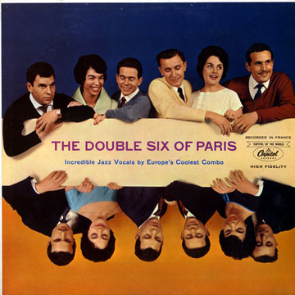

19. Always 3:09
Ella Fitzgerald-voc, Paul Weston and his Orchestra. March 13, 1958

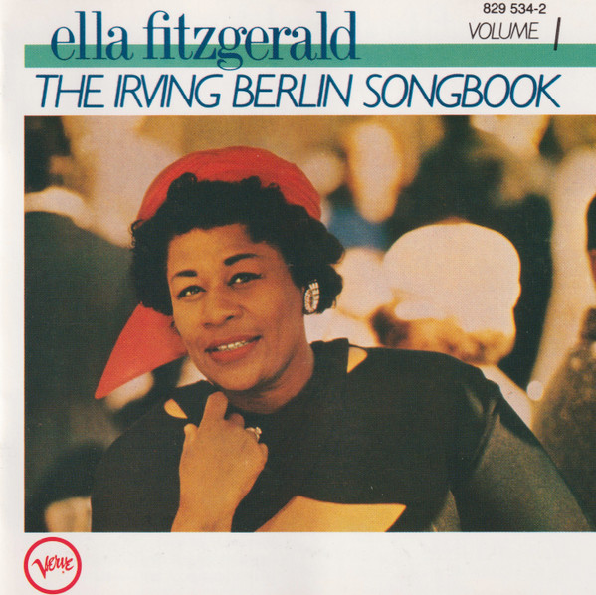

20. Always 2:18
Swingle Singers. February – March, 1988

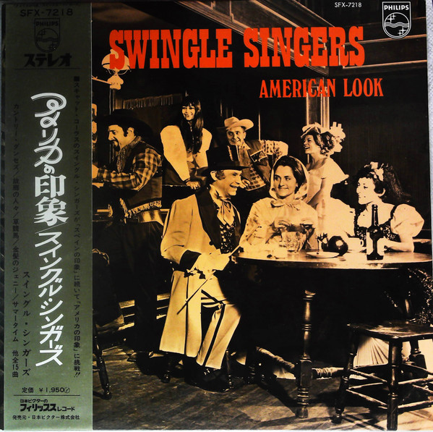

21. They Say It’s Wonderful 3:01
Swingle Singers. February – March, 1988

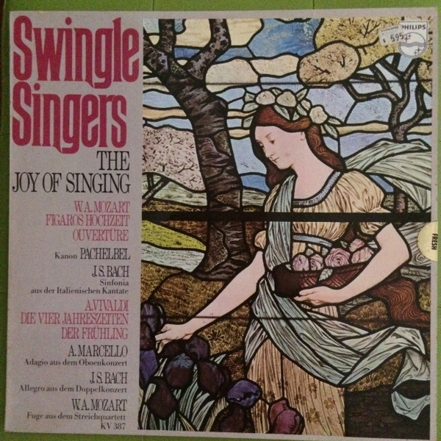

22. They Say It’s Wonderful 3:01
Swingle Singers. February – March, 1988 O M Y L E M 2x

23. White Christmas 3:01
Bing Crosby-voc, John Scott Trotter and his Orchestra. May 29, 1942

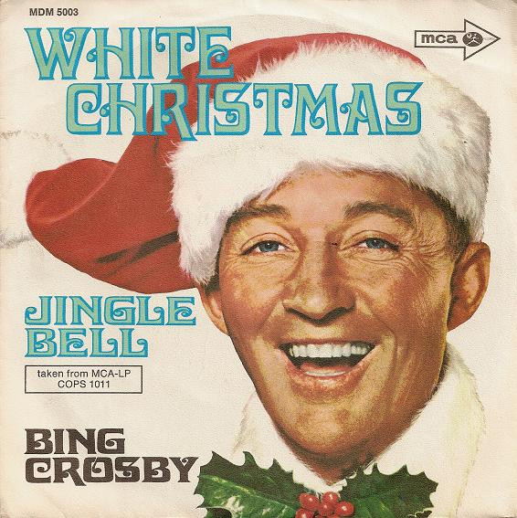

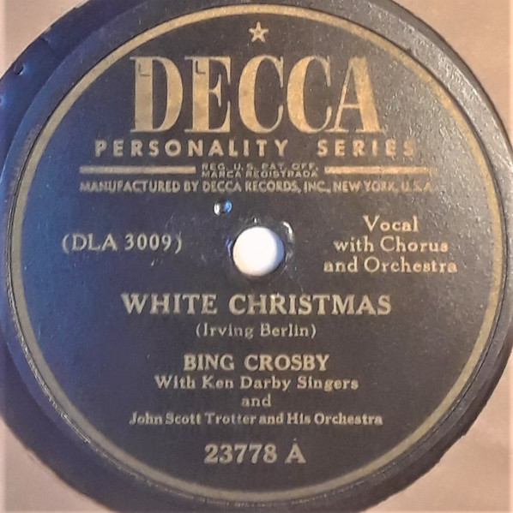
1947
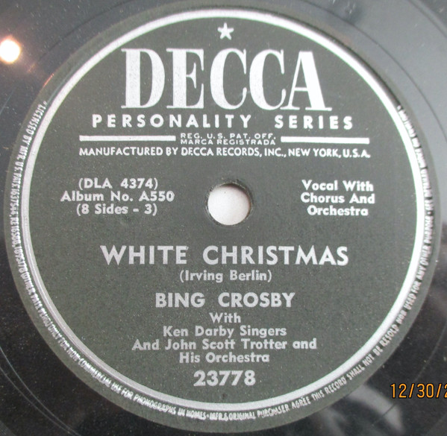
1950

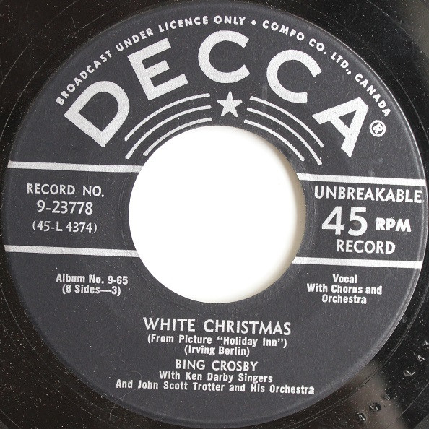
1950

24. White Christmas 3:04
Frank Sinatra-voc, Nelson Riddle and his Orchestra. August 23, 1954 N E N Í !!!

24. White Christmas 3:01
Swingle Singers. February – March, 1988

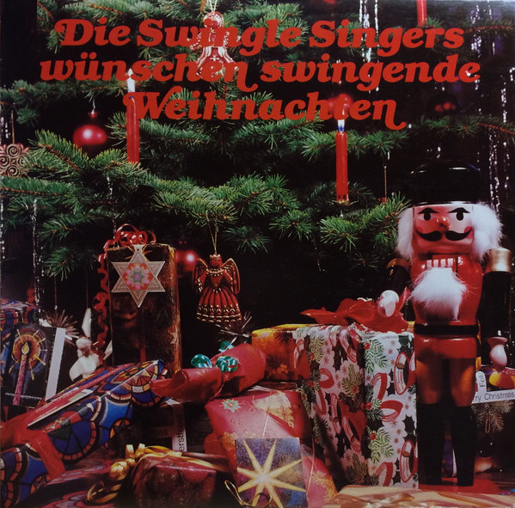

C D 2

1. Always 2:59
Tony Bennett-voc, Ray Conniff and his Orchestra. September 13, 1956

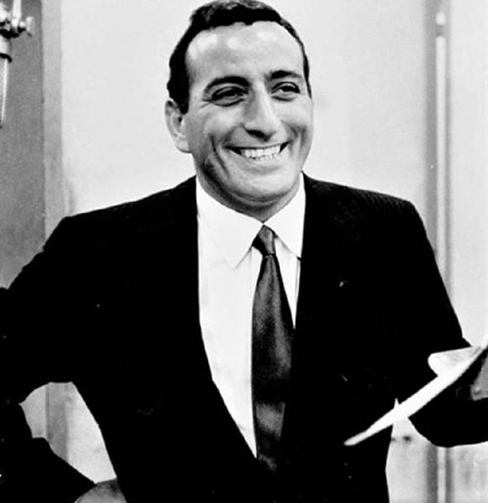

2. Always 1:42
Tony Bennett-voc, Ralph Sharon and his Orchestra. Carnegie Hall, June 9, 1962

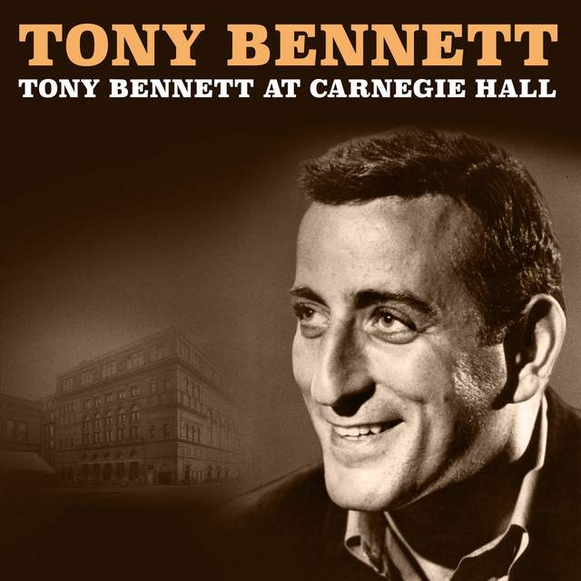

3. Top Hat, White Tie & Tails 3:51
Fred Astaire-voc, Oscar Peterson group. December 1952

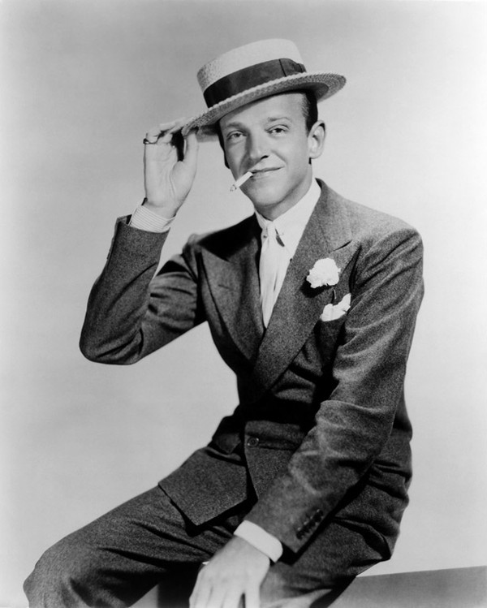

4. Top Hat, White Tie & Tails 2:36
Ella Fitzgerald-voc, Paul Weston and his Orchestra. March 19, 1958

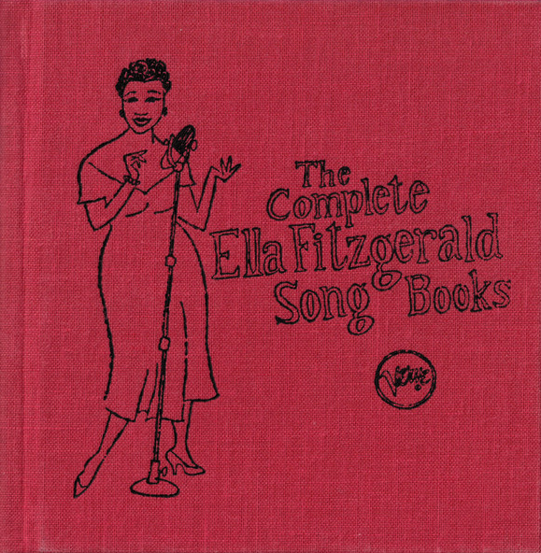

5. Top Hat, White Tie & Tails 3:13
Mel Tormé-voc, Marty Paich Dek-Tette. November 10 – 11, 1956

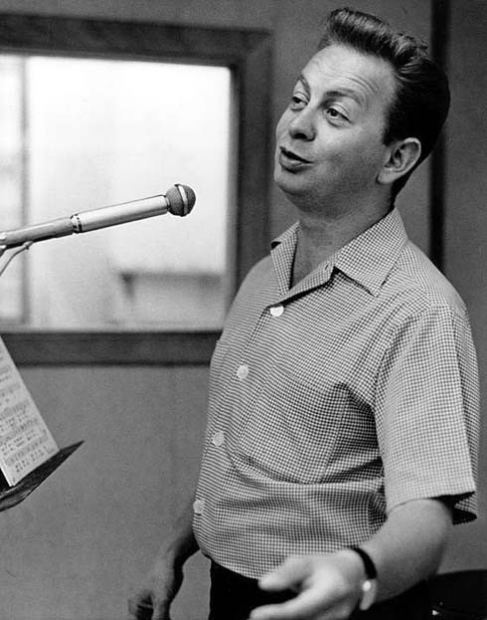

6. Top Hat, White Tie & Tails 2:17
Swingle Singers. February – March, 1988

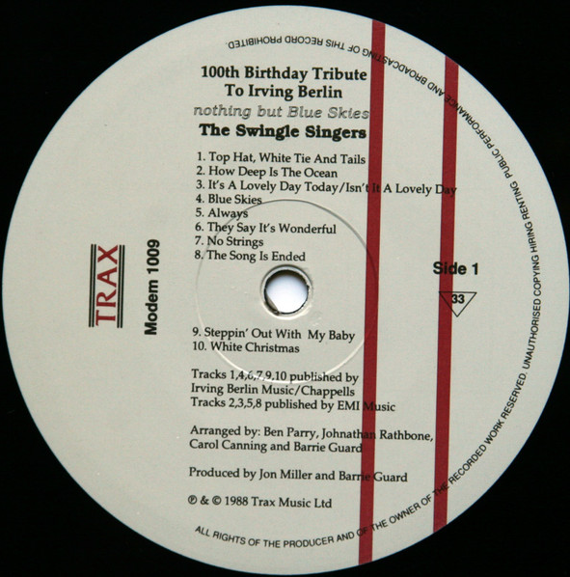

7. Let’s Face the Music and Dance 2:58
Ella Fitzgerald-voc, Paul Weston and his Orchestra. March 19, 1958

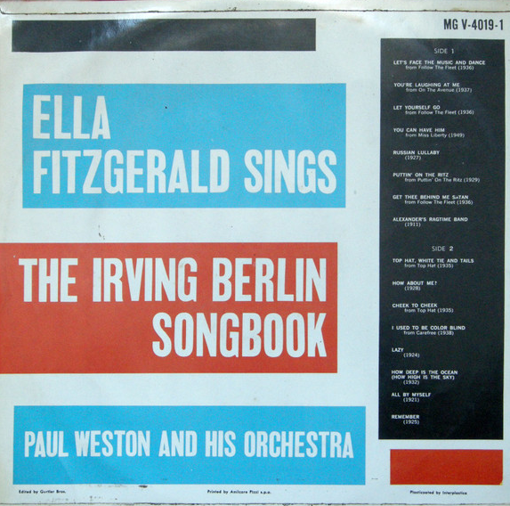

8. Let’s Face the Music and Dance 2:22
Mel Tormé-voc, Marty Paich Dek-Tette. November 10 – 11, 1956

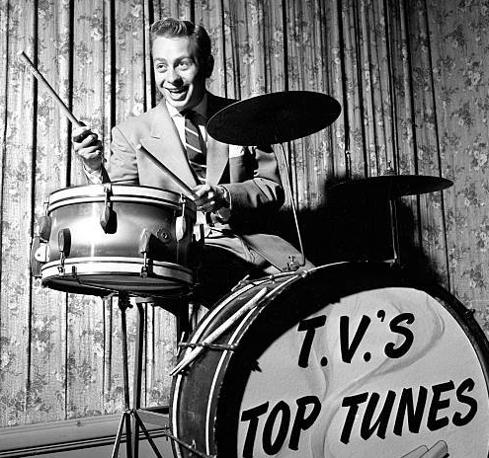

9. I’m Puttin’ All My Eggs in One Basket 2:59
Louis Armstrong-voc, and his Orchestra. February 4, 1936

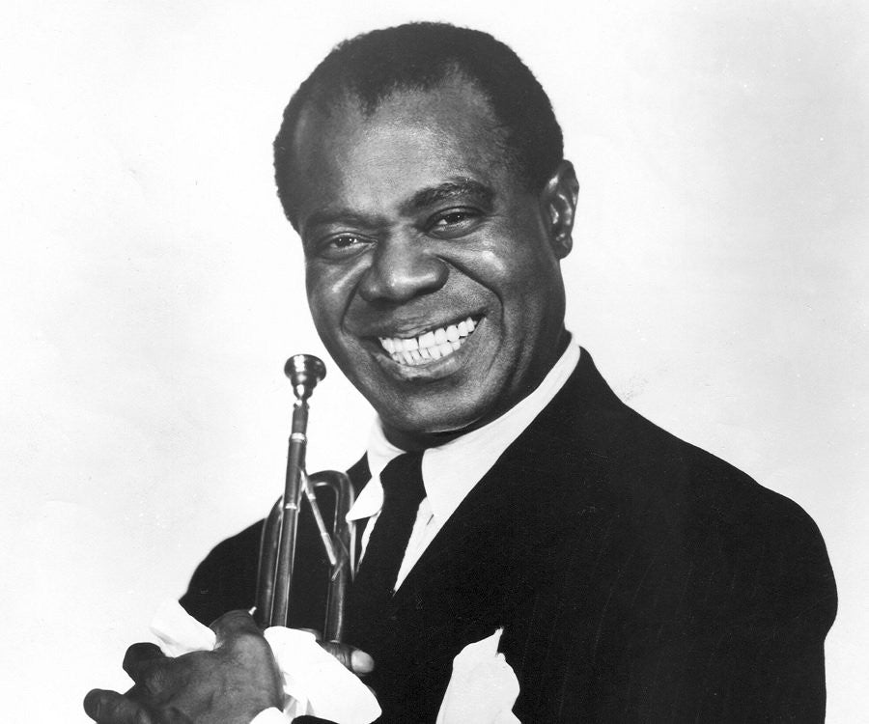

10. I’m Puttin’ All My Eggs in One Basket 3:01
Ella Fitzgerald-voc, Paul Weston and his Orchestra. March 19, 1958

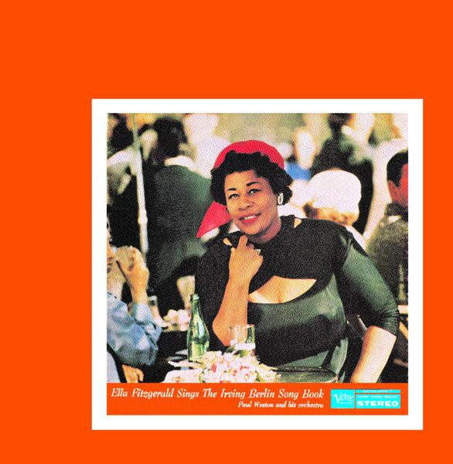

11. I’m Puttin’ All My Eggs in One Basket 2:55
Fred Astaire-voc, Oscar Peterson group. December 1952

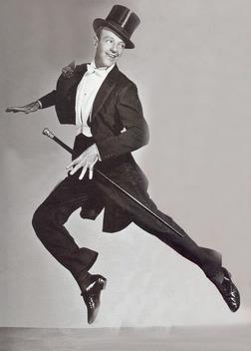

12. I’ve Got My Love to Keep Me Warm 3:00
Ella Fitzgerald-voc, Paul Weston and his Orchestra. March 18, 1958

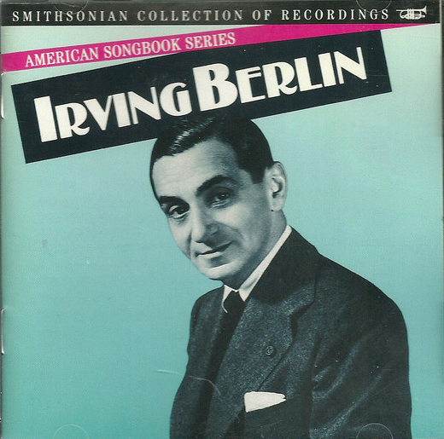

13. I’ve Got My Love to Keep Me Warm 2:48
Swingle Singers. February – March, 1988

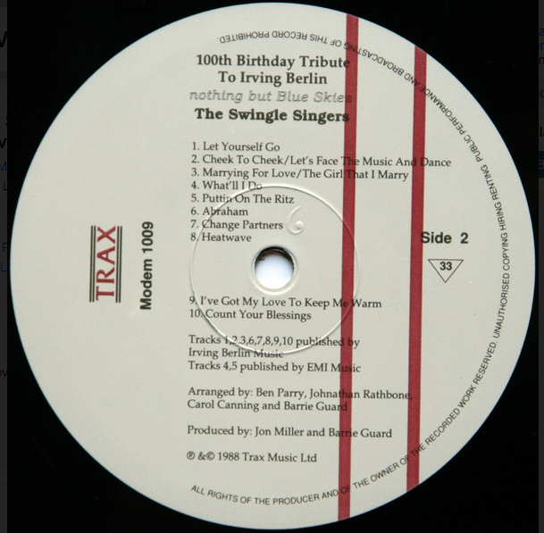

14. Heat Wave 3:03
Ethel Waters-voc, Bunny Berigan and others. October 10, 1933

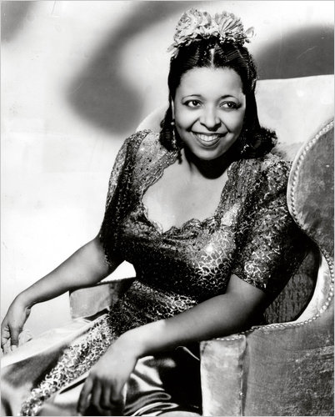

15. Heat Wave 2:25
Ella Fitzgerald-voc, Paul Weston and his Orchestra. March 18, 1958

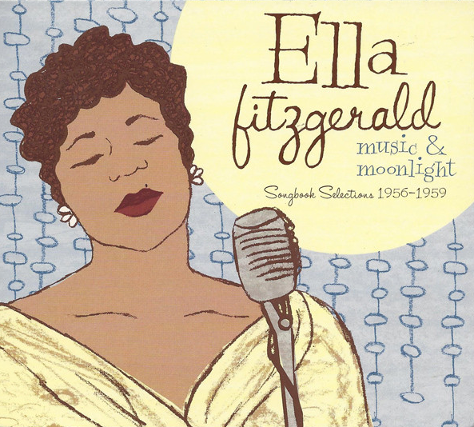

16. Heat Wave 2:55
Swingle Singers. February – March, 1988

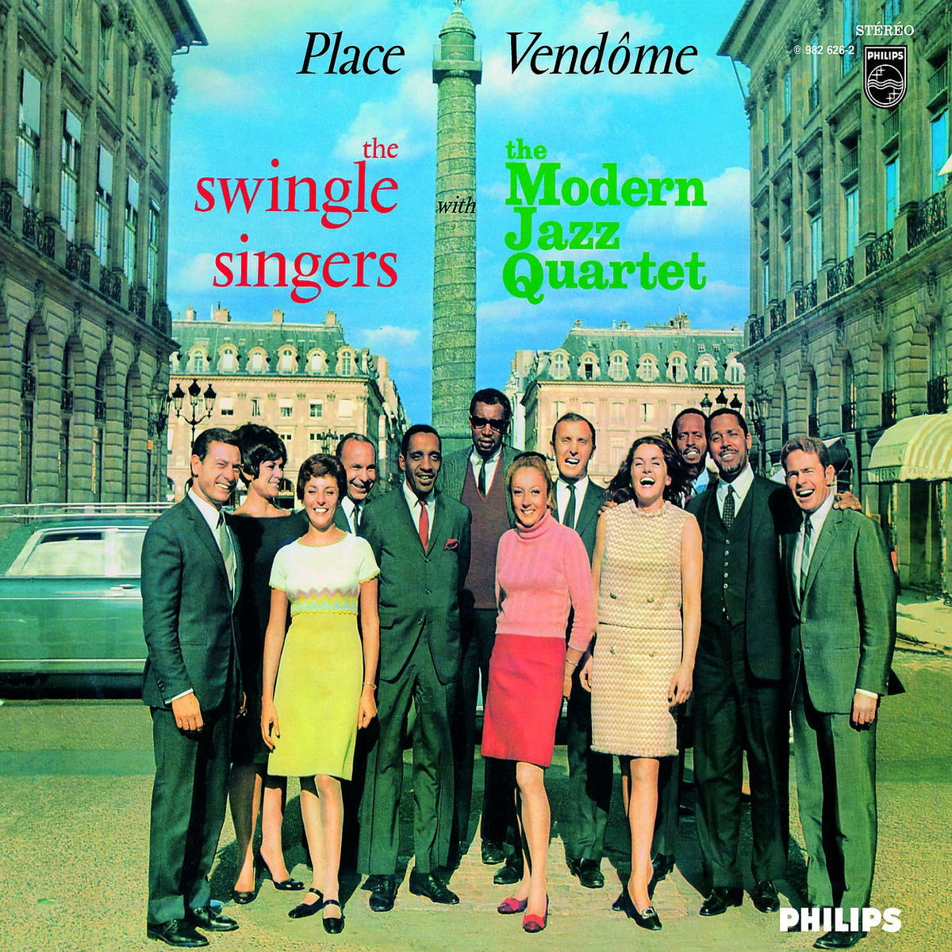

17. Alexander’s Ragtime Band 2:35
Louis Armstrong-voc, and his Orchestra. July 2, 1937

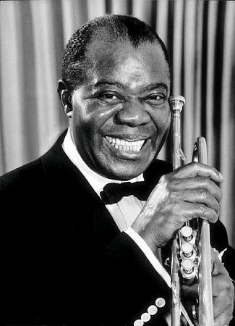

18. Puttin’ on the Ritz 2:12
Fred Astaire-voc, small orchestra. London, March 26, 1930

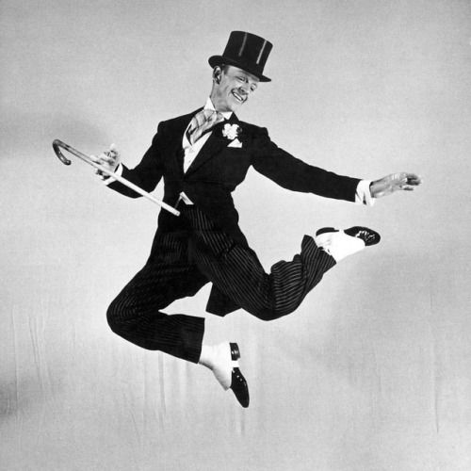

19. Puttin’ on the Ritz 2:53
Fred Astaire-voc, Oscar Peterson group. December 1952

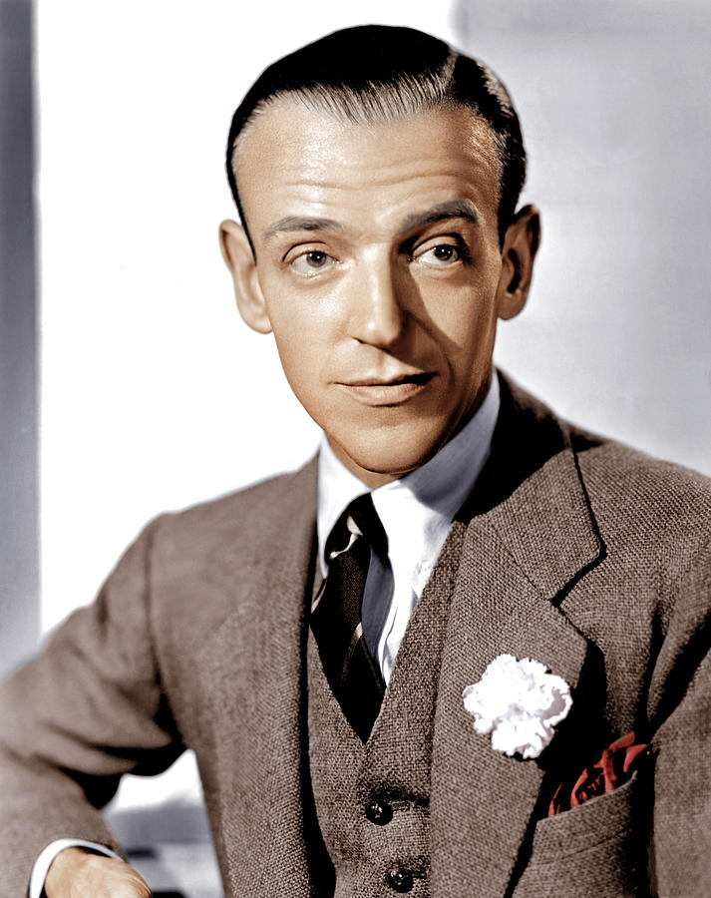

20. Puttin’ on the Ritz 2:18
Ella Fitzgerald-voc, Paul Weston and his Orchestra. March 18, 1958

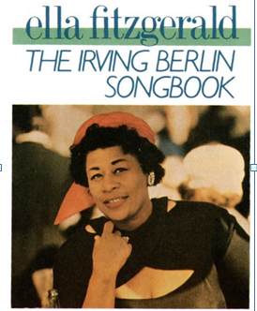

21. Isn’t This a Lovely Day 4:29
22. I Used to Be Color Blind 4:17
23. Change Partners 3:16
24. Steppin’ Out with My Baby 2:24
25. No Strings 2:57
26. You’re Easy to Dance With 3:24
Fred Astaire-voc, Oscar Peterson group. December 1952

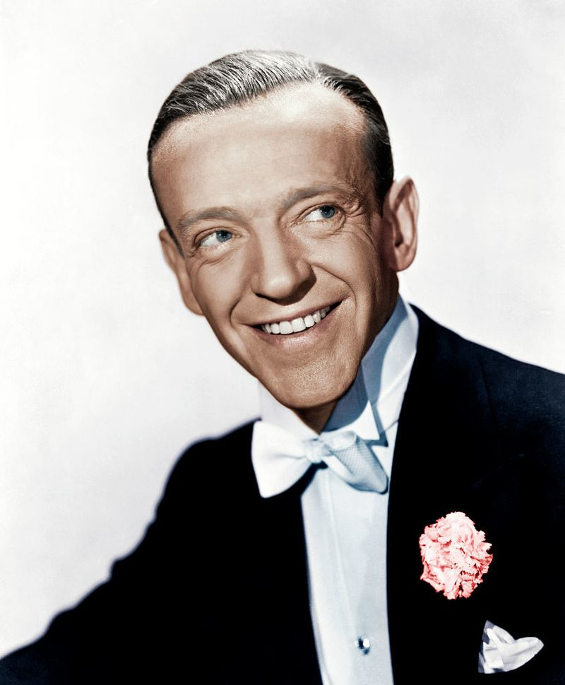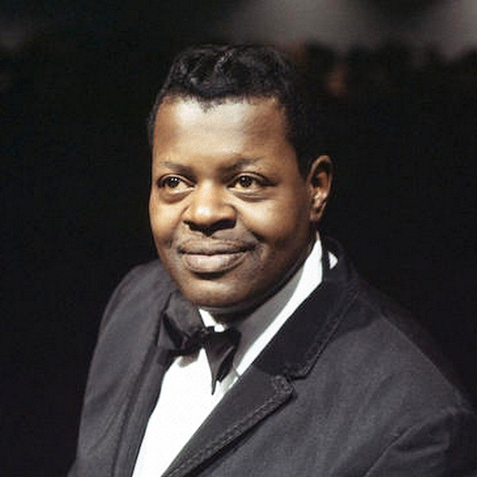

Fred Astaire (1899 – 1987) Oscar Peterson (1925 – 2007)

27. Song Is Ended 2:30
Ella Fitzgerald-voc, Paul Weston and his Orchestra. March 18, 1958

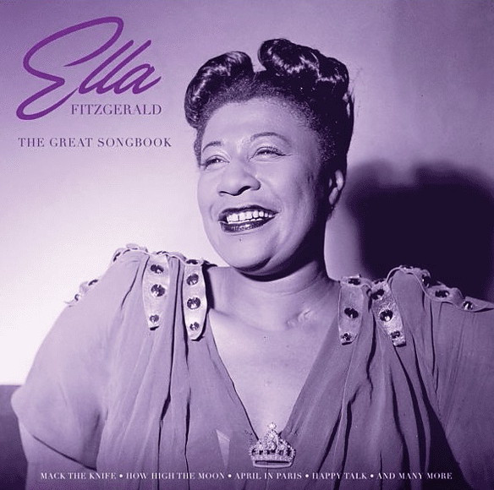

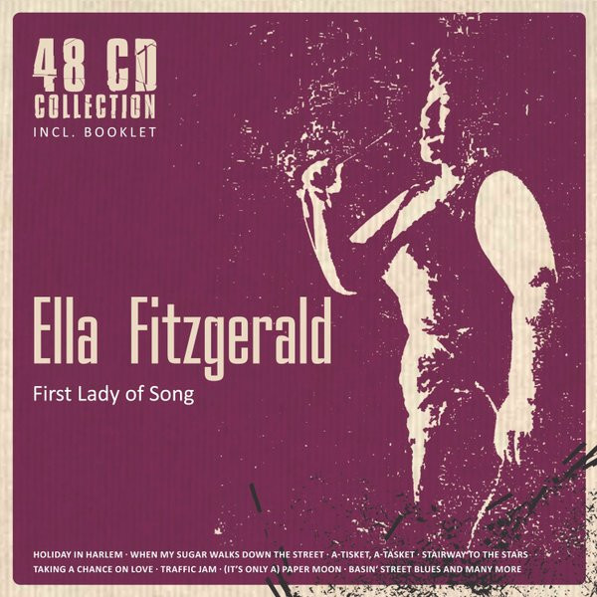

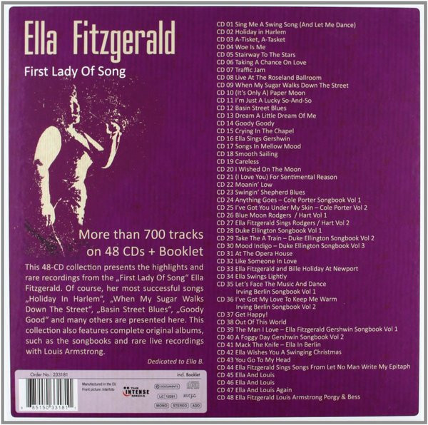

Ella Fitzgerald – First Lady Of Song (2012, CD) - Discogs

