The Enthusiast

The New York Times: In Praise of Karel Capek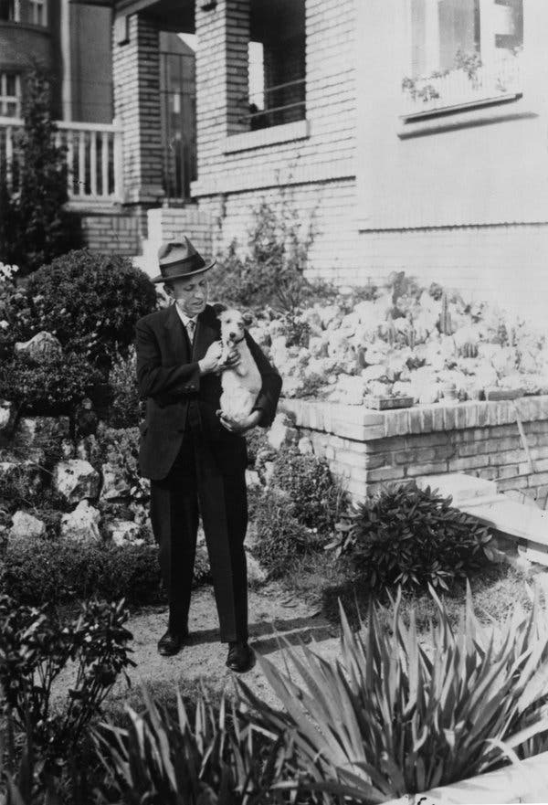
Karel Capek in the garden of his villa in Prague, with his fox terrier Dasenka, circa 1933.Credit...Keystone/Hulton Archive, via Getty Images

By Ben Dolnick
August 16, 2018

Two things keep Karel Capek’s “War With the Newts” from getting the recognition it deserves: its cover and its title. The best translation’s cover design, black text on teal, has all the panache of a dishwasher manual. And the title evokes spacesuit-clad heroes racing around cheap sets, firing laser guns at unscary animatronic lizards.
Forget all that.
Image
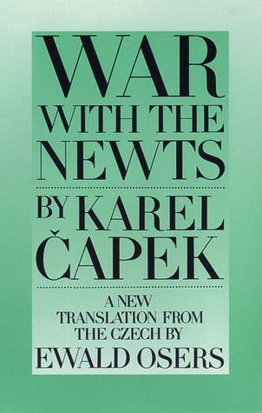

“War With the Newts,” published in 1936, is a funny, bizarre, dystopian masterpiece, and Capek deserves a place on the Mount Rushmore of authorial seers, right alongside George Orwell, Aldous Huxley and Margaret Atwood. To the extent that Capek is remembered today, it is largely by crossword puzzlers who know that he invented the word “robot” (and even this is dubious: Capek credits the term to his brother).
The book starts out on a remote island in the Indian Ocean, where a dissolute sea captain named Van Toch discovers a race of large and oddly intelligent newts. They stand about 4 feet tall, have small and dexterous hands, and, most important, eat oysters. That means, for Van Toch’s purposes: easy access to pearls.

So Van Toch makes a bargain with the newts. He’ll teach them how to use knives to open shells; they’ll make him a fortune in pearls. This works brilliantly, until it doesn’t. The newts begin using spear guns to defend themselves from sharks. They learn to speak. They reveal an unexpected aptitude for dam-building. The rest of the novel unfolds like one of those YouTube videos in which someone has arranged 10,000 dominoes in his garage: You watch the progress with a mixture of awe and trepidation.

Capek, who was Czech, wrote the book in the 1930s, so you might reasonably conclude — watching the newts sweep to global power — that he had fascism on his mind. He was in fact an avowed anti-fascist — in his politics, and in his funny, rueful war-weariness, he belongs to the lineage of Joseph Heller and Kurt Vonnegut.
But what makes “War With the Newts” so extraordinary is how it resists tethering itself to any particular allegorical scheme. Are the newts Nazis? (As they run out of coastal land, they encroach ever farther into human territory, bearing torpedoes.) Are they victims of capitalism? (Before overthrowing the humans, they’re traded as commodities, conscripted for undersea construction projects.)
Capek understands that few things make readers’ hearts droop quite like the realization that they’re trapped inside a too-tidy allegory. Aslan is Christ, the pig is Stalin, and suddenly we are vaulted out of the world of the story and into the writer’s office, where we have no choice but to contemplate his intentions.

Capek avoids all this by returning relentlessly to the newts, in all their hideous particularity. These are not dream-newts, or metaphor-newts. They are newt-newts. They stink, especially when their water needs changing. Their skin is oily. They get sick all the time.

Capek’s books have an eerie resonance, a worrisome sense of never-expiring relevance.
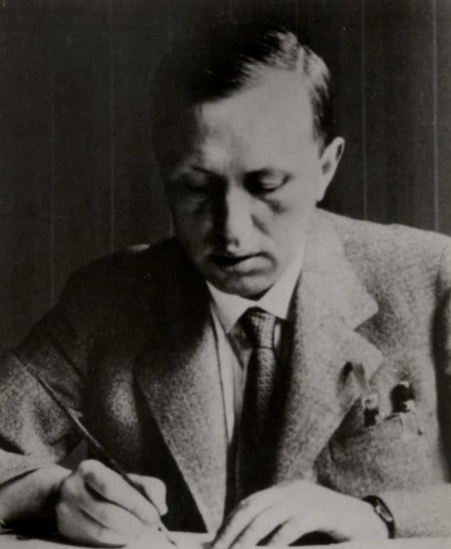
And so the novel follows its own dictates, creates its own history. Capek is less concerned with what any particular group of humans have done than simply with what humans do. This gives the book an eerie resonance, a worrisome sense of never-expiring relevance. On previous readings it has seemed to me a book about animal rights. This time it read like an extended warning about artificial intelligence.
Another thing about that reading experience: “War With the Newts” may be the most strangely told novel I’ve ever read. It has a bouncy, slangy narrator who pops up regularly, but it consists mainly of primary documents: newspaper stories, minutes from a shareholders’ meeting, scientific papers. This occasionally slows the book’s narrative engine — someone will have to tell me what the half page of untranslated Japanese on page 168 contributes to the proceedings — but it also lends it a length-belying heft. By the end you feel less like you’ve read a novel than like you’ve been visited by a harried time-traveler bearing an overloaded thumb drive. Look at all this stuff that’s going to happen!
And so we close the book feeling just like a certain Mr. Povondra, who is, I’ve always believed, the novel’s secret heart. He’s a lowly doorman who happens, early on, to let Captain Van Toch in to speak with his businessman boss — one small domino in the sea of dominoes. But Povondra takes inordinate pride in having played a role in history — and we watch, over the course of the book, as that pride curdles into shame and then horror.
This is the power of “War With the Newts,” and why it deserves to be read so long as there is dry land upon which books are printed. It leaves us staring with bewilderment at the ways that we — with our tiny acts of greed and insensitivity and willful blindness (how exactly did that package of T-shirts come to cost $7.99? Oh forget it, grab two) — did all this. How our humble flaws could have contributed to the kinds of evils, the epic disasters, that we read about in history books. We thought the newts needed knives. We only taught them a few words. It all made perfect sense.

Karel Capek: A Starter Kit
Here’s a brief guide to the newt-free portions of Capek’s oeuvre.
‘The Gardener’s Year’
When he wasn’t dreaming up sci-fi dystopias, Capek was in the garden. This cheerful, exasperated journal is fun even for readers who don’t know a daisy from a dahlia.
‘R.U.R.’
Capek’s most popular work while he was alive (it’s where the word “robot” first appears), today it reads mostly like a rough draft of “War With the Newts.”
‘Hordubal/Meteor/An Ordinary Life’
A trilogy of philosophical novels in which Capek dabbles in detective fiction and unreliable narration. Warning: It makes “War With the Newts” read like a conventional potboiler.
‘The Absolute at Large’
Capek, in 1922, foresees a device that can produce unlimited cheap energy, with the small catch that it might just lead to a world-destroying global war.
‘The Cheat’
When he died in 1938, Capek was working on this bleak polyphonic novel about a half-crazed, compulsively plagiaristic composer.
Ben Dolnick is the author, most recently, of “The Ghost Notebooks.”

