|  |  |  |
| --- | --- | --- |
| **Original Welsh** | **Word-for-word Translation (trans. Wade Dowdell)** | **Poetic Translation (trans. Louis Flint Ceci)** |
| Ellis Evans (Hedd Wyn) 1887 - 1917  Rhyfel (War) | | |
| **Gwae fi fy myw mewn oes mor ddreng,**  **A Duw ar drai ar orwel pell;**  **O'i ôl mae dyn, yn deyrn a gwreng,**  **Yn codi ei awdurdod hell.**  **Pan deimlodd fyned ymaith Dduw**  **Cyfododd gledd i ladd ei frawd;**  **Mae sŵn yr ymladd ar ein clyw,**  **A'i gysgod ar fythynnod tlawd.**  **Mae'r hen delynau genid gynt**  **Ynghrog ar gangau'r helyg draw,**  **A gwaedd y bechgyn lond y gwynt,**  **A'u gwaed yn gymysg efo'r glaw.** | Woe is me that I live in an age so boorish*,  And God at ebb on a distant horizon;  After him, man, (both) lord and commoner,  Raising his ugly authority.  When he felt God's going away  He raised a sword to kill his brother;  The sound of battle is on our ear,  And its shadow on poor cottages.  The old harps that were played before are  Suspended on the branches of yonder willows,  And the scream of the boys filling the wind,  And their blood mixed with the rain.  *perverse/churlish/peevish/morose | Alas, this is an age so mean  That everyman is made a Lord,  For all authority's absurd  When God himself fades from the scene.  As quick as God is shown the door  Out come the cannons and the sword:  Hate on hate on brother poured  And scored the deepest on the poor.  The harps that once could help our pain  Hang silent, to the willows pinned.  The cry of battle fills the wind  And blood of lads--it falls like rain. |

**Hen Wlad fy Nhadau**(Land of my Fathers)   
  
**Cymraeg   
  
Mae hen wlad fy nhadau yn annwyl i mi   
Gwlad beirdd a chantorion enwogion o fri   
Ei gwrol ryfelwr, gwlad garwyr tra mad   
Tros ryddid collasant eu gwaed.   
  
Gwlad Gwlad,   
Pleidiol wyf i'm gwlad,   
Tra môr yn fur i'r bur hoff bau   
O bydded i'r hen iaith barhau**English:   
  
Land of my Fathers, O land of the free,   
A land of poets and minstrels, famed men.   
Her brave warriors, patriots much blessed,   
It was for freedom that they lost their blood.   
  
Wales! Wales!,   
I am devoted to my country.   
So long as the sea is a wall to this fair beautiful land,   
May the ancient language remain.

**Mi glywaf dyner lais**

Mi glywaf dyner lais

Yn galw arnaf fi

I ddod a golchi 'meiau i gyd

Yn afon Calfari.

Arglwydd, dyma fi

Ar dy alwad di,

Canna f'enaid yn y gwaed

A gaed ar Galfari.

I hear a gentle voice

Calling to me

To come and wash all my faults

In the river of Calvary.

Lord, here I am

At thy call,

Bleach my soul in the blood

Which flowed on Calvary.

**Yr Eneth gad ei Gwrthod**

Welsh ballade:

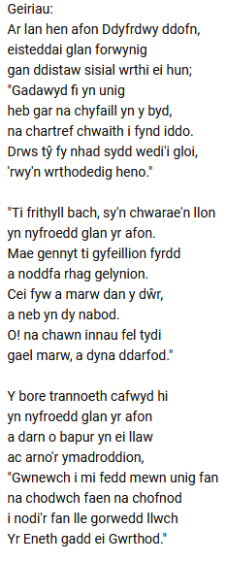 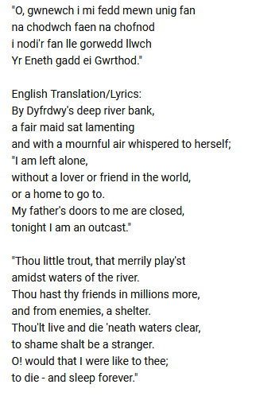

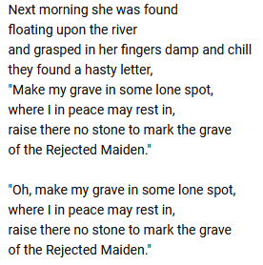

**Meic Stevens**

**(1942-)**

La la, la la la la la, la la la la la la la  
  
**O, mi wena'r haul yn y pwll glo**Oh, the sun is shining in the coal mine  
**Beth am botel o gwrw?**How about a bottle of beer?  
**O, mae gennai bres, ond mae'r mwg a tes**Oh, I've got money, but the smoke and haze  
**Yn troi pob un yn feddw**Is turning everyone woozy  
  
**Mor unig ar y llinyn tyn**So lonely on the taut line  
**Yn troedio'r eangderau**Treading the vastness  
  
**O, dim ond fi a'r brawd Houdini'n**Oh, only me and Houdini's brother  
**Cerdded lan i'r nefoedd**Walking up to the heavens  
  
La la, la la la la la, la la la la la la la (X2)  
  
**O, 'roedd y nos mor ddu ac mae brenin y dall**Oh, the night was so black and the king of the blind  
**Yn crawcian yn y bore**  
Is croaking in the morning  
**O, y dewin dwl ar y teleffon**  
Oh, the dim wizard on the telephone  
**Yn ceisio neud ei orau**  
Trying to do his best  
  
**A minau'n methu gweld tu fewn**And me who cannot see inside  
**Neu mas o'r byd a'i chwerthin**Or out of the world and its laughter  
  
**O, dim ond fi a'r brawd Houdini'n**  
Oh, only me and Houdini's brother  
**Cerdded lan i'r nefoedd**  
Walking up to the heavens  
  
La la, la la la la la, la la la la la la la