A Black Pearl of the Deep: Juraj Herz’s The Cremator
Adam Schofield

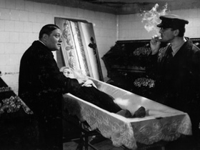
Director Juraj Herz was born on 4 September 1934 in Kežmarok, Czechoslovakia (now Slovakia). Interestingly, acclaimed Czech animator Jan Švankmajer was born on that very day.

http://www.sensesofcinema.com/2007/feature-articles/cremator-juraj-herz/

