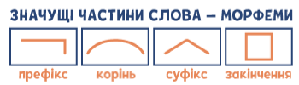

https://prirucka.ujc.cas.cz/?id=778

https://www.slideshare.net/slideshow/morfologie-254966346/254966346#8

https://dl1.cuni.cz/pluginfile.php/444557/mod_resource/content/0/Gramatick%C3%A9%20rozbory%20%C4%8De%C5%A1tiny_kapitola%20morfematiky.pdf

