Date:

Name:

Topic 1: Initiation of Carrot Callus Culture Daucus carota L.

The segments of various plant organs from many species of plants inoculated onto sufficient media form relatively undifferentiated tissue (callus) containing primarily clusters of parenchymatous cells. Rapid cell divisions appear especially on the segments consisting of the cells of primary or secondary meristem (shoot or root apical meristem, cambium, felogen). Differentiated mature cells produce callus to a less extent.
Material: Carrot roots (Daucus carota ssp. sativus (Hoffm.) Arcang.

Medium: 1D = MS solidified with 0.7% agar, 2,4-D (0.1 mg/l)

Procedures:
- Select typically shaped, clean, healthy and mechanically uninjured roots.
- Wash the roots with a brush and soap under running tap water.
- Disinfect 10 cm segments of the roots in aqueous solution of 20% commercial bleach SAVO (v/v) by agitation for 20 min.
- Rinse 3 times for 3 minute in sterile distilled water.
- Transfer the segments into a sterile Petri dish in a flow hood.
- Cut 1 cm of each cutting surface of the segment off and discard. Transfer the remaining section into a sterile Petri dish.

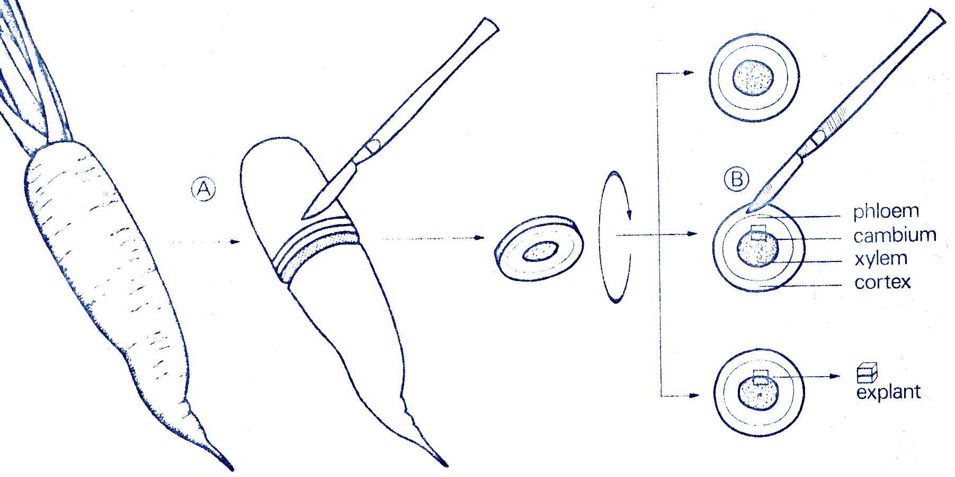
- Cut the transverse 2- mm- thick section of the root segments and excise uniform 5x5 cm pieces with cambium in a central part of a section. Close the top of Petri dish after each manipulation of the root segments.
- Pass the closure and the opening of the test tube through the flame. Place four explants with basal cutting part of segment in contact with agar media D1 (M-S, 2% sucrose, 0.1 mg/l 2, 4-D, 0.7% agar) into the tube.
- Each student will prepare 20 explants. Dip a scalpel and a forceps into the jar containing the 96% ethanol after each manipulation and pass the tip of tools through the flame repeatedly
- After inoculation pass the opening of a test tube through flame, cover with aluminium foil and pass through the flame again.
- Record the number of segments in a tube and number of test tubes.
- Transfer the test tubes into a thermostat and cultivate in dark at 25°C.

Evaluation:
Control contamination of the cultures in the following cultivation period and evaluate frequency of the segments with proliferating callus.

Topic 2: Subculture of callus culture of carrot Daucus carota L.
After 4 weeks the explants should produce large callus. Each explants with proliferating callus divide to two or three 5 x 5 mm segments, remove the necrotic brown - coloured tissue of the lower layer of the explants and transfer each segment into a fresh medium.

Procedure:
- Transfer the cultures from a thermostat to a flow hood.
- Pass the closure and the opening of a test tube through flame.
- Transfer the explants into a sterile Petri dish.
- Cut the segments to 2 – 3 sections and place them into the test tube containing fresh medium.
- Pass the opening of the test tube through flame and cover with aluminium foil.

Procedure | Days
Isolation of fresh root explants | 0
The first subculture | 28
The large proliferation | 42 – 48
Isolation of proliferating callus | 91 – 98
Subculture period | 4 weeks

Results:
Record the details of experiment to the protocols – the date of initiation of callus culture, the number of explants, the number of cultures, the frequency of contamination, the used procedures. Observe the cultures in a week interval and record the changes in morphology of explants.

Questions:
- What tissue of primary explants is a source of callus?
- Do you observe the equally growth of the explants? Why do the explants develop differently? Explain.

Literature:
Reinert J. et Yeoman M.M. (1982) Plant Cell and Tissue Culture. – Springer-Verlag, Berlin.

