
SEISMIC ALERT: OFF WEST COAST OF NORTHERN SUMATRA 26 DEC 2004 00:58 UTC MAGNITUDE 9.0
Devastating tsunamis have swept across the Indian Ocean triggered by a magnitude 9.0 earthquake. Latest reports indicate that at least 123,000 people have been killed. Affected areas include Thailand, Sri Lanka and other coastal areas of the Bay of Bengal, which have all reported wide scale damage and deaths. The USGS Earthquake Information Centre gives the following parameters for the earthquake location and magnitude.
DATE : 26 December 2004
ORIGIN TIME : 00:58 53 s UTC
LAT/LONG : 3.267° North / 95.821° East
DEPTH : 10 km
MAGNITUDE : 9.0
LOCALITY : 255 km SSE of Banda Aceh, Northern Sumatra
The earthquake occurred as a result of the convergence of the Indian and Asian tectonic plates, with the Indian plate moving approximately northeast at a rate of around 6 cm per year at an oblique angle to the Java Trench. As the Indian plate is subducted, this creates a thrust zone along the plate boundary. This thrusting motion along the interface between the two plates generated the earthquake.
The aftershock zone extends from Northern Sumatra to the Andaman Islands, some 1000 km to the north. This zone delineates the length of mainshock rupture. The width of the rupture zone is approximately 100 km and the maximum slip is approximately 20 m. The largest aftershock was magnitude 7.1 in the Nicobar Islands at 04:21 UTC on 26 December.
This is the largest earthquake in the world since a magnitude 9.2 earthquake struck Alaska in 1964 at Prince William Sound. Similar great earthquakes struck in Chile 1960 (magnitude 9.4) and Alaska 1957 (magnitude 9.1).
The devastating tsunami was a direct consequence of the earthquake, which caused movement of the seafloor all along the length of rupture, displacing a huge volume of water and generating the tsunami wave. The vertical uplift could have been as much as several metres. In the open ocean tsunami waves move very rapidly, 300-500km/hour (about the speed of a jet airliner) and are often very small (a few cms). As the wave approaches the coast it slows down and grows in height so that it can be many metres high when it strikes the coast.
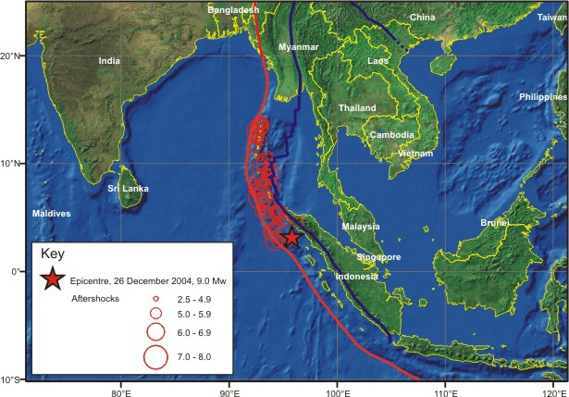 |  |  | 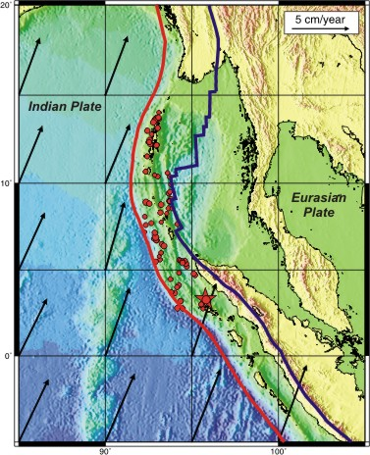
Above: The epicentre of the 26 December 2004 earthquake, marked by the star, along with over 70 associated aftershocks, marked by red circles, showing the approximate length of the rupture zone. The red line shows the plate boundary between the Indian and Asian plates. | kkkkk |  | Above: Direction of motion of the Indian Plate relative to Eurasia. The length of the arrows shows the rate of convergence.
Click here to see seismograms of the earthquake as recorded on BGS seismometers in the UK.
Click here to see the historical and instrumental seismicity of Northern Sumatra.
Tsunami & Earthquake Information Websites:
Latest News: |  | Tourist Videos & Satellite Images:
BBC News Online | SKY News | Photos & Videos
ITN News | CNN News | Satellite Images
General Tsunami Information: |  | Tsunami Information Specific to Bay of Bengal Event:
International Tsunami Information Centre |  | ITSU - Tsunami Animation
Tsunami Community |  | Tsunami Laboratory
NERC - The Tsunami Risks Project |  | PMEL Tsunami Research Programme
Tsunami Information for Children |  | University of Tokyo Earthquake Research Institute
University of Southern California Tsunami Reasearch Group |  | Tsunami Animation from Ocean Engineering Research Centre Turkey
Pacific Tsunami Museum
NOAA Tsunami Research Program
Australian Government Tsunami Information
The 1883 Krakatau Tsunami
Useful Booklet Explaining Tsunamis
Issued 31 December 2004

