Environment Here are some statements about the environment. Can you identify the authors? What is your opinion?

Environmentalism is a religion that is based more on political ambitions than science.
Communism has been replaced by the threat of an ambitious environmentalism.

Resources would be better spent investing in ending hunger and disease in developing countries than on climate change projects.

Our world faces a true planetary emergency.

Freezing carbon emissions would harm Americans and lead to "no new industry, no new people and no new cars".

Bjorn Lomborg, Director of the Danish Environmental Assessment Institute
Al Gore, former US vice-president
Joe Barton, the leading Republican on the House Energy and Commerce Committee
Václav Klaus

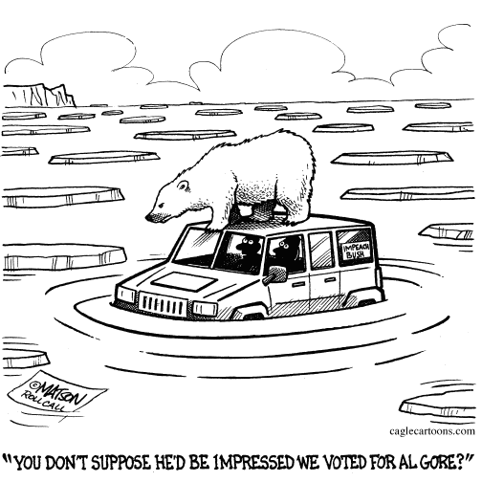

The Intergovernmental Panel on Climate Change (IPCC), February 2007, Paris. What do you know about the event? What are the findings?

Global climate change is "very likely" to have a human cause, an influential group of scientists has concluded.

Below you will find the key findings from Paris. However, the expressions of probability are omitted. First try to identify the probability of occurrence as defined in the IPCC Report.

more than 99%
more than 95%
more than 90%
more than 60%
more than 50%
less than 33%
less than 10%
less than 5%
very unlikely
extremely likely
more likely than not
very likely
likely
unlikely
virtually certain
extremely unlikely

adjectives: probable – improbable, possible - impossible

Now complete the statements from the IPCC Report with some of these expressions:

- It is ............................ that human activities are causing global warming temperature rise by the end of the century will be between 1.8C and 4C (3.2-7.2F)

- ............................ temperature rise by the end of the century will be between 1.8C and 4C (3.2-7.2F)
- ............................ temperature rise by the end of the century ranges between 1.1C and 6.4C (2-11.5F)
- Sea levels are ............................ to rise by 28-43cm
- Arctic summer sea ice is ............................ to disappear in second half of century
- It is ............................that parts of the world will see an increase in the number of heatwaves
- Climate change is ............................ to lead to increased intensity of tropical storms

C. The Article: Big Rise of CO₂

Available at http://www.bbc.co.uk/worldservice/learningenglish/newsenglish/witn/2006/03/060315_co2.shtml

1. Vocabulary Building: Match the words correctly with the definitions.

key | to watch
global warming | governments begin to follow the rules of the agreement
to monitor | the increase of the world's temperature
level | to be what is expected
that's a record | to have said for a long time that something would be a problem or danger
to confirm a trend | amount
mankind | most important
Kyoto Treaty takes effect | the world's people
to curb | to limit
to have long warned about | it has never been so big, so fast, the best etc

2. Listening:

a) Comprehension I - Listen to the BBC piece of news and answer this question:

Scientists feel optimistic about the earth's future. True or false?

b) Gapfill - Listen again and fill in the gaps.

Learning English - Words in the News

15 March, 2006 - Published 14:51 GMT

Big rise in CO2

US climate scientists in Colorado have recorded a big rise in the amount of carbon dioxide in the world's atmosphere. Their research indicates that 2005 saw one of the largest increases ever recorded. David Shukman reports from Colorado:
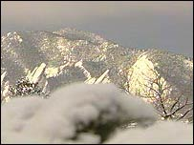
Air samples have been taken from the Rocky Mountains and other parts of the world

Carbon dioxide is seen as the key gas driving global warming so its level is monitored very closely. ………………… of air are gathered all over the world and sent here to Boulder in Colorado to the US government's global ………………………. project. Studies show that the level of carbon dioxide now stands at three hundred and eighty one ………... …… …………….. .That's a record, according to the researchers. It's the result of one of the largest annual increases for the past fifty years and it confirms a trend - that the …………. …… ………………… has doubled in the last thirty years. We asked the British government's chief scientist for his reaction. Sir David King says the new ………………. are worrying.
Today we're at three hundred and eighty parts per million, we're over three eighty parts a million. This is higher than the ………………. of carbon dioxide in our atmosphere for at least a million years, possibly for thirty million years. So mankind is changing the climate.
This sharp increase comes just as the Kyoto Treaty takes effect. It's meant to bring …………… ………………. down. The evidence of this new …………… is clear though - that efforts to curb the rise in greenhouse gases are, ………. ……… ………………….., failing, and the consequences that climate scientists have long warned about look far more likely.

c) Comprehension II: Are the following questions true or false? Read the text again and circle the correct
answer:

1. Carbon dioxide is an important indicator of how healthy the earth's atmosphere is. T/F

2. The level of carbon dioxide has never been higher than it is today. T/F

3. The increase this year was very unexpected. T/F

4. David King says that climate change is part of nature's cycle. T/F

5. The Kyoto agreement was signed and came into force in 1977. T/F

6. People are succeeding in trying to cut CO₂ levels. T/F

D. Follow-up activities: Take part in a short debate

You are going to take part in a short debate on climate change. The title
of the debate is: ‘Climate change – trivia or truth?’
(‘trivia’ means unimportant facts often used for entertainment)
Divide the into two equal groups, A and B. To prepare for the debate, students in group A have to agree the most powerful arguments they can think of for dealing with the problem of climate change. Students in group B have to agree the strongest arguments they can think of for discrediting the concept of climate change.

ARGUMENTS:

Advantages/disadvantages (Pros and cons)

It has both (its) advantages and disadvantages
One of the advantages / disadvantages of ... is ...
There are advantages / disadvantages to ... (-ing)
A further advantage (of) / problem (with) ... is ...
There are certain drawbacks
The (main) advantage / disadvantage of ... is ...
The (main) drawback (of) / problem (with) ... is
What are the advantages and disadvantages of ...

Different points of view are included
While it is true to say that ...
On the other hand, ...
It is not always the case that ...
On the contrary, ...
This (question) can be looked at from several points of view. Firstly ...
Opponents of ... take a very different view
It is often suggested that ...

This (problem) should be considered in relation to ...
It can be examined in terms of ...
... must be taken into account ...

Your own point of view
In my opinion
The first thing to be considered is ...
It is a fact that ...
There is no doubt that ...
I believe that (x I think)
One of the main arguments in favour X is that ...
against

Agreement
I agree with X when he writes that ...
says

Partial agreement
On the one hand ...... on the other hand
... but ...
... however ...

Emphatic agreement
X is certainly correct when he says that ...
I completely agree with X writes

Cautious agreement
X may be correct when he says that ... (is saying that)

Disagreement
I disagree with X when he says that ...

Contrast with what has preceded
instead in comparison
on the contrary on the other hand by contrast

Conclusions
in conclusion in brief overall thus
to conclude to summarize then finally
to sum up briefly altogether therefore in addition

