 | C₂O₄⁻ | Cl⁻ | Br⁻ | I⁻ | CrO₄²⁻ | Cr₂O₇²⁻ | SO₃²⁻ | SO₄²⁻ | NO₂⁻ | NO₃⁻ | PO₄³⁻ | HPO₄²⁻ | S₂O₃²⁻ | CO₃²⁻ | OH⁻ | AsO₄³⁻ | SCN⁻ | Fe(CN)₆⁴⁻ | Fe(CN)₆³⁻
Ag⁺ | 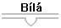 |  |  | 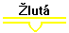 | 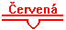 | 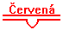 |  |  |  |  |  |  | 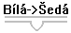 |  | 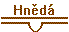 | 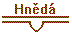 |  |  | 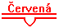
Pb²⁺ |  |  |  |  |  |  |  |  | ◉ Žlutá
Hg₂²⁺ |  | 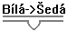 |  |  | 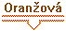 |  | 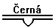 |  | 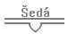 |  | 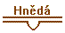 |  |  | 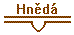 |  |  | 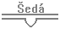 |  | 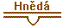
Hg²⁺
Cu²⁺ | 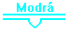 |  |  |  | 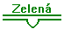 |  | 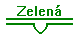 |  | ◉ Zelený |  |  |  |  |  | 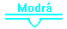 | 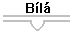 | ◉  Zelený | 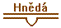 | 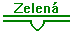
Bi³⁺ |  |  |  |  |  |  |  |  | ◉ Zelený |  |  |  |  | Uniká  plyn
Cd²⁺ |  |  |  |  |  |  |  |  |  |  |  |  |  |  |  | 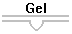
Sb³⁺ |  |  |  |  |  Zelený |  |  |  | ◉  Žlutá |  |  |  |  | Uniká  plyn
Al³⁺
Zn²⁺ |  |  |  |  |  |  |  |  |  |  |  |  |  |  |  |  |  |  | 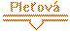
Cr³⁺ |  |  |  |  | 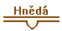 |  |  |  | ◉ Zelený |  | 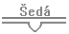 | 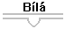 |  |  |  | ◉  Zelený
Mn²⁺ |  |  |  |  |  |  |  |  |  |  |  |  |  |  | 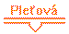 |  |  |  | 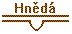
Fe²⁺ |  |  |  |  | 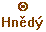 |  |  |  | 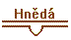 |  |  |  |  |  | 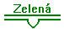 |  | ◉  Oranžový
Fe³⁺ | ◉ Zelený |  |  |  |  |  | ◉ Červená |  |  |  | 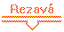 |  | ◉ červen | 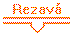 | 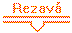 |  | ◉  Červený | 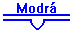 | ◉  Červený
Co²⁺ |  |  |  |  |  |  | 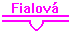 |  |  |  |  |  |  |  |  |  |  | 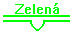 | 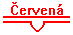
Ni²⁺ |  |  |  |  |  |  |  |  |  |  |  |  |  |  |  | 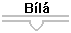
Ca²⁺
Sr²⁺
Ba²⁺
Mg²⁺
Na⁺
K⁺
NH₄⁺

