Osmometrie

Π = c . RT (Pa)

c_{m} = m/V, c = m/M_{r}V, c = c_{m}/M_{r}

Π = c_{m} . RT /M_{r}

Π/c_{m} = RT /M_{r}

Π/c_{m} = RT (1/M_{r} + B . c_{m})

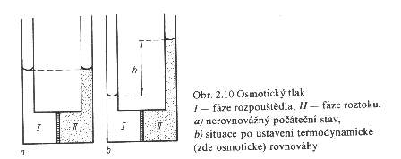

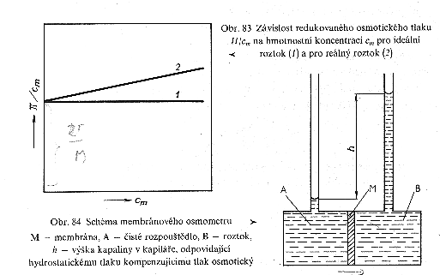

Π = h.ρ.g

