MALNUTRITION AND OBESITY

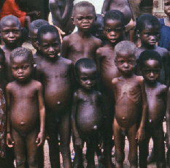

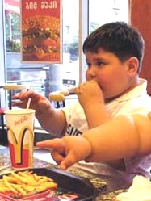

- Compare the two pictures. Work in pairs.
Everyone will talk for one minute. Try to keep talking; avoid any long gaps.

- What are the different ways that people can lose weight?

- Which one of these ideas is the most effective and why?

- Listen to the recording about people being overweight.
http://www.bbc.co.uk/worldservice/learningenglish/newsenglish/witn/2008/02/080220_obesity.shtml
Which of our ideas are mentioned in the text?

- Skim the text “Obesity epidemic” to check your answer.

How to skim the text:
Read the text ( 1-2’) to find the answer to the question. You do not need to understand the details of the text to answer it.

- Comprehension questions (T/F)
Complete Worksheet l to understand the text in more detail. Read the
text a second time in more detail and answer the questions. (5-6’)

- Vocabulary matching task – Worksheet 2
Match the words and phrases to their definitions.

- Discuss the following questions
What are some of the factors that contribute to the obesity problem in our society?

What is leptin, and what role does it play in weight gain?

What role does the melanocortin 4 receptor, or MC4R, play in obesity?

If someone asks you if obesity is genetic, how would you respond?

http://www.teachersdomain.org/resource/oer08.sci.life.gen.obesity/

Have you found the answers in the recording?

- Homework:
Gap-filling (IS)
Translate (IS)

