Problem Solution, Cause and Effect
(Based on Making Connections, K.J. Pakenham)

Introduction to problem-solution organization of the text

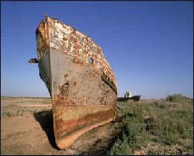
Writers often use a problem-solution type of organization for their texts. The ability
to identify the problem-solution method of text organization can help the reader
to read more effectively.
To be able to indicate the problem in the text, the writer may use vocabulary
that will help the reader recognize the problem-solution markers.

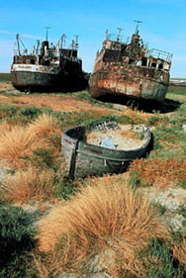
Look at the pictures and try to describe them using some of the problem-solution markers such as:
difficulty - crisis - obstacle - complication
danger - threat - concern - problem
- See the collocations of some of these words. Then write a few sentences about the problem.
Konec formuláře

Cause and Effect - word sets One way to remember your growing vocabulary is to group the new words into sets according to their meaning. All of the words below share the idea of causing something to happen.

reduce worsen raise
aggravate increase double
create cut restrict
halve lower set off

Group the verbs above into the following sets:

cause + START | cause + MORE | cause + LESS | cause + HARM

B. The Aral Sea Crisis

Today’s topic deals with the Aral Sea Crisis, which poses a big problem. Are you familiar with that crisis?
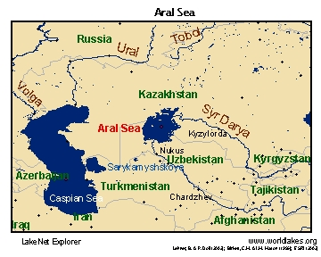
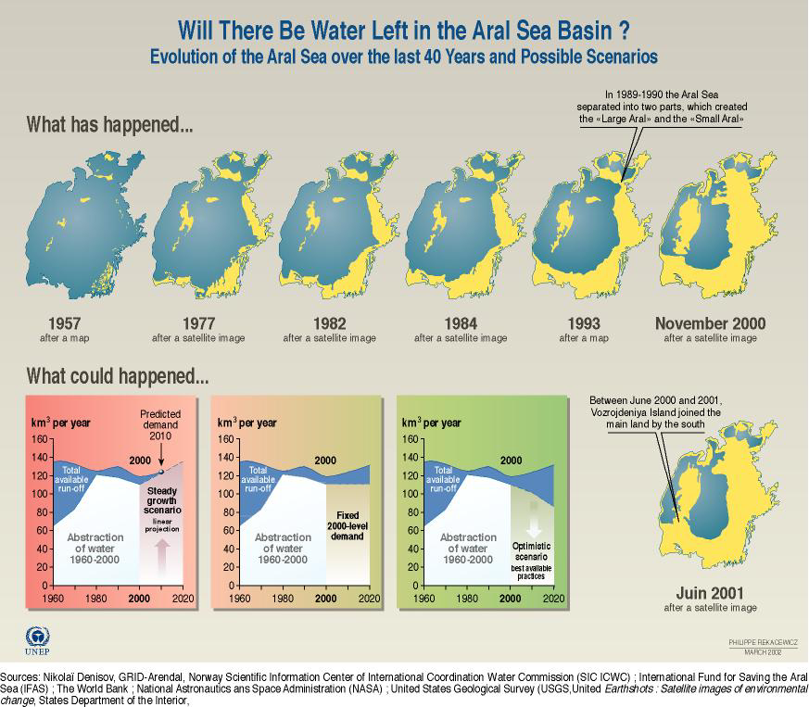

Match the words with their definitions.
irrigation, reclaim, cultivation, benefit, salinization, exploitation, drainage, leach, desiccate, salinity
the action of supplying land with water by means of channels or streams, or by sprinkling water over the surface of the ground to make an area of desert, wet land etc suitable for farming or building
the preparation and use of land for growing crops
an advantage, improvement, or help that you get from something
accumulation of salts in the soil
the development and use of minerals, forests, oil etc
the process or system by which water or waste liquid flows away
to remove a chemical or mineral from something such as soil as a result of water passing through it, or be removed by this process
the concentration of dissolved salts in water
to remove the moisture from, to dry up

Reading comprehension
Reading strategy:
- identify problem markers and solution markers
- use problem markers to identify passages containing problems
- use solution markers to identify passages containing solutions
- look for causes of problems
- look for the logical connection between the problem’s cause(s) and the suggested solutions(s)

Read Paragraph 1 of the text. In what part of an introduction are you likely to find the most help about the topic of the passage? Pay special attention to that part.

Read Paragraphs 2-3 of the text and write the main points.
before description of the region:

after description of the region:

Look at the pictures and identify the major changes in the Aral Sea area. You may find the following words helpful:

expand drop fall increase decrease reduce shrink
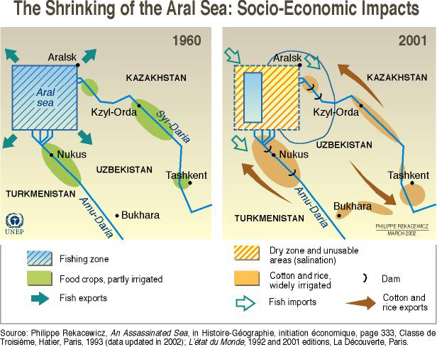
http://enrin.grida.no/aral/maps/aral.htm

Paragraphs 4-9: identify the environmental damage and the poorly planned human economic activity. Formulate the key ideas in a nominalized way (i.e. using noun forms in place of verbs, using the passive and avoiding personal pronouns. See the table).

the number of population has increased | increase of population
has decided | decision
are becoming aware | awareness
increasingly aware | increasing awareness
have suddenly emerged | the sudden emergence

- Match paragraphs with the main ideas.

- As a result of the chemical contamination of drinking water, there has been an increase in human health problems.
- The basic cause of the deterioration in the Aral Sea was the use of irrigation to expand agriculture.
- Short-sighted agricultural practices have increased levels of salt, pesticides, and other damaging substances in the environment.
- This paragraph gives physical details of the Aral Sea in 1950.
- The reduced flow of water into the Aral Sea has had disastrous consequences both for the sea and its basin.
- The story of the Aral Sea is one example of the global problem of desertification through human activities.
- This paragraph gives details of how the Aral Sea changed between 1950 and 1990.
- In 1990, a scientific conference decided that the Aral Sea region was an ecological disaster area in need of urgent action to prevent its complete destruction.
- The Aral Sea illustrates the massive ecological damage that can be caused by the careless economic development of a region.

Homework Complete the text referring to the satellite picture. Fill in the gaps with the correct form of the expressions (one or two words).
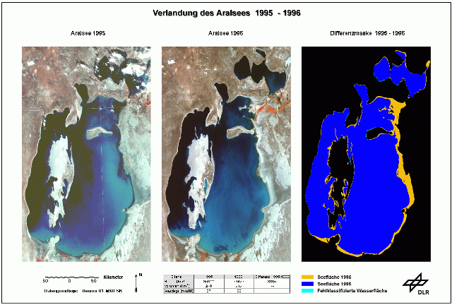

decrease, increase, level, salinity, fall dry, decline, volume, body,connect
The image shows the desiccation of the Aral sea in the years 1995 to 1996. Within only one year the area of the lake has by 3885 km2 and the by 36 km3. The sea level has decreased by another 1 m down to 36 m over Baltic sea The increased to 46 g/l (own measurement). The picture on the right side illustrates the desiccation process in one single data product. The remaining water body is shown in blue, whereas the yellow color shows the areas which have dry within one year. As the bathymetry of the Aral sea is especially shallow in the eastern parts of the lake, the desiccation process is very obvious there. Due to desiccation the remaining absolute water depth of the eastern water body has to 12 m, and of the steep western part down to 71 m. Since 1987 the lake has been into two separate water bodies, which can clearly be seen on the satellite images. Up to 1995 there was an artificial channel which enabled water exchange from the small Aral sea in the north to the large water In 1996 the distance between the two water bodies dramatically. Therefore, it is expected that it will be too expensive to keep up this connection between the two lakes.
1996 was the first year that the island "Barsakelmes" in the center of the lake was to the shoreline. The large island will connect with the south shoreline within the next 4-5 years, which will basically separate the steep western part from the shallow eastern part.
The desiccation process has been monitored since 1984 with NOAA-AVHRR data. Since 1995 the Russian Resurs-01 MSU-SK scanner has been utilized for this purpose due to its better geometric resolution.
http://www.dfd.dlr.de/app/land/aralsee/monitor.html

Design a diagram representing the process of environmental degradation in the region surrounding the Aral Sea. Stick the strips of paper on a poster, connect the ideas with arrows (flow chart).

Sources: Pakenham, J. Making Connections, CUP, 1998
www.grida.no/db/maps/ water/30-aral%20sea.jpg
http://www.dfd.dlr.de/app/land/aralsee/monitor.html

Listening comprehension:

Liten to the recording and complete the text:
http://www.voanews.com/english/archive/2005-03/2005-03-18-voa49.cfm (timing 3:35-end)
Elsewhere, the Aral Sea, once the fourth-largest ............................. body of water in the world, is also under dire threat. But unlike the Caspian, its problems stem from ............................. .
Up until the early 1950s, the Aral Sea area was designated by the former Soviet Union as a region that would provide independence from the West. But when central planners decided to ............................. large amounts of water from the rivers feeding the Aral for crop irrigation, the once ............................. sea shrank.
It continues to do so today at a rate scientists say is even faster than previously thought. The ............................. effects are enormous, according to the Moscow campaigner for the environmental group Greenpeace in Russia, Alexei Kiselyov.
"Its ............................. problems caused by pollution,” he noted. “First of all by salt, and some chemicals like pesticides which are everywhere there... in water, in dust, in soil and sand. So, people everywhere, especially kids, have huge health problems."
Mr. Kiselyov notes that the child ............................. ............................. around the Aral Sea are reported to be the highest in the former Soviet Union. There is also a high level of ............................. death, and diseases such as tuberculosis, typhus, and hepatitis have been noted. Blood, ............................., and heart disease are also on the rise.
Now known as one of the greatest man-made natural ............................. in the world, Mr. Kiselyov says Greenpeace believes the solution to the Aral Sea problem may lie with the public at large.
"It is possible for every citizen to push your [their] small company ............................. the part of the river [feeding into the Aral Sea] to change the situation, or to change ............................. .............................. I mostly believe in people's force, rather than in government," he added.
Mr. Kiselyov also subscribes to the view that money helps. But he says he personally does not believe the countries ............................. the Aral, Kazakhstan and Uzbekistan, will manage to raise the money needed, even with international support Ultimately, he says the Aral Sea is ............................. ............................. disappear.
Peter Zavialov of the Shirshov Institute of Oceanology in Moscow holds a more optimistic view. He told VOA more study is needed.
Mr. Zavialov says any ............................. with an ecosystem, especially if it is a water ecosystem, has to be ............................. examined. This was not the case with the Aral Sea, he adds, and the results speak for themselves.
Začátek formuláře
Konec formuláře
McAdams, Lisa: Aral, Caspian Seas Remain Under Ecological Threat ,Moscow18 March 2005
Article: The Aral Sea Crisis

- For many decades, environmental scientists have been warning us that immense damage can be caused to the ecology of a given region by pressure for economic development and by apparently reasonable, but in reality short-sighted, responses to this pressure. The damage will not only negate any economic progress the region might have experienced but also has the potential to make the region unlivable. The story of the Aral Sea, described in an article in Environment magazine by V. M. Kotlyakov, a Soviet geographer, is a clear example of the damage that poorly planned human economic activity can have on the environment.

- The Aral Sea is located in a semi-arid region of south-central Asia, close to the former Soviet republics of Karakalpakia, Kazakhstan, Uzbekistan, Turkmenia, and Tajikistan (see Figure 1). As recently as the 1950s, the sea covered an area of sixty-six thousand square kilometers, with a mean depth of sixteen meters. Its waters were fresh, with a mean salinity (salt content) of 1 percent to 1.1 percent. Two large rivers, the Amu Darya and the Syr Darya, flow into the sea. The water from the two rivers, plus the annual rainfall, maintained the volume and level of water in the sea.

- By 1990, however, the Aral Sea had shrunk to about 55 percent of its original area and had become two separate lakes; its total water volume had dropped to less than one-third of its 1950s volume. The salt content of the sea, on the other hand, had in-creased by almost 300 percent.

- The root cause of these massive changes in the physical character of the Aral Sea was the decision, made in the late 1950s, to develop agriculture by using water from the Amu Darya and the Syr Darya rivers for irrigation. Since the early 1960s, the area of irrigated agricultural land has expanded rapidly, an expansion that has reduced the flow of water into the Aral Sea to approx-imately 13 percent of its pre-1960 total.

- The consequences of this reduction in water flow have been catastrophic for the area surrounding the Aral Sea. Whole species of fish have died out, and commercial fishing, which used to be a productive economic activity, has practically stopped. Without the moderating influence of the vast expanse of the original sea, the climate of the territory within one hundred to two hundred kilometers of the sea has become more extreme. Rainfall has decreased, while summers have become shorter and warmer. As a result, there are no longer enough frost-free days in the year for growing cotton, once the main crop of the Amu Darya delta. In addition, as the water level has dropped, the forests on either side of the Amu Darya river have dried up, causing the loss of about half of the region's bird and mammal species. Another problem is that salt from the exposed sea bed is spread by storms on the surrounding land, increasing its salt content and reducing its fertility.

- The impact of recent attempts at economic development on the ecology of the region, however, is not restricted to the consequences of the falling water levels in the Aral Sea and its two main rivers. Inefficient methods of irrigation allow much of the water to evaporate, causing crop-damaging salts to accumu-late in the soil. Then farmers use more water to wash these salts out of the soil; the salts enter into the rivers where they ultimately increase the salinization of areas downstream and the Aral Sea itself. Other agricultural practices in the irrigated land include the extensive use of artificial fertilizers and chemical pesticides to support production of the two main crops, rice and cotton. As a result, the water that ultimately drains back into the Amu Darya and the Syr Darya from the fields also carries high concentrations of phos-phates and nitrates, as well as chemical pesticides.

- The accumulation of these toxic chemicals in the rivers is now contaminating local supplies of drinking water. As a result, in the years since 1975, people living in the area have begun to suffer increasingly from a number of serious health problems. As is often the case with environmentally linked illness, infants and children are the most vulnerable. In the city of Karalpakia, for example, the 1989 mortality rate for children was among the highest in the
world.

- In 1990, a conference of international scientists met to consider "the Aral crisis." The scientists concluded that the Aral region was already an ecological disaster area and that massive changes in agricultural policy and practices were urgently needed to reverse the process of environmental destruction. If such measures were not taken without delay, the Aral basin would become a wasteland, incapable of supporting the human settlements and activities it once supported.

- The case of the Aral Sea and its basin is not unique; it is so merely one
example of the process of anthropogenic desertification, the conversion of agricultural land to desert by environmentally destructive human activities. This is a global problem. Indeed the United Nations Environment Program estimates that about 60 percent of all agricultural land in drier regions may be affected to some degree by desertification. Salinization, for example, threatens 20 percent of all irrigated land in the United States. The Aral crisis, therefore, offers a clear warning of the dangers of poorly planned economic development. It also offers an opportunity to gather information needed in the search for solutions and alternative models of economic development.

Source: K.J. Pakenham: Making Connections, CUP, 1998

PROBLEM - SOLUTION COLLOCATIONS
source: Longman on-line
Problem  have a problem big/serious/major problem  cause a problem  deal with/sort out a problem  solve/fix/overcome a problem  address/tackle a problem  pose/present a problem  a problem arises/occurs/comes up (=it happens)  economic/financial problems | Issue  subject/problem [countable] a subject or problem that is often discussed or argued about, especially a social or political matter that affects the interests of a lot of people  the issue of something  raise an issue (=say that an issue should be discussed)  address an issue (=discuss or deal with an issue)  resolve an issue  avoid/dodge/duck/evade an issue (=avoid discussing an issue)  confuse/cloud an issue (=make an issue more difficult by talking about things not related to it) important/key/major/big issue  thorny/vexed issue (=difficult issue)  complex issue  sensitive issue  political/social/economic/environmental issues  something is not the issue spoken (=used to say that something is not the important part of what you are discussing)  Abortion is a highly controversial issue.  We should raise the issue of discrimination with the council.  Dillon addressed the issue of child abuse in his speech.  How the issue is resolved is crucial.  When asked about the bill, the senator tried to duck the issue.  They're clouding the issue with uninformed judgements.  The key issue is whether workers should be classified as 'employees'.  the thorny issue of creating a single European currency  Economic issues should get more attention.  Unemployment is not the issue - the real problem is the decline in public morality.
Crisis
economic/financial/political crisis
deal with/handle a crisis
energy/oil/housing crisis
debt/budget crisis
a crisis erupts/arises
a major/severe crisis
resolve/solve/defuse a crisis
avert a crisis in/during
a crisis be in crisis
crisis management (=dealing with a crisis)

Threat
The fighting is a major threat to stability in the region.
present/pose a threat (to somebody/something)
Pollution poses a threat to fish.
Concern – (worry) [uncountable] a feeling of worry about something important:
The recent rise in crime is a matter of considerable public concern.
concern for
our concern for human rights
concern about/over/with
the rise of concern about the environment
the growing concern over inflation
concern with worsening law and order
concern that
increased concern that the war could continue for a long time
be a cause for concern/cause concern

NOMINALIZATION

irrigation has been greatly intensified.

the irrigated area in the Aral sea region increased

the water demand for agricultural use increased
The discharge to the Aral sea by the two rivers dropped from originally 60 km/a³ to almost 0 km/a³.

salt has accumulated due to evaporation

solonchaks have developed

the water evaporates completely unused.

increased salinity

the sea level has decreased

the salinity increased to 46 g/l

the eastern water body has declined to 12 m

The desiccation process has been monitored since 1984.

Since 1960 the two rivers have been heavily exploited for the irrigation

the Aral sea has lost more than 50% of its former area

