STEM CELLS

Thinking point
"The richer we are, the longer we live. The longer we live the more expensive it is to take care about diseases as we get older." Alan Russell
Any solution?

Listening: Alan Russell: Why can't we grow new body parts? (lecture)
http://www.ted.com/index.php/talks/alan_russell_on_regenerating_our_bodies.html

  - What is the outline of the lecture? (key points) (timing 0-1:03)
1)
+list the debilitating diseases
2)
3)
4)
5)

debilitating - weakening, or reducing the strength of
spike - an abrupt increase or rise: a chart showing a spike of unusual activity in the stock market
aging/ageing
health care plot. debilitating asi incurable
hurdle - a difficult problem to be overcome; obstacle

- Regenerative medicine
  - What is it?
How to ameliorate symptoms with devices and drugs or how to regenerate the lost function of the body by regeneration the function of organs and damaged tissues? (→2:20)

  - Complete the definition with the words in a correct form repair, induce, differenciate, destroy
"A treatment in which stem cells are ______________ to ______________ into the specific cell type required to ______________ damaged or ______________ cell populations or tissues."

- Complete the text with the following words:
damaged, healthy, based, single, medicine, discoveries, stem, questions, organisms, disease
Research on cells is advancing knowledge about how an organism develops from a cell and how cells replace cells in adult . This promising area of science is also leading scientists to investigate the possibility of cell- therapies to treat , which is often referred to as regenerative or reparative . Stem cells are one of the most fascinating areas of biology today. But like many expanding fields of scientific inquiry, research on stem cells raises scientific as rapidly as it generates new . http://stemcells.nih.gov

- Here are some questions. Do you know the answers?
- What are stem cells?
- What different types of stem cells exist?
- What is the potential for new medical treatments using stem cells?

- Now scan the text on stem cells and find the answers.

What are stem cells, and why are they important?
Stem cell: One of the human body's master cells, with the ability to grow into any body's more than 200 cell types.
All stem cells are unspecialized (undifferentiated) cells that are characteristically of the same family type (lineage). They retain the ability to divide throughout life and give rise to cells that can become highly specialized and take the place of cells that die or are lost.
Stem cells contribute to the body's ability to renew and repair its tissues. Unlike mature cells, which are permanently committed to their fate, stem cells can both renew themselves as well as create new cells of whatever tissue they belong to (and other tissues). http://www.medterms.com

- Read the text Human Embryonic Stem Cell and then describe the chart below.
Human embryonic stem cell (hESCs) Also known as a human pluripotent stem cell, one of the cells that are self-replicating, are derived from human embryos or human fetal tissue, and are known to develop into cells and tissues of the three primary germ layers. Although human pluripotent stem cells may be derived from embryos or fetal tissue, such stem cells are not themselves embryos
"Self-replicating" means the cell can divide and to form cells indistinguishable from it. The "three primary germ layers" -- called the ectoderm, mesoderm, and endoderm -- are the primary layers of cells in the embryo from which all tissues and organs develop. http://www.medterms.com
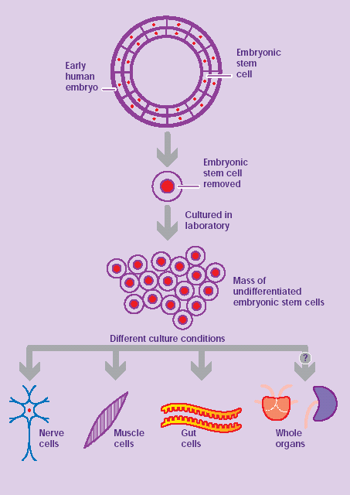
- Read the text on Adult Stem Cell and then describe the chart below.

An adult (somatic) stem cell is an undifferentiated cell found among differentiated cells in a tissue or organ that can renew itself and can differentiate to yield some or all of the major specialized cell types of the tissue or organ. The primary roles of adult stem cells in a living organism are to maintain and repair the tissue in which they are found. Scientists also use the term somatic stem cell instead of adult stem cell, where somatic refers to cells of the body. Unlike embryonic stem cells, which are defined by their origin (the inner cell mass of the blastocyst), the origin of adult stem cells in some mature tissues is still under investigation.
http://stemcells.nih.gov/info/basics/basics4.asp

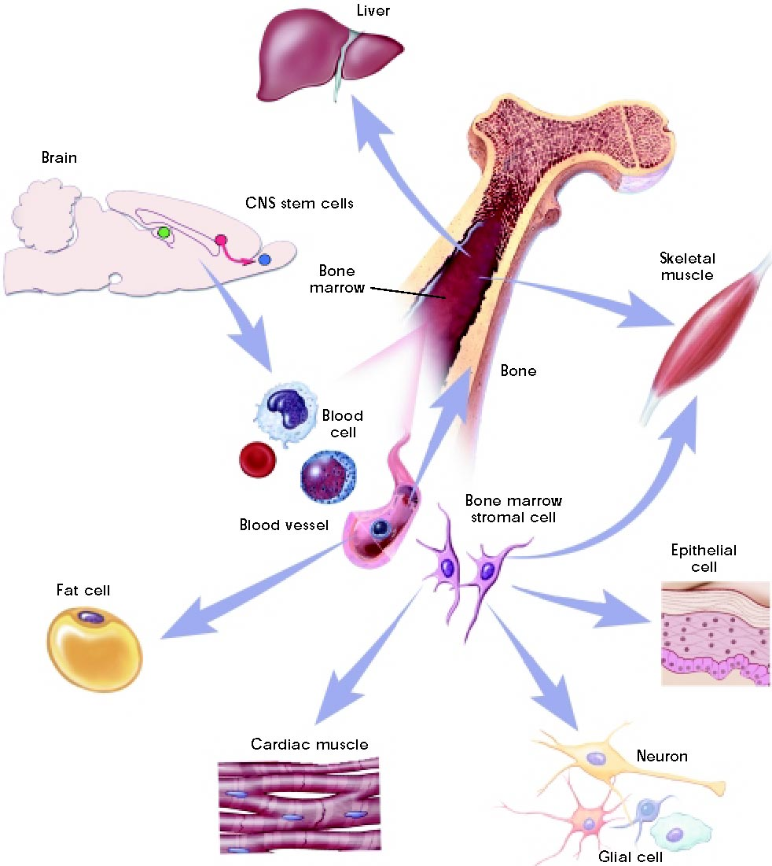

What are the similarities and differences between embryonic and adult stem cells? Read the text and complete the table below.
Human embryonic and adult stem cells each have advantages and disadvantages regarding potential use for cell-based regenerative therapies. One major difference between adult and embryonic stem cells is their different abilities in the number and type of differentiated cell types they can become. Embryonic stem cells can become all cell types of the body because they are pluripotent. Adult stem cells are thought to be limited to differentiating into different cell types of their tissue of origin.
Embryonic stem cells can be grown relatively easily in culture. Adult stem cells are rare in mature tissues, so isolating these cells from an adult tissue is challenging, and methods to expand their numbers in cell culture have not yet been worked out. This is an important distinction, as large numbers of cells are needed for stem cell replacement therapies.
Scientists believe that tissues derived from embryonic and adult stem cells may differ in the likelihood of being rejected after transplantation. We don't yet know whether tissues derived from embryonic stem cells would cause transplant rejection, since the first phase 1 clinical trial testing the safety of cells derived from hESCS has only recently been approved by the United States Food and Drug Administration (FDA).
Adult stem cells, and tissues derived from them, are currently believed less likely to initiate rejection after transplantation. This is because a patient's own cells could be expanded in culture, coaxed into assuming a specific cell type (differentiation), and then reintroduced into the patient. The use of adult stem cells and tissues derived from the patient's own adult stem cells would mean that the cells are less likely to be rejected by the immune system. This represents a significant advantage, as immune rejection can be circumvented only by continuous administration of immunosuppressive drugs, and the drugs themselves may cause deleterious side effects. http://stemcells.nih.gov/info/basics/basics4.asp
 | SIMILARITIES | DIFFERENCES
EMBRYONIC STEM CELLS
ADULT STEM CELLS

Watch the animation http://www.sumanasinc.com/webcontent/animations/content/stemcells_scnt.html

