Introduction
The dolichoderinae ant Liometopum microcephalum (Panzer, 1798) is the only species of this genus living in Europe (Schlaghamerský & Omelková 2007). It is arboricolous, thermophilous and lives predominantly in floodplains (forests and open landscape) (Omelková et al. 2005). Nests are built in trunks of old trees, mainly oaks, but also in limes, alders, elms, rarely in willows and horse-chestnuts (Omelková 2005). Usually the nest is located several metres above ground. Dead or almost dead trees are abandoned. Thus the species requires that are still vital but old and large enough to have a suitable cavity (Schlaghamerský & Omelková 2007). Its’ colonies are huge, hundreds of thousands of individuals, and its’ food territory contains area about 600 m2 (Wiest 1967). It is preeminently a predatory ant and lives almost exclusively on animal food (Emery 1891). Emery (1891) suggests that the ants are even able to capture flying insects with their sharp mandibles. The striking behaviour of lifting the forelegs from the ground and swaying to and fro with open mandibles might be an ethological adaptation to active hunting. In contrast to the traditional opinion (Mayr 1856) there was found that individual trails also lead to bark aphid populations. L. microcephalum workers tend these animals and lick up their sweet excretes. Wiest found many Liometopum workers busy by transporting Stomaphis sp. into their colony at the beginning of November 1961; it can be assumed that the animals overwinter in the ant colony (Wiest 1967). Our objectives were to confirm trophobiosis in L. microcephalum and assess its importace, to confirm that foraging trees are visited (also) to collect honeydew and to assess seasonal differences in the use of trophobiosis. We compared the amounts of total and reducing sugars (which are the main component of honeydew) in gasters of workers which we collected on nest and foraging trees in four dates (from April to July 2009).

Material and methods
Ant collection
Nest and foraging trees were identified in an old forest stand (Rendezvous National Nature Monument) between the towns of Valtice and Břeclav in South Moravia, Czech Republic (48°44'52"N, 16°47'33"E). From April to July 2009 workers of L. microcephalum ascending and descending nest and foraging trees were collected once per month at this site. These four months covered the main activity period of this ant: in August the activity of workers declined rapidly and foraging trees were hardly visited anymore. At each sampling date 20 workers climbing up and 20 workers climbing down were collected from the trunk at a high of 1.5 m above ground from one nest tree and one foraging tree (both oak) visited by the same colony. Thus 40 Liometopum specimens were collected from each tree type (nest vs foraging tree) per date, resulting in a total of 320 specimens. The workers were picked from the bark with entomological pincers and thrown into plastic tubes (separately for each combination of sampling date, tree type and direction of movement), which where immediately (in the field) put into an ice box with carbon-dioxide ice to avoid excretion or regurgitation of the crop content under stress conditions.
Total sugars
Total sugars were assessed by hot-anthrone test (Olson 2000). An abdomen was cut off, weighed and homogenized in 1 ml of chloroform-methanol (1:2). Homogenized sample contains glycogen, which has to be separate off the soluble sugars just with chloroform-methanol. The whole sample was centrifugated (12000 g/3 min.) and it created the sediment (glycogen) and supernatant (soluble sugars). The supernatant was put into two microcentrifuge tubes - 600 µl for reducing sugars and 100 µl for total sugars. The tube with 100 µl of supernatant was put into a hot water bath (90° C) and the solution was evaporated to 50 µl. After the evaporation the sample was cooled in cold water and 950 µl of the Anthrone reagent was added into the tube (Anthrone reagent: 120 mg of anthrone in 100 ml 20% H2SO4). The solution was well mixed and put again into the hot water bath (90°) for 15 min. After the cooling the absorbance at 625 nm was recorded.
Reducing sugars
Reducing sugars were assessed by Somogyi-Nelson method (Nelson 1944). The microcentrifuge tube containing 600 µl of sample was put into the hot water bath (90° C) and the solution was evaporated to 50 µl. 150 µl of distilled water was put into the tube. Then the deproteination was necessary. It was made by addition of 100 µl 0,3 N Ba(OH)₂ and 100 µl 5% ZnSO_{4.} After 10 min the deproteination was successful and the sample was centrifugated (6000 g/7 min.). 200 µl of sample and 200 µl of Somogyi-Nelson reagent were put into the new microcentrifuge tube and it was put into the hot water bath (90° C). After the cooling 200 µl of Arsen-molybden reagent was added, the solution was mixed and the absorbance at 670 nm was recorded.
Measuring the mass of individual gasters
Each gaster was cut off by scissors (without petiolus), put on the filter paper (to swab the drops of water on the surface of gaster) and weighed on the analytical balance. The mass was recorded (fw – fresh weight).
Data analysis
We tested whether there are some differences between amount of total and reducing sugars in the workers which walk up or down on the nest tree and on the foraging tree and whether there are some differences in the gaster mass. The data was analyzed by Kruskal-Wallis and Mann-Whitney U (Wilcoxon rank sum) tests (sofware package STATISTICA). We couldn’t use some of the parametric tests, because the data doesn’t have homogeneous dispersion.

Results
Amount of sugars
In nest trees the differences in amount of total and reducing sugars depending on the direction of movement were not statistically significant (Fig. 1).
(A)
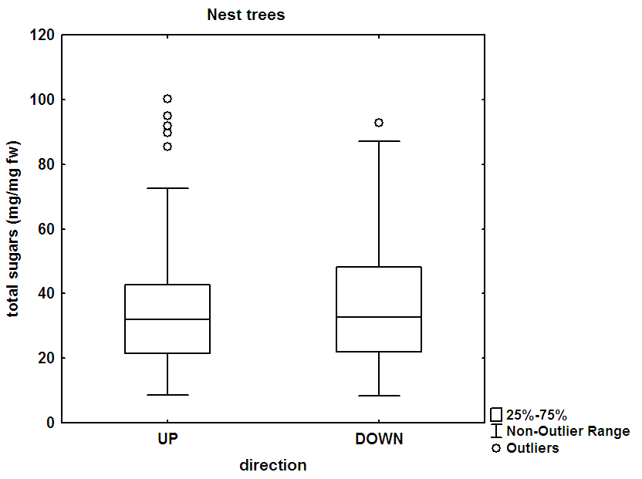

(B)
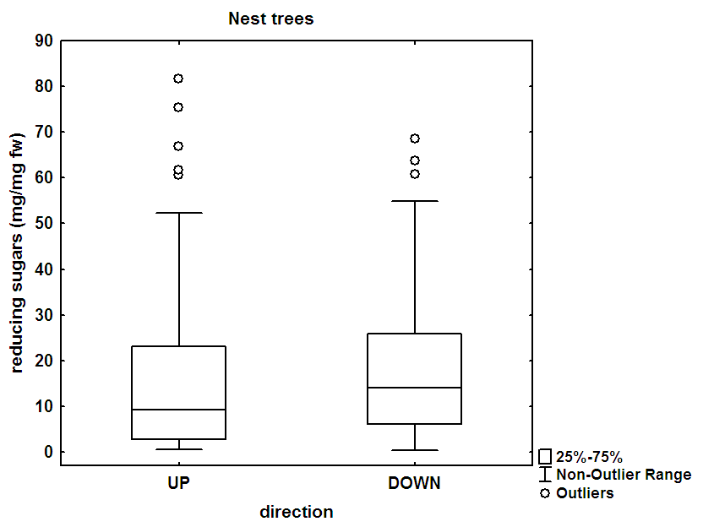
Figure 1: The differences in amount of total (A) and reducing (B) sugars depending on the direction of movement in nest trees. Wilcoxon test: P=0.55 (A), P=0.059 (B)
Against in foraging trees the differences in amount of total and reducing sugars depending on the direction of movement were statistically significant in both cases (Fig. 2).

(A)
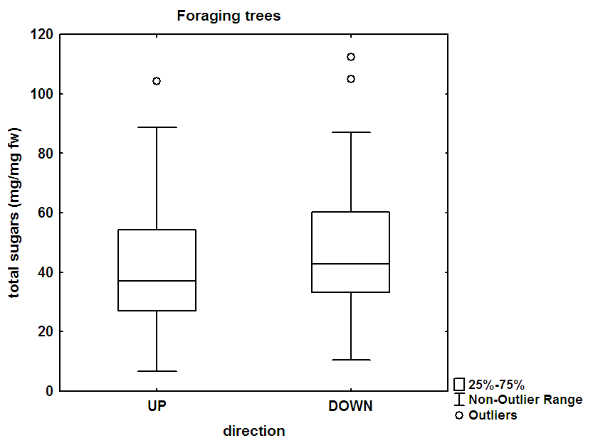
(B)
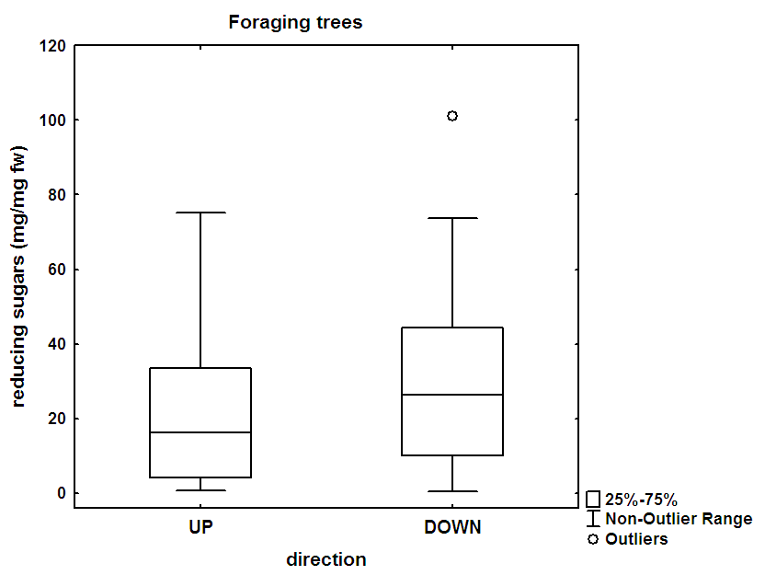
Figure 2: The differences in amount of total (A) and reducing (B) sugars depending on the direction of movement in foraging trees. Wilcoxon test: P=0.026 (A), P=0.032 (B)

Seasonality in total and reducing sugars
Concentrations of total sugars in workers collected on nest and foraging trees did not differ between the individual months (April – July) (Fig. 3).
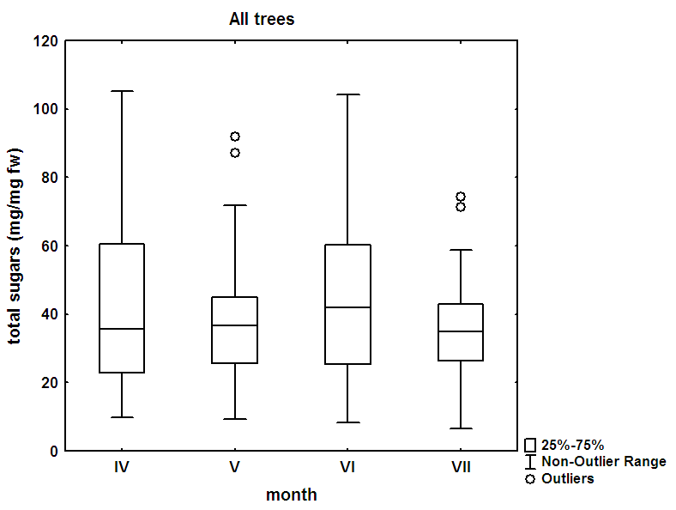
Figure 3:
The concentration of reducing sugars in workers collected on nest and foraging trees was significantly higher in May and June than in April (Fig. 4).
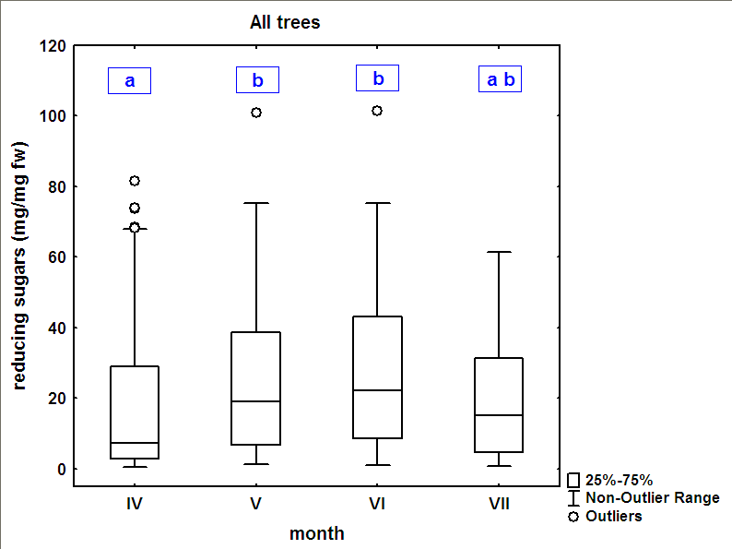
Figure 4:
Gaster mass
Gasters of workers climbing down nest trees of significantly lower mass than those of workers climbing up. Gasters of workers climbing down foraging trees of significantly higher mass than those of workers climbing up (Fig. 5)
(A)
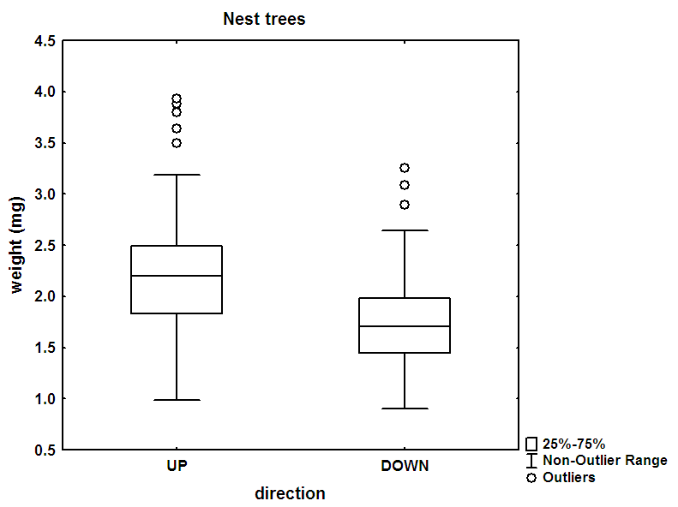

(B)
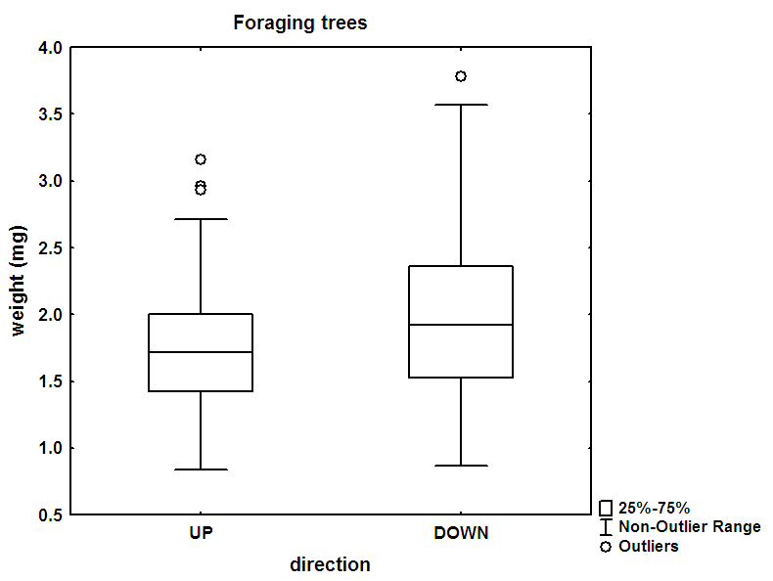
Figure 5: The differences in gaster mass depending on the direction of movement in nest trees (A) and in foraging trees (B). Mann-Whitney U test: P=0.000000 (A), P= 0,015569 (B)

For individual months only gasters of workers from nest trees differed significantly in mass in April and May (Fig. 6)
(A)
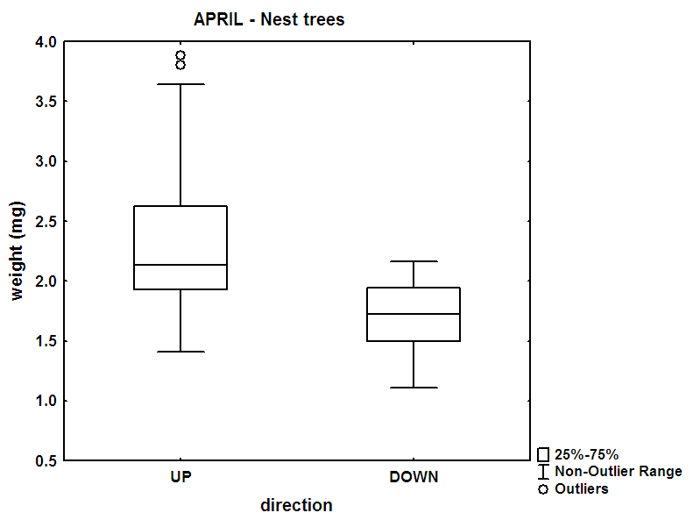
(B)
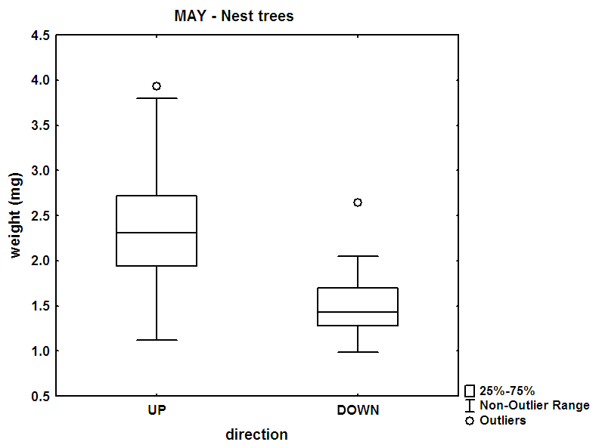
Figure 6: The differences in gaster mass depending on the direction of movement in nest trees in April (A) and in May (B). Mann-Whitney U test: P= 0.000458 (A), P= 0,000157 (B)

Discussion
Our hypotheses were that workers leaving the nest tree (going down the trunk) and climbing up a foraging tree will contain few (reducing) sugars. Workers going down a foraging tree and up a nest tree will contain much more (reducing) sugars. Sugar content will be highest in spring (need of fast energy).
Gaster mass corresponds to expected transport of food from foraging to nest trees (most pronounced in nest trees in April and May). We measured the amount of total and reducing sugars in gasters of workers Liometopum microcephalum. All the consumed food, including the food reserve to feed other workers and larvae, occurs just there. The differences in amount of total sugars on foraging trees, where up-going workers had less amount than down-going workers, seems to be logic, because if a worker walks up on the tree, it should be hungry and consequently it should have less amount of total sugars than a worker, which walks down on the tree and it is full. Almost same value measured on nest trees could we explain by the fact, that workers don’t forage only in foraging trees but on nest trees too.
The Somogyi-Nelson method gives us similar results like the hot-anthrone test. The reducing sugars are the main component of honeydew (van Handel et al., 1972), which workers of L. microcephalum collect from aphids. When a worker walks down on the foraging tree, it has much more amount of reducing sugars than a worker, which walks up on the tree. It indicates that workers collect honeydew just on foraging trees. On nest trees the amount of reducing sugars was similar in up-going workers as well as down-going. So are up-going workers passing sugar-rich gaster content to down-going workers (on the lower trunk portion)? Are up-going workers loaded with other food (in their gaster) blurring the picture? Are workers that have tended aphids in the nest tree crown going down the trunk (by-passing the nest)?
Trophobiosis is an important part of foraging in L. microcephalum.It is most important in May and June, but decline in July is non-significant.

