- Yeast two-hybrid system
- Process workflow

Mating of haploid two-hybrid strains on YPD plates

Replica-plating of diploids on selective plates

Two-hydrid experiment – plating on selective plates

- Motivation

Protein-protein interactions are operative at almost every level of cell function, in the structure of sub-cellular organelles, the transport machinery across the various biological membranes, packaging of chromatin, the network of sub-membrane filaments, muscle contraction, and signal transduction, regulation of gene expression, to name a few. Abbberant protein-protein interactions have been implicated in a number of neurological disorders such as Creutzfeld-Jacob and Alzheimer´s disease. Because of their importance in development and disease, these interactions have been the object of intense research for many years. (Royer & Beechem, 1992). In this chapter we will focus on the yeast two hybrid system. The two-hybrid system is a useful technique to detect other proteins that interact with a protein of your interest.
This practical course provides theoretical base as well as the practical demonstrations necessary to complete the two hybrid screens easily and successfully.

- Theoretical background

In learning about proteins and their roles in the cell, it has been discovered that many cellular functions are carried out by proteins that contact one another (Russel, 2002). If two proteins interact with each other, they usually participate in the same, or related, cellular function (Oliver, 2000). Yeast genetics provides a couple of methods of seeing whether two proteins physically interact. One experimental method to find genes which encode proteins that interact with a known protein is the yeast two-hybrid system, developed in 1989 by Stanley Fields and his colleagues (Fields & Song, 1989).
The yeast two-hybrid system is based on knowledge of the transcription of the galactose-metabolizing genes. The GAL4 gene is a regulator of galactose metabolism in yeast. The Gal4 protein contains two domains. One domain, the DNA - binding domain (BD), binds to a regulatory sequence in the DNA upstream of the genes it regulates. The other domain, the activation domain (AD), activates RNA polymerase for transcribing those genes. Both domains are part of the same gene, and can be separated by recombinant DNA manipulation yet retain their individual activities (Figure 1).
The Gal4 protein regulates the GAL1 and GAL10 genes. Between these two genes is a promoter element called upstream activator sequence G (UAS_{G}). The Gal4 protein forms a dimer and the BD of the protein binds to UAS_{G}. Then the AD binds RNA polymerase and transcription of the GAL1 and GAL10 genes commences in opposite directions. The transcription of the GAL1 gene is shown in Figure 2.
In the two-hybrid system, two types of plasmids are constructed. One type contains the sequence for the known protein, X, fused to the BD sequence of the GAL4 gene. The plasmid must also contain yeast selectable marker, e. g. URA3, or TRP or LEU2 as shown in Figure 3 A-D.
The second plasmid carries the sequence of the Gal4 AD fused to a library of cDNA fragments that possibly contains the gene for the protein Y that interacts with X. The result is a family of similar recombinant plasmids, each containing a different cDNA. The AD plasmid must contain other selectable marker than the BD plasmid, e. g. TRP1, as ilustrated in Figure 4.
The BD and AD recombinant plasmids are co-transformed into a yeast strain that carries the reporter gene(s). The lacZ gene from E. coli encoding β-galactosidase is one of the most widely used reporter genes. Other reporter genes that can also be used are yeast selectable markers such as HIS3, ADE2 or some others (Figure 5).
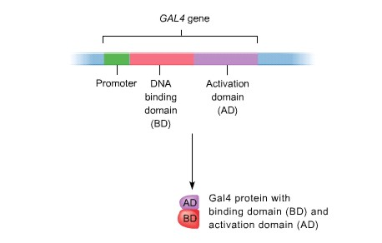How is product of the reporter gene produced? The Gal4 BD plasmid with the bait gene, X, produces a fusion protein that binds to the regulator sequences in the promoter region of the reporter gene. If the Gal4 AD plasmid carries a cDNA fragment encoding a protein, Y, that interacts with the X protein, BD and AD domains of Gal4 are brought to proximity through X-Y interaction. This allows expression of the reporter gene(s) (Figure 6).

Figure 1. Schematic picture of the GAL4 gene and its product (Russel, 2002).
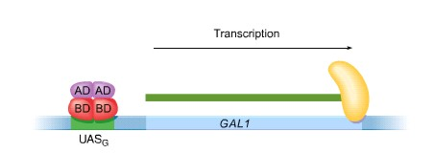

Figure 2. The model of transcription of the GAL1 gene which is regulated by the Gal4 protein (Russel, 2002).
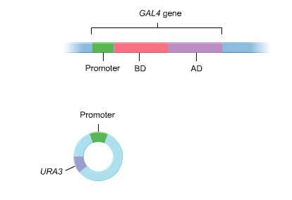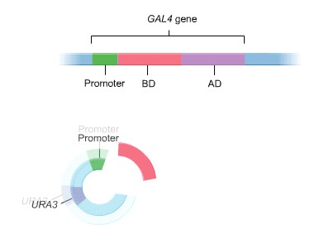

3A 3B
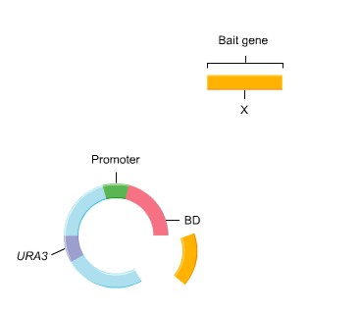
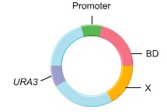

3C 3D

Figure 3. The yeast two-hybrid plasmid which contains sequence of the Gal4 BD fused to the coding sequence of the known protein X (bait). 3A – parental plasmid, 3B – plasmid with Gal4 BD domain sequence, 3C – plasmid with the X gene fused to Gal4 BD domain, 3D – recombinant two – hybrid plasmid with BD and X gene (Russel, 2002).

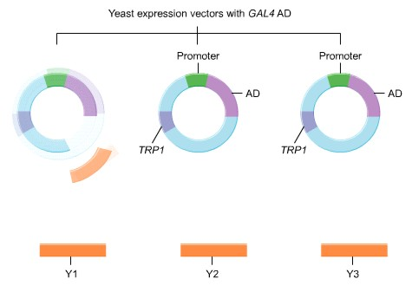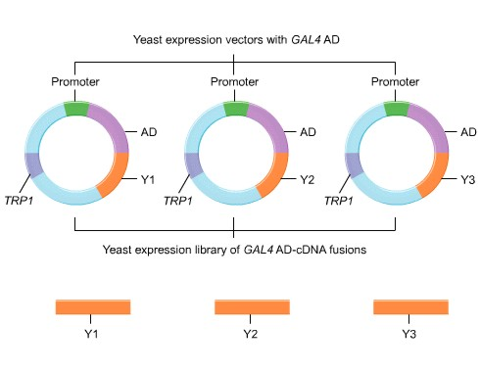

4A 4B

Figure 4. The yeast plasmid which contains sequence of the Gal4 AD fused to the coding sequence of the unknown protein Y (prey). 4A – parental vectors, 4B recombinant vectors containing Y gene (Russel, 2002)
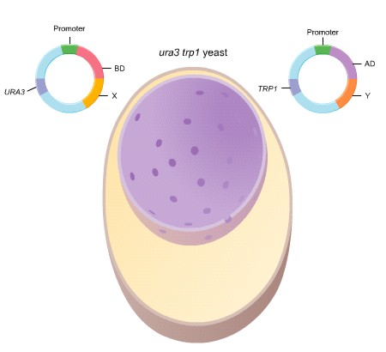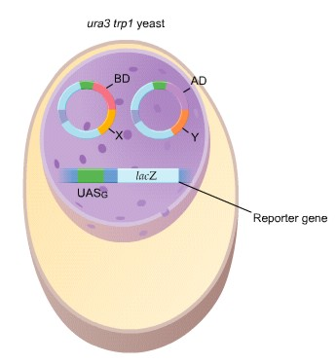 5A 5B
Figure 5. Co – transformation of both two – hybrid plasmids into a yeast strain. 5A – yeast strain before transformation, 5B – yeast strain after transformation (Russel, 2002) .
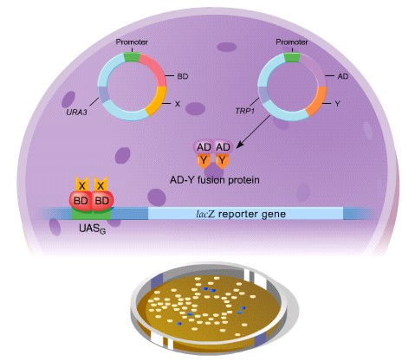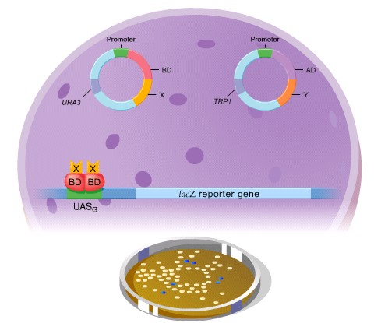

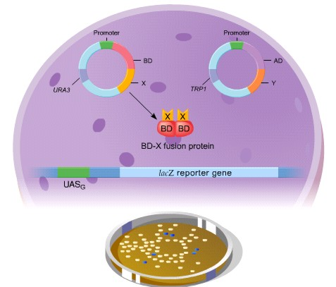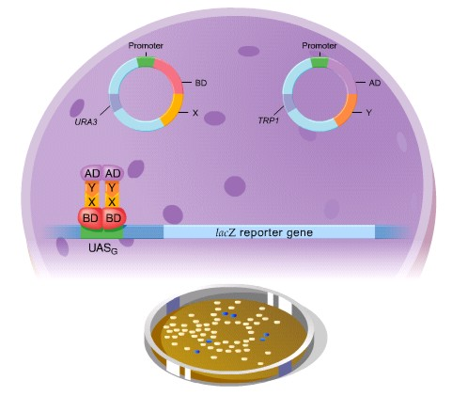

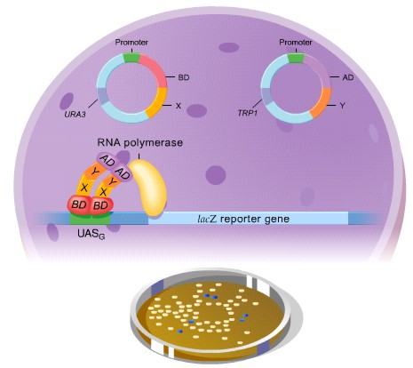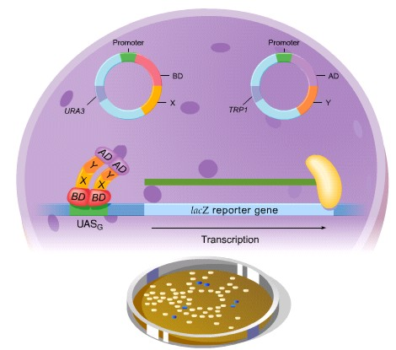

Figure 6. X-Y protein interaction allows expression of the E. coli lacZ reporter genes (Russel, 2002).

Here, we describe interaction mating, a two hybrid variation that can be adapted to most versions of the system and which can be simplify and facilitate most two-hybrid experiments.
In interaction mating, the AD and DSB fusion proteins begin in two different haploid yeast strains with opposite mating types. To test for interaction, the hybrid proteins are brought together by mating, a process in which two haploid cells fuse to form a single diploid cell. The technique is fairly simple, requiring only that the two haploid strains be mixed together on rich medium. The diploids that form are then tested for reporter activation as in a conventional two-hybrid experiments.
The key to choosing a combination of strains and plasmids is to ensure that the two strains to be mated are of opposite mating type (MATa and MAT&) and that both have auxotrophies to allow selection for the appropriate plasmids and reporter genes (Finley et al., 2000).
- Design of the experiment

Yeast strains and plasmids
Strain | Genotype | Source
Saccharomyces cerevisiae  PJ69-4A | MATa, trp1-901, leu2-3,112, ura3-52, his3-200, gal4Δ, gal80Δ, GAL2-ADE2, LYS2::GAL1-ADE2, LYS2::GAL1-HIS3, met2::GAL7-lacZ | Dr. Philip James, University of Wisconsin, USA
Saccharomyces cerevisiae  PJ69-4& | MAT&, trp1-901, leu2-3,112, ura3-52, his3-200, gal4Δ, gal80Δ, GAL2-ADE2, LYS2::GAL1-ADE2, LYS2::GAL1-HIS3, met2::GAL7-lacZ | Dr. Philip James, University of Wisconsin, USA

Plasmids | Size | Transformation markers | Source
pAS1  (BD = bait) | 8.4 kb | amp ^{r}  TRP1 | Clontech, USA
pGAD10  (AD = prey) | 6.65kb | amp ^{r}  LEU2 | Clontech, USA
pGADT7  (AD = prey) | 8.0kb | amp ^{r}  LEU2 | Clontech, USA
Combination of the two-hybrid plasmids that will be used in the screen:

Sample No. Yeast strain Plasmid Note
1. PJ69-4& pAS1 RAD51 positive control
PJ69-4A pGADT7 SRS2 (783-998)
2. PJ69-4& pAS1 NEJ1
PJ69-4A pGADT7 SRS2
3. PJ69-4& pAS1 RAD51 negative control
PJ69-4A pGADT7
The interaction mating hunt can be divided into four tasks. (1) First the bait and prey plasmids are constructed. (2) The second task is to transform the particular plasmids to defined strains (in this case pAS1 plasmids to PJ69-4& and pGADT7 plasmids to PJ69-4A strain by yeast high-efficiency yeast transformation (Hill et al., 1991, Ito et al.,1983). Transformants are incubated on selective plates (SC-TRP for AD), (SC-LEU2 for BD) at 30˚C for 3-4 days. (3) The third task is to mate the bait strain with and aliquot of the prey strain and allow diploids to form on solid YPD medium overnight. (4) The resulting diploid yeast strains are then replica plated on SC plates lacking leucine and tryptophane in order to select diploid co-transformants and after 3 days incubation at 30˚C screened for interactors by testing of activation of two different reporter genes: the yeast HIS3 and ADE2 genes. This is performed by replica plating of the diploids on different selective plates (either adenine or histidine is ommited in the SC plates, onto which the PJ69-4A co-transformants are replica plated. Since there is a low level of HIS3 expression in PJ69-4A strain, SC plates lacking histidine need to be supplemented with 2mM or 4mM 3-amino 1,2,4 triazole (3-AT).
Our work will focus on the third and the fourth task of two hybrid screen (mating of the strains and performing of entire two hybrid screen using different selective plates).
Testing interactions between small sets of proteins by cross-mating assay

Equipment and Reagents

- Haploid two hybrid strains of different mating type (see decription above Combination of the two-hybrid plasmids that will be used in the screen)
- YPD plates
- SC plates (Glu leu-trp-, Glu leu-trp-ade-, Glu leu-trp-ade-his-, Glu leu-trp-his-2mM 3AT, Glu leu-trp-his-4mM 3AT)

- Toothpicks, sterilized by autoclaving

- Replica plating apparatus and sterile velvets or filters

Method

Mating of haploid two-hybrid strains on YPD plates

- Use sterile toothpicks to streak individual PJ69-4& transformants onto standard 100 mm YPD plate in parallel horizontal lines (see Figure 7). Streaks should be at least 3 mm wide and at least 5 mm apart, with the first streak starting about 15 mm from the edge of the plate. A 100 mm plate will hold up to 8 different bait strains.

- Likewise, streak different PJ69-4A transformants in diagonal parallel stripes on a same YPD plate. Put a colony a little above the horizontal lane of alpha strain, then cross the alpha strain, mix the strains well and lead the toothpick away. Incubate plates at 30oC overnight.

Replica-plating of diploids on selective plates

Replica-plate the cells from YPD on selective plates (Glu leu-trp-). Incubate at 30ºC for 1-2 days.

Two-hydrid experiment – plating on selective plates

Plate diploids on different selective media: Glu leu-trp-, Glu leu-trp-ade-, Glu leu-trp-ade-his-, Glu leu-trp-his-2mM 3AT, Glu leu-trp-his-4mM 3AT. Incubate at 30ºC and examine the results after 1, 2, and 3 days. Only diploids will grow on the Glu leu-trp- plates and only interactors will grow on glucose plates lacking adenine, histidine + 3AT.

A
YPD plate

pGADT7 SRS2 (783-998)
PJ69-4& pAS1 RAD51

pGADT7 SRS2

& PJ69-4& pAS1 NEJ1

pGADT7
PJ69-4& pAS1 RAD51

REPLICA-PLATE on SC PLATES
lacking described amino-acids

-Leu, -Trp

-Leu,-Trp, -Ade -Leu,-Trp,-His, -Leu,-Trp,-His -Leu,-Trp,-His
-Ade 2mM 3AT 4mM 3AT

Figure 7. Interaction mating assay for protein interactions.

- References

- Fields, S., Song, O. (1989): A novel genetic system to detect protein-protein interactions. Nature 340, 245-246.
- Finley, R.L., Kolonin, G.M., Zhong, J. (2000): Interaction mating methods in two hybrid systems. Methods in Enzymology, Applications of Chimeric Genes and Hybrid Proteins, Part C, Protein-Protein Interactions and Genomics 328, 26-46.
- Hill, J., Ian, K.A., Donald, G., Griffiths, D.E. (1991): DMSO-enhanced whole cell yeast transformation. Nucleic Acids Res. 19, 5791.
- Ito, H., Fukuda, Y., Murata, K., Kimura, A. (1983): Transformation of intact yeast cells treated with alkalications. J. Bacteriol. 153, 163-168.
- Oliver, S. (2000): Guilt - by - association goes global. Nature. 403: 601-603.
- Royer, C. A. and Beechem, J.M. (1992). Methods in Enzymology, 210, 481-497.
- Russel, P.J. (2002): Genetics. International Edition. Benjamin Cummings. ISBN 0-321-18172-7

- Question

After mating of the two haploid strains, the diploids need to be replica-plated on another selective media plates. What selective media would you use and why particulary that one?

