HUMAN BODY
Body World Exhibition - video
http://www.youtube.com/watch?v=i5bBtohsCCI

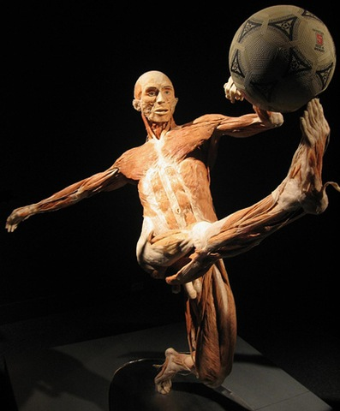
http://www.thedctraveler.com/files/2008/03/the-kicker.jpg

Watch the video and answer the questions

- What is the process of preservation called?

- How does the preservation take place?

- How long does it take to prepare a specimen?

- What are the advantages of the technique?

- What are its limitations?

Share the opinion on the exhibition with your colleagues

