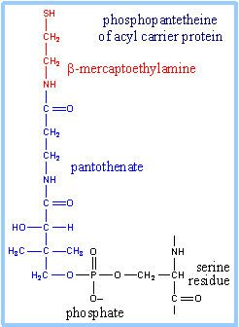

Struktura FASyntas

Bakterie – E. coli – cytosolické nezávislé enzymy

Rostliny podobně – chloroplasty (jediné místo syntézy)

Kvasinky – α₆β₆ multifunkční komplex – 2,5 MDa – matrix a funkční

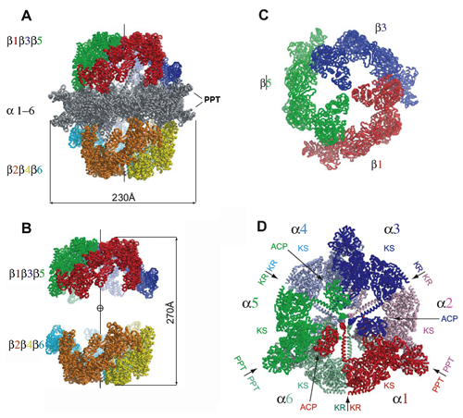

Overall structure of yeast fatty acid synthase. (A) The barrel-shaped structure of FAS has two domes composed of β-subunit trimers (colored) and an equatorial wheel composed of α subunits (gray). (B) Two β-subunit trimers do not interact with each other (α subunits are omitted). (C) The top view of the β-subunit trimer showing it is formed by interactions between its N-terminal domains at the center and by interactions between neighboring subunits. (D) The α-subunit hexamer viewed from the top.
S. cerevisiae, pohledy z boku a seshora
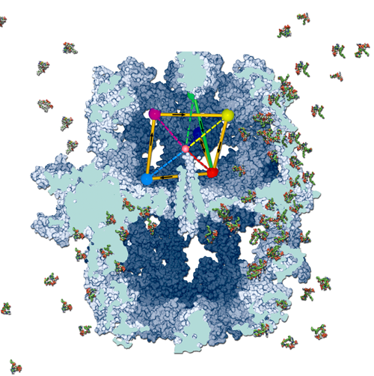

Reaction chambers of yeast fatty acid synthase. The FAS particle is shown in a surface representation and is sliced for a better view of the inside chambers with the ACP domain omitted. The positions of unique catalytic centers are represented by large balls, and the pathway traversed by ACP is presented as solid connecting lines. The arrows indicate the directions in the pathway. The small ball in the center (pink) represents the pivot about which ACP swings, and the broken lines indicate the orientations of the ACP in the pathway.
Fatty acid assembly line. Six fatty acid assembly lines (reaction chambers) comprise the yeast fatty acid factory (FAS). The FAS particle is shown in a surface representation and is sliced for a better view of the inside chambers with the ACP domain omitted. Palmitoyl-CoA molecules (final product of yeast FAS), shown as balls, are leaving the structure through the pores around MPT domains

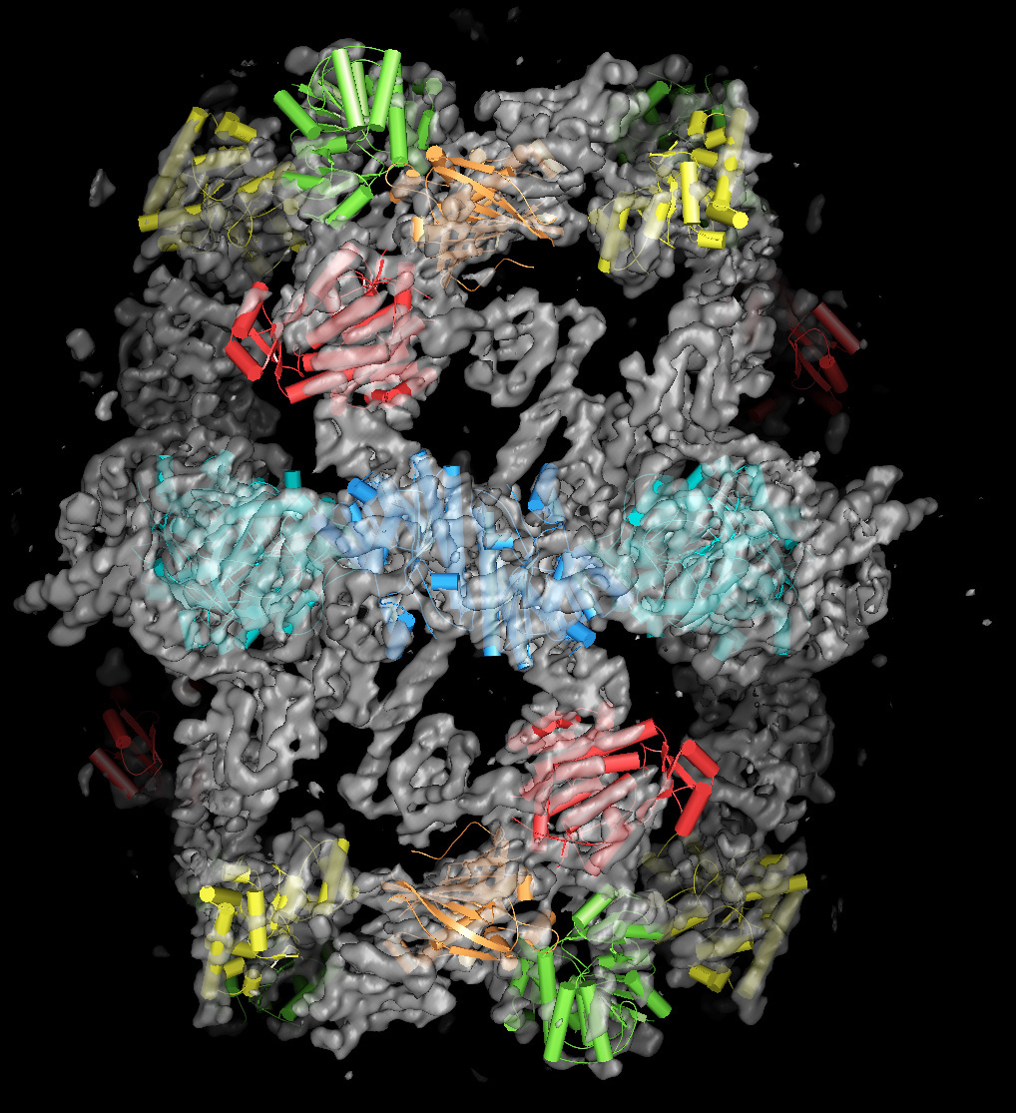

Model ETH Curych

Živočichové – multifunkční homodimer 534 kDa

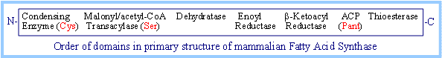

Schema pořadí aktivních center v primární struktuře

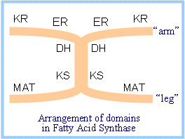
KR = β-Ketoacyl Reductase;
ER = Enoyl Reductase; DH = Dehydratase;
KS = β-Ketoacyl Synthase (Condensing Enzyme); MAT = Malonyl/Acetyl-CoA Transacylase.
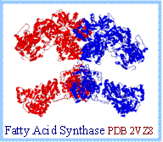

Model z proteinové databáze

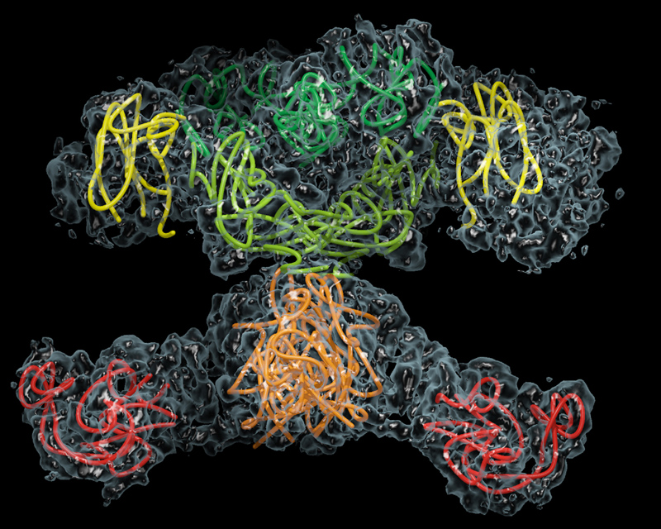

Model ETH Curych

ScienceDaily (Sep. 8, 2008) — Mammalian fatty acid synthase is one of the most complex molecular synthetic machines in human cells. It is also a promising target for the development of anti-cancer and anti-obesity drugs and the treatment of metabolic disorders. Now researchers at ETH Zurich have determined the atomic structure of a mammalian fatty acid synthase.

