DANGEROUS SUBSTANCES (by courtesy of A. Rozkošná)

A) INTRODUCING THE TOPIC
1. Match the pictogram, the name of the hazardous substance and its definition:
PICTOGRAM | NAME OF SUBSTANCE | DEFINITION
A)  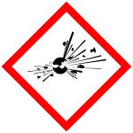 | 1. oxidising substance | a) may explode under  special conditions
B)  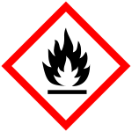 | 2. explosive substance | b) toxic to the environment
C)  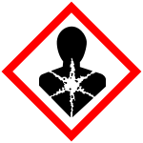 | 3. flammable substance | c) destroys materials or living tissue (e.g. skin) on contact
D)  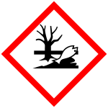 | 4. toxic substance | d) can ignite (=set on fire) combustible materials or worsen (=make worse) existing fires
E)  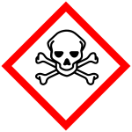 | 5. corrosive substance | e) easily ignited and burns rapidly (=quickly)
F)  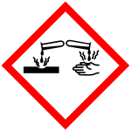 | 6. chronic toxic | f) harmful (=dangerous), destructive or deadly to living things
G)  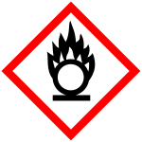 | 7. ecotoxic | g) toxic after frequent exposure  VOCABULARY viz Page 2

- Useful Vocabulary
flammable (adj) – hořlavý | target (n) – terč, cíl
corrosive (adj) – žíravý | to sum up (v) – shrnout
harmful (adj) – škodlivý | to state (v) / statement (n) - prohlásit / prohlášení
harmless (adj) – neškodný | dose (n) – dávka
exposure to … (n+prep) – vystavení se … | remedy (n) – lék
living tissue (adj+n) – živá tkáň | oil spill (adj+n) – ropná skvrna
to ignite (v) – vznítit | responsible for … (adj+prep) – zodpovědný za …
under special conditions – za zvláštních podmínek | chemical weapons (adj+n) – chemické zbraně

3. Discussion.
All living things are potential targets of poisons. So, too, all chemicals are potential toxicants. Paracelsus, a scientist from the Middle Ages, summed up this concept by stating: „All substances are poisons; there is none which is not a poison. The right dose differentiates a poison from a remedy.”

Go through these questions in pairs. Note down possible answers:
- Do you agree with the statement by Paracelsus?
- Can you name some poisonous/toxic substances? Can you explain how they work? Where are they used? Which toxic substances can you buy in a normal shop?
- Do you think water could be toxic? Under what conditions?
- Do you know any substance which is normally safe (=harmless), but under special conditions it could be harmful?
- Have you ever had an accident in a laboratory (or elsewhere) connected to dangerous substances? If so, how did the accident happen? How can you protect yourself from such accidents?
- Think about oil spills from ocean tankers that transport hazardous substances. This is an example of acute exposure to oil by fish and birds. Compare this to the chronic exposure - animals that live near oil terminals are frequently influenced by small spills. Which do you think is worse? Why?
- Can you think of acute and chronic exposure to toxic substances, connected to humans? What are the different ways of exposure? (e.g. by inhalation) Do you think chemists are responsible for these situations?
- Have you ever heard of chemical weapons? What do you know about them? If somebody offered you a job in manufacturing weapons, would you accept it?

Regroup and discuss these topics in small groups. Use the typical vocabulary and phrases.

EXPRESSING OPINIONS
To express your opinion, you may use these phrases: Based on BBC Learning English
I think that… | in my opinion in my view
It seems to me that… | to my mind
I would argue that… | I feel
I do not believe that… | if you ask me
I am unconvinced that… | to be honest (with you)
I disagree. I do not agree that… | as far as I'm concerned
To express other people´s view, you can say: Of course, many / some people argue… It is sometimes argued…
admittedly… while…
Another useful phrase: It depends. It depends on…

Example: A: I believe that developing new chemical and biological weapons is dangerous. In my view the research of such weapons may be potentially harmful for our civilisation. B: I disagree. I would argue that the development of such weapons is necessary.

B) READING

CASTOR BEAN TOXINS
1. Vocabulary
Do you know these verbs?

to consider (v) They considered him to be a fair man.
to occur (v) This disease occurs everywhere.
to develop (v) The scientists have developed a new drug.
to release (v) CO₂ is released into the atmosphere.
to contain (v) How much water does this glass contain?

Now write 2-4 similar sentences, using some of these verbs in context:

New words:
castor bean (n+n) – skočec obecný | ingestion (n) – polknutí, požití
castor oil (n+n) – ricinový olej | severe (adj.) – vážný, těžký
sufficient (adj.) – dostatečný | concern (n) – starost, obava, zájem
to agglutinate / to coagulate (v) – srážet se (o krvi) | device (n) – přístroj, zařízení
readily obtainable (adv+adj) – snadno dostupný | intestine (n) – střevo

2. Scanning. Scan (=quickly read) the text and find these abbreviations. What do they mean?
a) RCA -
b) BTWC -
c) CWC -

3. Transferring Information - Supply the missing information:

a) Name of Toxins: | 1.  2.
b) Effects of Exposure to Toxins: | ad 1.  ad 2.

4. Answer the following questions. The answers can be found in the text. Start the question with How much/many:

a) How much / many ricin may be sufficient to kill a human adult?
.................................................................................................................... .
b) How much / many days after exposure to ricin does a person die?
..................................................................................................................... .

c) How much / many ricin or RCA do products made from castor oil contain? ..................................................................................................................... .
d) How much / many routes of exposure to these toxins are possible?
..................................................................................................................... .

5. Grammar

a) Little / few?
Products made from castor oil contain very little ricin or RCA.
The effects of ricin ingestion may be felt within a few hours.
……………. proteins ……………… poison ……………… blood
……………. castor bean plants ……………… ribosomes ……………. plant seeds

b) Much/ many?
……………. contaminated food …………….. castor oil ……………… red blood cells ……………. biological weapons …………...routes of exposure ………………. fluid

6. Vocabulary Building - Find the English equivalents for the following expressions:

- je považován jak za zbraň chemickou, tak za zbraň biologickou
- jed, který účinkuje pomalu
- silná dehydratace
- pokročilá otrava (jedem)
- jinými slovy
- způsobí, že krev se srazí
- riziko otravy
- z několika důvodů
- práškový toxin
- špatně určit diagnózu
- očkovací látka proti toxinu
- testování je v plném proudu

7. Translation

Translate the underlined sections of the text into Czech/Slovak.

8. Speaking.
Work in pairs. Summarize the main points of the article. Say all the facts regarding the two toxins that you can remember, using the vocabulary you have learnt.

Lesson adapted from Mária Sabolová

Castor Bean Toxins
The castor bean plant, Ricinus communis, contains two toxins that are poisonous to people, animals, and insects. The main toxic protein, ricin, is so potent that a single milligram may be sufficient to kill a human adult. Ricin is considered both a chemical and biological weapon and is explicitly prohibited by the Biological and Toxin Weapons Convention (BTWC) and Schedule 1 of the Chemical Weapons Convention (CWC). | 1 | Castor oil and products made from castor oil contain very little ricin or RCA. However, castor beans are grown for ornamental purposes, too. The seeds from the garden plant present a poisoning hazard to children and pets. Dehydration and vomiting are more dangerous for children than adults, so ingestion of a single castor bean seed may be fatal for a child. However, if the seed is ingested whole, there is a chance that it may pass through the gastrointestinal system without releasing its ricin. | 4
Ricin works by destroying small parts of cells, called ribosomes. Ribosomes produce all of the proteins needed by a cell. If the proteins cannot be produced, the cell dies. Although the effects of ricin ingestion may be felt within a few hours (abdominal pain, diarrhea, vomiting), it is a slow-acting poison, with death occurring after 1-3 days. A victim who survives the severe dehydration and lowered blood pressure of advanced ricin poisoning will generally recover. | 2 | Purified ricin and RCA are of considerable concern as weapons for several reasons. First, castor bean seeds are readily obtainable. Second, several routes of exposure are possible (for ricin: inhalation, injection, or ingestion). Once the proteins are purified, the powdered toxin can be used to contaminate food or beverages. Ricin is heat-stable, so it can be applied to shrapnel within an explosive device. Possibly the greatest concern about ricin used as a weapon is that symptoms of poisoning can be misdiagnosed. | 5
The other toxic protein in the castor bean, RCA (Ricinus communis agglutinin), agglutinates red blood cells. In other words, injection of RCA into the bloodstream essentially causes a person's blood to coagulate. Ingestion of a castor bean or its products will release ricin, but the RCA cannot cross the intestinal wall. | 3 | At present, therapy for ricin poisoning consists of replacing fluids and treating the symptoms of poisoning, but research is underway to develop a vaccine for the toxin. Also, testing is underway for a new drug, using an inactivated form of the ricin protein, to treat individuals following exposure. Adapted from http://chemistry.about.com/cs/toxicchemicals | 6

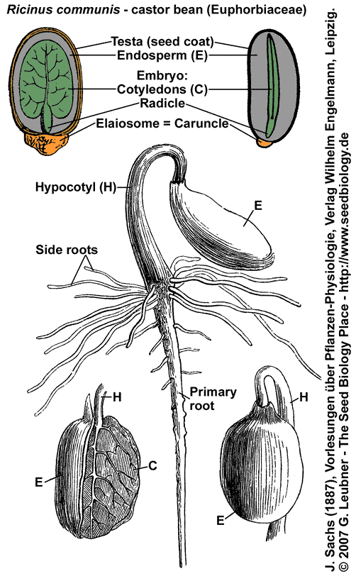

C) HOMEWORK: SOME / ANY
SOME se používá hlavně v kladných oznamovacích větách : There is some milk in the fridge. V lednici je nějaké mléko.

+ někdy v otázce, čekáme-li kladnou odpověď, dále když něco nabízíme, žádáme apod. Would you like something to eat? Dáte si něco k jídlu? - Can I have some more coffee, please? Mohu dostat ještě kávu? - Haven't you got some money for me? Cožpak pro mě nemáte peníze?

Some používáme před podstatnými jmény v množném čísle a před nepočitatelnými podstatnými jmény. I saw some people in the street. Na ulici jsem viděl nějaké lidi. - I spent some money on the books. Utratil jsem nějaké peníze za knihy.
ALE před počitatelnými podstatnými jmény v jednotném čísle používáme neurčitý člen, pokud nejsou určena situací (např. jediné okno v místnosti: Open the window, please). I have bought a book. Koupil jsem si knihu.

ANY používáme
- v otázkách
Is there any milk in the fridge? Je nějaké mléko v lednici?

- v záporných větách
No, there isn't any milk in the fridge. Ne, v lednici není žádné mléko.

Any používáme také ve významu jakýkoli, kterýkoli, jakákoliv, jakékoliv, nezáleží na tom, který, které atd.
Have you got any letters for me? Máš pro mě nějaké dopisy? - You can catch any bus. Můžeš jet kterýmkoli autobusem. They all go to Prague. Všechny jezdí do Prahy.

1. Fill in the gap with some / a
a) They are watching ........ film on television tonight.
b) He got......... news from his mother.
c) Jack has got........ new flat.
d) I can do it because I've got........... time.
e) She has got............. pen friend in Japan.
f) We have got.......... books at home.
g) There were ........... people when we came back.

h) They met......... friends at the disco.
i) I spent ............ money there yesterday.
j) He doesn't need ........... map.
2. Fill in the gap with some / any
a) We had ..... tea, but there wasn't..... .sugar in it.
b) There isn't..... ...milk left.
c) Did you have .......... trouble at the customs?
d) Have you got .......... questions?
e) Are there ............. letters for me? /I don't expect any./
f) Have you .......... eggs? Then I'll get............ .
g) Let's have ............... sandwiches!
h) If you haven't............ money, you can get............ from the bank.
i) Did you have ............ visitors last night?
j) Please give me .......... more coffee. I'm sorry but there isn't............ left.
Adapted from: Julišová, Marta: What are you good at? Praha: Global, 2003.

Week 4 – Vocabulary – Dangerous Substances

flammable (adj) | hořlavý
corrosive (adj) | žíravý
harmful (adj) | škodlivý
harmless (adj) | neškodný
exposure to … (n+prep) | vystavení se …
living tissue (adj+n) | živá tkáň
to ignite (v) | vznítit
target (n) | terč, cíl
to sum up (v) | shrnout
dose (n) | dávka
remedy (n) | lék
under special conditions | za zvláštních podmínek
oil spill (adj+n) | ropná skvrna
responsible for … (adj+prep) | zodpovědný za …
chemical weapons (adj+n) | chemické zbraně
It seems to me that… | Zdá se mi, že
I would argue that… | Argumentoval bych, že …
I am unconvinced that… | Nejsem přesvědčený, že …
I disagree. | Nesouhlasím.
in my opinion | podle mého názoru
in my view / to my mind | z mého pohledu / podle mě
to be honest (with you) | abych byl (k vám) upřímný
as far as I'm concerned | co se mně týče
It is sometimes argued … | Někdy se argumentuje, že …
Admittedly… | Připouštím, že …
While… | Zatímco …
It depends. It depends on… | Jak kdy. Závisí to na …
castor bean (n+n) | skočec obecný
castor oil (n+n) | ricinový olej
sufficient (adj.) | dostatečný
to agglutinate / to coagulate (v) | srážet se (o krvi)
readily obtainable (adv+adj) | snadno dostupný
ingestion (n) | polknutí, požití
severe dehydration (adj.) | vážná dehydratace
concern (n) | starost, obava, zájem
device (n) | přístroj, zařízení
intestine (n) | střevo
Ricin is considered both a chemical and biological weapon. | Ricin je považován jak za zbraň chemickou, tak za zbraň biologickou.
slow-acting poison (adj+n) | jed, který účinkuje pomalu
advanced poisoning (adj+n) | pokročilá otrava
in other words | jinými slovy
poisoning hazard (adj+n) | riziko otravy
for several reasons | z několika důvodů
powdered toxin (adj+n) | práškový toxin
to misdiagnose (v) | špatně určit diagnózu
vaccine for the toxin | očkovací látka proti toxinu

