IN A LABORATORY (courtesy of A.Rozkošná)

1. Play a memory game.
Look at the pieces of laboratory equipment that teacher passes around the room and try to remember their names. Each student repeats one extra word. In the end write down as many words as you can remember.

Vocabulary from the exercise:

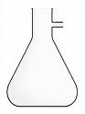  FLASK | 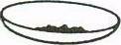  EVAPORATING DISH | 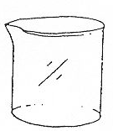  BEAKER
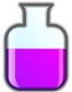  BOTTLE | 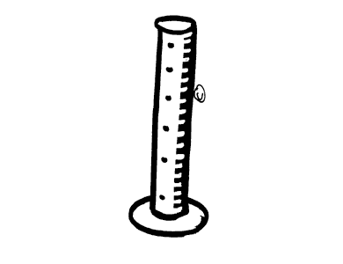  CALIBRATED CYLINDER | 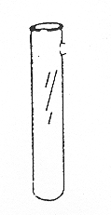  TEST-TUBE
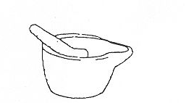  MORTAR AND PESTLE | 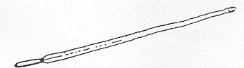  THERMOMETER | 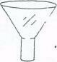  FUNNEL
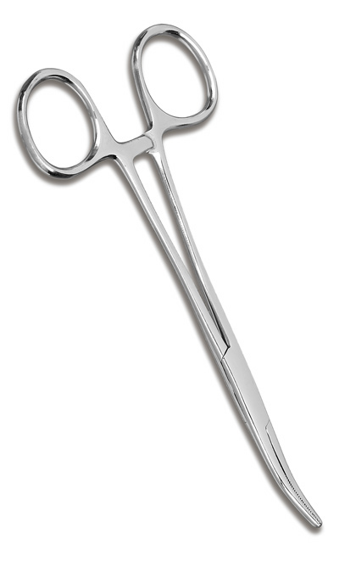  FORCEPS | 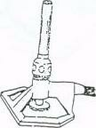  BURNER | 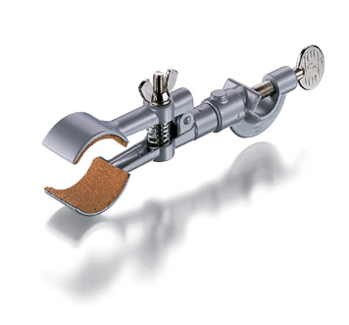  CLAMP
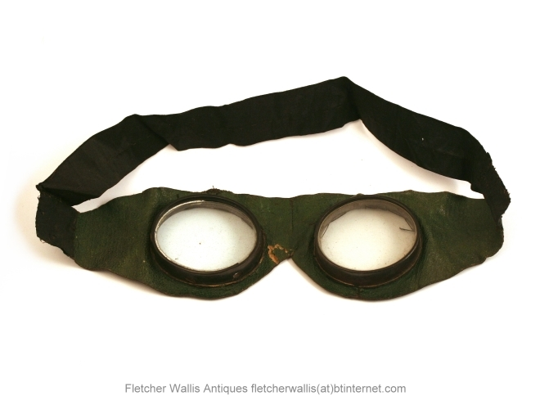  GOGGLES | 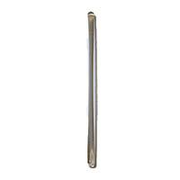  STIRRING ROD

2. Look at this picture of a science lab and learn more vocabulary by matching the number of a picture with its description:

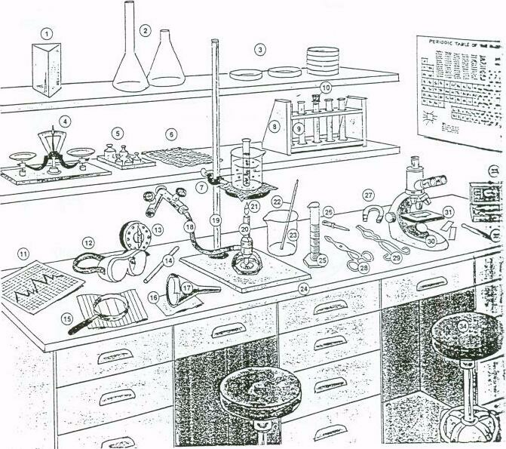

microscope  flask  evaporating / petri dish  scale  filter paper  dissection kit  clamp  test-tube rack  test-tube  timer  graph paper  safety glasses /goggles | graduated cylinder  pipette  magnifying glass  cork  funnel  rubber tube  ring stand  Bunsen burner  flame  thermometer  beaker  bench | wire gauze  medicine dropper  magnet  forceps  tongs  weights  slide  tweezers  prism  stool

3. What is true for you?
Read these statements. Label them as either True or False. Than discuss your responses.

Vocabulary:
to carry out experiments (v+n) – provádět pokusy | protective goggles (adj+n) – ochranné brýle
laboratory report (adj+n) – protokol | to be emloyed in a lab – být zaměstnaný v laboratoři
to follow safety precautions – dodržovat  bezpečnostní předpisy | to analyze blood samples – analyzovat krevní vzorky
 | responsibility (n) - zodpovědnost

- Carrying out chemical experiments is very interesting for me, it is often good fun. T/F
- I had very good laboratory lessons at high school. T/F
- I don´t like laboratory lessons at this university. T/F
- Writing laboratory reports is quite easy for me. T/F
- Doing chemical calculations is rather boring. T/F
- I think that laboratory work may be dangerous and that following
safety precautions is very important (wearing protective goggles etc.) T/F
- I have never had an accident in a laboratory. T/F
- I have never been to a „real“ laboratory (i.e. outside school). T/F
- In my future job, I would like to be employed in a chemical or biochemical lab (e.g. in a hospital, analyzing blood samples). T/F
- In my opinion, working in a science laboratory means hard work and a lot of responsibility. T/F
- I think that in the future much more of the chemist´s work will be done on computers. T/F

4. Listening: Listen to the description of an experiment and answer these questions:
Nucleus of General Science – Unit 12 / Listening Practice 2

  - What is the purpose of the experiment?

  - What does the apparatus consist of?

  - What is the flask filled with?

  - What comes out of the flask when it is heated?

  - What is then placed in the flask?

  - What happens when the flask cools under running water?

  - What is the result of driving the air out of the flask?

  - What can we conclude?

5. Read this description of an apparatus and add labels to the picture below.

a) On the left OF the apparatus inside a trough THERE IS is a gas-jar filled with oxygen.  b) On the right OF the gas-jar there is a stand. At the top OF the stand THERE IS a clamp which holds a test-tube.  c) Between the test-tube and the gas-jar THERE IS a tube.  d) At the bottom OF the stand THERE IS a base. The base is under the test-tube.  e) THERE IS a tripod and a bunsen burner on the right OF the stand. The burner is on the tripod. At the top OF the burner THERE IS a flame.  f) The gas comes from a gas-tap which is in front OF the tripod.  g) Behind the stand THERE IS a conical flask. Beyond the conical flask THERE IS a beaker.  h) THERE IS a light bulb over the stand. The light bulb is above the apparatus and the flasks. | 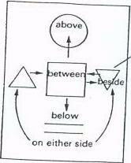  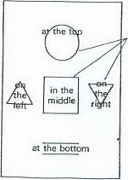
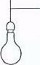

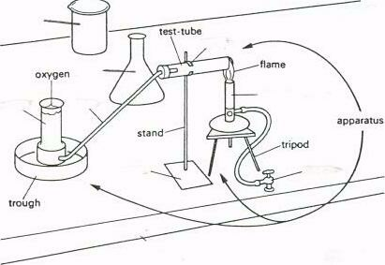 | 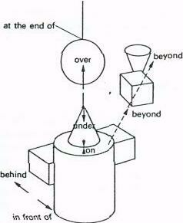

6. Speaking. Work in pairs. Ask and answer questions about the position of laboratory equipment.
Example: A: What´s on the left OF the apparatus inside a trough?
B: On the left OF the apparatus inside a trough THERE IS A gas-jar.

7. Read the text. Then draw a picture of the apparatus, using the parts shown in the diagram. The flask and the trough are in the right position. Then add labels to your diagram.

Vocabulary:
a beehive shelf – probublávačka | gas-jar (n) – nádoba na plyn
delivery tube – přívodová trubička | it is fitted into ... – je to zasunuto do ...
thistle funnel – nálevka (ve tvaru bodláku) | it is held in place by ... – drží to za pomoci...
trough (n) – káď | it is supported by ... – je to podepíráno ...

The apparatus for preparing hydrogen consists of a flask, a gas-jar, a beehive shelf, a trough, a delivery tube and a thistle funnel. The flask is spherical and has a flat bottom. It contains zinc and hydrochloric acid. The thistle tube and the delivery tube are fitted into the neck of the flask. They are held in place by a two-holed cork. The thistle tube leads down to the hydrochloric acid. The delivery tube leads from the flask to the hole in the beehive shelf. The beehive shelf is placed in the middle of the trough. The trough contains water. The gas-jar is supported by the beehive shelf. Hydrogen is collected at the top of the gas-jar.

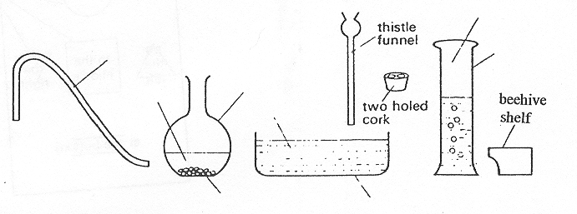

8. Speaking. Work in pairs. Describe this apparatus as fully as possible, using these expressions: On the left / in the middle / on the right OF the apparatus THERE IS a ... It consists of / is situated at / is supported by ... / placed under ... / fitted into ... / held in place by It leads from... to ... / It is filled with ...

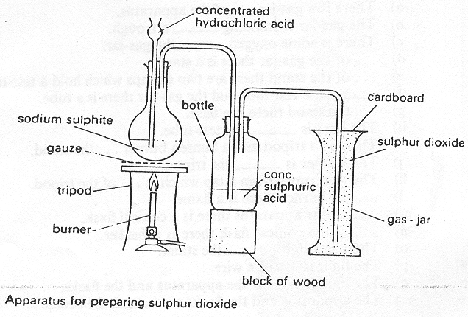
Based on: Bates, Martin and Dudley-Evans, Tony: Nucleus of General Science
9. HOMEWORK: -ing forms (Tvary končící na –ing)
Based on: Alžběta Oreská et al. Angličtina pro studenty VŠCHT.
Tvary končící na – ing se v angličtině používají:
a) ve funkci přídavného jména slovesného (“-ící, “-oucí”):
Every laboratory is provided with running water. - Každá laboratoř je vybavena tekoucí vodou.
Chemistry is a science dealing with substances. - Chemie je věda zabývající se látkami.
b) ve funkci podstatného jména slovesného (“-ání)
Heating is a physical process. - Zahřívání je fyzikální proces.
Bacteria are killed by adding chlorine. - Bakterie se zabíjejí přidáním chlóru.
Typická předložková spojení:
- by + ... ing tím, že ... Steam is made by heating water. Pára se vyrábí tím, že zahříváme vodu (zahříváním vody).
- (use) for + ing – (používat) na ...
Steam is used for heating. - Pára se používá na topení.
- in+ - ing při ... Chlorine is used in purifying water. - Chlor se používá při čištění vody. - on + - ing - po, v důsledku ... Gases expand on heating. - Plyny se rozpínají v důsledku zahřívání. - without + -ing – bez, aniž by
Coal gives heat without producing much smoke. - Uhlí vydává teplo, aniž by vytvářelo mnoho kouře.
Zkracování vedlejších vět pomocí tvaru na - ing:
Atoms gain or lose electrons. Atoms form ions.
→Atoms gain or lose electrons, forming ions. - Atomy získávají a ztrácejí elektrony a tak vytvářejí ionty.

Odpovězte na otázky použitím konstrukce “by+ ...ing
1. How do we separate a solid from a liquid? (we filter the mixture through a filter paper in a funnel)
2. How can a liquid be purified? (we distil it in a still)
3 How can we obtain ice? (we cool water)
4 How can we determine the composition of an alloy? (we melt it)
5. How can the boiling point be changed? (we change the pressure)

Odpovězte na otázky použitím konstrukce for + - ing:
1. What is ice used for? (to prepare ice cream)
2. What are pipes used for? (to transport liquids)
3. What is water used for? (to wash and drink)
4. What are vessels used for? (to store liquids)
5. What is a distilling apparatus used for? (to separate and purify liquid substances)

Odpovězte na otázky použitím konstrukce in+ - ing:
1. Where is ozone used? (to purify water)
2. Where is hydrogen used? (to manufacture ammonia)
3. When are stills most effective? (to separate liquid mixtures into their components)
4. Where is sulphuric acid used? (to manufacture many chemicals and drugs)
5. How can computers help technologists? (to control production)

Odpovězte na otázky použitím konstrukce on+ - ing:
1. When does this substance burn? (when it is heated)
2. When does the liquid contract? (when the temperature is lowered)
3. Why did the reaction stop? (if the heat was removed)
4. Why does water solidify? (if it is frozen)
5. Why does benzene evaporate? (if exposed to air)
6. When was the substance giving off harmful vapours? (when it was heated)

Spojte věty použitím konstrukce without+ing
1. Carbonic acid decomposes at once. It need not be heated.
2. Refractory glass withstands sudden changes in temperature. It does not break.
Week 6 – Vocabulary – Laboratory Equipment

laboratory equipment (adj+n) | zařízení laboratoře
apparatus (n) | aparatura
conical / spherical flask (n) | kónická / kulovitá baňka
evaporating dish (adj+n) | odpařovací miska
test tube (n) | zkumavka
clamp (n) | svorka
safety glasses / protective goggles (adj+n) | ochranné brýle
funnel (n) | nálevka
burner (n) | hořák
thermometer (n) | teploměr
beaker (n) | kádinka
graduated cylinder (adj+n) | odměrný válec
forceps / tongs (n) | kleště
mortar and pestle (n) | třecí miska a tlouček
stirring rod (adj+n) | míchací tyčinka
scale and weights (n) | váha a závaží
gas-jar (n) | nádoba na plyn
stopper / cork (n) | zátka
pipette (n) | pipeta
magnifying glass (adj+n) | zvětšovací sklo
filter paper (adj+n) | filtrační papír
rubber tubing (n+n) | gumová hadice
stand (n) | stojan
flame (n) | plamen
dropper (n) | kapátko
microscope and slide (n) | mikroskop a sklíčko
tweezers (n) | pinzeta
bench and stool (n) | lavice a stolička
prism (n) | hranol
gas-tap (n) | kohoutek na plyn
trough (n) | káď
tripod (n) | trojnožka
wire gauze (n) | azbestová síťka
a beehive shelf (n+n) | probublávačka
delivery tube (adj+n) | přívodová trubička
it is fitted into ... | je to zasunuto do ...
it is held in place by ... | drží to za pomoci...
it is supported by ... | je to podepíráno ...
to carry out experiments (v+n) | provádět pokusy
laboratory report (adj+n) | protokol
to follow safety precautions | dodržovat bezpečnostní předpisy
to be emloyed in a lab | být zaměstnaný v laboratoři
to analyze blood samples | analyzovat krevní vzorky
responsibility (n) | zodpovědnost
purpose (n) | účel
to conclude (v) | vyvodit
to drive out (v) | vyhánět

