ANGLIČTINA PRO CHEMIKY IV, jaro 2012

- KONTAKT: Andrea Rozkošná, e-mail: rozkosna@rect.muni.cz,
kancelář: Kampus Bohunice, pavion A-15, kancelář č.119

- OBSAH KURZU: odborná angličtina (práce s odborným textem, poslech, slovní zásoba), akademická angličtina (mluvení o studiu, prezentace, diskuse), konverzace a gramatika - 4 semestry (JAC01 – JAC04) - kurzy volně navazují, je vhodné absolvovat je po sobě - nepovinné, ovšem doporučené jako příprava na povinné zkoušky z odborné angličtiny: - kurzy 01 a 02 slouží jako příprava na zkoušku JA001 (úroveň B1, bakalářské studium), - kurzy 03 a 04 slouží jako příprava na zkoušku JA002 (úroveň B2, magisterské studium).
Pokud jste na požadované úrovni, můžete složit zkoušku JA002 už v bakalářském studiu. V tom případě nemusíte skládat zkoušku JA001.
- vstupní úroveň do kurzu: B1 - lower intermediate
- možnost přihlásit se navíc do online kurzů PdF MU bez prezenční výuky:
Angličtina Online (kód ONLINE_A) nebo Cvičení z gramatiky on-line - AJ (kód ZS1BK_AC2A)

    - STUDIJNÍ MATERIÁLY uloženy v ISu v INTERAKTIVNÍ OSNOVĚ:
https://is.muni.cz/auth/el/1431/jaro2012/JAC04/index.qwarp
VE KTERÉ SE NACHÁZÍ

- kopie všech lekcí v elektronické podobě+klíč, složka pro odevzdávání úkolů
- užitečné odkazy (informace o zkouškách z odborné aj, jazyková studovna, studium v zahraničí, online slovníky, vyhledávače, envyklopedie, gramatika, odborné články…)
- STUDIJNÍ MATERIÁLY PŘEDMĚTU SI PROSÍM VYTISKNĚTE SAMI. - na vyučovací hodinu si vždy přineste první dokument uložený v aktuální lekci - pokud jste na hodině chyběli, je třeba přinést do příští hodiny vyplněný domácí úkol
- POŽADAVKY NA ZÁPOČET:
- aktivní účast – max. 2 absence za semestr, není třeba posílat omluvenku
- prezentace v angličtině
- zápočtový test – píše se v zápočtovém týdnu, z probraného učiva; případně další úkoly

- DOPORUČENÁ LITERATURA:

- Chemická a vědecká angličtina:
Oreská, Alžbeta. English for chemists + Activity book. Bratislava: STU, 2006.
Weisse, Gunter et al. Angličtina pro chemiky. Praha: SNTL, 1988.
Dastych, Milan et al. English for Laboratory Technicians + Key. Brno: MU, 2007.
Science. Edited by Keith Kelly. Oxford: Macmillan, 2008.
- Akademická angličtina, gramatika:
Academic vocabulary in use. Ed. by Michael McCarthy - Felicity O'Dell. Cambridge: CUP, 2008.
Douglas Bell: Passport to Academic Presentations. Reading: Garnet, 2008.
Murphy, Raymond. English grammar in use : a self-study reference and practice book for intermediate students. 2nd ed. Cambridge : Cambridge University Press, 1995..
- Slovníky:
Bláha, Karel. Česko-anglický / Anglicko-český chemický slovník, Praha: SNTL 1989.
Dictionary of chemistry. Edited by John Daintith. 5th ed. Oxford : OUP, 2004.
Lingea Lexicon 5. Anglický technický slovník (elektronický slovník na CD).

- STEM CELL RESEARCH

- SPEAKING. Getting to know each other.

- Make 5-7 wh... questions that you would like to ask someone you see for the first time.

Example: What are your hobbies? When … / where … / who … / who … / why … / how … ?
1)
2)
3)
4)
5)
6)
7)
b) Give your questions to another student. Work in pairs. Ask and answer questions. Take notes.

c) Now report this information to the first student. Speak from you notes.
Example: Hanka is studying biochemistry. She likes kickbox. …

Useful phrases:

LIKES | DISLIKES
She quite likes … | She doesn´t like …
She is interested in… | She can´t stand …
She is keen on … | She dislikes …
She is fond of … | She can´t stand …
She loves … | She hates …

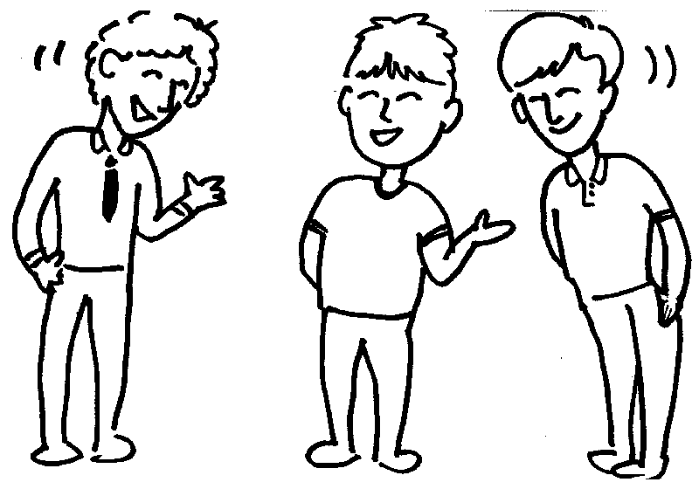

Listening: STEM CELL RESEARCH

- Vocabulary: Match the words and their definitions

- stem cells | - eating the flesh of your own species
- tissue | - young animal (here human) in the earliest stage of development
- hampered | - very similar or identical set of genes
- ethical concerns | - are produced or developed from
- are derived from | - the same as something else (especially something bad), equal in meaning
- embryos | - hindered, affected the progress of
- tantamount | - flexibility, capable of many different uses
- cannibalism | - moral problems, or worries relating to professional conduct
- versatility | - general cells which produce other specialised types of cells (e.g. blood cells)
- genetic match | - a collection of cells with a similar structure and particular function in an animal/plant (here)

- Scientists, from the Wake Forest University School of Medicine in Harvard University, say they have discovered a new source of cells that could one day repair damaged human organs. This report is from Science correspondent Matt McGrath.
- Listen and answer these questions:

1. What are the 'ethical concerns' that may prevent some types of stem cell research?

2. What are the scientists working on?

b) Listen again. Are the following sentences true or false?
If they are false, say what is true.

1. Stem cells are useful because they kill diseases. T/F
2. The best stem cells are produced from animal embryos. T/F
3. People who disagree with stem cell research think that using embryos is almost like eating humans. T/F
4. Scientists in the United Kingdom think they have found another source
of stem cells. T/F
5. The new source of cells is in the liquid which surrounds a baby before
it is born. T/F
6. Scientists think that they only need one thousand cells for almost the
whole population. T/F

c) Listen once more and fill in the gaps:

Scientists believe that stem cells offer real hope of treating illnesses like diabetes, Parkinson's and Alzheimer's. Stem cells act like master cells and can 1…………… into the types of tissue that are destroyed by the progression of these diseases. But this field of 2.……………has been hampered by ethical concerns over the source of stem cells.  Scientists say the most useful types are derived from specially grown human embryos.Opponents say that because these embryos are destroyed in the process, this is tantamount to cannibalism.  Now scientists in the United States, after a seven year research 3…………….., say they have found a ready source of useful stem cells in amniotic fluid, the liquid that surrounds a 4……………….. baby. The researchers say that these cells seem to have many of the qualities of embryonic stem cells. The team have managed to turn them into functioning 5………………., fat, blood vessel, nerve and liver cells. In tests, these newly made cells seemed to 6………………….. some function in brain damaged mice.  Although amniotic fluid derived stem cells are small in number, their ability to 7………………. themselves and their versatility gives the researchers great hope. They say that a bank of 100,000 of these stem cells could 8……………….. a genetic match for 99 percent of the US population.  Matt McGrath, BBC | 1  2  3  4

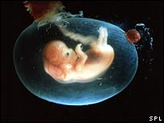
The cells came from the fluid surrounding the developing foetus

4. Grammar: Word-formation – adjectives.

Adjective Noun
1. ethical concerns
2. amniotic fluid
3. genetic match

Possible adjectival endings (example is given in brackets):

-able (understandable) -ant (fragrant)
-al (maternal) -ent (intelligent)
-ate (consummate) -ful (delightful)
-an (American) -ible (visible)
-ic (economic) -ory (inflammatory)
-ist (capitalist) -ous (enormous)
-ive (positive) -some (bothersome)
-less (careless) -y (hazy)

a) Fill in the following table, adding the adjective or noun. All the roots to the
words are in the text:

Noun | Adjective
reality | 1.
2. | hopeful
3. | typical
embryo | 4.
5. | ethical
function | 6.
ability | 7.
versatility | 8.
9. | genetic

b) Add more information to each of the following sentences by using adjectives.
Try to add at least three adjectives:

Example: I went to see a film.→
I went to see a terrible, badly-directed, romantic film.

1. In this performance of Shakespeare’s play ‘Romeo and Juliet’, Kate Winslet took the role of Juliet.
- The politician made a speech
- The celebrity was wearing a dress.
- The cook prepared a meal.
- In the garden, the bird was singing.
- During the lesson, the student was day-dreaming.
- The shop sold fruit and vegetables.

5. Descriptive Writing/ Reading

Work in small groups. Write a news story on research breakthrough.
Follow the style of today’s lesson – limiting your news to no more than five paragraphs. Use your imagination, also while deciding when the article is published (in late 2007 or in 2027) You can answer the following questions in your article:

- Where did the research take place?

- When did the research take place?

-Who did the research and what did they say about it?

-How many people will be affected by the research?

-When can the public expect to be able to use this invention?

-Are there any opponents? If yes, what did they say about the research?

-Were there any ethical concerns?

In the end of the lesson, read your article to other students. Useful phrases from the text:
Scientists, from ……………………………….. University, say they have discovered …….. This report is from………………………. and was published in …………….. Scientists believe that ……………… The researchers say that ………….. Opponents say that …………………… This field of research …………… In tests …………….. After a ………year research effort, scientists say they have found …………………. The team have managed to ……………….

- HOMEWORK Word-formation (Slovotvorba – změna slovních druhů):⁴

SUFFIXES (Přípony):

Nouns (n -podstatná jména): - ment, - ness, - tion, - - ity, - ance, - ist, -er (replacement, richness, formation, flexibility, assistance, chemist, fighter)
Adjectives (adj - přídavná jména) - able, -ible, -ine, - ous, - ic, -ing, -ed (countable, flexible, saline, famous, toxic, interesting, prepared)
Verbs (v - slovesa): - ify, - ize, - ate, - en (intensify, minimize, activate, frighten)
Adverbs (adv - příslovce): - ly, - ally (quickly, technically)
Ovšem často jsou změny složitější: např. long (adj) – length (n)
Někdy u určitého slovního druhu není žádná přípona – např. profitable (adj) - profit (n)
Někdy nemá příponu žádný slovní druh (tzv. konverze - stejné slovo pro více slovních druhů)
Např. a stone bridge – a bridge stone – to stone somebody
stone – adj / n / v

- Which of these words is a noun / adjective / verb?

1. Calcium is a silvery metallic element that occurs in bone, shells, limestone, and gypsum and forms compounds used to make plaster, quicklime, cement, and metallurgic and electronic materials.
2. Calcium carbonate is a colourless or white crystalline compound, occurring naturally as chalk, limestone, marble.
3. An electrical circuit is a complete route, which an electric current can flow around.
4. You can have your house fitted with circuit breakers in place of fuses.
5. A hammer is a tool used for hitting things, for example nails into walls, for breaking things by force.
6. He hammered the table and told the Minister he wanted results.

b) Use nouns expressing given properties in following sentences.
1. You can always find ....................... in such examples. (similar) 2. When producing swimsuits, ..........................of material is needed, (elastic)
3. Teachers reported on poor ..................................... of students for the tests. (prepared)
4.You should work on higher glass ....................... . (opaque)
5. Metals are known for their high electric ............................... . (conduct)
6.We cannot speak of ........................... of oxygen in that chemical reaction.(constant)
7.They were considering the ............................... of the substance. (flammable)
8.Scientists attach great.................................... of the project. (important)
9. .................................... of water is often mentioned in TV commercials. (hard)
10. Fractures of bones are due to the ………………....... of the human body. (fragile)

Sources: ¹ Available at http://www.bbc.co.uk/worldservice/learningenglish/newsenglish/witn/2007/01/070110_stemcell.shtml
- Adapted from Oreská, Alžbeta. Activity book English for chemists.. Bratislava : STU, 2005
Lesson adapted from © BBC Learning English bbclearningenglish.com
.
..

