7. OZONE, PRESENTATIONS: VISUAL AIDS

Answer these questions in small groups.

What types of visual aids do you know?

Why do we use them?

What do you put there?

What should you check?

Watch versions 1 and 2 of the video¹ (Visual aids) As you watch, compare the way Joanna uses her visuals. Note anything you particularly like or dislike.

Good:

Bad:

Visual aids – basics:

Design:
Don’ t use visuals to repeat what you can say with words.
Don’t overcrowd visuals with too much information.
Use visuals to support or summarize what you say.
Only use key words and phrases, not long lines of text.
Use big letters so that everybody can see them.
Think about which kind of visual is right for you.
Use colour, pictures, sound, videos (but not too much).

Use:
Don’t use too many visuals.
Don’t read from the visual.
Make sure the audience understands the visual.
Use a pointer and/or masking techniques where appropriate.
Face the audience as much as possible.
Don’t block the audience’s view.

KISS – keep it simple and short
PRACTICE USING THE EQUIPMENT before your presentation!

Describing charts, tables an graphs

- Match the phrases with the pictures

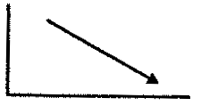  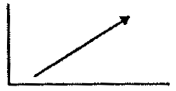  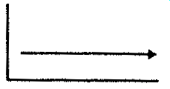  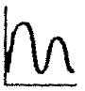  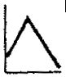  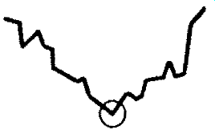 | a) bottom out reach a low point hit a low  b) reach a peak peak  c) increase / rise / go up  grow/expand  rocket/boom / shoot up / take off  Our sales rose last year.  d) remain constant / stable / steady  stay the same/at the same level  Sales have remained constant.  e) fluctuate  f) decrease/fall/drop/ decline/  go down  contract / slump /collapse / plunge  Profits have fallen recently.

- Complete the verbs by adding vowels a, e, i,o, u

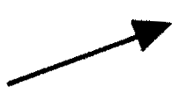 | 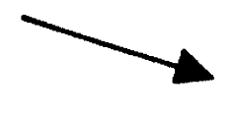 | 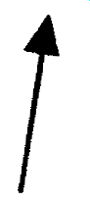 | 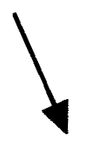
1. _ncr_ _s_  2. r_s_ | - d_cr_ _ s_  - f_ll | - sh_ _ t _p  - t_k_ _ff | 7. pl_ng_  8. sl_mp
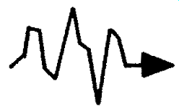 | 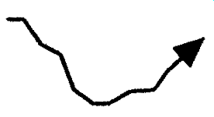 | 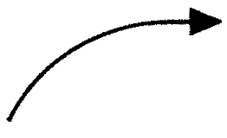 | 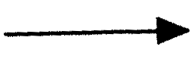
9.fl_ct_ _t_ | 10. r_c_v_r  11. p_ck _p | 12. st_b_liz_  13. l_v_l _ff | 14. r_m_ _n st_ _ dy
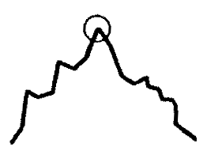 |  | 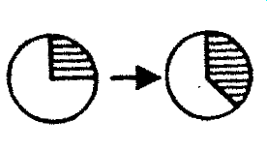 | 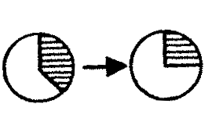
15.p_ _k | 16. h_t _ l_w  17.b_tt _ m _ _ t | 18. gr _ w  19. _ xp_nd | 20. sh r_nk  21. d_cl_n_

Useful phrases:

Speed of change  rapidly/quickly/suddenly/gradually/steadily/slowly |  | Degree of change  dramatically/considerably/significantly/moderately/ slightly
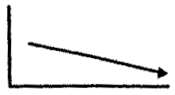 | 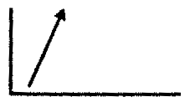 | 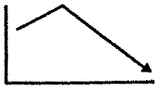 | 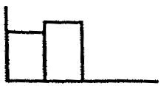
Absenteerism had dropped slowly. | Sales went up rapidly. | Sales have fallen considerably. | Profits rose slightly.
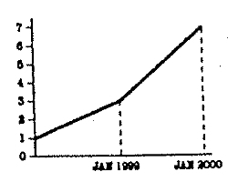
Sales rose from 3 million to 7 million.
Sales rose by 4 million.
There was an increase of 4 million over last year.
Sales stood at 3 million in January.

- Read this description of a chart²:
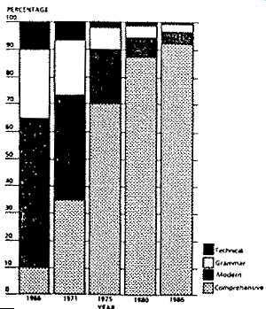

Introduction
Chart 1 shows the percentage of pupils in state secondary schools in England and Wales. The vertical axis shows the percentage of pupils in the different types of secondary school. The horizontal axis compares five years: 1966, 1971, 1975, 1980 and 1986.

Comment
As can be seen from the chart, a larger percentage of secondary school pupils were at comprehensive schools than at any other kind of school in 1986. Since 1966, the number of pupils in comprehensive schools went up rapidly, it rose from 10% to 92%. On the other hand, the percentage of pupils in grammar schools and secondary modern schools has dropped cosiderably. In 1966 they accounted for only 7 % of the total.
OZONE

- Vocabulary. Do you know these expressions?

ozone layer current measurements
chemical symbol greenhouse gas
earth surface global warming
ultraviolet rays ground level
it disappears entirely car exhausts
ozone hole major ingredient
upper atmosphere enviromental issues
to phase out the CFCs

- Answer these questions:

- What kind of molecules does oxygen form? How do they differ?
- Which of them is less common and why?
- Why do we currently hear of ozone so often? Where can we find it?
- What is an ozone layer? Why is it important?
- What is an ozone hole? What is it caused by? How can the problem be solved?

- Read the statements and try to guess if they are true or false.
Then listen to the recording and check your answers.

- Ozone occurs only in the upper atmosphere. T/F
- Ozone layer is 15-50 kilometers above the earth. T/F
- The ozone layer will be repaired by the end of the next century. T/F
- Ozone is a poisonous green gas. T/F

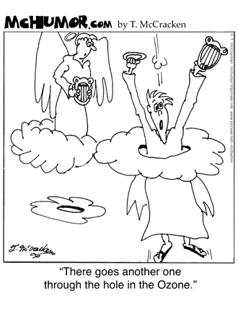

- Listen again and complete the text with the missing words.

As we´ve just heard, oxygen is usually found in molecules which pair 2 atoms together. However, it can also form another kind of molecule which ………………….. 3 oxygen atoms. This is ozone – chemical symbol O₃. It´s much less common than O₂ because it´s extremely ……………… . These days we come across ozone most commonly in the context of ozone ………………. . Between 15 and 50 kilometres above the earth ……………. there is a layer of air which absorbs ………………. coming from the sun which are …………………….. for living things. These are ultraviolet rays. A decade or so ago scientists dicovered that the ozone layer is getting ……………….. . In fact for parts of the year it disappears …………….. above the South and the North Poles – the ozone holes. The reason for this is that chemicals called CFCc which we use for example in refrigerators are ……………. converted into other substances in the ……………….. atmosphere which destroy ozone.
Governments across the world have agreed to phase-out the CFCs and if current …………………. are correct the ozone layer will be …………………. again by the middle of the next century. However, in other parts of the atmosphere ozone has different effects. Just a few kilometers above the …………………. ozone is a greenhouse gas. It contributes to global warming. At …………………. level ozone is produced in car exhausts, for example. It´s a major ingredient of city smogs and it´s poisonous. A relatively …………. gas, ozone therefore plays a major role in modern enviromental issues.
Ozone – O₃ is a poisonous bluish gas. Its molecules contain 3 oxygen atoms. Ozone in the upper atmosphere absorbs harmful ultraviolet rays from the sun.

- Work in small groups. Each group will a text and a diagram describing one aspect of ozone³. You should present the diagram to your colleagues. There should be an introducion, main body+ending. Mind your delivery and correct use of visual aids.

The following expressions can help you.

Introducing the visual
OK. Let’s take a look at …..
I have a diagram to show you.
The first / second / next / final slide is …..

Meaning of the visual
This shows / illustrates / demonstrates / refers to …..
This is a graph / chart / table, / diagram which shows …..
As you can see from the Table 1 / Figure 2 / Chart 3, this is …..
As can be seen on the right side of the table …
According to this diagram …
Here we can see ….. It can be seen from the statistics that ….

Focusing attention
I’d like to draw your attention to …..
One of the most important aspects of this is …..

- HOMEWORK: Reported Speech - He said that …

- while using reported speech the main verb is usually in the past (he said that…….)

- when reporting the general truth the tense can either be changed or remain the same.
(She explained us that the week has /had seven days.)

- the personal pronouns and possessive adjectives are changed according to the meaning

- direct speech => reported speech

present tense => past tense
(My father works very hard. => She said that her father worked very hard.)

present perfect => past perfect
(I haven ´t finished my work yet. => She said she hadn´t finished her work yet.)

past tense => past perfect
(We were in the cinema yesterday. => They said they had been in the cinema
the day before.)
It is not necessary to transform the sentence with past tense. (They said they were in the cinema the day before.)

future tense ( will ) => conditional ( would )
(I will return the book tomorrow. => He said he would return the book the following day.)

- to report orders we use infinitive
(Stop talking! => He told us to stop talking.)

- transformation of modal verbs
can => could
may => might
must => had to ( was to )
needn´t => didn´t have to or I wouldn´t have to in future
mustn´t => wasn´t to
NOTE: the verbs must, mustn´t and needn´t are not necessary to be transformed
- time tenses – past tense is not transformed into past perfect
(He said that when he was in London he used to stay in the same hotel.)
- conditionals are not transformed in reported speech
(John would help you. => He said John would help me)

- certain words and time expression are changed as follows:
now => then, immediately
today => that day
yesterday => the day before, the previous day
tomorrow => the next day, the following day
this week => that week
ago => before
here => there
this => that
come => go
bring => take

Exercise:

Put the direct speech into reported speech:
a) „Will you stay in a hotel ?“ I asked him.
I asked him ................................................................................................................
b) „I knew it a long time ago,“ he said.
He ..............................................................................................................................
c) „Where did you go last night ?“ she asked me.
She wanted to know ..................................................................................................
d) „I´ve forgotten,“ she said.
She .............................................................................................................................
e) „Do you often visit your aunt ?“ she asked him.
She .............................................................................................................................
f) „I think she is married,“ he said.
He ..............................................................................................................................
g) „I can´t believe it,“ he said.
He .............................................................................................................................
h) „I must leave,“ she told me.
She .............................................................................................................................

- „I´m living in London now“, he said.

He .............................................................................................................................
j) „I will be here next week“, she said.

She .............................................................................................................................

Sources: ¹ Comfort, Jeremy and Utley, Derek: Effective Presentations. OUP 2000
- Jordan: Academic writing.
- Available at http://www.met.sjsu.edu/~cordero/ozone/
- Adapted from Essential grammar in use. Edited by Raymond Murphy. 3rd ed. Cambridge : CUP, 2007.
Lesson adapted from Hana Němcová and Milada Pavlovová.

IN-CLASS PRESENTATIONS
In the next two lessons you are going to present a chemical / scientific topic of your choice to the others, using Powerpoint. Your presentation should last about 5 minutes.

POINTS TO CHECK:

STRUCTURE

Is it clear? Are all parts present? Is it an interesting topic, appropriate to the audience?
Is there an : Introduction
Outline, Main body
Ending - Summary, Conclusion?
Check the timing!

SIGNALLING DEVICES

Is the audience able to follow main points?
Is there a clear signal to the start / main body / end?
Are there appropriate signalling devices? (e.g.: I would like to talk about… First of all …That´s all. Thank you for your attention. … Are there any questions? …)

DELIVERY:

Voice: loud, clear?
Pronounciation good? What about tempo, intonation, pauses?
Speaking from the notes?

BODY LANGUAGE – Mind the eye contact, gestures, postures

LANGUAGE Grammar accurate? Vocabulary appropriate? Easy to understand?

VISUAL AIDS – Nice layout? Interesting? Easy to follow? Grammar correct?
What about use of the equipment?

HANDLING QUESTIONS – Good communication skills?

Prepare appropriate questions to the others´ presentations.

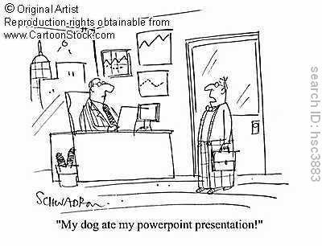

What could help you avoid panic:
How to say it in English?
Sorry, what’s the expression I’m looking for?

It’s wrong.
Sorry, let me rephrase that.
Only three minutes left!
So, just to give you the main points here.

Rubbish!
Sorry, perhaps I didn’t make that quite clear.
Oh, I’ve forgotten something.
Sorry, I should just mention one thing.

I’m too fast.

Let’s recap on that.

