**THE UNIVERSE**

1. **In two minutes try to tick the right answers to the questions below. Then read the text following it and check whether your answers were correct.**

Začátek formuláře

1. Which theory of the universe is Cosmic Microwave Background radiation used to explain?

Steady State  
Big Bang  
Intelligent design

2. What type of star is more likely to form a black hole?

Lightweight stars  
Medium weight stars  
Heavyweight stars

3. Approximately how long has our sun been shining for?

1 billion years  
5 billion years  
10 billion years

4. What type of star is our sun?

Yellow dwarf  
Red giant  
White dwarf

Konec formuláře

5. In the formation of a star what do hydrogen nuclei fuse to form?

Carbon  
Helium  
Neon

6. What is the average lifespan for stars similar to our sun?

1 billion years  
10 billion years  
100 billion years

7. What does a massive star form when it has fused its available hydrogen and helium?

Red supergiant  
Red giant  
Green giant

8. What is formed when a massive star begins to collapse and then explode?

Neutron star  
Black hole  
Supernova

9. When is a neutron star formed?

The remains of a massive star have a low density  
The remains of a massive star have no density  
The remains of a massive star have a high density

10. When is a black hole formed?

The remains of a massive star have a low density  
The remains of a massive star have no density  
The remains of a massive star have a high density

11. Why can't light escape from a black hole?

The gravitational pull is too weak  
The gravitational pull is too strong  
There is no light in a black hole

12. About how long ago do scientists believe the universe began?

137 million years  
1,370 million years  
13,700 million years

13. Which is the main scientific theory for the origin of the universe?

The Big Bang Theory  
The Oscillating Universe Theory  
The Steady State Theory

14. Which piece of evidence supports the Big Bang theory?

The more distant galaxies are moving the slowest.  
The more distant galaxies are moving the quickest.  
The more distant galaxies are moving towards us.

15. What is the name for the change in the light emitted by a moving object?

Red shift  
Blue shift  
Ultra violet shift

16. About how many galaxies are there in the universe?

A million  
A hundred million  
A billion

17. What does SETI stand for?

Send Earth Tourists Instead  
Search for Extra-Terrestrial Intelligence  
Search for Extra-Terrestrial Intellect

18. What keeps planets in their orbits?

Gravitational pull from each of the planets  
Gravitational pull from the sun  
Radiation from the sun

19. Which of the following is not a dwarf planet?

Neptune  
Pluto  
Ceres

**The Universe**

Scientists have gathered a lot of evidence and information about the universe. They have used their observations to develop a theory called the Big Bang. The theory states that about 13,700 million years ago all the matter in the universe was concentrated into a single incredibly tiny point. This began to enlarge rapidly in a **hot explosion**, and it is still expanding today.

Gravity is slowing down the rate of expansion. It is possible that the universe may expand for ever, or it may stop expanding. It may even contract and become very small again - the '**Big Crunch**'. There are other scientific theories for the origin of the universe. For example, the **Oscillating Theory** suggests that this universe is one of many - some that have existed in the past, and others that will exist in the future. When the universe contracts in a Big Crunch, a new universe is created in a new Big Bang. The **Steady State Theory** suggests that as the universe expands new matter is created, so that the overall appearance of the universe never changes.

**Stars and galaxies**

Our Sun is a star. It seems much bigger than other stars in the sky because it’s much closer to Earth. Stars form immense groups called galaxies. A galaxy can contain many millions of stars, held together by the force of gravity.

Our Sun is in a spiral galaxy with 'arms' of stars, called the Milky Way. The Sun is about half-way from the centre of the galaxy, on one of the arms.

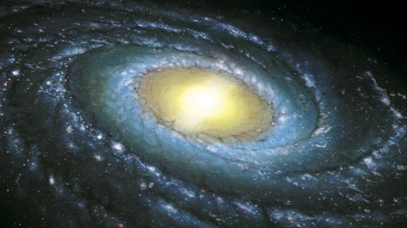

The Milky Way galaxy is home to planet Earth. The universe contains all the galaxies, thought to number over one billion. The distances involved in galaxies are huge. The distance from one star and another in a galaxy is millions of times more than the distance between the planets in the solar system. Meanwhile, the distance from one galaxy to another is millions of times more than the distance between the stars in a galaxy.

**The solar system**

The solar system consists of: a star - the Sun, planets and dwarf planets in orbit around the Sun, satellites - moons - in orbit around most of the planets, comets and asteroids in orbit around the Sun. There are eight planets, including the Earth, and smaller dwarf planets, such as Pluto, Ceres and Eris. The Sun's gravity keeps the planets, dwarf planets, comets and asteroids in orbit. The gravity of a planet keeps its satellites in orbit.

# The birth of a star

Stars form from massive clouds of dust and gas in space called nebula, an [interstellar cloud](http://en.wikipedia.org/wiki/Interstellar_cloud) of [dust](http://en.wikipedia.org/wiki/Cosmic_dust), [hydrogen](http://en.wikipedia.org/wiki/Hydrogen), [helium](http://en.wikipedia.org/wiki/Helium) and other [ionized gases](http://en.wikipedia.org/wiki/Ionized_gases). As the gas falls together, it gets hot. A star forms when it is hot enough for nuclear reactions to start. This releases energy, and keeps the star hot. The outward pressure from the expanding hot gases is balanced by the force of the star's gravity. Our sun is at this stable phase in its life. Gravity pulls smaller amounts of dust and gas together, which form planets in orbit around the star.

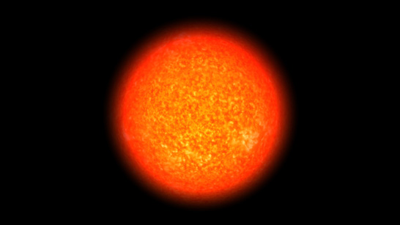

## Our sun is a type of star called a **yellow dwarf**. It has been shining for nearly five billion years, and has enough hydrogen fuel to last another five billion years. The sun and other stars eventually begin to run out of hydrogen. Gravity makes the core of the star smaller and hotter, which results in the outer layers expanding. They eventually expand so much that the star becomes a red giant star. After a star becomes a red giant, what happens next depends on how massive the star is. If its mass is relatively small, gravity eventually leads to the star contracting to form a white dwarf. It fades and changes colour as it cools. The matter in a white dwarf is millions of times denser than the matter on Earth. Stars that are much heavier than our Sun have a different fate. A heavy-weight star will still become a red giant, but then:

* it blows apart in a huge explosion called a supernova
* the central part left behind forms a neutron star, or even a black hole, if it is heavy enough
* black holes have a large mass, and a large gravity - even light cannot escape them because their gravitational field is so strong

# Evidence for the Big Bang Theory

There are two key pieces of evidence for Big Bang Theory: these are **red shift** and the **Cosmic Microwave Background** (CMB) radiation.

Our sun contains helium. We know this because there are black lines in the spectrum of the light from the sun, where helium has absorbed light. These lines form the absorption spectrum for helium.



Spectrum of the sun

When we look at the spectrum of a distant star, the absorption spectrum is there, but the pattern of lines has moved towards the red end of the spectrum, as you can see below.



Spectrum of a distant star

This is called **red-shift**, a change in frequency of the position of the lines. Astronomers have found that the further from us a star is the more its light is red-shifted. This tells us that distant galaxies are moving away from us, and that the further a galaxy is the faster it is moving away. Since we cannot assume that we have a special place in the universe this is evidence for a generally expanding universe. It suggests that everything is moving away from everything else. The Big Bang Theory says that this expansion started billions of years ago with an explosion. Scientists also discovered that there are microwaves coming from every direction in space. Big Bang Theory says this is energy created at the beginning of the universe, just after the Big Bang, and that has been travelling through space ever since. A satellite called COBE has mapped the background microwave radiation of the universe as we see it. Big Bang theorists are still working on the interpretation of this evidence.

## Space probes

Space probes can explore other planets without needing astronauts. Scientists are using different methods to see if there is life on planets other than the Earth. Space probes are space craft that can visit other planets without the need for astronauts. Some of the missions undertaken by such craft include:

-Viking 1 and Viking 2 - landed on Mars in the 1970s, took photographs and analysed soil samples

-Mars Global Surveyor - went into orbit around Mars in 1997 and mapped the surface in 3D

-Spirit and Opportunity - two robot vehicles that landed on Mars in 2004

Information about the planets and space can also be obtained using telescopes. These can be based on Earth, or - as with the Hubble Space Telescope - in space.

## SETI

The Earth's atmosphere contains about 21 per cent oxygen as a result of photosynthesis by plants. If we found evidence of oxygen in the atmosphere of another planet, it could indicate the presence of life forms. It is possible to detect oxygen and other gases on other planets by studying the light reflected between planets.

It is thought possible that alien civilisations, which are capable of transmitting radio signals, may exist. The Search for Extra-Terrestrial Intelligence (SETI) is a programme that uses radio telescopes to look for non-natural signals coming from space. It should be possible to even detect alien TV programmes, if they exist!

Space probes and landers are also looking for extra-terrestrial life. Space probes photograph planets looking for evidence of life. We have photographs of channels on Mars that may have been created by flowing water. Landers touch down on planets and take a soil sample, which is analysed for evidence of life.

1. **Find words or phrases in the text that correspond with synonims or definitions** **below;**

*The Universe*

collect

very little

become bigger and bigger

draw together, reduce

here: reduce to small pieces or particles by pounding

involving main features

*Stars and galaxies*

huge, vast, large

cencerned with, referring to

*The birth of a star*

between or among stars

the very center of an object

lose colour or light, or become less clearly visible

an event that will inevitably happen in the future

*Space probes*

enter upon, start an aktivity

a small part of something intended as representative of the whole

gained

*SETI*

trace, proof

discover or determine the existence

of the sky or heaven, celestial

1. **Watch the video and answer the questions below: (source:** [**www.bbc.co.uk**](http://www.bbc.co.uk)**)**
2. Where is the VLT situated?
3. What does it consist of?
4. How big telescope can be generated with the VLT?
5. What problems can atmospheric turbulence cause?
6. How is the VLT different from other telescopes?
7. What will happen to the VLT after the new telescope has been bulit?
8. **Stephen Hawking said: "We are just an advanced breed of monkeys on a minor** **planet of a very average star. But we can understand the Universe. That makes us something very special."** Do you agree? Find arguments for (or against)