Volcanoes - The power of a major volcanic eruption
Figure 10-2. In some eruptions, the mountaintop collapses into the empty portions of the magma chamber beneath the mountain, forming a caldera.
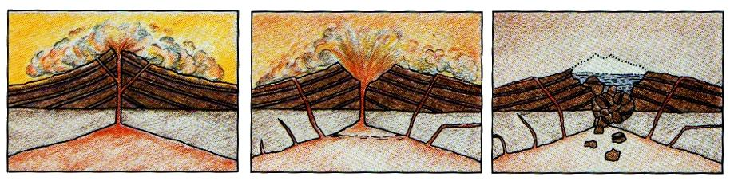
Figure 10-3. Crater Lake is located in a caldera that formed after a violent eruption of Mount Mazama. How long ago did that eruption occur?
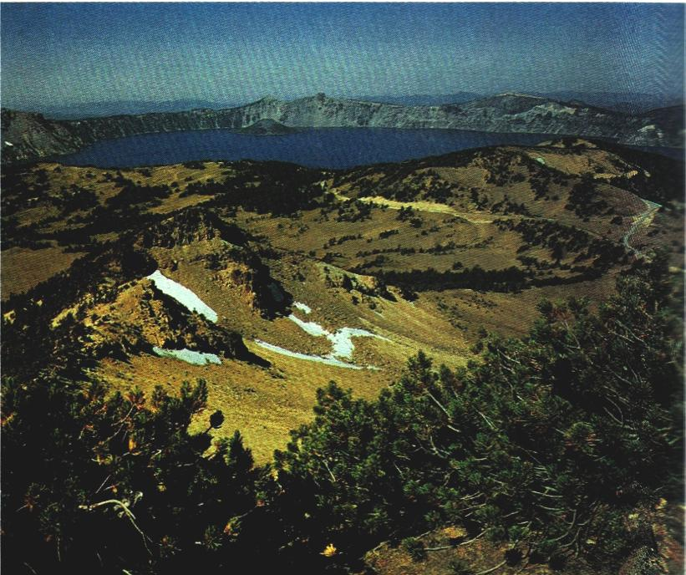
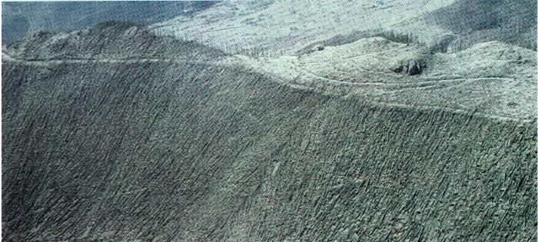
Figure 10-5. The bleak landscape of the Mount St. Helens blast area is a grim reminder of the death-dealing nature of volcanoes.

Figure 10-6. These erosion patterns were photographed in the Valley of the 10,000 Smokes, Alaska. How and when was this valley formed?

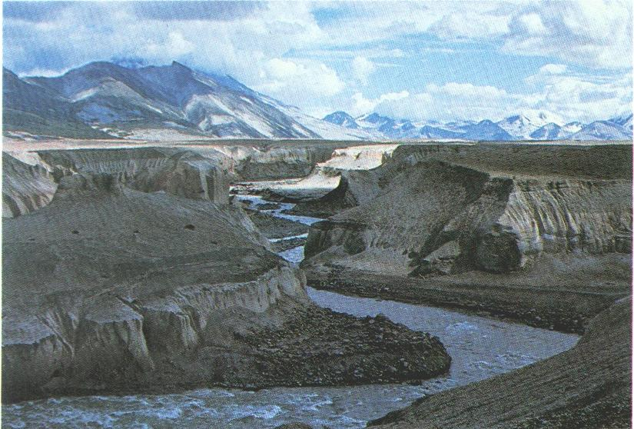

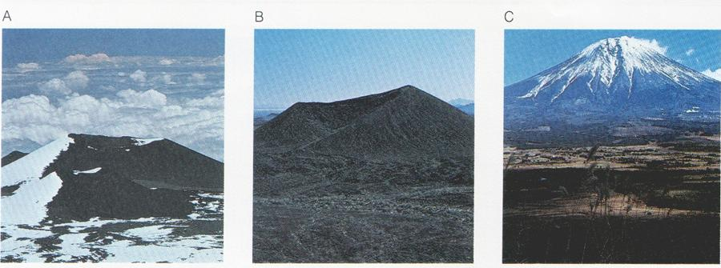
Figure 10-7. (A) Mauna Kea, Hawaii, shield cone.
(B) Cinder cone in a volcanic field near Sonora, Mexico.
(C) Mount Fuji. Japan, composite cone.

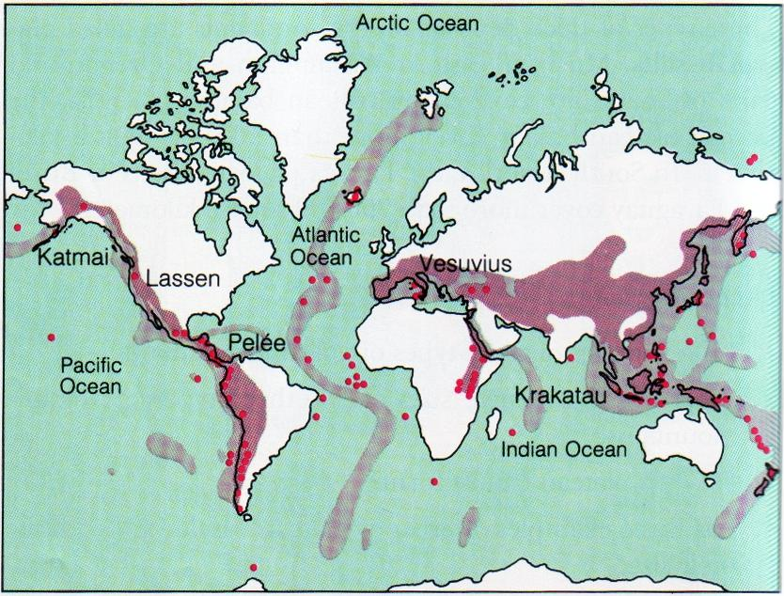
Figure 10-8. Many volcanoes are located around the edge of the Pacific Ocean and form what is called the Circum-Pacific Ring of Fire. Where are many volcanoes of the Atlantic Ocean?

Figure 10-9. Surtsey, off the southern coast of Iceland, is located along the mid-ocean ridge, a site of much volcanic activity.
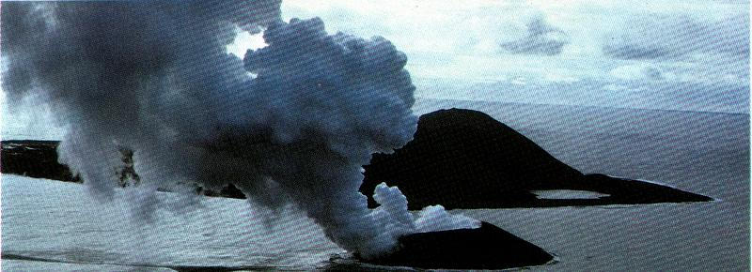
Fariel, R. - Hinds, R. - Berey, D.: Earth Science, Addison-Wesley 1987
Mid-Ocean Ridges
The Mid-Ocean Ridge system, snaking its way between the continents, is more than 56,000 kilometers long. This series of mountains and valleys marks where the Earth’s crustal plates are moving apart.

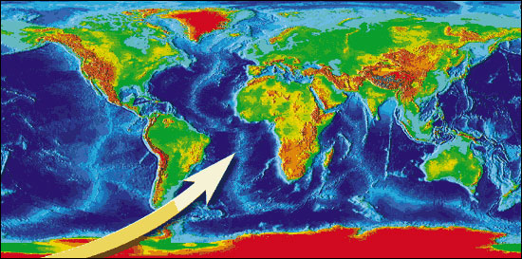

http://www.platetectonics.com

