Anion Receptor Bambus[6]uril

Jan Svec, Vladimir Sindelar

Department of Chemistry, Masaryk University, Kamenice 5, 625 00 Brno, Czech Republic

Glycoluril is a rigid bicyclic molecule that has been used as a building block of various supramolecular objects. Besides acyclic supramolecular hosts based on glycoluril, such as molecular clips, glycoluril oligomers and capsules, the most attention is paid to macrocyclic compounds - cucurbiturils. Recently, we prepared a new macrocyclic derivatives based on glycoluril - bambus[6]uril (BU[6]). The macrocycle is prepared by acid catalyzed condensation between 2,4-dimethylglycoluril and formaldehyde. The reaction is carried out in diluted HCl which acts not only as a catalyst but also as a template. BU[6] and chloride anion form an inclusion complex in which anion is localized in the middle of positively charged cavity of the macrocycle. In our poster presentation, we will present the ability of BU[6] to bind various anions in various solvent mixtures with high affinity and selectivity. We will also discuss method for the preparation of anion-free macrocycle.

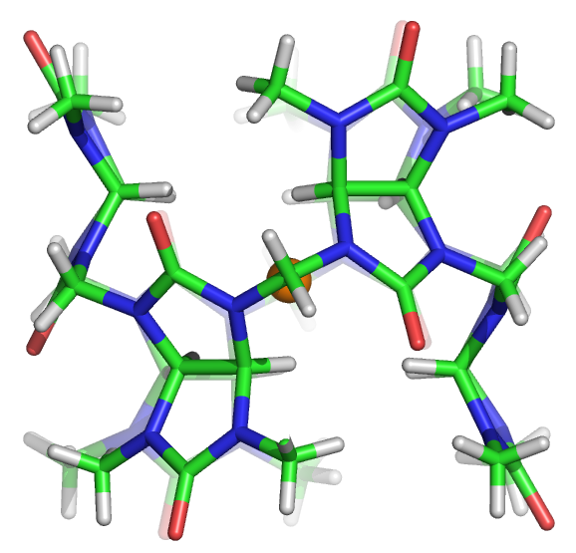
BU[6]·HCl complex

Support for this work was provided by the Grant Agency of the Czech Republic (P207/10/0695) and the project CETOCOEN (no. CZ.1.05/2.1.00/01.0001) from the European Regional Development Fund.

