Srdečně vás zveme na Zoologický seminář

Jamie Caroline Winternitz
(Odum School of Ecology, University of Georgia, Athens a ÚBO AV ČR)

Mechanisms of selection and immune gene diversity in the montane vole and other wild mammals

Guadalupe Corcobado
(Department of Functional and Evolutionary Ecology, Estación Experimental de Zonas Áridas – CSIC, Spain)

Implications of locomotor ability of spiders (Araneae) in the adaptive evolution of size and shape depending on sex, habitat and living mode
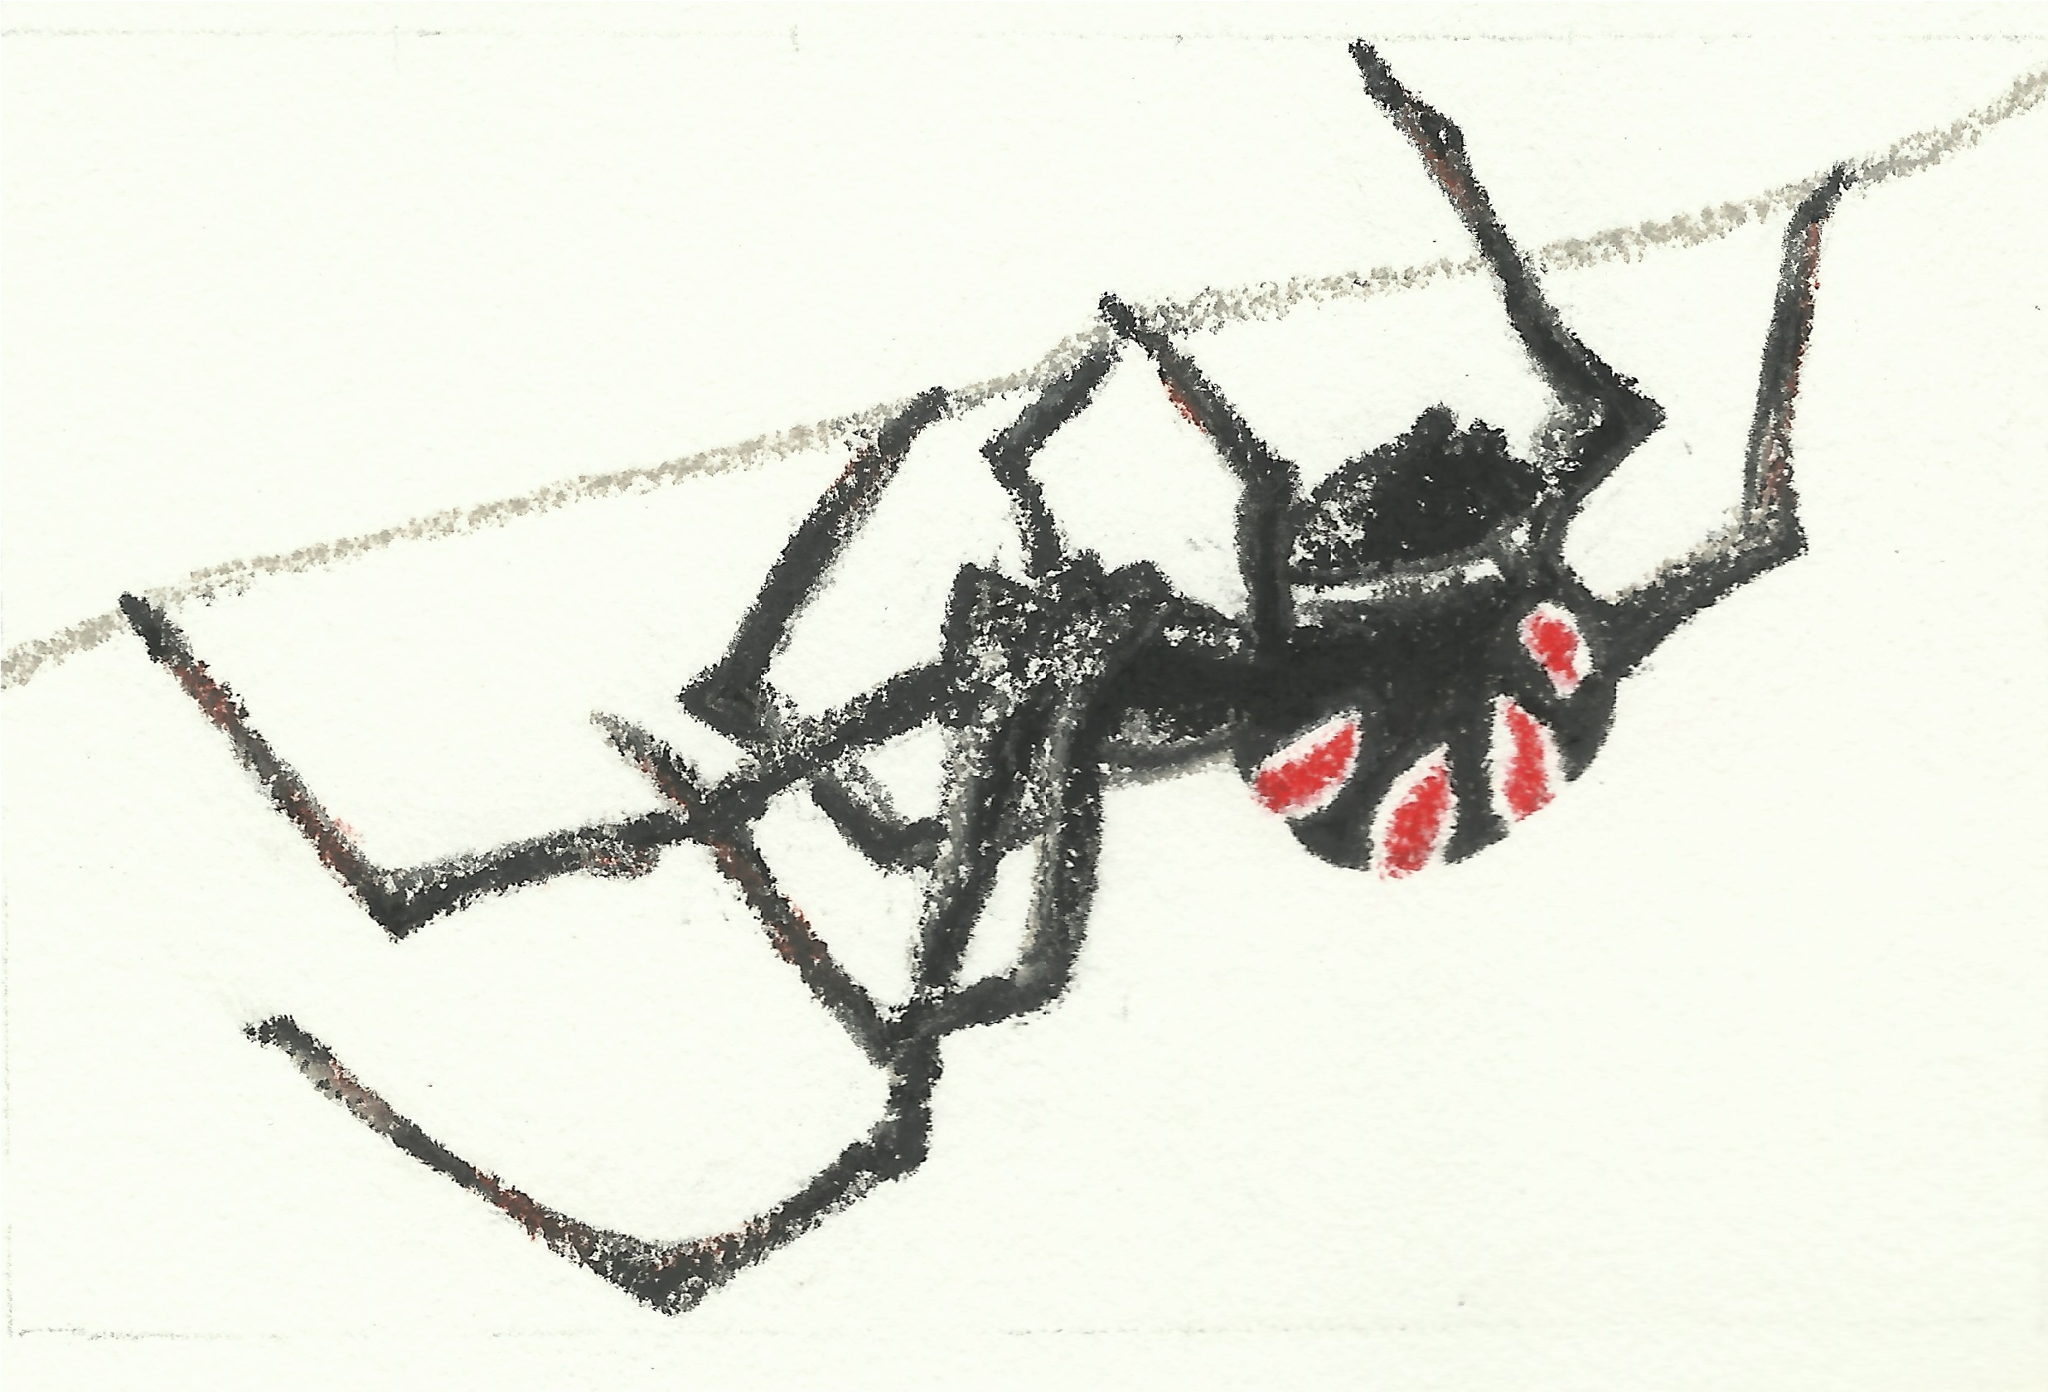
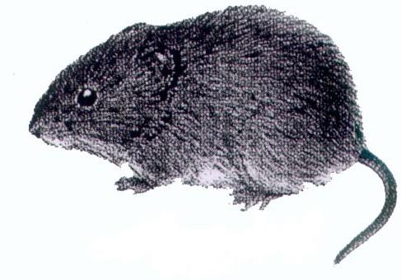

9. 5. 2013

ve 13:00

posluchárna BR3 (budova č. 23)
Terezy Novákové 64, Brno-Řečkovice

