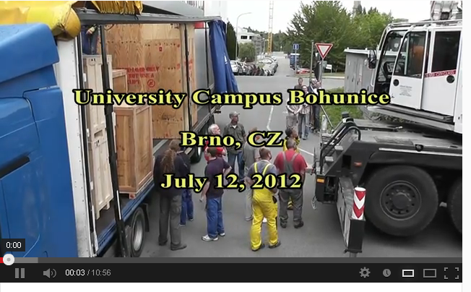

http://www.youtube.com/watch?v=AH9WY76LuP0

