Deposition
Suppose you find a deposit of earth materials many meters thick. The bottom layers contain a wide range of particle sizes. The particles are angular and of different shapes. The upper layers contain particles that are the same size and they are rounded, with smooth surfaces. This evidence provides clues to what happened in that area.
The deposits left by each agent of erosion differ greatly. In the example just mentioned, the evidence indicates both glacial deposits (the lower layers) and deposits eroded by running water (the upper layers). As you might have inferred, deposition means the process whereby particles and fragments of earth materials are deposited or laid down by an agent of erosion.

Deposition by running water
Deposits formed from running water contain layers of different particle sizes. Also, the particles deposited from running water are rounded rather than angular. As the particles are carried along by the water, they become round and smooth from striking each other.
Rivers and streams carry particles of weathered earth materials like soil and rock downstream. The size of the particles a stream can carry depends on the volume and speed of the water. When a river reaches the sea, the water slows down. As the flow of the water slows down, the particles begin to settle to the bottom. In a process called sorting, the largest and densest particles settle out first. As the flow becomes slower and slower, increasingly smaller particles settle out until all material has been deposited except the material in solution.
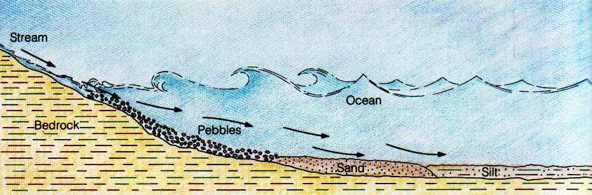
Figure 9-18. This diagram shows a profile of the deposits of material near the mouth of a river. Why are the smaller particles found farther out?

As deposits build up near the mouth of a river, the slope of the riverbed decreases. This further slows down the speed of the water. Smaller and smaller particles settle out in layers as the speed of the flow decreases. That is why a cross section of the deposits near the mouth of a river will show the largest particles near the bottom of the deposit. The particles become smaller and smaller toward the top of the deposit.
Along the coasts of continents, layers of deposits build up wherever rivers flow into the sea. Deposits from large rivers can cover many square kilometers and can be hundreds and even thousands of meters thick. As a river enters the sea, the particles carried by the river are deposited in the shape of a fan. A deposit near the mouth of a river is called a delta.
Delta regions contain rich soils that have formed from materials deposited from the water.
Soils formed from eroded materials are called transported soils. Other soils, which remain near the bedrock from which they have weathered, are called residual soils.
Transported soils have often determined the location of human civilizations. Farming has always been important because it provides the food needed for life. Due to heavy precipitation in the fall or spring, the volume of some rivers increases greatly. These rivers overflow their banks at least once a year. Figure 9-19 shows a valley where this happens. The soil in such a valley is very rich from material deposited by the overflowing river. Some of the earliest civilizations developed in such regions because the soil was good for farming.

Check yourself
- Explain the underlined words in the text.
- As a river begins to slow down, which particles settle first?
- Compare the size of the particles at a cross section near the mouth of a river.
- How do transported soils differ from residual soils?

Stream erosion and deposition
In some places in a stream or river, it is possible to observe evidence that erosion and deposition are both taking place at the same time. One such place is at a curve, or meander, in a river or stream, as shown in the top view in Figure 9-20.
When the water in a river reaches a meander, the speed of the water changes. Along the outside of the meander, the speed of the water increases. The increase in speed causes erosion. That is why the riverbank along the outside of the meander (labeled A in the diagram) is steeper than the riverbank along the inside. Along the outside of the meander, it is possible to observe material being eroded away from the riverbank.
Along the inside of the meander of a river or stream, the water slows down. This decrease in speed causes material to be deposited along the inside of the meander. That is why the riverbank along the inside of the meander slopes more gently than the steeper bank on the outside of the meander.
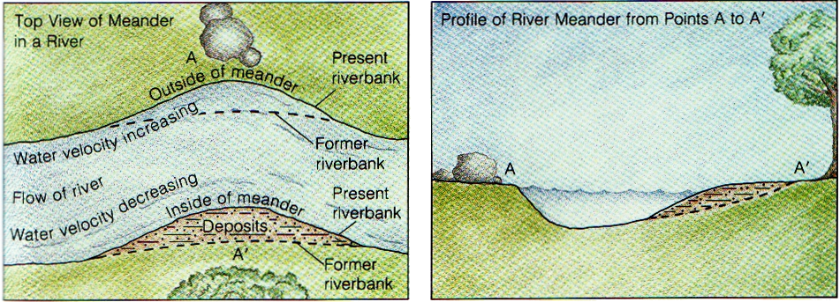
Figure 9-20. Erosion is the dominant process on the outside of a meander.
Deposition is the dominant process on the inside.

Check yourself
- At a meander, where does the most erosion take place? Why?
- How can both erosion and deposition take place at the same meander?

Deposition by wind
Winds can carry only very small particles. Therefore, deposits formed by winds contain particles that are all small and all about the same size. Also, the surfaces of particles carried by wind become scratched from striking each other.
On a worldwide basis, the effects of wind erosion and deposition are more limited than those of running water and glaciers. In a desert, however, it is often possible to see the distinctive effect of wind on the shaping of the landscape. The most distinctive wind-formed feature of a desert landscape is the sand dune. As shown in Figure 9-21, the sand dune is commonly a crescent-shaped mound of sand.
Figure 9-22 illustrates how a sand dune drifts. Wind carries the sand up and over the gentle slope of the windward side the sand dune. The sand is then deposited along the steep-slope of the slip face or a leeward side, which is the side away from the wind. This erosion and deposition causes the sand dune to move in the direction that the wind is blowing. This is what is meant when people refer to drifting sand dunes in a desert.
Figure 9-23 is a close-up photograph of rock layers in Utah´s Zion National Park. These rock layers are really buried sand dunes whose grains have been cemented into rock. If you look closely you can see the slanted sides of what formerly were sand dunes. The rock layers are hundreds of meters thick. Just imagine how long it must have taken for all of those sand dunes to build one on top of another.
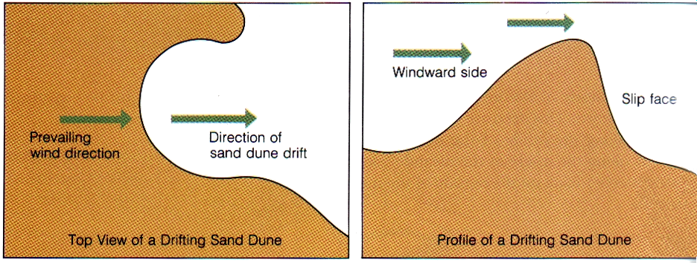
Figure 9-22. The steeper side of a sand dune, the side away from the wind, is called the slip face, or a ……………………………………….. .

Check yourself
- What are three characteristics of particles deposited by the wind?
- A sand dune involves both erosion and deposition. Explain.
- Explain the underlined words in the text.

Deposition by glaciers
Glacial deposits are easy to identify. They may contain a wide range of particle sizes—from tiny grains to large boulders. When a glacier moves, it picks up and carries particles of all sizes. This mixture is deposited when the glacier melts. Because the particles are carried frozen in the ice, they do not become rounded and sorted like particles carried by running water.
The deposits of material made by advancing or retreating glaciers along their margins (or edges) are called moraines. The deposit formed at the foot or end of the glacier is called an end moraine. If that point is the farthest south that the glacier advanced, this end moraine is called a terminal moraine. At some locations in the United States, there are terminal moraine deposits with a thickness of 30 m or more.
Sometimes a glacial lobe will form along the side of a continental glacier. This lobe of ice, which sticks out like a tongue from the main ice mass, may be more than 30 km wide.
The melting ice at the foot of the glacier forms rivers and streams that carry with them the smaller particles. Most of this material is deposited and sorted within a few kilometers of the foot of the glacier, as the speed of the running water decreases. This area of deposition is called an outwash plain. Figure 9-24 shows the outwash plain at the foot of a glacier. Most of the earth material, including all the large particles, is deposited at the foot of the glacier. The smaller particles are carried away from the foot of the glacier and deposited on the outwash plain, which has a gentle slope.
The material in a glacial moraine is called till. Till can easily be distinguished from river deposits because it contains such a wide variety of unsorted and unrounded particles that range in size anywhere from boulders to tiny fragments.
The material that is carried away from the glacial moraine by meltwater and deposited in the outwash plain is called stratified drift. Stratified drift is similar to river deposits in that the particles are well sorted. As the meltwater slows down, the largest particles settle out first. Farther out on the outwash plain, particles are deposited in increasingly smaller size.
Continental glaciers produce many interesting and unique landscape features. Figure 9-25 shows a series of drumlins, which are smoothly rounded hills of glacial till. From the air, drumlins are more or less teardrop-shaped. The narrow end of the "teardrop" points in the direction in which the glacier was moving. (The word drumlin comes from the Irish word druim, which means "a narrow ridge.")
How drumlins formed is something of a mystery. One theory suggests that drumlins solidified from a fluid mass of rock, soil, ice, and water that flows along with and under an advancing glacier. Increases in pressure, caused perhaps by rocks or other obstructions on the earth's surface, "squeeze" the water out of the fluid mass and cause it to solidify. The abrasive action caused by the glacier's continued movement over this solid mass would tend to explain why the surface of this kind of glacial deposit is so well rounded.
Sometimes large blocks of ice break off from a glacier and become buried under large masses of overlying deposits. When the ice melts, a large cavity in the deposit is left behind. The cavity, which fills with water from the melting ice, forms a kettle lake. Kettle lakes are usually round and very deep.

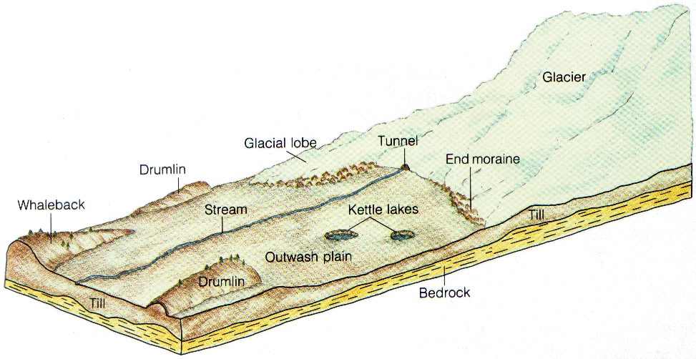
Figure 9-24. How do the particles deposited at the foot of a glacier differ from those deposited on the outwash plain?

Check yourself
- River deposits are said to be well sorted. How are they sorted? What causes the sorting?
- Compare a moraine with stratified drift.
How are they similar?
How are they different?
- What verbs refer to a glacier which moves forward /backward?
- What are big stones called?
- Explain the underlined words in the text.

Adapted from Fariel, R. - Hinds, R. - Berey, D.: Earth Science, Addison-Wesley 1987
English for Geology, Věra Hranáčová, 2012
Homework
Translation
- Částice unáčené vodou se zakulacují a ohlazují.
- Jakmile se tok vody zpomalí, částice se začnou usazovat na dno.
- Svahy říčního koryta se zvolňují.
- Zvýšení rychlosti toku proudu způsobuje erozi.
- Snížení rychlosti toku způsobuje ukládání materiálu na vnitřním oblouku menadru.
(Použij vazbu akuzativ + infinitiv: st causes st else to …..)
- Nejvýraznějším krajinným útvarem vytvořeným větrem je písečná duna.
- Pokud se podíváte blíže, vidíte šikmé strany původních dun.
- Til se snadno rozezná od říčních usazenin, protože obsahuje širokou škálu neutříděných a nezakulacených částic, od velkých balvanů po drobné úlomky.
- Při pohledu shora mají drumliny tvar slzy. Užší konec ukazuje směr, ve kterém se ledovec pohyboval.
Substitute the underlined word without changing the meaning.
Due to heavy precipitation in the fall or spring, the volume of some rivers increases greatly.

That is why the riverbank along the outside of the meander is steeper than the riverbank along the inside.

English for Geology, Věra Hranáčová, 2012

