The Interaction of Light and Small Molecules with Certain Boron Hydrides.

Dr. Michael Londesborough
Institute of Inorganic Chemistry of the AS CR, v.v.i., 250 68 Husinec-Řež, Czech Republic

The boron hydrides are a group of compounds new to our planet. There is no mechanism leading to their synthesis in nature. Instead it was German Chemist, Alfred Stock, who in 1912 first developed the vacuum-line techniques necessary for their production. Over the last 100 years the boron hydrides have proved to be the richest and most diverse of all hydride series apart from the obvious exception of the hydrocarbons. Our laboratories at the Institute of Inorganic Chemistry have a long history, dating from an era of top secret research during the Cold War, in developing the basic chemistry of the boron hydrides and applying their unique properties in areas such as microelectronics, novel materials, and medicine. This contribution will discuss new results^{[1-3]} regarding the interaction of light and small molecules with certain boron hydrides.

The talk will focus on two main areas. The first is our discovery of the propensity of bimetallic boron hydride [L₄M₂B₁₀H₁₀] cluster systems, such as [(PMe₂Ph)₄Pt₂B₁₀H₁₀] shown in Fig.1, to reversibly capture small gaseous molecules such as O₂, CO and SO₂. This property is accompanied by a clear colour changes, and may be controlled via alterations in pressure or irradiation with UV light. Presented will also be our work on tuning this system to suit various criteria, and our steps being taken towards the application of this property.
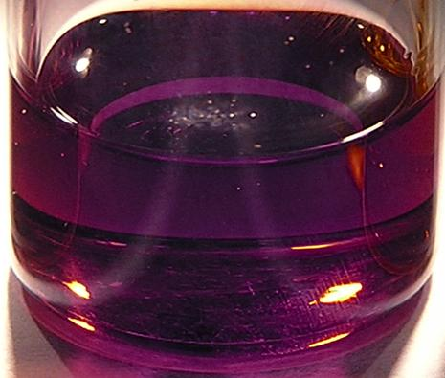
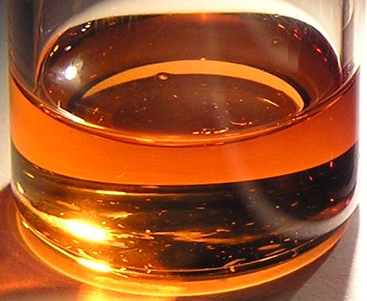
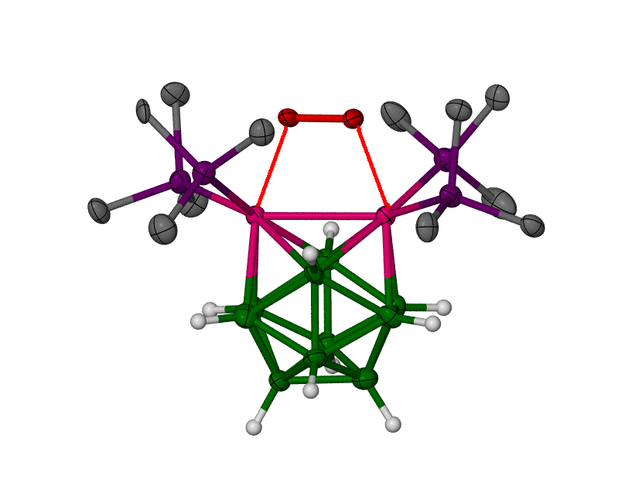

Fig.1. Picture of [(PMe₂Ph)₄Pt₂B₁₀H₁₀] with a sequestered molecule of O₂ (left). Graph showing the release of sequestered molecule of O₂ via irradiation with UV light and the associated colour changes (right).

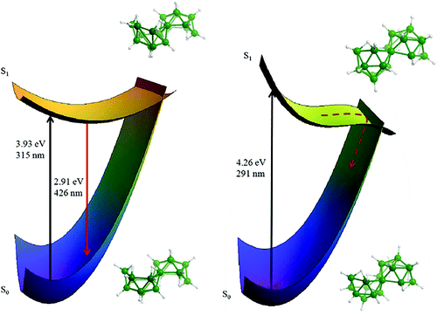
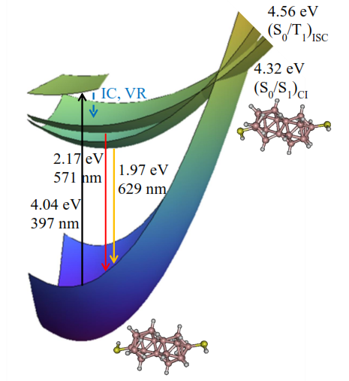
The second part of the talk will be focused on our recent work describing the fluorescent properties of the large boron hydride, B₁₈H₂₂. The photophysical properties of this compound are unique amongst the boron hydrides, and include a blue-light fluorescence under UV irradiation with a Φ=0.97 quantum yield. In addition we have found that the tuning of the photophysical properties of the highly fluorescent boron hydride cluster anti-isomer of B₁₈H₂₂ is possible by the straight-forward chemical substitution to produce 4,4’-(HS)₂-anti-B₁₈H₂₀, which facilitates intersystem crossing from excited singlet states to a triplet manifold. This subsequently enhances O₂(¹Δ_{g}) singlet oxygen production.

Fig 2. Photophysics of B₁₈H₂₂ isomers; (left) anti-B₁₈H₂₂ isomer showing fluorescence, and (centre) syn-B₁₈H₂₂ isomer showing non-radiative relaxation to ground state. Photophysics of 4,4’-(HS)₂-anti-B₁₈H₂₀ (right).

Other related results will also be mentioned and discussed.

References.
[1] M.G.S Londesborough, K. Lang, J. Oliva, et al., “Distinct Photophysics of the Isomers of B₁₈H₂₂ Explained.” Inorg. Chem. 2012, 51, 1471-1479.
[2] M.G.S Londesborough, K. Lang, J. Oliva, et al., “Tuning the Photophysical Properties of anti-B₁₈H₂₂: Quantum Hopping between Excited Singlet and Triplet States in new 4,4’-(HS)₂-anti-B₁₈H₂₀.” Inorg. Chem. 2013, Submitted.
[3] J. Bould, M.G.S Londesborough, T. Baše, K. Lang, et al., “Reversible Capture of Small Molecules On Bimetallaborane Clusters: Synthesis, Structural Characterization, and Photophysical Aspects.” Inorg. Chem. 2011, 50, 7511-7523.

Michael G.S. Londesborough Feburary 2013

