PLAGIARISM

1. Study the diagram below.

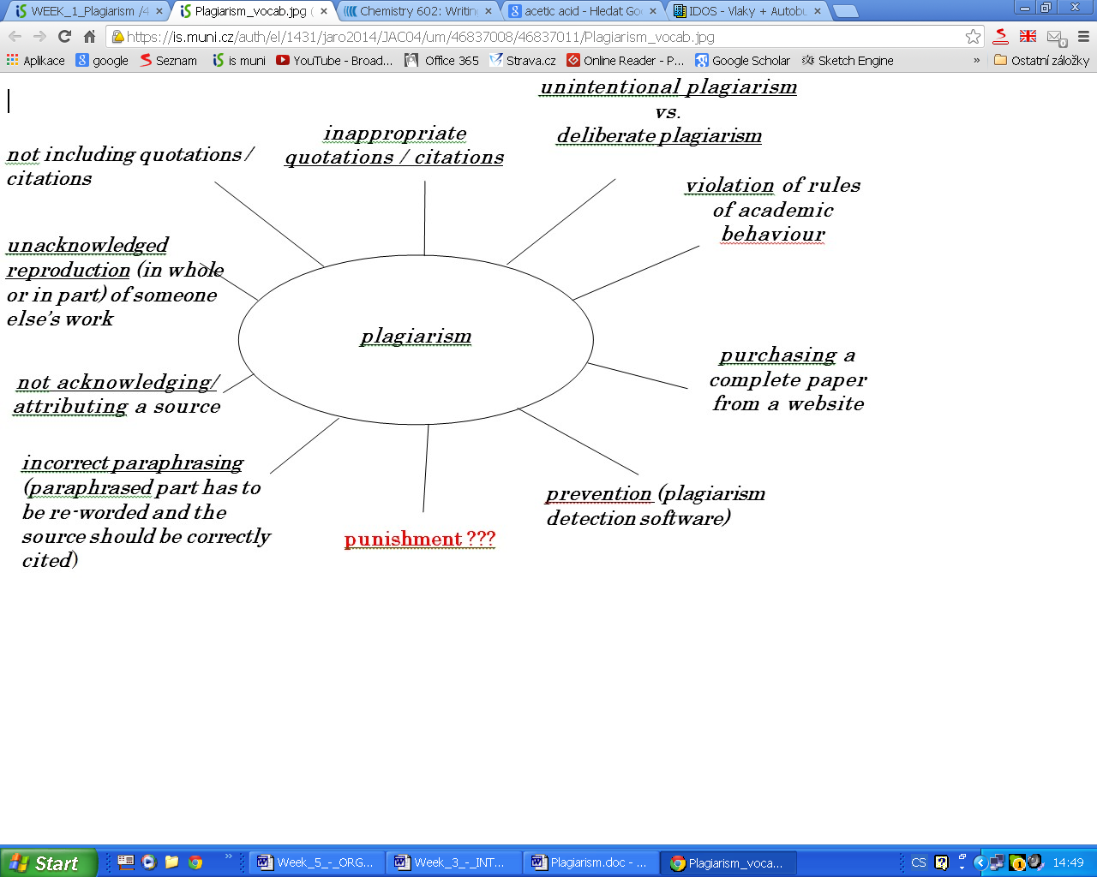

2. Watch these two explanatory videos

http://www.youtube.com/watch?v=2q0NlWcTq1Y&feature=related
http://www.youtube.com/watch?v=NK7PdBBG5po&feature=related

3. Explain what plagiarism is and give examples:

4. Match the words with correct meanings:
1. forgery A an author's statement announcing his use of the works of other authors
2. fraud B an idea or abstract principle which relates to a particular subject
3. acknowledgement C saying that something/somebody has a particular quality or feature
4. offense / offence D the crime of copying e.g. money or documents so that they look genuine in order to deceive people
5. attribution E something that deceives people in an illegal or immoral way, a swindle
6. concept F a crime which breaks a particular law and requires a punishment

5. Complete the text and use the words on the right in correct forms.
Plagiarism
Plagiarism (from the Latin plagiare, "to kidnap") is the practice of claiming, or implying, original authorship of (or incorporating material from) someone else's written or creative work, in whole or in part, into one's own without adequate 1)________________. Unlike ACKNOWLEDGE cases of forgery, in which the 2) __________________of the writing, document, or some AUTHENTIC other kind of object, itself is in question, plagiarism is concerned with the issue of false attribution. Plagiarism can also occur 3)________________; in some cultures certain forms CONSCIOUS of plagiarism are accepted because the concept can be interpreted differently.
Within academia, plagiarism by students, professors, or researchers is considered academic HONEST 4)________________ or academic fraud. Some individuals caught plagiarizing in academic contexts claim that they plagiarized 5)________________ , by failing to include quotations INTENTION or give the appropriate citation. While plagiarism in scholarship and journalism has a centuries-old history, the 6)________________of the Internet, where articles appear as DEVELOP electronic text, has made the physical act of copying the work of others much easier, simply by copying and pasting text from one web page to another.
In the academic world, plagiarism by students is a very serious offense that can result in punishments such as a failing grade on the particular 7)________________ (typically at ASSIGN the high school level) or a failing grade for the course (typically at the college or university level).
Repetition in student projects or paper topics between academic terms and years provides students with ample resources from which to plagiarize. Many students feel pressured to get papers done well and quickly, and with the 8)________________ of new technology ACCESS (The Internet) it is quite possible for students to plagiarize by copying and pasting information from another source. This type of plagiarism is often easily detected by teachers, for several reasons. First, students' choice of sources is frequently 9)________________as well; ORIGIN instructors may receive the same passage copied from a popular source (such as Wikipedia) from several students. Second, it is often easy to tell whether or not a student is using his or her own "voice." Third, students may choose sources which are 10)____________________, PROPER off-topic, or even wrong. Fourth, many universities now use plagiarism detection software.

Adapted from: http://en.wikipedia.org/wiki/Plagiarism

Key 1D, 2E, 3A, 4F, 5C, 6B
1 acknowledgement, 2 authenticity, 3 consciously, 4 dishonesty, 5 unintentionally, 6 development, 7 assignment, 8 accessibility, 9 unoriginal, 10 improper

lesson based on Plagiarism handout by Eva Složilová

