DESIGNING AN EXPERIMENT, DESCRIBING AN EXPERIMENT

1. **Complete the collocations for describing the stages in the scientific method using the words and phrases in the box.**

|  |
| --- |
| a hypothesis an experiment (2x) conclusion data(3x) the question |

analyse ___ design ____

collect ___ draw ____

conduct (or run) ____ form ____

define ____ interpret ____

1. **Number the stages from 1-8 in the order you would normally do them.**
2. **Read the extract below and check your answers**

The scientific method is a process in which experimental observations are used to answer questions. Scientists use the scientific method to search for relationships between items. That is, experiments are designed so that one variable is changed and the effects of the change observed. While the exact methodologies used vary from field to field, the overall process is the same. First, the scientist must define the question – what exactly they are trying to find out. Next comes the formation of a hypothesis, which is an idea or explanation for a situation based on what is currently known. The next stage of the method is the design of an experiment which will allow this hypothesis to be tested. Usually a primary run of the experiment is conducted, and any changes to the experimental set-up made. In each experimental run, data collection takes place, followed by data analysis. Finally the data is interpreted and from this, the scientist is able to draw conclusions.

1. **Find in the text the noun forms of the verbs in the box below.**

|  |
| --- |
| analyse collect design explain form observe relate run vary hypothesise |

1. **Find in the text words that mean the same as the synonyms/definitions below (one word per definition).** They appear in the text in the same order as the order of the definitions.
2. a number or quantity that can change or be changed;
3. be different from each other;
4. whole, covering or including everything;
5. an idea or explanation based on a few facts, but not yet proved to be true or correct;
6. now
7. first
8. understood in a certain way;
9. results, outcomes
10. Read each summary and then choose which word correctly completes the heading.
11. Practical/Theoretical research

Murray Gell-Mann and George Zweig proposed that particles such as protons and neutrons were not elementary particles, but instead were composed of combinations of quarks and antiquarks.

1. Field/Laboratory experiment

Mark-and-recapture models were used to measure seasonal and habitat changes in house mouse densities on sub-Antarctic Marion Islands.

1. External/Internal validity

The students were carefully matched for social status, subject area, ethnicity, education level, parental smoking, and exposure to targeted advertising.

1. Descriptive/Experimental study

The amount of soy products eaten by each participant was assessed at the start of the study. During the 30 years of the study, the women’s incidence of breast cancer was recorded.

1. Qualitative/Quantitative research

To investigate the effect of eating dark chocolate on stress levels, a blood sample was taken and the levels of stress hormones measured. After eating the chocolate, a second sample was taken and hormone levels measured again.

1. **Complete the text below on variables. There are three words too many.**

|  |
| --- |
| depends affecting affects collecting dependent independent controlled data samples |

How much a variable 1.___________ a relationship can be discovered by 2._____________ experimental 3.___________ on changes to the relationship as the variable is changed. In an experiment, there will be: one 4.___________ variable – this is the feature you are measuring; one or more 5.__________ variables – these are the variables which you change; one or more 6.___________ variables – these are not being tested and so they stay the same.

1. **Look at the sentences taken from descriptions of various experiments and choose the right preposition (a, b or c) to complete them.**
2. First, leucine was separated _____ other amino acids in the protein hydrolysate.

a for b from c with

1. Many bacteria, such as Bacillus spp., can be isolated ______ insects.

a from b to c with

1. Subsequently, the specimens were embedded _____ methylmethacrylate.

a at b in c to

1. The sections were stained ____ uranylacetate and lead citrate solution.

a with b to c under

1. pH is maintained _______ 6.5, using Waterlife Buffer and Sera pH Minus

a at b in c to

1. **The abbreviations and symbols below could all be used in a scientist’s lab notebook. What do they mean?**
2. 5. 9.
3. RT 6. 10. w/
4. w/v 7. 11.
5. @ 8. E
6. **Decide how you might represent each of the following in a lab notebook.**
7. decreases 6. volume per volume
8. degrees Celsius 7. without
9. kelvin 8. two to one ratio
10. greater than or equal to 9. hours
11. positive 10. Concentration
12. **Listen to the recording and complete the notes from the lab notebook with a number and/or abbreviation or symbol from the two previous exercises.**

5mg char into TGA pan.

*Heat* **1***___________ -* **2***___________ - hold 30 min*

*=***3***_____________ from last time*

*Heat 20* **4***__________ /min to 873 K*

*then* **5***___________ rate –* **6***__________ K/min*

*to 1473 K.*

*Gas = high purity CO2*

*(***7***_________ 25%) +N2*

**XII. Label the laboratory equipment in the picture below.**

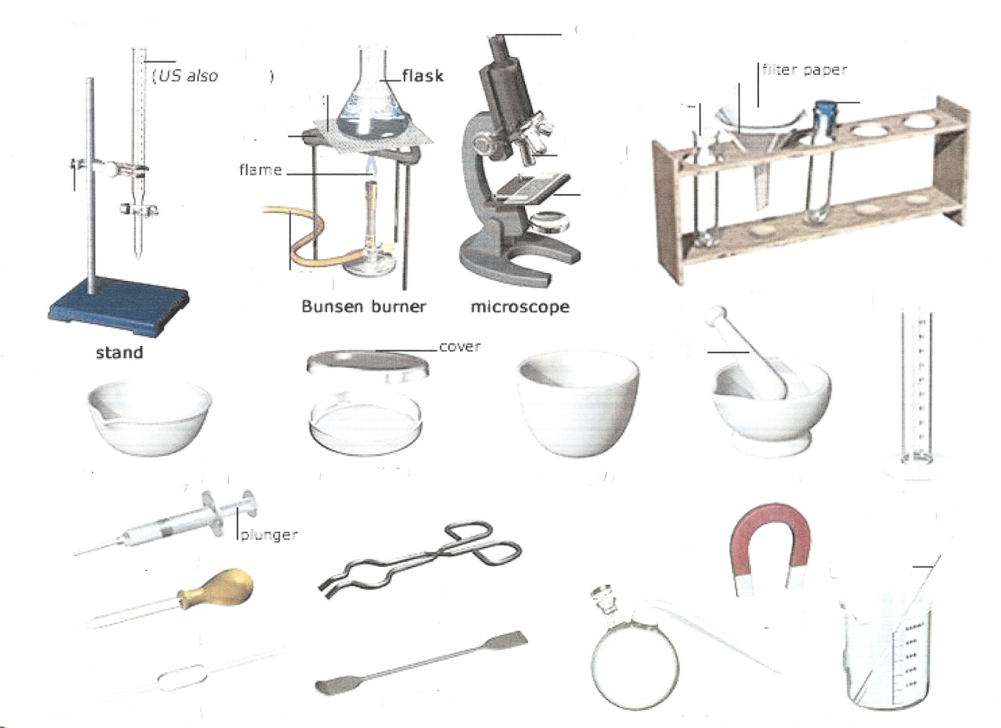

**XIII. Read the description of an experiment below. Then, in groups, think about another experiment and prepare to describe it to the class, stating its purpose, materials, steps, results and conclusion.**

-**An elephant trunk of hot water**-  
  
**Purpose**: To know which kind of water has less relative density: hot or cold water.  
  
**Materials:**  
1. Two empty similar bottles.  
2. A sheet of wax paper.  
3. Hot water.  
4. Cold water.  
5. Red ink (or any colour).  
  
**Steps:**  
- First, put some of the red ink in one of the bottles.  
- Then, fill the same bottle with hot water to the top  
- After that, fill the other bottle with cold water and cover  its mouth with a sheet of wax paper.  
- Next, put the bottle with cold water upside down on  the  bottle which contains the hot water and the ink, with the wax paper between them.  
- Finally, drag the wax paper gently from between the two bottles.  
- Pay attention not to spill any water while doing the last step.  
  
**Result:** The hot water goes up in the bottle of the cold water as an elephant trunk.  
  
**Conclusion**: What we conclude from this experiment is that hot water is lighter than cold water. This means the relative density of hot water is less than the relative density of cold water.