1. Scientific Method
1. Key terms
science measurement hypothesis experiment law theory

scientific method scientific attitude standard unit

Match each key term with a description
- a fixed value for making measurements
- having curiosity, objectivity, and rationality
- a process in which a theory of nature must be in agreement with experimental results
- an organized body of knowledge about the natural universe
- a concise statement about a fundamental relationship of nature
- a controlled observation of a natural phenomenon
- a very tentative, possible answer, an educated guess
- a quantitative observation
- a well-tested explanation

2. Discuss the questions
- What is your definition of science?

……………………………………………………………………………………………
- Which generally comes first in solving problems – hypothesis or experiment?
- What characteristics are necessary for having a scientific attitude?
biased, unbiased, objective, subjective, rational, irrational, logical, intuitive, dreamy
- What are the names of the five senses? How do you rank their importance in learning about our environment, i.e. which is the most important?
- Can the senses be completely relied upon?

3. Pre-reading vocabulary

snap to take a photograph, especially without formal posing of the subject
temper to moderate, make more acceptable or suitable
contention idea, claim, declaration
howls sound like animal howling, cry of dissatisfaction and disagreement
wispy thin and weak
extol express approval of something, glorify
gullible easily deceived or cheated, naive

The “Face” on Mars

4. Complete the right forms of verbs. (Think about possible ways of expressing past).

In 1976, NASA’s Viking 1 spacecraft (circle) 1……………….. Mars and (snap) 2………………. photos when it (capture) 3……………….. the shadowy likeness of an enormous head, two miles from end to end, located in the region of Mars called Cydonia.
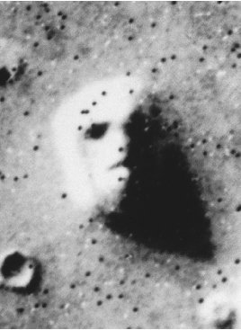

The surprise among the mission controllers at NASA was quickly tempered as planetary scientists decided that the “face” was just another Martian messa, a geological landform common in the Cydonia region. NASA released the photo to the public a few days later and believed that it (attract) 4……………….. the public’s attention to its Mars mission, and indeed it did.
The “face” on Mars became a sensation that appeared in movies, books, talk shows, websites and tabloids for years. Some people thought it (be) 5……………….. evidence for life on Mars, either at present or in the past. As for NASA’s contention that the “face” was a combination of natural landform and unusual lighting conditions, howls arose from some of the public about conspiracy. Other people, with a more developed scientific attitude, accepted NASA’s conclusion.
In 1998, twenty-two years later, the Mars Global Surveyor mission (reach) 6……………….. Mars, and its camera (snap) 7……………….. a picture of the “face” ten times sharper than the 1976 Viking photo. Thousands waited for the image to appear on NASA’s website. The photo revealed a natural landform and not an alien monument. However, the image (take) 8…………… through wispy clouds, and some of the public were still not convinced that the object was just a plain old mesa.
It was not until 2001 that the MGS camera again passed over the object. This time, there were no clouds, and the high-resolution picture was clearly that of a mesa similar to those common in the Cydonia region and in the American west.
Why would so many books and articles be written extolling the alien origin of the “face”? Perhaps many authors were trading on the gullibility and ignorance of part of the population in order to line their own pockets or to gain attention. If so, the best way to deal with similar situations in the future would be to try to improve the standard of education among the general public and to emphasize the importance of a well-developed scientific attitude.

- Reread the text and answer the questions.

- What did Viking 1 spacecraft capture?
- How did scientists temper the surprise?
- Why did NASA release the photo?
- How did the public and businesses react to the image?
- Why wasn’t the sharper picture convincing for some people?
- What proved clearly that the photo showed a messa?
- Why did many authors write about the alien origin of the “face”?
- What is the best way to deal with such situations?

Space Documentary - National Geographic: Is It Real? Life On Mars
https://www.youtube.com/watch?v=5rMXS3lWcgA

Pre-listening task

Canal
Channel
These two landforms are similar. However, they have different origin. Which one is formed naturally and which one is a man-made structure?

Do you know these words?

rumor irrigation surveillance aerial photograph resemble extraterrestrial contraption

Watch a part of the documentary and focus on the following question. 10.15 –13.09 , 43.25- 44.57
What views on Mars do these four men hold?

- Richard Hoagland (conspiracy theorist )
- Giovanni Schiaporelli ( astronomer 1835 – 1910)
- Percival Lowell (mathematician, astronomer 1855 – 1916)
- James Garvin (scientist)

PROBLEM-SOLVING

“It is a capital mistake to theorize before one has data. Insensibly one begins to twist the facts to suit the theories, instead of the theories to suit the facts. ”
Sherlock Holmes

Questions

- Are you a good problem-solver?
- What steps do you use to solve problems? Give an example of a situation when you solved a problem
- How do your steps correspond to the scientific method?

1. What’s wrong in the method shown by the diagram? Make your corrections of the process.

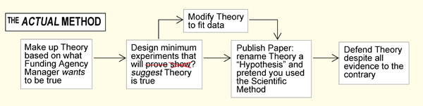

2. Suggest a correct method with the right steps. Then compare your ideas with https://www.youtube.com/watch?v=BVfI1wat2y8

3. Which of these claims are a part of the scientific method and which aren’t?

a) Experiments are conducted in a controlled way so that the results can be duplicated.
b) Results or observations that are not consistent with current beliefs are ignored.
c) If a hypothesis does not withstand repeated testing, it must be modified or rejected.
d) It starts with a conclusion and gives easy answers to complex problems.
e) It is often driven by social, political or commercial goals.
f) An attempt to disprove the beliefs is considered hostile and unacceptable.
g) A hypothesis that cannot be tested is of no use in science.
h) It is expected that modifications of laws and theories will occur.
yes a c g h , no b d e f
THE SENSES
Read about the senses and complete the text with connectors

Not only but therefore although thus

The five senses – sight, hearing, touch, taste, and smell make it possible for us to know the environment. 1__________the senses are important in studying and understanding the physical world. Most information about our environment comes through sight. Hearing ranks second in supplying the brain with information about the external world. Touch, taste, and smell, 2_________ important, rank well below sight and hearing in providing information. 3 ________ the senses have limitations. For example, the unaided eye cannot see the vast majority of stars and galaxies. Or our hearing is limited to certain frequency range. 4___________the senses have limitations, they also can be deceived, 5__________ providing false information about our environment. For example, perceived sight information may not always be a true representation of the facts because the brain can be fooled.

Some optical illusions

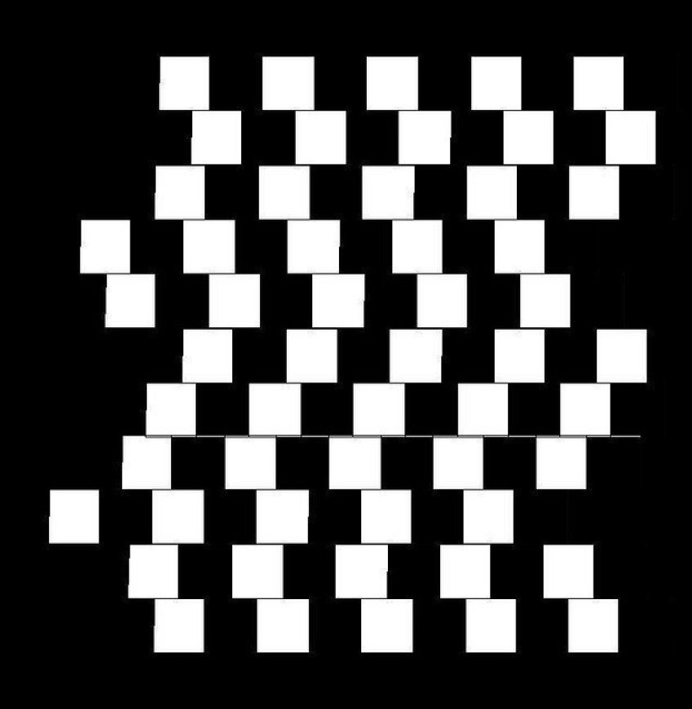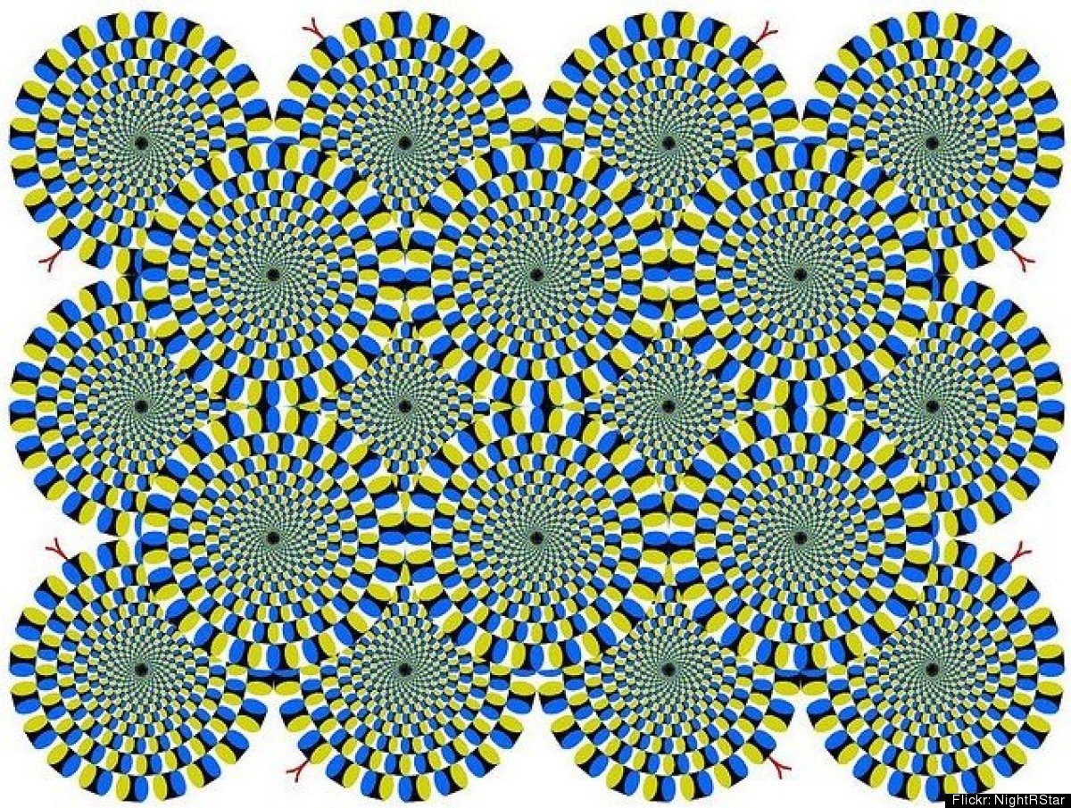
Are these lines parallel or curved? These overlapping circles give off the impression of gear-like circular movement. Try to make the motion stop.

Try and find the black dots.
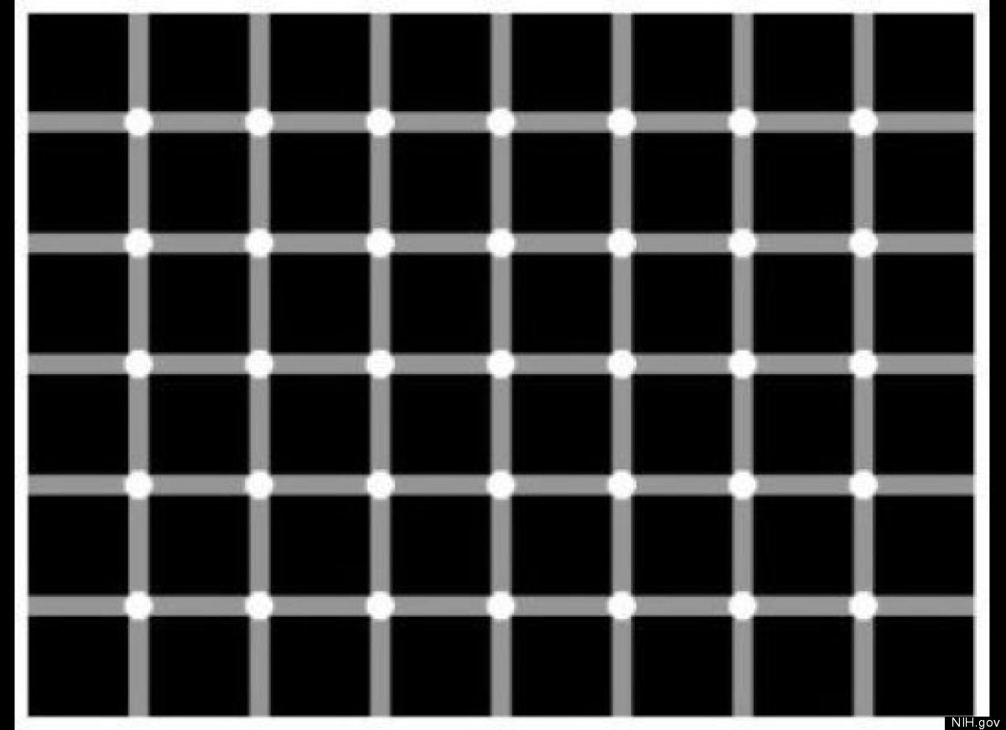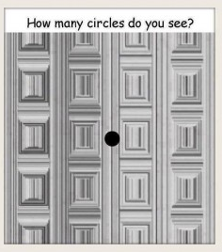

sources J. Shipman, J. Wilson, A. Todd, An Introduction to Physical Science, Houghton Mifflin Company, 2006, p.5
picture from http://www.abovetopsecret.com/forum/thread468075/pg1
http://chemwiki.ucdavis.edu/Analytical_Chemistry/Quantifying_Nature/The_Scientific_Method/Science_vs._Pseudo-science%3A_Limitations_of_the_Scientific_Method
http://pc.blogspot.cz/2014/05/piketty-bad-theory-bad-data.html

Reading for Week 3 http://www.edinformatics.com/math_science/states_of_matter.htm
OR read http://idahoptv.org/sciencetrek/topics/matter/facts.cfm

