3. States of Matter in Physical Geography

- Give different examples of different states of matter.

Describe what happens with water in the water cycle.

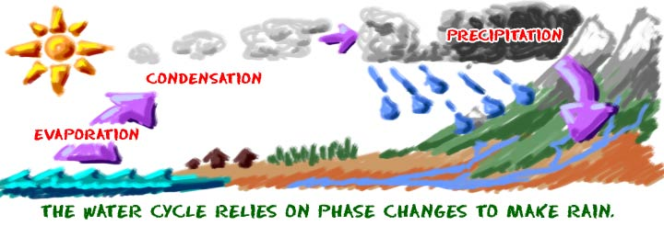

Describe what changes in state of matter can be observed in winter.

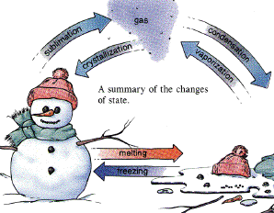

2. Match the terms with definitions.

radiation phases heat Celsius scale convection pressure conduction

  - Energy transferred because of temperature difference
  - Transfer of heat by molecular collision
  - Common forms of matter
  - Transfer of heat by mass movement
  - Force per unit area
  - Common temperature scale worldwide
  - Transfer of heat by electromagnetic waves

3. Discuss the questions in pairs.

  - What determines the phase of a substance – whether it is solid, liquid or gas?
  - Describe different states of matter in terms of shape and volume.
(e.g. …definite shape or the substance takes up the shape of the container?)
  - What is the name of a process of going a) from a solid to a gas?
b) from a gas to a solid?

Page 4 Key to Homework Ex.1- 1 solids, 2 liquids, 3liquid, 4 solids, 5 gases, 6 liquids depth, attraction, weakness
Ex. 2 1 gases, 2 gases, 3 solids, 4 liquid, gases, 5 gases, 6 plasma, plasma
LISTENING: Particulate Nature of Matter and Changes of State
https://www.youtube.com/watch?v=ndw9XYA4iF0

1. In pairs, check whether you know what these words mean and how to pronounce them.

particle framework sealed ether evaporate
string bulb nitrogen immerse shrink brittle

2. Answer the questions from the 1st part of the program. 0 – 2.56
- How are particles in a solid arranged?
- What is the process of changing a solid into a liquid called?
- How much has the temperature in the container with ice changed?
- What happens with particles in the process of evaporation?
- What temperature does ether evaporate at?
- What is the instrument for measuring temperature called?
- What can be observed on sample 4?

3. Watch the 2nd part. 2.57 – 4.19
What two changes of phase are demonstrated?

Phase Changes
1. Use of passive voice: Read the text and put the verbs in the active or in the passive forms.

Substances in our environment are usually classified as solids, liquids, or gases. These forms are called phases of matter. When heat 1. (add) ___________ to or 2. (remove) ___________ from a substance, it may undergo a change of phase. For example, when water 3. (heat) ___________ sufficiently, it 4. (boil) ___________ and 5. (change) ___________ to steam, and when enough heat 6. (remove) ___________, water 7. (change) ___________ to ice.
The temperature of the substance at which the change from solid to liquid takes place is known as the melting point. The temperature at which the change from liquid to gas phase 8. (occur) ___________ is known as the boiling point.

- Describe the processes that are illustrated in the diagram .

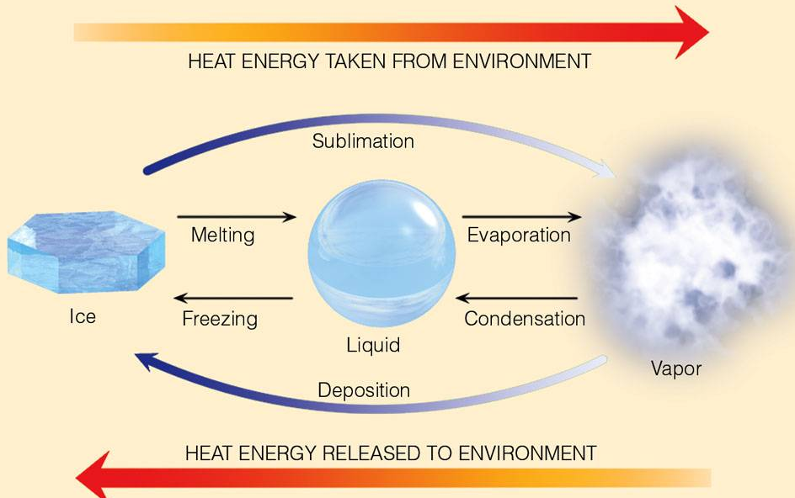

3. Change the nouns which are the names of the processes into verbs.

E.g. 1. deposition – to deposit
2.
3.
4.
5.
6.

READING: The Pressure Cooker
J. Shipman, J. Wilson, A. Todd, An Introduction to Physical Science, Houghton Mifflin Company, 2006, p.110

- What is a pressure cooker?
- What is the purpose of this device?

1. Read the text and insert the missing phrases in the right places.
Pressure has an effect 1_________. The boiling point of water increases with increasing pressure. Boiling is the process by which energetic molecules escape from a liquid. This energy is gained from heating. If the pressure is greater above the liquid, the molecules must have more energy to escape, and the liquid has to be heated 2_________ to take place.
Normally, when a heated liquid approaches the boiling point 3_________ , pockets of energetic molecules form gas bubbles. When the pressure due to the molecular activity in the bubbles is great enough, or greater than 4_________ , the bubbles rise and break the surface. We then say that the liquid is boiling. In this sense, boiling is a cooling mechanism for the water. Energy is removed, and the water’s temperature cannot exceed 100ºC.
In a sealed pressure cooker, 5_________, causing the boiling point to increase. The extra pressure is regulated by a pressure valve, which allows vapor to escape. Hence the water content of the cooker boils at a temperature greater than 100ºC and the cooking time is reduced.
At mountain altitudes, the boiling point of water may be several degrees less than at sea level. For example, at the top of Pike’s Peak (elevation 4300m), 6_________ to the point where water boils at about 86ºC rather than at 100ºC. Pressure cookers 7_________– if you want to eat on time. It is interesting to note that for high altitudes, cake mixes contain less baking powder than those at or near sea level. The baking powder supplies gas to “raise” a cake. If normal cake mixes were used at high altitudes, the cake 8_________.

A come in handy at high altitudes
B the atmospheric pressure is reduced
C would rise too much and could explode
D to a higher temperature for boiling
E in an open container
F the pressure on the surface of the liquid
G on the boiling point of water
H the pressure above the liquid is increased

After reading the text,
- describe on molecular level cooking in an open container
- describe cooking in a pressure cooker
- why is less baking powder used in high altitudes for making cakes?

2. Heat Transfer - Convection, Conduction, and Radiation

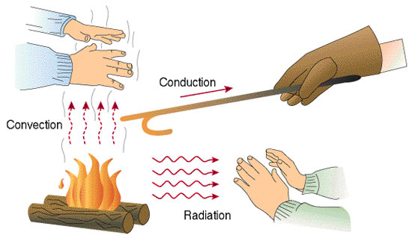
Look at the picture above and read the texts A, B, C. Decide which text is about which process.

A
The heat from the Sun is transmitted through the vacuum of space by ….. . It is the process of transferring energy by means of electromagnetic waves. Electromagnetic waves carry energy and can travel through a vacuum. Another example of heat transfer by …. is an open fire or a fireplace. We can readily fell the warmth of the fire on exposed skin.

B
… is the transfer of heat by the movement of a substance, or mass, from one position to another. The movement of heated air or water is an example. Many homes are heated by movement of hot air. The warm-air vents are usually in the floor. The warm air entering the room rises. As a result, cooler air is forced toward the floor, and cycles that promote even heating are set up in the room. Heat is distributed in the Earth’s atmosphere in a manner similar to the transfer of heat in a room.

C
…. is the transfer of heat by molecular collisions. The kinetic energy of molecules is transferred from one molecule to another through collision. How well a substance transfers heat depends on the molecular bonding. Solids, especially metals, have generally the best ability. Substances with poor ability to transfer heat are sometimes referred to as thermal insulators.

3. Sea and Land Breezes –
Convection currents in the air close to the sea.

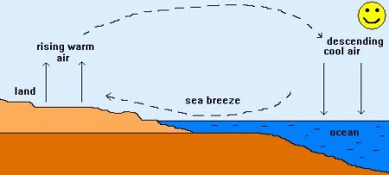 http://www.weatherwizkids.com/weather-wind.htm

gets hot moves in warms up expands

During the day the Sun 1 …………… the land and the sea, but the land warms up more than the water. As the land 2…………, it warms the air directly above it. The warm air 3 ……………. and rises and the cooler air above the sea 4………….. to take its place. The movement of cool air from the sea is called a sea breeze

Similarly, explain the formation of land breeze during the night.
K. Kelly, Science, Macmillan

HOMEWORK
1.Complete the following text with words for different states of matter.

Earth’s interior is primarily composed of 1_______ , the densest of the three states of matter. 2 _______ are not as dense as solids , and thus most of Earth’s 3________ water lies at the planet’s surface thousands of kilometers above the densest 4_________ located deep inside Earth. 5________ , with an even lower density than 6________ , have the weakest gravitational attractive force and are held relatively loosely around Earth as the atmospheric envelope, rather than within the planet or on its surface.
James Petersen, Dorothy Sack, Robert Gabler: Fundamentals of Physical Geography, p.256

2. The following adjectives are used in the text above. Try to change them into nouns.
Example dense – density deep - attractive - weak -

3.Complete these sentences with words for different phases of matter

- ________ are often invisible and assume the shape and volume of their container.
- The air we breathe is made up of different ________, but it is mostly nitrogen and oxygen.
- We can see through some ________ like glass.
- When ________ gasoline is burned in a car, it turns into various ________ which go into the air from the exhaust pipe.
- Fire is a mixture of hot ________.
- _______ is by far the most abundant state of matter in the universe because stars are mostly_______.

