Apples
The tasty fruit we eat today likely descends from wild apples in Central Asia. Wild apples' genetic diversity allows growers to develop thousands of varieties. The popular “Honeycrisp,” cultivated around 1960, is a cross of Macoun and Honeygold apples. Most apples we see in the grocery store are best for eating raw, but some varieties are more commonly used for cooking.

What's in Apples?
Apples are a good source of fiber and vitamin C. Most of the antioxidant power they provide comes from phytochemicals, including:  - Quercetin: a flavonoid that shows anti-inflammatory and antioxidant properties  - Other flavonoids, including epicatechin and, in red apples, anthocyanins  - Triterpenoids are found especially in apple peel | 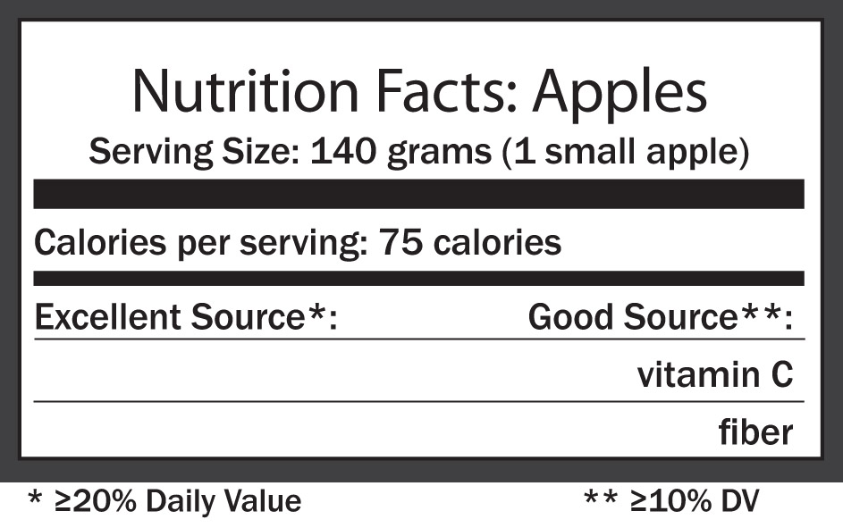

Blueberries
The blueberry is one of the few fruits native to North America. Native Americans used the berries and parts of the plant for medicine. Today, blueberries have a rockstar reputation among fruits; one popular claim is that blueberries help reduce age-related memory loss. It's too early to know whether that's true, but we do know they contain powerful phytochemicals called anthocyanins, which give these berries their blue color.

What's in Blueberries?
Blueberries are an excellent source of vitamins C and K, manganese and a good source of dietary fiber. Blueberries are among the fruits highest in antioxidant power, largely due to their many phytochemicals:  - Anthocyanins, catechins, quercetin, kaempferol and other flavonoids  - Ellagitannins and ellagic acid  - Pterostilbene and resveratrol | 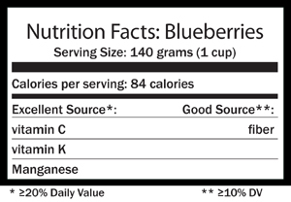

Broccoli & Cruciferous Vegetables
The four-petal flowers from these veggies resemble a cross or "crucifer," hence the name. Broccoli is probably the best known cruciferous vegetable. Like Brussels sprouts, rapini, cabbage (green), cauliflower and turnips (white), it forms a "head." Others - known as the "headless crucifers" - include dark green leafy vegetables like kale and collard greens.

What's in Cruciferous Vegetables?

Nearly all are excellent or good sources of vitamin C and some are good sources of manganese. Dark greens are high in vitamin K.  - Glucosinolates are compounds found in all cruciferous vegetables; Glucosinolates form isothiocyanates and indoles.  Other nutrients and phytochemicals vary:  - Broccoli, Brussels sprouts, cauliflower and rapini are all excellent sources of folate, a B vitamin.  - Broccoli is a good source of potassium.  - Broccoli and Brussels sprouts are good sources of dietary fiber and rich in magnesium.  - Broccoli, Brussels sprouts and rapini contain carotenoids such as beta-carotene.  - Red cabbage and radishes supply anthocyanins. Other cruciferous vegetables provide different polyphenols, such as hydroxycinnamic acids, kaempferol and quercetin. | 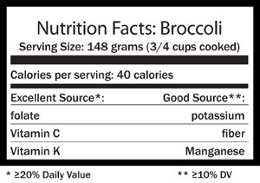

Cranberries
Cranberries grow in northern bogs on low-lying vines, just above water. These bright red gems are native to North America and at one time whalers and mariners carried cranberries on their ships to prevent scurvy. Today you've probably heard claims that cranberry juice helps prevent urinary tract infections; though it appears to help some women, it is not a treatment. We do know that with their healthful nutrients and phytochemicals along with the rich color and flavor, cranberries make a great addition to any meal, not just at Thanksgiving.

What's in Cranberries?
Cranberries are good sources of vitamin C and dietary fiber. They're very high in antioxidant power,[3-5] most of which comes from phytochemicals:  - Flavonoids, including anthocyanins, proanthocyanidins and flavonols  - Ursolic acid  - Benzoic acid and hydroxycinnamic acid | 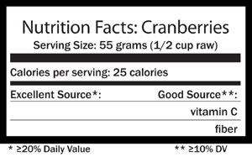

  - UPDATED: Blueberries
  - UPDATED: Broccoli & Cruciferous Vegetables
  - UPDATED: Cranberries
  - Dark Green Leafy Vegetables
  - UPDATED: Dry Beans and Peas (Legumes)
  - UPDATED: Flaxseed
  - Garlic
  - Grapes and Grape Juice
  - Green Tea
  - Soy
  - UPDATED: Squash (Winter)
  - Tomatoes
  - Whole Grains

Sign up
Subscribe to our monthly eNewsletter and email updates
Začátek formuláře
Cancer Research Update (Bi-weekly)

Foods That Fight Cancer

Dark Green Leafy Vegetables
Spinach, kale, romaine lettuce, leaf lettuce, mustard greens, collard greens, chicory and Swiss chard are excellent sources of fiber, folate and a wide range of carotenoids such as lutein and zeaxanthin, along with saponins and flavonoids.
According to AICR's second expert report, Food, Nutrition, Physical Activity, and the Prevention of Cancer: A Global Perspective, foods containing carotenoids probably protect against cancers of the mouth, pharynx and larynx.
Researchers believe that carotenoids seem to prevent cancer by acting as antioxidants – that is, scouring potentially dangerous “free radicals” from the body before they can do harm. Some laboratory research has found that the carotenoids in dark green leafy vegetables can inhibit the growth of certain types of breast cancer cells, skin cancer cells, lung cancer and stomach cancer.
The Second Expert Report also noted probable evidence that foods containing folate decrease risk of pancreatic cancer and that foods containing dietary fiber probably reduce one’s chances of developing colorectal cancer.

Legumes (Dry Beans, Split Peas & Lentils)
Kidney and black beans, yellow split peas and red lentils are among the thousands of colorful legumes. Legumes use nitrogen from the atmosphere to make protein and are an important protein source worldwide. So valuable in ancient Rome, prominent families derived their names from legumes; for example, Cicero is from the Latin word for chickpea.

What's in Beans and Peas?
Dry beans and peas are rich in fiber (20% of Daily Value) and a good source of protein (10% of Daily Value). They are also an excellent source of folate, a B vitamin. Foods containing folate help reduce the risk of pancreatic cancer probably because of folate's role in healthy cell division and repair of damaged cells.  Legumes contain other health-promoting substances that may also protect against cancer:  - Lignans and saponins  - Resistant starch, starch not digested in the small intestine, is used by healthful bacteria in the colon to produce short-chain fatty acids, which seem to protect colon cells.  - Antioxidants from a variety of phytochemicals, including triterpenoids, flavonoids, inositol, protease inhibitors ans sterols. | 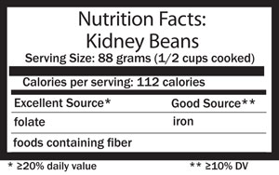

Flaxseed
Flaxseed, flaxseed oil and linen are all products of flax, one of the first crops to be domesticated. Flaxseed has long been used for nutritional and medicinal purposes.
Today, it is being touted for many health benefits and researchers are studying flaxseed and its oil to sort through the many claims.

What's in Flaxseed?
Flaxseed is an excellent source of magnesium, manganese and thiamin, and fiber; a good source of selenium; and provides protein and copper, too.  - Lignans: flaxseed is a particularly rich source of these plant estrogens  - Dietary fiber: One serving, about 4 tablespoons of ground flaxseed, contains more than 7 grams of fiber.  - Alpha-linolenic acid (ALA): about half of the fat in flaxseed is this plant form of omega-3 fat.  - Gamma-tocopherol: a form of vitamin E | 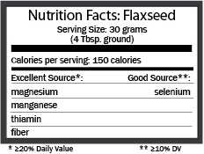
Flaxseed oil provides alpha-linolenic acid and both alpha- and gamma-tocopherol, two forms of vitamin E. It is not a source of fiber, selenium or the other nutrients noted above. It does not naturally contain lignans, though some brands contain added lignans.

Garlic
Garlic belongs to the family of vegetables called Allium, which also includes onions, scallions, leeks and chives. According to AICR's second expert report, Food, Nutrition, Physical Activity, and the Prevention of Cancer: A Global Perspective, foods belonging to the allium family of vegetables probably protect against stomach cancer. Moreover, the evidence in the report shows that garlic, in particular, probably decreases one’s chances of developing colorectal cancer.
The protective effect of garlic was shown to have a dose response relationship. In other words, highest exposure to the food showed the greatest decrease in risk. For cancer protection, AICR experts suggest including garlic as part of a well-balanced predominantly plant-based diet.
These allium vegetables contain many substances now being studied for their anti-cancer effects, such as quercetin, allixin and a large group of organosulfur compounds that includes allicin, alliin and allyl sulfides. In laboratory studies, components of garlic have shown the ability to slow or stop the growth of tumors in prostate, bladder, colon and stomach tissue.
Laboratory research has also shown that one garlic component, called diallyl disulfide, exerts potent preventive effects against cancers of the skin, colon and lung. Recently, this compound proved able to kill leukemia cells in the laboratory. A compound derived from garlic called ajoene has displayed similar activity.
In animal studies, components in Allium vegetables have slowed the development of cancer in several stages and at various body sites: stomach, breast, esophagus, colon and lung.

Grapes and Grape Juice
Both grapes and grape juice are rich sources of resveratrol, a type of natural phytochemical that belongs to a much larger group of phytochemicals called polyphenols.
The skin of the grape contains the most resveratrol, and red and purple grapes contain significantly more resveratrol than green grapes. Grape jam and raisins contain much smaller amounts of this phytochemical. Red wine also contains resveratrol. However, with AICR’s second expert report noting convincing evidence that alcohol is associated with increased risk for cancers of the mouth, pharynx and larynx, esophagus, breast (pre- and postmenopausal) and colon and rectum (in men), wine is not a recommended source of resveratrol.
Studies suggest that polyphenols in general and resveratrol, in particular, possess potent antioxidant and anti-inflammatory properties. In laboratory studies, resveratrol prevented the kind of damage known to trigger the cancer process in cell, tissue and animal models.
Other laboratory research points to resveratrol’s ability to slow the growth of cancer cells and inhibit the formation of tumors in lymph, liver, stomach and breast cells. Resveratrol has also triggered the death of leukemic and colon cancer tumors.
In one series of studies, resveratrol blocked the development of skin, breast and leukemia cancers at all three stages of the disease (initiation, promotion and progression).

Green Tea
Since ancient times, tea has been used as both beverage and medicine. Both black and green teas contain numerous active ingredients, including polyphenols and flavonoids, which are potent antioxidants.
One class of flavonoids called catechins has recently become the focus of widespread study for their anti-cancer potential. Tea is the best source of catechins in the human diet, and green tea contains about three times the quantity of catechins found in black tea.
In laboratory studies, green tea has been shown to slow or completely prevent cancer developent in colon, liver, breast and prostate cells. Other studies involving green tea have shown similar protective effects in tissues of the lung, skin and digestive tract.
Studies that track the diets of human subjects over several years (particularly studies conducted in Asia, where green tea consumption is common) have also associated regular usage of green tea with lower risk for bladder, colon, stomach, pancreatic and esophageal cancers.
AICR’s second expert report, Food, Nutrition, Physical Activity, and the Prevention of Cancer: A Global Perspective, was unable to make a recommendation regarding the relationship between tea consumption and cancer risk due to insufficient evidence.
Note: Very high amounts of green tea components (usually associated with overdosage of green tea supplements) have been shown to interact with drugs that affect blood clotting such as aspirin and change the way the body metabolizes certain medications.

Soy
Soybeans are a type of legume, or bean. Foods made from soybeans include tofu, soymilk, soybeans, soynuts, miso (soy paste), tempeh, soy burgers and soynut butter.
Scientists believe that several active ingredients in soy may have anti-cancer effects. These include: isoflavones (which have been studied most), saponins, phenolic acids, phytic acid, phytosterols, and protein kinase inhibitors.
Soy appears to contain some components that resemble very weak forms of the body’s natural hormones. As a result, soy foods can mimic the actions of hormones under certain conditions and counteract these hormonal actions at other times. Because of such complexities, most of the studies that have investigated soy’s role in cancer development have dealt with hormone-related cancers such as those of the breast and prostate.
Soy has been shown to inhibit the growth of prostate cancer cells in a variety of laboratory conditions. Soy has also been associated with the inhibition of breast cancer cells in some, but not all, laboratory experiments. Diets rich soy have been shown to alter the metabolism of breast tissue in animal subjects in ways that may translate into added anti-cancer protection.
Several human and laboratory studies suggest that consuming soy early in life (such as adolescence) may help protect against breast cancer later in life. Results are less encouraging when soy is consumed later in life.
As a general rule of thumb, soy seems to be a good food to include in your diet (along with other beans) as a source of protein and nutrients. But, there's limited evidence in U.S. populations supporting hopes that soy food might offer special protection against breast cancer.
Current research shows that it is safe to eat moderate amounts of soy foods (e.g., soymilk, tofu), up to two to three servings per day.As a precaution, women receiving anti-estrogen treatments such as tamoxifen, should minimize soy foods and avoid isoflavone supplements.

Squash (Winter)
True American natives, winter squash have hard skins unlike the soft-skinned summer squash. They also come in a wonderful variety of colors, textures and flavors. Names like buttercup, banana, turban and delicata may sound delightful and pique your interest, but if you’re like many Americans, their irregular shapes and textures have kept you from venturing beyond the convenient canned pumpkin. The most common varieties you’ll see in supermarkets are acorn, butternut, spaghetti and hubbard.

What's in Winter Squash?
Winter squash are excellent sources of vitamin A, good sources of vitamin C and dietary fiber. They are also a good way to get potassium.  Winter squash, including pumpkins, are rich in carotenoids, including:  - beta-carotene and alpha-carotene: these carotenoids can act as antioxidants. Also, our bodies convert these to vitamin A, a nutrient important for immune function and maintaining healthy cells among other roles.  - lutein and zeaxanthin: these yellow pigmented carotenoids help protect eye health by filtering high-energy ultraviolet rays that can damage our eyes’ lens and retina. They act as antioxidants here and possibly elsewhere in our bodies. | 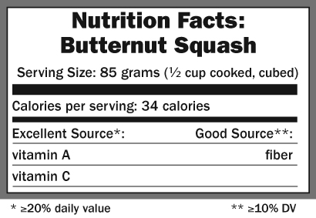

Tomatoes
The tomato’s red hue comes chiefly from a phytochemical called lycopene. Tomatoes have attracted particular attention from prostate cancer researchers because lycopene and its related compounds tend to concentrate in tissues of the prostate.
AICR's second expert report, Nutrition, Physical Activity, and the Prevention of Cancer: A Global Perspective, found substantial and convincing evidence that foods containing lycopene probably protect against prostate cancer.
In animal models, consumption of tomato compounds has been linked to large decreases in prostate cancer risk. Moreover, there is evidence that this cancer-fighting potential is increased if tomatoes are consumed in a processed form that allows these natural compounds to be released and more easily absorbed, such as tomato sauce, tomato paste or tomato juice.
Lycopene, a powerful antioxidant, together with a group of related compounds collectively called the “red family,” has displayed anti-cancer potential in a variety of laboratory studies. In the laboratory, tomato components have stopped the proliferation of several other cancer cells types, including breast, lung, and endometrial.
Although the evidence suggests it is likely that foods containing lycopene, including tomatoes, offer cancer protection, AICR stresses the importance of eating a variety of plant foods to ensure the most protection against cancer development. No food in isolation can effectively lower cancer risk.

Whole Grains
The term “whole grain” means that all three parts of the grain kernel (germ, bran and endosperm) are included. Refined grains usually have the bran and germ removed, leaving only the starchy endosperm. Brown rice is a whole grain, white rice is not. Other whole-grain foods include wheat breads, rolls, pasta and cereals; whole grain oat cereals such as oatmeal, popcorn, wild rice, tortilla and tortilla chips, corn, kasha (roasted buckwheat) and tabouleh (bulghur wheat).
Whole grains are rich in fiber, vitamins, minerals and hundreds of natural plant compounds, called phytochemicals, which protect cells from the types of damage that may lead to cancer. In addition research points to specific substances in whole grains that have been linked to lower cancer risk, including antioxidants, phenols, lignans (which is a kind of phytoestrogen) and saponins.
AICR's second expert report, Nutrition, Physical Activity, and the Prevention of Cancer: A Global Perspective, found probable evidence that foods containing dietary fiber, like whole grains, can decrease one’s risk of developing colorectal cancer.
Moreover, limiting energy dense foods and eating a predominantly plant-based diet rich in vegetables, fruits, whole grains and beans can help with weight maintenance and, in turn, may decrease your risk of developing cancer.
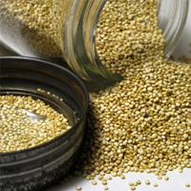

Breastfeeding and Cancer
Many know that breastfeeding gives babies a healthy start in life. It provides the nutrients babies need, helps protect them from infections and asthma and boosts their immune system.
But relatively few know that breastfeeding protects both mother and child against cancer.
But that finding is why AICR recommends that new mothers breastfeed exclusively for up to six months and then add other liquids and foods. This advice is in line with recommendations from the World Health Organization.

How is breastfeeding linked to cancer prevention?
There is convincing evidence that breastfeeding reduces the risk of breast cancer in mothers and probably helps prevent excess weight gain in their children.

What are the long-term benefits for the baby?
Breastfed babies have a decreased risk of becoming overweight or obese as they grow. Research shows that babies who are breastfed are less likely to consume too many calories than babies who are fed infant formula.
It is now well known that obesity is a strong risk factor for many cancers, including those of the colon and breast in postmenopausal women).

What are the long-term benefits for the mother?
As well as helping mothers lose any excess baby weight more quickly, breastfeeding can reduce the risk of breast cancer.
The protective effect of breastfeeding is likely due to the balance of hormones produced during the breastfeeding process. By lowering levels of some cancer-related hormones in the mother’s body, risk of cancer is reduced.
Also, at the end of breastfeeding, the body gets rid of many cells in the breast, some of which may have DNA damage. This reduces the risk of developing breast cancer in the future.

