Week 10 MAP PROJECTIONS

1.Name examples of well-known map projections. What is characteristic for these examples?

2. What do the following pictures represent? What are the main differences between them?

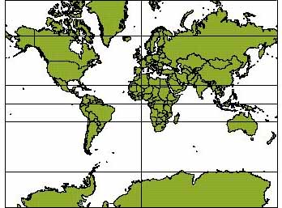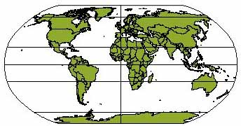

3. Metric properties of maps - match the properties and their definitions
Many properties can be measured on the Earth's surface independently of its geography. Some of these properties are:
area shape direction bearing distance scale

- the information contained in the relative position of one point with respect to another without distance information
- the angle between a line connecting two points and a north-south line
- a numerical description of how far apart objects are
- the ratio of a distance on the map to the corresponding distance on the ground
- the form of an object or its external boundary
- a quantity expressing the two-dimensional size of a defined part of a surface

Map Projections: A video Lecture
https://www.youtube.com/watch?v=v5fSBQRbPR0 0 - 5.15

1. Check the meaning and pronunciation of these words:
oblique cylinder cone plane tangent secant

2. Complete the definition and key points.

A map projection is a method of ……………….. the Earth’s ………………… surface as a flat …………………. surface.

- Projections are ……………….. transformations.
- Scale is ……………… in only certain places.
- Many different ……………… have been devised.
- All map projections ……………… .
- Distortion characteristics ……………… from projection type to type.
- Some types are better for some applications than ……………… .
- A few types are ……………… used.
Clue : mathematical, types, representing, three-dimensional, other, two-dimensional, true, distort, vary, widely

3. Supply the terms for types based on projection surfaces.

4. What are standard lines?
Standard lines are where the map projection surface ……………... the globe model.
They are the only place of the map where the …………….. is true.

5. What spatial properties are distorted on maps?

Discuss after listening: Where is the smallest and greatest distortion in the following examples?
Projection | preserves
Conformal

Equal area

Equidistant

Azimuthal

Choosing a model for the shape of the Earth
- What models for representing the shape of the Earth are used?

There are some missing parts of sentences in the text, try to fill them in.
- This model is not used for mapping due to its complexity but is instead used for control purposes in the construction of geodetic datums.

- at the expense of some accuracy in smaller regions.

- Historically, datums have been based on ellipsoids that best represent the geoid within the region the datum is intended to map.

- However, the Earth is not exactly spherical but is closer in shape to an oblate ellipsoid,

Projection construction is also affected by how the shape of the Earth is approximated. In the following discussion on projection categories, a sphere is assumed. A).......... a shape which bulges around the equator. Selecting a model for a shape of the Earth involves choosing between the advantages and disadvantages of a sphere versus an ellipsoid. Spherical models are useful for small-scale maps such as world atlases and globes, since the error at that scale is not usually noticeable or important enough to justify using the more complicated ellipsoid. The ellipsoidal model is commonly used to construct topographic maps and for other large and medium scale maps that need to accurately depict the land surface.
A third model of the shape of the Earth is called a geoid, which is a complex and more or less accurate representation of the global mean sea level surface that is obtained through a combination of terrestrial and satellite gravity measurements. B) ................... (In geodesy, plural of "datum" is "datums" rather than "data".) A geoid is used to construct a datum by adding irregularities to the ellipsoid in order to better match the Earth's actual shape (it takes into account the large scale features in the Earth's gravity field associated with mantle convection patterns, as well as the gravity signatures of very large geomorphic features such as mountain ranges, plateaus and plains). C).................. Each ellipsoid has a distinct major and minor axis. Different controls (modifications) are added to the ellipsoid in order to construct the datum, which is specialized for a specific geographic regions (such as the North American Datum). A few modern datums, such as WGS84 (the one used in the Global Positioning System GPS), are optimized to represent the entire earth as well as possible with a single ellipsoid, D)....................................

Explain the meaning of these terms:
- geodetic datums
- geoid
- mantle convection patterns
- WGS84

WORD STUDY
Supply the missing forms. (if there exists)

noun | adjective | adverb
sphere
 | global
 |  | geographically
equator
 | cylindrical
mathematics
geomorphology
 |  | topographically
 | gravitational
complexity

Sources
http://geography.about.com/
http://en.wikipedia.org/
Reading activities prepared by E. Čoupková

