Lesson 11 BIOGEOGRAPHY

1.Discuss in small groups:

- What is a biome?
- What do you think the picture represents?
- How does an ecosystem differ from a biome?
- What are different types of biomes?
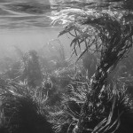

2. Vocabulary. Match each word with the right meaning.

- Soil coniferous evergreen tree, cultivated for timber
2. Terrestrial type of plant that sheds its leaves once a year
- Spruce characterized by rich vegetation
- Deciduous having to do with the Earth or dry land
- Lush top layer of the Earth's surface where plants can grow

3. Compare your answers from task 1 with the information from an encyclopedia.

A biome is an area of the planet that can be classified according to the plants and animals that live in it. Temperature, soil, and the amount of light and water help determine what life exists in a biome.
A biome is different from an ecosystem. An ecosystem is the interaction of living and nonliving things in an environment. A biome is a specific geographic area notable for the species living there. A biome can be made up of many ecosystems. For example, an aquatic biome can contain ecosystems such as coral reefs and kelp forests.
Not all scientists classify biomes in the same way. Some use broad classifications and count as few as five biomes. These are forest, grassland, freshwater, marine, desert, and tundra.
Other scientists use more precise classifications and list dozens of different biomes. For example, they consider different kinds of forests to be different biomes. Tropical rain forests that are warm and wet year-round are one biome. Temperate deciduous forests—those that have cold winters, warm summers, and are dominated by trees that lose their leaves—are a different biome. Taiga forests, which are in cold regions and are dominated by cone bearing firs and spruces, are yet another biome.
Boundaries between biomes are not always sharply defined. For instance, there are sometimes transition zones between grassland and forest biomes. Coasts and wetlands are transition zones between terrestrial and aquatic biomes.
Biomes move as the climate changes. Ten thousand years ago, parts of North Africa were lush landscapes cut by flowing rivers. Hippopotamuses, giraffes, and crocodiles lived amid abundant trees. Gradually, the climate dried out. Today, this region is part of the Sahara Desert, the world's largest desert. http://education.nationalgeographic.com/education/encyclopedia/biome/?ar_a=1

4. Look at the text and find words which correspond to these expressions:
- a special kind of seaweed d) the reproductive body of conifers made up of scales
- water that is not salty e) large, chiefly aquatic African herbivorous mammals
- exact f) present in great quantity, plentiful
5.Biomes and habitats- read about the difference and match pictures with habitats:

HABITAT
The natural environment in which an organism lives. A habitat is not necessarily a geographic area—for a parasitic organism it is the body of its host.

BIOME
The area or natural environment in which an organism or population lives. A major geographic region that contains a distinctive community of plants, animals, fungi, etc.

Beech wood | Broadleaf forest | Urban | Desert
Tundra | Coastal | Rainforest | Mountain grassland
Brackish water | Lakes and ponds | Wetland | Mangrove
Rivers and streams | Intertidal zone | Coral reefs | Rock pools
Shallow seas | Taiga
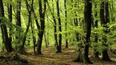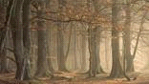
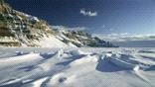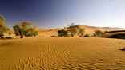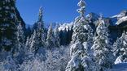
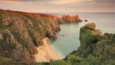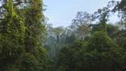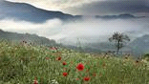
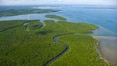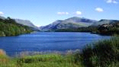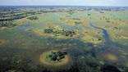
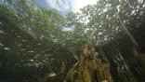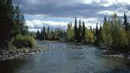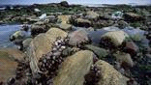
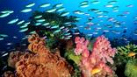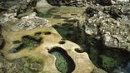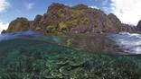

Which of the zones do the following mammals inhabit?

puma dolphins and whales Arctic fox yak walrus

tundra | pelagic | coastal | mountain

6. EXAMPLES OF SPECIFIC ZONES-Complete these types of zones in the descriptions below:
pelagic littoral chapparal brackish benthic

Any water in a sea or lake that is neither close to the bottom nor near the shore can be said to be in the ……………….. zone. The word is derived from Greek πέλαγος, meaning "open sea".
……………. is a shrubland or heathland plant community. It is shaped by a Mediterranean climate (mild, wet winters and hot dry summers) and wildfire, featuring summer drought-tolerant plants with hard sclerophyllous evergreen leaves.
………………. zone is the part of a sea, lake or river that is close to the shore. In coastal environments the zone extends from the high water mark, which is rarely inundated, to shoreline areas that are permanently submerged.
……………….. water or briny water is water that has more salinity than fresh water, but not as much as seawater. It may result from mixing of seawater with fresh water, as in estuaries.

The ……………. zone is at the lowest level of a body of water such as an ocean or a lake, including the sediment surface and some sub-surface layers. The organisms generally live in close relationship with the substrate bottom and many are permanently attached to the bottom.

7. CONSERVATION STATUS

- What is the Czech/Slovak term for conservation status?
- Translate the terms and match examples of species.
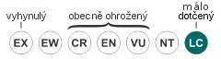 koala blue whale dodo snail white rhinoceros
LC - málo dotčený |  | platypus
NT - téměř ohrožený
VU - zranitelný |  | lemur
EN - ohrožený
CR - kriticky ohrožený |  | Siberian tyger
EW -vyhynulý v přírodě
EX - vyhynulý
DD - chybí údaje |  | fennec
NE – nevyhodnocený

- What system of protecting the landscape is there in the Czech / Slovak Republic?
- Which species were displaced form the territory of these countries in the past? Are any of them returning?

8. LISTENING Colts instead of Rifles
http://www.radio.cz/en/section/curraffrs/colts-instead-of-rifles-ngo-to-introduce-wild-horses-at-former-army-bases

You will hear a report about the re-introduction of wild horses into the Czech Republic.

Explain in English the meaning of these phrases:
1. eventual release of horses
- weed-eating horses
- marked benefits to environment
- chief objective of the project
- disused military sites
- the breed has barely changed

Answer the questions.

- Which breed of horses will be imported?
- What is the name of the NGO involved in the project?
- Which two countries are selling the horses to the CR?
- Why were the original horses displaced?
- Why is this breed ideal for the project?
- Where will the horses be kept during adaptation time?
- Which vegetation types will benefit from the horses?
- Which locality will they be introduced to?
- How can the horses help the landscape?
- What is the reason for the title Colts instead of Rifles?

9. GRAMMAR
Complete plural forms of these nouns
alga fungus species analysis synthesis

sources
http://www.stepmap.com/map/geo-biome-map-196544 map + brief characteristics
http://www.ucmp.berkeley.edu/glossary/gloss5/biome
H. Němcová – Mammals, English for Biologists
Video http://science.howstuffworks.com/life/biomes-videos-playlist.htm
http://www.bbc.co.uk/nature/habitats

