Week 3 CHANGES IN THE STATES OF MATTER

Discuss:

- Which states of matter (=phases) do you know?
- Describe the picture – what different changes occur under different conditions?

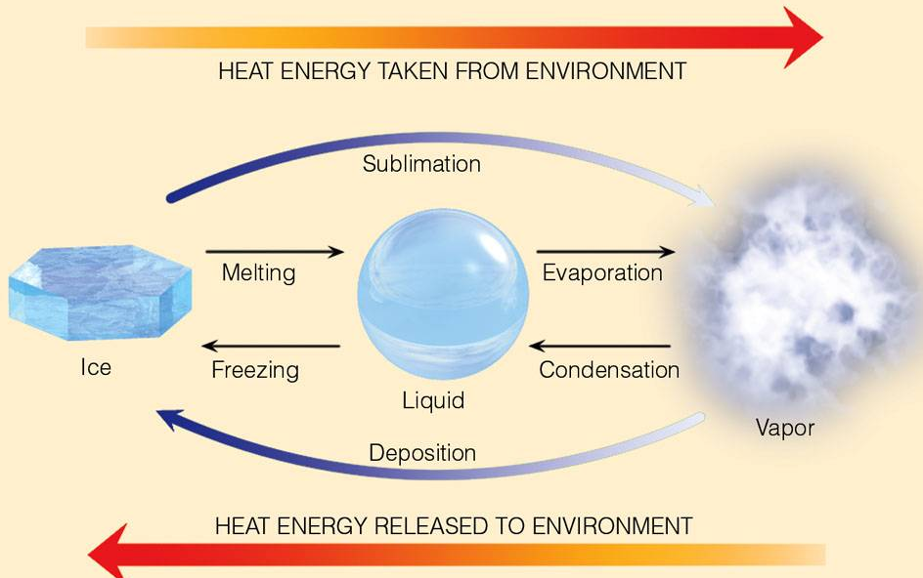
- What determines the phase of a substance – whether it is e.g. a solid or a different phase?
- How do different phases behave in terms of shape and volume? (e.g. have definite shape or take up the shape of the container?)

LISTENING: Particulate Nature of Matter and Changes of State
https://www.youtube.com/watch?v=ndw9XYA4iF0

1. In pairs, check whether you know the equivalents of these words in your mother tongue.

glossary
particle - a very small piece of matter, an elementary part
framework - a structure enclosing / supporting something, structural plan or basis
sealed – closed very tightly
nitrogen - chemical element with the symbol N, constitutes nearly four-fifths of the air by volume
immerse - cover completely in a liquid; submerge
brittle – easily broken, fragile
shrink - become smaller from exposure to heat, moisture, or cold

Answer the questions from the 1st part of the program. 0 – 1.32
- How are particles in a solid arranged?
- What is the process of changing a solid into a liquid called?
- How much has the temperature in the container with ice changed?
- What happens with particles in the process of evaporation?

2. Watch the 2nd part. What three changes of phase are demonstrated? 2.57 – 4.17

3. Are there double letters in the missing words? Listen and complete. 2.57 – 3.43
Liquid nitrogen is …………….. cold. …………………… a balloon full of air in it and see what happens. The balloon shrinks and becomes ………………. . This time the balloon is ………….. with carbon dioxide gas. In liquid nitrogen it ……………. rapidly.

READING
Discuss before reading:
The boiling point of water is 100°C at the sea level. Why is it different at high altitudes? How is the pressure cooker helpful?

Pressure has an effect on the boiling point of water. The boiling point of water increases with increasing pressure. Boiling is the process by which energetic molecules escape from a liquid. This energy is gained from heating. If the pressure is greater above the liquid, the molecules must have more energy to escape, and the liquid has to be heated to a higher temperature for boiling to take place.
Normally, when a heated liquid approaches the boiling point in an open container, pockets of energetic molecules form gas bubbles. When the pressure due to the molecular activity in the bubbles is great enough, or greater than the pressure on the surface of the liquid, the bubbles rise and break the surface. We then say that the liquid is boiling. In this sense, boiling is a cooling mechanism for the water. Energy is removed, and the water’s temperature cannot exceed 100°C.
In a sealed pressure cooker, the pressure above the liquid is increased, causing the boiling point to increase. The extra pressure is regulated by a pressure valve, which allows vapour to escape. Hence the water content of the cooker boils at a temperature greater than 100°C and the cooking time is reduced.
At mountain altitudes, the boiling point of water may be several degrees less than at sea level. For example, at the top of Pike’s Peak (elevation 4300m), the atmospheric pressure is reduced to the point where water boils at about 86°C rather than at 100°C. Pressure cookers come in handy at high altitudes – if you want to eat on time. It is interesting to note that for high altitudes, cake mixes contain less baking powder than those at or near sea level. The baking powder supplies gas to “raise” a cake. If normal cake mixes were used at high altitudes, the cake would rise too much and could explode.
Shipman, Wilson, Todd, An Introduction to Physical Science, Houghton Mifflin Company, 2006, p.110

Find words with this meaning (synonyms) in the text:

- comes close to something (par2)
- go beyond a limit (par2)
- release energy by sudden production of gases (par3)

Complete the following text with words for different states of matter.
The Earth’s interior is primarily composed of 1_______ , the densest of the three states of matter. 2 _______ are not as dense as solids , and thus most of the Earth’s 3________ water lies at the planet’s surface thousands of kilometers above the densest 4_________ located deep inside the Earth. 5________ , with an even lower density than 6________ , have the weakest gravitational attractive force and are held relatively loosely around the Earth as the atmospheric envelope, rather than within the planet or on its surface. James Petersen, Dorothy Sack, Robert Gabler: Fundamentals of Physical Geography, p.256

