Week 4 Atmospheric Regions

1. ELEMENTS THAT MAKE UP AIR
- Write down as many English names of chemical elements as you know.

- What do these symbols stand for?
H | N | O | C
Ca | Mg | Hg | Na
Cl | Si | S | Fe
He | Ar | Ne | Cu

- Which gases make up air and what are the proportions of the components?

- Compare your answer with the percentages in the following text.

The air of the atmosphere is a mixture of many 1 _________ . In addition, the air holds many suspended liquid 2 _________ and solid particles. However, only two gases make up about 99% of the 3 _________ of air near the Earth. This air is composed primarily of nitrogen (78%) and oxygen (21%), with nitrogen being almost four times as 4 _________ as oxygen. Atmospheric nitrogen and oxygen are diatomic (two-atom) 5_________, N2 and O2. The other main 6 _________ of air are argon Ar (0.9%) and carbon dioxide CO2 (0.03%). Minute quantities of many other gases are found in the atmosphere, along with 7 _________ matter. Some of these gases, especially water 8 ________ and carbon monoxide CO, vary in concentration, depending on conditions and locality.

- Complete the text - 3 words will not be needed. This is one of the types of exam tasks.

vapor pollutants droplets volume gases particulate frequent abundant molecules by-products constituents

2. STRUCTURE OF THE ATMOSPHERE
- What regions can the atmosphere be divided into? Draw a curve showing the temperature changes in different parts.

- Describe the atmosphere with the help of the diagram. Include the information which answers the questions beside the graph.

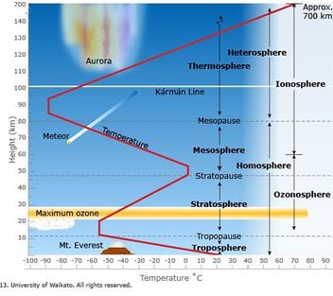

- What are the different divisions according to:
- The concentration of ozone and ions
- Temperature variations
- Uniformity of composition (how well the parts are mixed)
- In which section is the greatest mass of the atmosphere? Why?
- In which part do weather phenomena occur?
- How does the temperature change in different divisions?
- Where is the layer of maximum ozone amount?
- Where do the auroras (beautiful displays of light) form?

3. READING
Source Shipman, Wilson, Todd p. 530

- Match the words and the description of their meanings.

associate ionize charge discharge ionization dissociate charged

1. property of matter responsible for electric phenomena
2. having an amount of electricity
3. the release of stored energy by a flow of electricity
4. to link or connect
5. to separate or cause to break
6. to change into ions
7. separation into ions by heat, electrical discharge or chemical reaction

LISTENING Aurora Borealis Explained https://www.youtube.com/watch?v=1DXHE4kt3Fw
eddy - a circular movement of air or water
funnel - a cone-shaped utensil with a tube used for pouring liquids through a small opening in a bottle
hurl out – to throw something out of a place

1. What do you know about the formation of auroras?

2. Express these sentences in English. Then watch and check your translation.
a) Slunce se chová jako obří elektrárna.
b) Jaderná reakce uvolňuje energii.
c) Světlo vyzařuje ven z jádra Slunce.
d) Elektricky nabitý plyn se nazývá plazma.
e) Magnetické pole Země odkloní sluneční bouři.
f) Plyn ze sluneční bouře proudí podél siločar k pólům.

3. Watch again and answer the questions in the table below. (This is another type of exam task)

1. Where do the auroras start?
2. In high temperature and pressure, hydrogen atoms change into
3. Heat moves to the surface in convection cells, which are huge
4. What appears on the Sun when surface cools?
5. The phenomenon when plasma is hurled out from the Sun
6. Solar storm can reach this speed | km/hour
7. Solar storm reaches the Earth after | hours
8. The magnetic fields create a path for the gas - of this shape

EAP – DESCRIBING A LINE GRAPH

  - Study the description of the graph on p.2 and find words corresponding to these directions:

The atmosphere can be divided vertically into four layers based on temperature. The bottom layer, where temperature decreases with an increase in altitude, is the troposphere. It is in this layer that essentially all important weather phenomena occur. The thickness of the troposphere is not the same everywhere. It varies with latitude and the season. On average, the temperature drop continues to a height of about 12 kilometers, where the outer boundary of the troposphere, called the tropopause, is located.
Beyond the tropopause is the stratosphere. In the stratosphere, the temperature remains constant to a height of about 20 kilometers. It then begins a gradual increase in temperature that continues until the stratopause, at a height of nearly 50 kilometers above Earth’s surface. Temperatures increase in the stratosphere because the atmosphere’s ozone is concentrated here. Ozone absorbs ultraviolet radiation from the sun and, as a result, the stratosphere is heated.
In the third layer, the mesosphere, temperatures again decrease with height until the mesopause. The mesopause is more than 80 kilometers above the surface and the temperatures approach −90°C. The fourth layer extends outward from the mesopause and has no well-defined upper limit. It is the thermosphere, a layer that contains only a tiny fraction of the atmosphere’s mass. Temperatures increase in the thermosphere because oxygen and nitrogen absorb short-wave, high-energy solar radiation.

2. Suggest synonyms for these verbs / phrases.

- GO UP I _ _ _ _ _ _ _ R _ _ _ G _ _ _
- GO DOWN D _ _ _ _ _ _ _ F _ _ _ D _ _ _ D _ _ _ _ _ _
- BE ON THE SAME LEVEL REMAIN C _ _ _ _ _ _ _ / REMAIN S _ _ _ _ _
- BE CHANGEABLE F _ _ _ _ _ _ _ _
- BE EXTREME REACH M _ _ _ _ _ _ / M _ _ _ _ _ _ P _ _ _

The verbs combine with adverbs: GRADUALLY, STEADILY, SHARPHLY, STEEPLY, SLIGHTLY, GENTLY

Nouns combine with adjectives: SLIGHT, HUGE, SUBSTANTIAL, SHARP, …

3. In pairs describe the course of annual rainfall in London and Berlin.
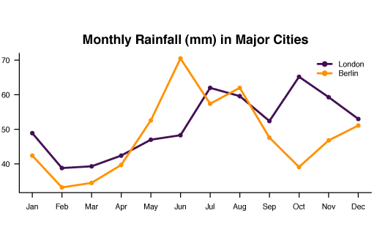

4. Make up a graph showing a changing phenomenon by means of a curve. Do not show it. Describe the graph and the course of the curve to a partner who will draw it according to your instruction. Say what quantities there are on x-axis and y-axis.

Sample answer ex.3
In the first month, the average amount of rain fall is 50 mm in London but 43mm in Berlin. In February, we have a considerable decline in both cities. For the next two months we can see a slight rise. In May, MRF of Berlin goes up to 53 mm which is a dramatic growth. On the other hand, MRF in London has a slight growth of 5 mm. In this point MRF of Berlin gets more monthly rain fall than London. Going to June, Berlin's MRF peak at more than 70 mm, but London's has a just small increase. We have some fluctuations for the remaining months with Berlin dropping sharply to 40 mm in October while London’s MRF at this time reaches its maximum value. https://med-tehuni.wikispaces.com/Tech+2-+Single+Line+Graph-G.105

