Week 6 WEATHER

Revision Sea and Land Breezes

Complete the comment explaining sea breeze
K. Kelly, Science, Macmillan
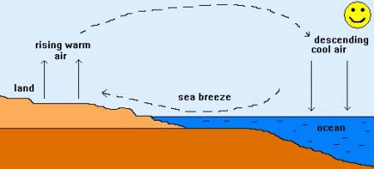
Convection currents in the air close to the sea.

gets hot moves in warms up expands

During the day the Sun …………… the land and the sea, but the land warms up more than the water. As the land …………, it warms the air directly above it. The warm air ……………. and rises and the cooler air above the sea ………….. to take its place. The movement of cool air from the sea is called a sea breeze.

Similarly, explain the formation of land breeze during the night.

LISTENING: WEATHER http://idahoptv.org/sciencetrek/topics/weather/ 0.57 –2.03

Vocabulary: check in pairs whether you know the equivalents in your language.

evenly average result in particular pattern precipitation figure out likely conditions violent wiped out swirl

1.Watch the video and cross out the picture of cloud which is not mentioned.

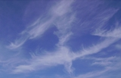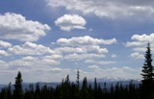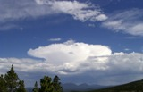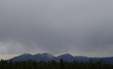

cirrus cumulus cumulonimbus stratus

2. Listen again and complete the explanations of the terms.

atmosphere - the …….. the Earth

weather - the ……… time and place

meteorologist - the …….. who tries to ….

barometric pressure – the measure of …

moisture – …

fog – a cloud that …

tornado - …. of air that …..

3. Which words refer more to water and which refer more to light?

drizzle hail hazy dull sleet bright showers clear

4. What’s the weather like where you are today? Is it typical for the time of the year?

What’s the weather forecast for tomorrow?

EXTREME WEATHER CONDITIONS
Work in groups of 3, three experts on different topics. Read your information and be prepared to answer questions on your topic. Also, ask the others. The purpose is for everyone to complete the gaps.

1. Thunderstorms are produced by …………….. columns of ……………….

…………… clouds are produced by condensation from warm moist rising air.

3. These massive clouds extending 300 m or more are called ………………..
4. They can produce a ……………………. .
5. When …………………………………, the resulting storm is called a thunderstorm.

6. Lightning is a flash of light produced because parts of a cloud have………………

7. The lightning causes ………………..

8. A blizzard is a ………….. snowstorm with ………………… and ………………….. .

9. A tornado is a funnel of air that extends down from a …………………… cloud.
- The winds in a tornado travel in a …………… direction at speeds of up to 800 km per hour
11. When a tornado reaches a ground, it can cause ………………. damage.
12. The funnel cloud of a tornado is usually only ……………… m or less in diameter.
13. Hurricanes are very large circular storms with wind speeds at least 64 knots (which is ……… km/hr) and …………….. at the center.
14.A hurricane is accompanied by ……………… and ……………..
15.The diameter of a hurricane …………………… than that of a tornado.
16. Weather conditions in the center, or eye of the hurricane may be ……………..

Has Sahara always been a desert? http://news.softpedia.com/news/Has-Sahara-Always-Been-a-Desert-47128.shtml

Here is a description of the Sahara desert.
Continue the description. Speculate about the characteristics of the area in the past.

How much water, what fauna and flora might have been there? Use your imagination and give reasons. Prepare your characteristics and present it in the class.

Today's Sahara is a huge desert area, with dunes (called ergs) and plains covered by rocks (called hamada), punctuated by mountains 3,400 m high, all in 9 million square kilometers, with less than 100 mm of rainfall annually and only modest bursts of life, the oases.

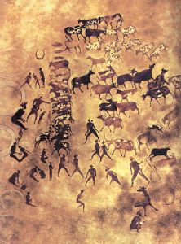

Tassili n'Ajjer Mountains

But …

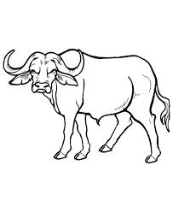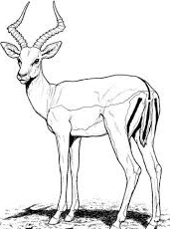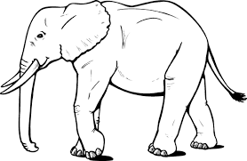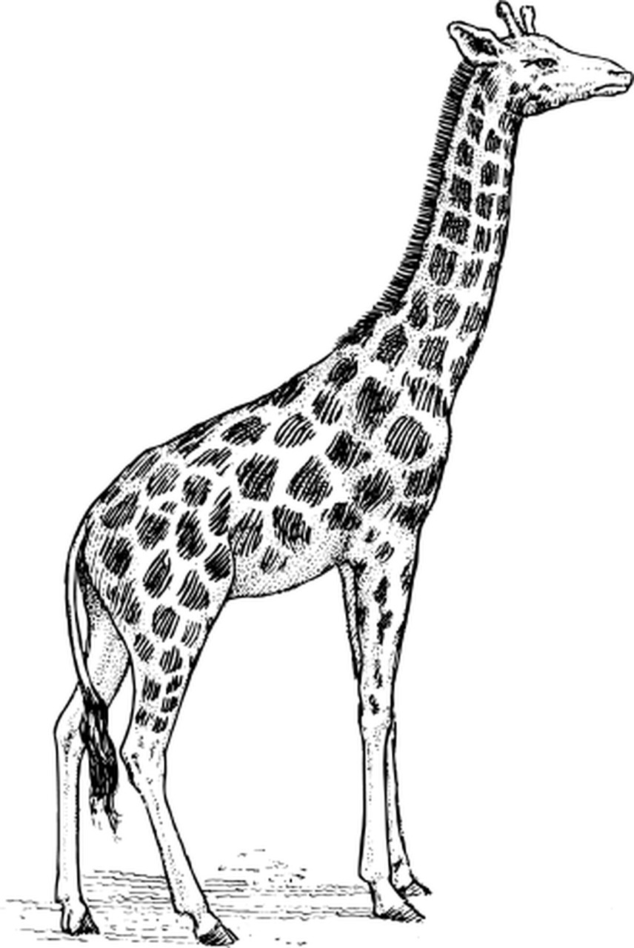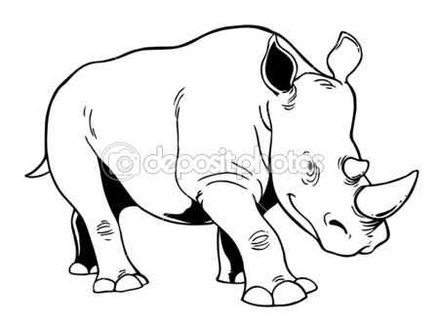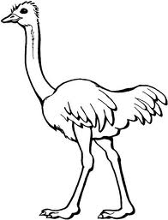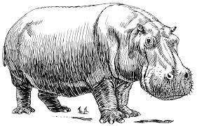

b_ _ f _ _ o a_ _ _ _ _ _ e e_ _ ph _ _ _ g_ _ _ _ _ e rh _ _ _ _ _ _ _ s o_ _ _ _ _ h h _ _ _ _ po _ _ _ _ s

