#### Metal-organic frameworks as matrices for mass spectrometry of biomolecules

Lenka Kolářová1, Kristina Hajtmanová2, Lukáš Kučera3, Petr Vaňhara3, Eladia María Peña-Méndez4, Jose Elias Conde4, Aleš Hampl3, and Josef Havel1

1Department of Chemistry, Faculty of Science, Masaryk University, Kamenice 5/A14, 625 00 Brno, Czech Republic 281376@mail.muni.cz

2Department of Biochemistry, Faculty of Science, Masaryk University, Kamenice 5/A5, 625 00 Brno, Czech Republic

3Department of Histology and Embryology, Faculty of Medicine, Masaryk University, Kamenice 3/A1, 62500 Brno, Czech Republic

4Analytical Chemistry Section, Faculty of Science, University of La Laguna, Campus de Anchieta, 38206 La Laguna, Tenerife, Spain

Metal-Organic Frameworks (MOFs) belong among new hybrid nanomaterials with porous structure consisting of a framework of metal ions and organic ligands. These coordination polymers with unique properties, such as large surface area, tunable pore size, high porosity and high absorption capability in UV-visible range, make MOFs very prospective material in many diverse applications like adsorption of dyes, gas storage, gas separation, catalysis, drug storage and delivery, imaging, sensing, and as matrices in mass spectrometry [1, 2].

In this work, possibilities of MOFs, e.g. benzene-tricarboxylic acid and Cu2+ ions framework (HKUST-1, Fig. 1), to be used as possible matrices for mass spectrometry of various kinds of molecules from a simple (retinoic acid) to complex (peptides/proteins of mouse embryonic fibroblast) were examined. Either MOFs alone or in combination with classical MALDI matrices like dihydroxybenzoic acid, gold nanoparticles or other nanoparticles were extensively studied for Matrix and Surface Assisted Laser Desorption Ionization (MALDI and SALDI).

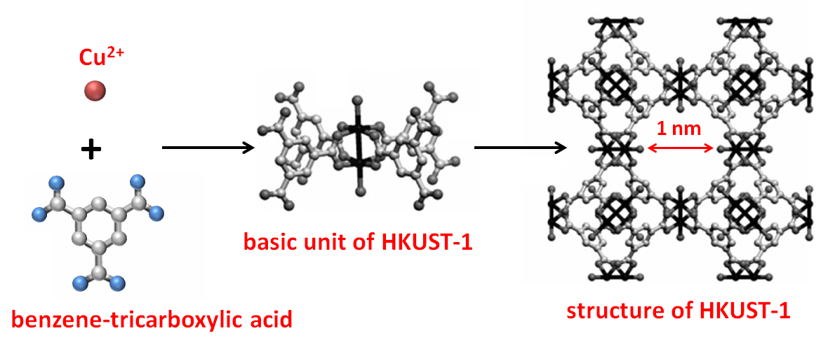

**Fig. 1**Synthesis of HKUST-1(adapted from [3])

It was found that, HKUST-1 is capable of increasing the ionization and MS detection of simple organic and/or various bio-molecules. The use of MOFs presents several advantages, including lower interference of background, salt tolerance, high sensitivity and reproducibility. Further potential use MOFs might be as a concentration probe and/or staining agents, for example.

Acknowledgements

This study was supported by Grant Agency of Masaryk University (MUNI/M/0041/2013 and MUNI/A/1558/2014, MUNI/A/1014/2013) and by funds from the Faculty of Medicine MU to junior researcher (Petr Vaňhara). Grant MAT2014-57465-R (Ministry of Economy and Competitivity, Spain)is also acknowledged.

References

[1] Z. A. Lin, W. Bian, J.-N. Zheng, and Z. Cai: *Chem. Commun.* 51, (2015).

[2] M. Zhao, C. Deng, X. Zhang, and P. Yang: *Proteomics* 13, (2013).

[3] S. Bordiga, L. Regli, F. Bonino, E. Groppo, C. Lamberti, B. Xiao, P. S. Wheatley, R. E. Morris, and A. Zecchina: *Phys. Chem. Chem. Phys.* 9,( 2007).