**Propanediurea Dimer Clips**

Tomáš Lízal,Vladimír Šindelář

Propanediurea is a heterocyclic compound analogous to glycoluril. It’s a suitable building block for supramolecular objects such as molecular clips1 and macrocycles.2

Here we report synthesis of the new molecular clips based on a dimer of *o*‑xylylene walled propanediurea (Fig. 1: **1**, **2**). Dimers were characterized by means of NMR, HRMS and X‑ray crystallography. Supramolecular interactions between clips and halide anions were studied by NMR titration experiments.

In a non-polar solution the dimers act as a host for halide anions. Weak binding of guest molecules surprisingly proceeds on a concave side of dimer instead of the cavity formed by *o*-xylylene groups. The complexes features C-H∙∙∙X- bond between methine protons and anions. Geometry of complex were further studied by DFT calculations.

Fig. 1

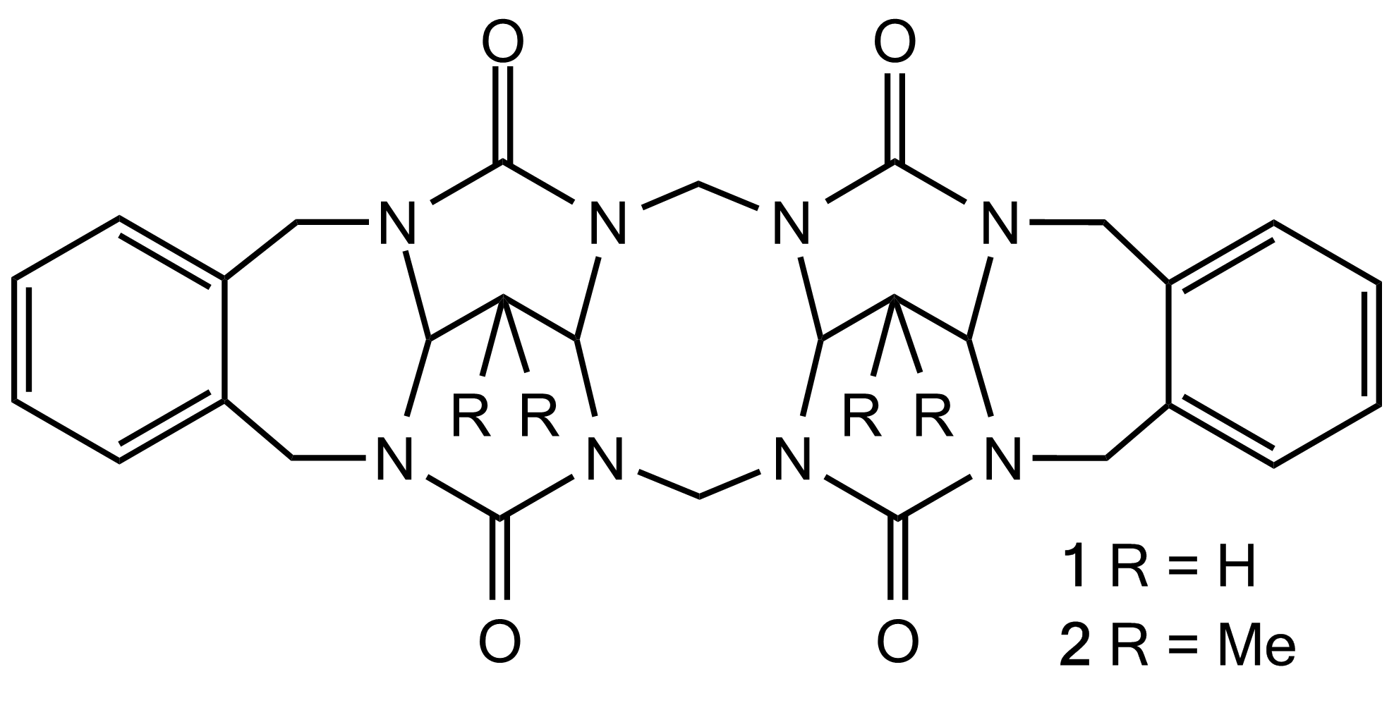

1) Jansen, R. J.; Rowan, A. E.; Nolte R. J. *Chem. Commun.* **1998**, 121.

2) Ustrnul, L.; Kulhánek P.; Lízal, T.; Šindelář, V. *Org. Lett.* **2015**, 17, 1022.