**Hidex Plate CHAMELEON V**

**(quick start guide)**

* **Turning ON**
  1. Turn on the computer
  2. Turn on the power source (big black box behind luminometer)
  3. Turn on the luminometer
* **MikroWin 2000**
  1. Start MikroWin (doubleclick on MikroWin 2000 icon on desktop)
  2. Join MikroWin to luminometer - **Read** **--> Options**, choose Chameleon in **Device** field and press **Ok**
* 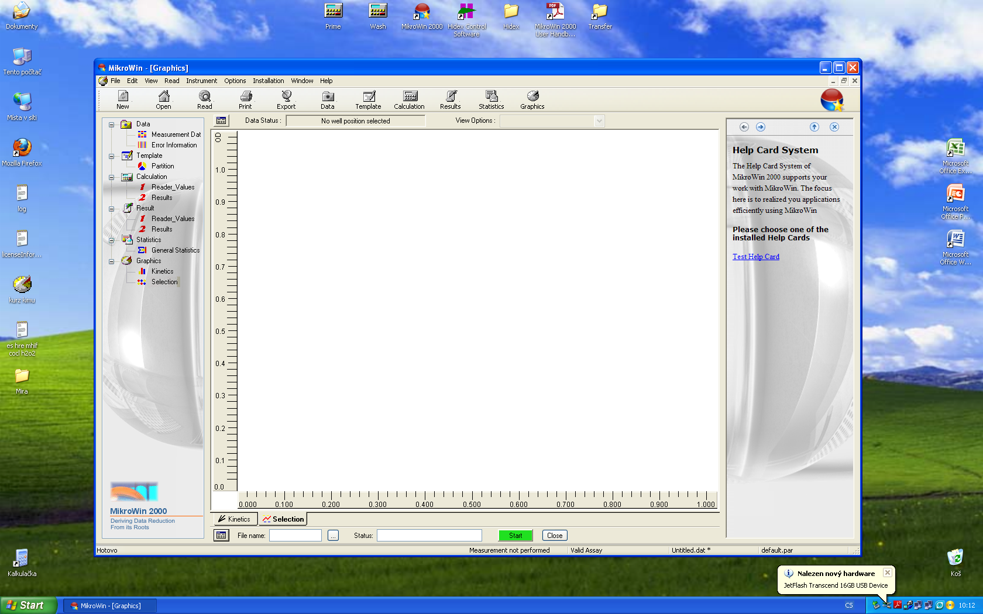**Setting up the measurement**
  1. Click on the icon ( ) next to file name in the lower left part of the screen to open the **option screen**
  2. In the lower right part of the option screen choose which wells do you want to measure - **black dots** are **selected wells**, and if you want to measure **by columns** or **by rows**
  3. In the lower left part of the option screen you can activate **Temperature Unit** and set the **targeted temperature** (2 - 42 °C), **!!!**the machine starts to heat up after starting any measurement, so if you wish to heat it up just run any random measurement first**!!!**, luminometer can not **cool down**, only **heat**
  4. Click on **Add Tech** icon and choose **Luminescence** (other two possibilities does not work on our machine)
  5. Click on **Edit Tech** icon to set up parameters of your measurements, for basic measurements use following set up:
     + In **Measurement Mode** screen set **Operation Mode** to **Single Measurement** if you want to measure your wells just once or **Range Kinetic** if you want to measure continuous measurement - set **Interval Time** equal to the number of wells you want to measure (10 wells = 10 sec IT), **Number of Repeats** depends on how long you want to measure and
     + how many wells you selected, if you want to measure one hour 10 wells then the NoR would be 360 (3600/10) - measurement will be a little bit longer than one hour but it does not matter
     + In the **Shaker Unit** screen you can **Activate Shaker** if you need it - **Shake Mode** enable you to set when do you want to shake, usually **Ranges** are used for shaking before every plate cycle, set the **Shake Time** and **Shake Amplitude** - for 96 well microtitre plate use 2 - 3 interval (the number means length in mm which the plate will be moved - bigger number means longer distance but slower shaking and the other way around)
     + click **Ok**
     + If you need more **sophisticated settings** (Measurement mode, shaker, dispenser...), you can set up more parameters clicking on **Edit Item** icon
* **Starting measurement**
  1. Type the name of the measurement to the **File Name** column and press **start** icon
  2. Click on **no** when it ask you to set the parameters as default
  3. After luminometer opens the lid, place your plate inside and push **start**
* **During measurement**
  1. You can see the exact luminescence numbers (in CPS) for each well when choosing **Measurement** **Data** on left side column in basic screen
  2. You can also see curves for each well or for selected wells when choosing **Kinetics** or **Selection**, to see the curves you need to set up the **Y axis range** by clicking on icon placed in upper left side of the screen to appropriate number (when the values you are measuring are about 1000 CPS - set Y axis range to e.g. 2000), in selection mode you need to select wells you want to see by clicking on them - little red triangle shows selected well
* **Closing measurement** 
  1. Wait until the measurement ends, lid will be **automatically open**, take away your plate and click **proceed** (the lid will be **automatically closed**), if you were heating the machine up choose if you want to **keep heating** or **not**, the data will be saved in the data folder by a name you chose before measurement
  2. If you wish to stop measurement before it ends automatically just click on **cancel** icon on the bottom of the screen and then choose what do you want to do , usually click on **end counting** and the rest is the same like in the previous section
* **Extracting data**
  1. To extract your data in the *.txt file which can be opened in MS Excel click on **Export** icon in the upper side of the main screen, choose **Raw Data Export Driver** in the **Active Export Driver** field and press ok, then you will find your file in the **Transfer** folder, its shortcut can be easily found on the computers desktop, if you wish to save your file somewhere else, just set up a destination you want
* **Turning OFF**
  1. Check if there is no plate presented in the luminometer chamber, if not **take it out!** (**Instrument--> Open lid/Close lid**)
  2. Close MikroWin software and computer
  3. Turn off the luminometer
  4. Turn off the power source

PS.: If you wish to use **dispenser** or set more **sophisticated options** for measurements, please contact **dr.** **Vojtek**, **Dobeš** (room 116) or **dr.** **Hyršl** (room 113) and they will kindly help you.