***MUSIC TO YOUR EARS (sound and hearing)- Ss***

1. **Look at the idiomatic phrases below and decide which one suits each sentence best.**

*to face the music it rings a bell safe and sound to jazz up play it by ear*

1. You didn’t spend much time studying, now you have to _________________ and re-take your exams.
2. This theory ________________, but I don’t know how to explain it.
3. He never prepared his presentations. He always ______________.
4. Try to ______________ your essay with some analytical insights rather than simply sum up everything you’ve read.
5. **Read the description of how our ears work and label the picture.**

The three parts of the ear anatomy are the outer ear, the middle ear and the inner ear. The inner ear is also called the cochlea. (‘Cochlea’ means ‘snail’ in Latin; the cochlea gets its name from its distinctive coiled up shape.)

The **outer ear** consists of the pinna, ear canal and eardrum.  
The **middle ear** consists of the malleus (hammer), incus (anvil) and stapes (stirrup).  
The **inner ear** consists of the cochlea, the auditory (hearing) nerve and the brain.  
Sound waves enter the ear canal and make the ear drum vibrate. This action moves the tiny chain of bones (ossicles – malleus, incus, stapes) in the middle ear. The last bone in this chain ‘knocks’ on the membrane window of the cochlea and makes the fluid in the cochlea move. The fluid movement then triggers a response in the hearing nerve.

[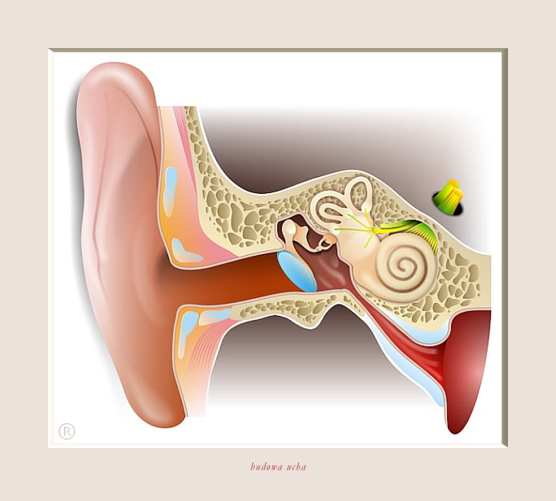](https://www.google.pl/url?sa=i&rct=j&q=&esrc=s&source=images&cd=&cad=rja&uact=8&ved=0ahUKEwiNgtOamvbRAhWBfxoKHQl6CM8QjRwIBw&url=http://www.scislowska.pl/08_ryciny_anatomiczne.html&bvm=bv.146094739,d.d2s&psig=AFQjCNGFhdpMwVfiRSk6lI6o2eAOsMho-g&ust=1486288475886589)

<http://www.scislowska.pl/08_ryciny_anatomiczne.html> visited: 4.2.2017

1. **Match the beginnings of the sentences with their endings.**

|  |  |
| --- | --- |
| Sound waves are longitudinal waves that can | vibrations per second and has units called hertz (Hz). |
| The loudness and softness of a sound | is measured in units called decibels (dB). |
| The loudness of a sound | depends on its amplitude. |
| The frequency of a sound is the number of | the impulse to the brain via the auditory nerve. |
| Sounds with irregular frequencies | which could lead to permanent deafness. |
| Sound waves are heard when they are transferred | are classified as noise. |
| The cochlea contains the sensory cells that transfer | through the structures in the ear to the cochlea. |
| Very loud sounds may rupture the eardrum | cause air molecules to compress and rarefy as they pass. |

1. **Read the text about sound ranges and fill in the gaps with appropriate words (1 or 2 words). Then listen to the recording and check your answers.**

Humans are usually able to hear sounds ranging between 20 and **1.**_________________ Hz. Animals, such as cats, bats and dogs are sensitive to sounds of **2.**_____________________. Sounds with frequencies exceeding the range normally heard by humans are often referred to as ultrasound. Although we cannot hear it, we have scientific instruments that use ultrasound for a wide range of important **3.**_______________________. Ultrasound is safer to use than **4.**_____________________ when trying to “see” inside the body as it does not damage **5.**_____________________, so we use it for: monitoring the growth **6.**________________________ of a foetus; detecting **7.**_______________________ growth (cancer) in the body; detecting brain damage.

Sounds with frequencies below the normal range heard by humans are very **8.**___________________ waves and are called infrasound. It is believed that some birds, such as pigeons, use infrasound for **9.**_______________________. Infrasound has also important uses. For example, it is used to move air around in air conditioners and other **10.**______________________. At very high intensities, these low frequency sounds may cause **11.**________________________ to vibrate, which can result in **12.**_______________________ such as nausea and internal injury.

1. **Put the phrases in the correct order to make sentences.**
2. a ruler that and produces sound. at the edge of a table is flicked vibrates
3. by the ruler the distance moved up and down of the vibration. the amplitude We call
4. loud of a sound wave or soft. The amplitude the sound is whether will determine
5. a small amount of energy If is flicked only a little, is supplied the ruler then to the ruler.
6. a small amplitude a soft sound and causes in vibration is heard. This
7. and and a large energy However, if the ruler is larger is flicked more strongly, is supplied, louder. the amplitude the sound will be
8. on the ruler, that occurs. The harder the louder the sound you pluck
9. a guitar. applies of on the strings The same to plucking
10. can be cycle graphically. of represented The complete the vibrations
11. A a amplitude. greater has louder sound
12. **In the description above find words or phrases that you can use to explain any phenomenon**.
13. **Read the text about an ancient Greek amphitheatre and complete it with the phrases from A to H**
14. may have acted as primitive loudspeakers
15. hushes low frequency background noises like the murmur of a crowd
16. was acting as a filter for sound waves at certain frequencies
17. the low frequencies of speech were also filtered out to some extent
18. makes the ancient amphitheatre an acoustic marvel
19. similar to the ridged acoustics padding on walls or insulation in a parking garage

[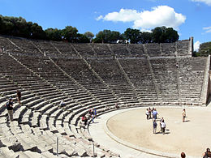](https://www.google.pl/url?sa=i&rct=j&q=&esrc=s&source=images&cd=&cad=rja&uact=8&ved=0ahUKEwjA8ZeFo_bRAhVItxoKHYtdAWgQjRwIBw&url=https://en.wikipedia.org/wiki/Epidaurus&bvm=bv.146094739,d.d2s&psig=AFQjCNFXdoxDGdWfroKFvUhsbMC1mHgd4g&ust=1486291901242646)

1. which may have played a large role in the gradual abandonment of Epidaurus’ design
2. well before any theatre had the luxury of a sound system

As the ancient Greeks were placing the last few stones on the magnificent theater at Epidaurus in the fourth century B.C., they couldn’t have known that they had unwittingly created a sophisticated acoustic filter. But when audiences in the back row were able to hear music and voices with amazing clarity (1. _____), the Greeks must have known that they had done something very right because they made many attempts to duplicate Epidaurus’ design, but never with the same success.

Researchers at the Georgia Institute of Technology have pinpointed the elusive factor that 2. ______. It’s not the slope, or the wind — it’s the seats. The rows of limestone seats at Epidaurus form an efficient acoustics filter that 3. _______ and reflects the high-frequency noises of the performers on stage off the seats and back toward the seated audience member, carrying an actor’s voice all the way to the back rows of the theater.

While many experts speculated on the possible causes for Epidaurus’ acoustics, few guessed that the seats themselves were the secret of its acoustics success. There were theories that the site’s wind — which blows primarily from the stage to the audience — was the cause, while others credited masks that 4. _______ or the rhythm of Greek speech. Other more technical theories took into account the slope of the seat rows.

When Declercq set out to solve the acoustic mystery, he too had the wrong idea about how Epidaurus carries performance sounds so well. He suspected that the corrugated, or ridged, material of the theater’s limestone structure 5. ______, but he didn’t anticipate how well it was controlling background noise.

“When I first tackled this problem, I thought that the effect of the splendid acoustics was due to surface waves climbing the theater with almost no damping,” Declercq said. “While the voices of the performers were being carried, I didn’t anticipate that 6. _____.”

But as Declercq’s team experimented with ultrasonic waves and numerical simulations of the theater’s acoustics, they discovered that frequencies up to 500 Hz were held back while frequencies above 500 Hz were allowed to ring out. The corrugated surface of the seats was creating an effect 7. ______.

So, how did the audience hear the lower frequencies of an actor’s voice if they were being suppressed with other background low frequencies? There’s a simple answer, said Declercq. The human brain is capable of reconstructing the missing frequencies through a phenomenon called virtual pitch. Virtual pitch helps us appreciate the incomplete sound coming from small loudspeakers (in a laptop or a telephone), even though the low (bass) frequencies aren’t generated by a small speaker.

The Greeks’ misunderstanding about the role the limestone seats played in Epidaurus’ acoustics likely kept them from being able to duplicate the effect. Later theaters included different bench and seat materials, including wood, 8. ______ over the years by the Greeks and Romans, Declercq said.

1. **Find in the text words that mean:**

Par I: nevědomky, mimoděk;

Par II: určit, identifikovat; prchavý, těžko pochopitelný; zázrak, div; svah, sklon; vápenec;

Par IV: vlnitý

Par V: tlumení

Par VI: hřebenovitý, drážkovaný; tlumený

Par VII: potlačovaný; výška, poloha (tonu)

Par VIII: zanechání

1. **Ask about the underlined part of the sentence**
2. The Greeks must have known that they had done something very right.
3. The Greeks must have known that they had done something very right.
4. Limestone seats at Epidaurus form an efficient acoustics filter.
5. Limestone seats at Epidaurus form an efficient acoustics filter.
6. Limestone seats at Epidaurus form an efficient acoustics filter.
7. Limestone seats at Epidaurus form an efficient acoustics filter.
8. Declercq’s team experimented with ultrasonic waves of the theatre’s acoustics.
9. Declercq’s team experimented with ultrasonic waves of the theatre’s acoustics.
10. They had unwittingly created a sophisticated acoustic filter.
11. The magnificent theatre at Epidaurus was built in the fourth century B.C.
12. **With information from the reading and phrases from ex.V write an explanation of the virtual pitch phenomenon.**

Sources:

Kelly, K. (2008) ***Science*** MacMillan

bing.com/images accessed on February 1, 2017

<https://www.hearinglink.org/your-hearing/how-the-ear-works/> accessed on February 1, 2017

http://www.sciencedaily.com accessed on March 18, 2015