**LIGHT AND SIGHT; describing a process**

1. **What is Light?**

Read the text about light and complete it with the missing parts of sentences A-H. There is one phrase too many.

to propagate - přenášet, šířit (se)

to hold sway - (to be master, to rule) vládnout, kralovat

1. called photons
2. contained in each photon
3. detected by the human eye
4. as demonstrated in the dual slit experiment
5. which is the color of the light
6. changing electric and magnetic fields
7. which is the brightness of the light
8. speeding those particles

Light is simply a name for a range of electromagnetic radiation that can be 1. ____. What is electromagnetic radiation, then?

Electromagnetic radiation has a dual nature as both particles and waves. One way to look at it is as 2. ____which propagate through space, forming an electromagnetic wave. This wave has amplitude, 3. ____, wavelength, 4. ____, and an angle at which it is vibrating, called polarization. This was the classical interpretation, crystallized in Maxwell's equations, which held sway until Planck, Einstein and others came along with quantum theory. In terms of the modern quantum theory, electromagnetic radiation consists of particles 5.____, which are packets ("quanta") of energy which move at the speed of light. In this particle view of light, the brightness of the light is the number of photons, and the color of the light is the energy 6.____.

Which interpretation is correct? Both of them, actually. It turns out electromagnetic radiation can have both wave-like and particle-like properties 7. ____.

**II. Fluorescent lamps**

Read the text and underline the correct words.

The fluorescent lamp is a sealed 1 (cylindrical / circular) glass tube that 2 (contains / consists) mercury at high pressure and electrodes at either ends of the tube. Sometimes a small amount of inert gas, such as argon, is placed in the tube. A phosphor powder 3 (skirts / coats) the inside of the glass. When the lamp is turned on, the current 4 (swims/flows) through the electrical circuit to the electrodes, which shoot electrons into the mercury vapour causing it to 5 (emit / emerge) a bluish light and ultraviolet radiation. We are unable to see the radiation but, when it hits the phosphor powder in the glass tube, it causes the emission of 6 (visible / seeable) light. These lamps do not produce much heat. 7 (Incandescent / Non-candescent) light bulbs glow because the filament is 8 (heated / heating) to a very high temperature. So a lot of energy is wasted as heat. Therefore fluorescent lamps are more 9 (economical / economic) than conventional light bulbs, even though the initial installation 10 (price / cost) of the fluorescent lamp is higher.

Now label the picture below according to the information in the above text.

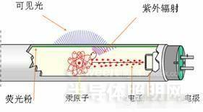

**III. Filament lamps**

Read the text and label the diagram.

A filament lamp is an incandescent source of light, that is, it gives off light because it is very hot. The filament light bulb has a very thin tungsten filament coil, which is connected to electrical foot contacts via two stiff pieces of support wire. The support wires are enclosed in insulation at the base of the glass mount. The filament is enclosed in a glass case or bulb filled with an inert gas such as argon, and is fixed on a glass mount so that it sits in the middle of the bulb. When the bulb is connected to a power supply, an electric current passes through the tungsten filament. This makes the filament heat up to 2500 °C, at which point the tungsten glows white hot and emits light and heat. The heat is wasted energy since it produces no illumination. At these high temperatures the metal tends to evaporate and become condensed on the sides of the bulb, gradually darkening it. The inert gas in the bulb slows down this process and prevents oxidation of the tungsten which would happen if air was used to fill the bulb. Some bulbs have a screw thread to allow them to be securely fixed into a lamp.

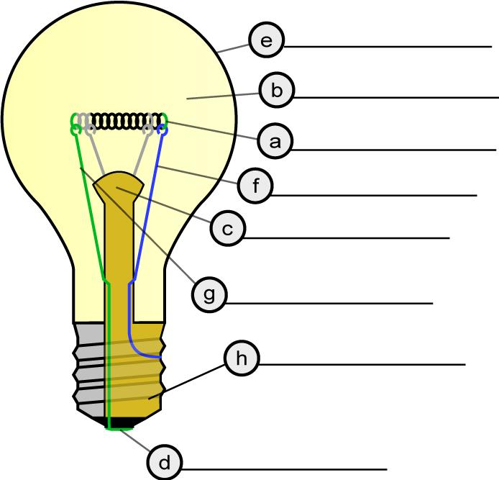

**IV. LED LAMPS - how does LED light work?**

Listen to the recording and complete the table with most suitable information. Use one word only per each gap, unless stated otherwise.

|  |  |
| --- | --- |
| 1.What any LED is made up of | 3 main _____ |
| 2. Between an anode and a cathode | a semiconductor _____ |
| 3. The basis of an LED operation | ______ |
| 4. Determines the colour of the LED light | semiconducting ____ |
| 5. Most common use of LEDs | ______ |
| 6. The problem with using LEDs as a light source | amount of ______________ (2 words) |
| 7. The example of a less efficient light source mentioned | ______ light bulbs |
| 8. Absorbs heat to reduce an LED’s depreciation | ________________ (2 words) |

**V. DESCRIBING A PROCESS**

These points are commonly covered in a process description:

Sequence

Method

Position

Purpose

Go over the texts about fluorescent and incandescent lights and find ways of wording the above points.

**VI. LED LAMPS**

Combining some information from the listening and the diagram below describe a process of generating light by an LED.

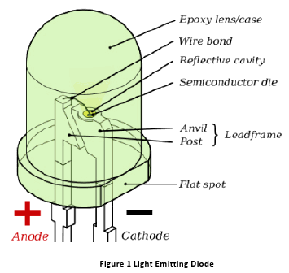

http://www.udaipurtalents.com/technical-learning/how-led-works

**Homework:**

1. **The effect of different types of material on light**

Read the text and then label the three pictures.

Opaque materials and objects block the passage of light, that is, they do not allow any light to pass through them, so it is impossible to see through them to objects on the opposite side. However, not all materials are opaque. Transparent materials allow light to pass through completely. As a result, it is easy to see things clearly on the other side of a transparent object. Clear glass and plastic wrap are examples of materials that are transparent. Translucent materials on the other hand only allow some light to pass through them, so it is difficult to see objects on the other side clearly. Examples of materials that are translucent are tracing paper, grease paper and frosted glass.

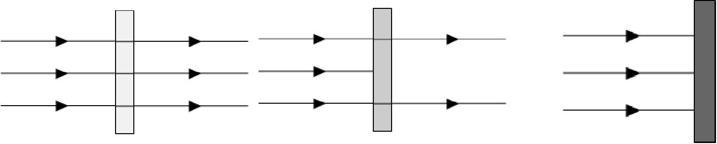

1. **Refraction of light**

Read the text and fill in the gaps with these words. There are three words you will not need to use.



**bend bent incidence light normal effect refracted refraction incident transparent optical**

When a pencil is half submerged in a beaker of water, the pencil should appear to bend at the point it enters the water. This 1_____________________ is due to refraction. When light passes from one 2_____________________ medium to another, such as from air to water, its speed changes. This change in speed causes the light to 3_____________________. When light travels from a less dense medium, such as air, to a denser medium, such as glass or water, 4_____________________ bends towards the normal but when it travels from a denser medium to a less dense medium it bends away from the 5_____________________. The angle between the incident ray and the normal is called the angle of 6_____________________ and the angle between the 7_____________________ ray and the normal is called the angle of 8_____________________

Sources:

<http://library.thinkquest.org>

Kelly, Keith (2007) ***Science;*** MacMillan

<https://www.youtube.com>