Week 10 **ENVIRONMENTAL SCIENCE**

**1. You are going to listen to a one-minute introduction to environmental sience.** 1.05 – 2.05

**Before listening, think about the pictures:**

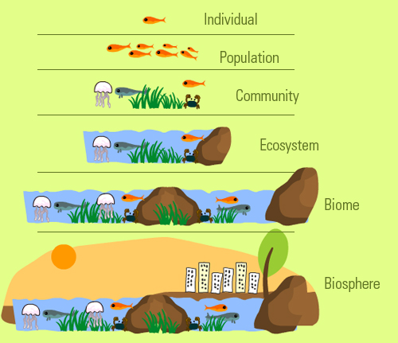  

 



**Now describe how life is organized – by supplying a term for each picture and explaining the diferences between the successive levels.**

LANGUAGE FOR COMPARING

DESCRIBING DIFFERENCES DESCRIBING SIMILARITIES

Compared to …, In comparison to …, both … and …

Unlike …, In contrast to …, Like …, Similarly to …,

is different from… is similar to …, is comparable with …

differs from … in resembles / parallels

whereas / while … are equal / identical

* Which of the comparing phrases did you use?
* Describe how *an ecosystem* is similar to and also different from *a biome*.

**OTHER TERMS THAT MIGHT BE CONFUSED**

HABITAT – an environmental area that is inhabited by a particular species of animal, plant or other type of organism. The term refers to the zone in which the organism lives and where it can find food, shelter, protection and mates for reproduction. It is the natural environment in which an orgnism lives or the physical environment that surrounds a species population. A habitat is not necessarily a geographic area - for a parasitic organism it is the body of its host.

NICHE – a term with a variety of meanings related to the behaviour of a species (e.g. the specific area where an organism inhabits, or the role of an organism in an ecosystem). The ecological niche describes how an organism or a population responds to the distribution of resources and competitors (e.g. by growing when resources are abundant) and how it in turn changes the same factors (e.g. by limiting acces to resorces or acting as food for predators).

**Write two / there sentences explaining the similarities and differences between habitat and niche.**

**2. BIOMES: Which factors do you think determine the types of biomes?**

TERRESTRIAL AQUATIC

1. …….. 2. …….. 1. ……. 2. DEPTH 3. WATREFLOW

**Below are examples of biomes. Select the terrestrial ones and design a graph which shows their relationship to the two factors.**

salt marshes boreal forest grassland mangroves temperate seasonal forest

coral reefs shrubland rainforests savanna tundra

Compare with the graph in the video <https://www.youtube.com/watch?v=FhaldPmkoNE&t=245s> 2.06- 4.08

**3. Read the comparison of two related disciplines. What are the disciplines and their different subjects?**

Ecology and biogeography are closely related, interdependent and are easily confused because of the overlap regarding subject matter. There are, nevertheless, some distinctions that can be drawn. While biogeography is concerned with distributional patterns and their explanations, ecology is more concerned with factors controlling abundance. While biogeography deals with a range of taxonomic groups, from species to phyla, ecology is more generally focused on the species level and developed through a consideration of interactions between individuals within a population and between populations of different species within a community and their environmental relations.

Geographical considerations of biogeography tend to adopt a wider range of contexts. For example, geographers consider the analysis of the multiple functional roles of the many components of the biosphere to be biogeography. Geographers are also more concerned with applied aspects of the discipline, for example the impact of people on biodiversity. Finally, geographers tend to restrict their consideration of temporal factors in biogeography to relatively short periods of change over decades up to millennia, whereas the more biologically-minded frequently consider long-term evolutionary changes over periods encompassing deeper geological time. <http://www.eolss.net/Sample-Chapters/C01/E6-14-02-04.pdf>

* **Let’s take examples of two biomes** **- *arctic tundra* and *alpine tundra*. Prepare a speech on their comparison.** http://www.ucmp.berkeley.edu/glossary/gloss5/biome

*Arctic – northern hemisphere - encircling the north pole, growing season 50/60 days, subsoil permafrost exists, plants are short and group together*

*Alpine – on mountains at high altitudes, growing season 180 days, soil is well drained, plants are similar to arctic ones*